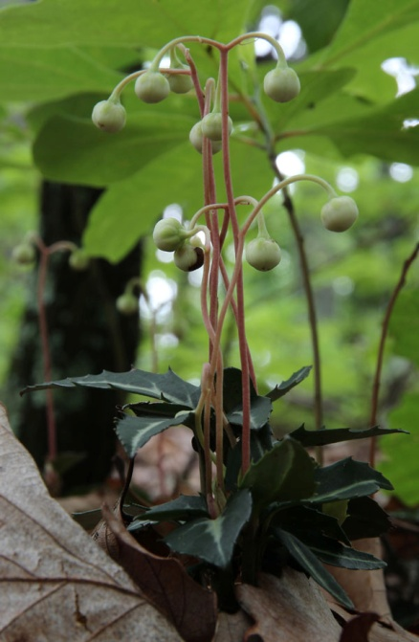
Today we will build a population viability analysis (PVA) for Striped Pipsissewa / Spotted Wintergreen (Ericales: Pyrolaceae: Chimaphila maculata). This plant is a low evergreen forest perennial, listed as locally rare in several states and provinces, including New Hampshire and Maine. Flowers appear in early summer; fruit capsules are retained through winter. Fruit capsules contain thousands of tiny seeds. Plants also reproduce vegetatively through rhizomes that may be up to 2.5 m long.
- Our first goal is to construct a transition matrix for striped pipsissewa (Chimaphila maculata) using our data. In the printed out data sheets, we have listed the recorded stage for each individual plant in the given surveys. Survey 1 corresponds to Spring 2011, Survey 2 corresponds to Fall 2011, and Survey 3 corresponds to Spring 2013.

Stage Number | Stage Description
-1 | Not Observed
0 | Dead
1 | Less than 3 leaves, or longest leaf longer than 3 cm, no fruit
2 | 3 or more leaves, and longest leaf longer than or equal to 3 cm, no fruit
3 | Fruiting

- Work as a group to fill in the tables on the next page. You can ignore the transitions in the grey boxes (those won’t go into the model).
 |  | Survey 1
 |  | -1 | 0 | 1 | 2 | 3
Survey 2 | -1 |  |  |  |  | *Use for Recruitment only, not other transitions
 | 0
 | 1
 | 2
 | 3

 |  | Survey 2
 |  | -1 | 0 | 1 | 2 | 3
Survey 3 | -1 |  |  |  |  | *Use for Recruitment only, not other transitions
 | 0
 | 1
 | 2
 | 3

- Enter Sum of observed Transition #1 and Transition #2, corresponding to the two transition matrices on the previous page, (count data)
 |  | Year 1
 |  | Stage 1 | Stage 2 | Stage 3
Year 2 | Mortality
 | Stage 1
 | Stage 2
 | Stage 3
 | SUM:

- Enter Transition Probabilities (divide cells in table above by column sums):
 |  | Year 1
 |  | Stage 1 | Stage 2 | Stage 3
Year 2 | Mortality
 | Stage 1
 | Stage 2
 | Stage 3

- Estimate Recruitment by comparing last year’s Stage 3 plants to this year’s new recruits:
For observed Transition #1:
Number of New Stage 1 plants (transtition -1 1): ______
Total Number of Stage 3 plants: ________
Estimated Recruitment (new plants this year/adults last year): ________
For observed Transition #2:
Number of New Stage 1 plants (transtition -1 1): ______
Total Number of Stage 3 plants: ________
Estimated Recruitment (new plants this year/adults last year): ________
Recruitment Averaged across these two transitions:_______
- Fill in the transition matrix below, incorporating fertility/recruitment into the first row, and try projecting the population forward two years using matrix multiplication.
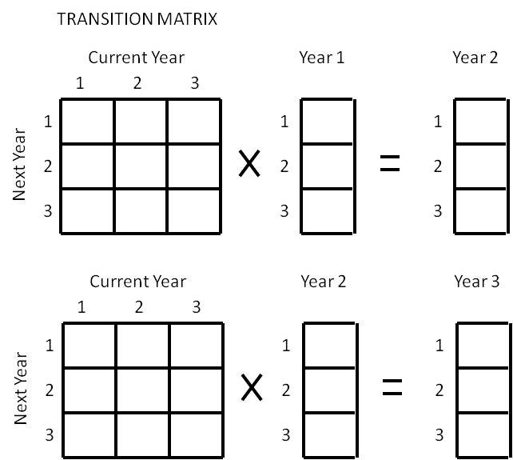
NOW WE ARE READY TO MODEL IN R!!
- Create a directory/folder on the local hard drive, such as: “c:/R/.” From the course website, download the files ‘PVA_student_script.R’ and ‘PVA_source.R’ into that directory.

- Open the R-GUI program with an icon that looks kind of like:
- Go to “file” “Open script” then navigate to the “PVA_lab.R” file you just downloaded.
This file has pre-written code for you to run. To run a line of code, put your cursor on that line, and hit the “Ctrl” key and then the “R” key (or “Enter” key for Macintosh or RStudio) while still holding down “Ctrl.” The code will execute in the R console window. Anything with a “#” in front of it is just a note, and won’t run.

- Follow the instructions in the script to set up and run a simulation. When you get to step # 5 in the script, answer the following questions:

  - How do you interpret the jagged lines plotted on the graphs?

  - What is “quasi-extinction,” and why do we use that instead of regular extinction?

  - Which transition probability is the population trajectory most sensitive to? Explain your process for reaching this conclusion.

  - If you add a few plants, or remove a few plants each year (by fixing the supplemental matrix with positive or negative numbers), at which stage does adding/removing plants have the biggest impact on the populations?

  - If you were to harvest five flowering plants each year, how long would the population persist?

  - What if you were to sprinkle seed capsules into the forest, how many would you need to put out there each year to offset the harvest? Note, you’ll need the germination rate – unless otherwise instructed, let’s assume one plant establishes for each capsule put out there.

  - What assumptions went into this model? Are there any simplifications we made that might not match reality well? How is reality different from the model, and how would it affect the predictions?

