ISSUES : DATA SET
The Invasive Grass-Fire Cycle in the U.S. Great Basin

Jennifer K. Balch^{1,2,5}, Marnie K. Carroll³, and Bethany A. Bradley⁴

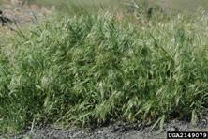
1 - National Center for Ecological Analysis & Synthesis, University of California, Santa Barbara, Santa Barbara, CA 93101-3351

2 - The Pennsylvania State University, Department of Geography, University Park, PA 16802

3 - Diné College, Shiprock, NM 87420

4 - University of Massachusetts-Amherst, Amherst, MA 01003

5 - Corresponding Author: Jennifer K. Balch
(jkbalch@psu.edu)

THE ECOLOGICAL QUESTION:
How does cheatgrass (Bromus tectorum) alter fire regimes in the Great Basin?

ECOLOGICAL CONTENT:
invasive species, cheatgrass (Bromus tectorum), fire ecology, disturbance, spatial analysis tools

WHAT STUDENTS DO:
- Design hypotheses about how an invasive plant species may alter fire behavior.
- Explore NASA’s data archive and download some of the large, publicly available datasets, specifically the MODIS burned area product.
- Perform basic statistics using Excel, including creating linear regression lines, interpreting R-squared values, and conducting t-tests.
- Perform basic spatial processing steps and analysis using ArcGIS, including using zonal statistics and reclassify tools.
- Compare analysis and conclusions from both local field-based data and regional satellite data.

STUDENT-ACTIVE APPROACHES:
Students will be actively engaged through the exercises, which require students to conduct data analysis and answer questions using field-based data and satellite data. The exercises can be done in pairs to facilitate group learning and problem-solving. The module includes a number of short-answer questions designed to help students interpret fire data, as well as an in-class “minute paper,” “think-pair-share” exercise, and a take-home essay at the conclusion of the module. The “minute paper” is an active-learning exercise, which gives students only a couple minutes to write an essay in class, with the intention to generate quick feedback and resolve any confusion. The “think-pair-share” exercise is designed to give students a minute to think on their own, before discussing major concepts or ideas with their nearest neighbor, and then sharing with the whole class. In addition the lab exercises can be split so that two groups can work on separate parts of the problem. If you want to split the exercises for multi-group work Lab 1 can be split into two manageable sets: Part I (questions 1-5); and Part II (questions 6-9). In Lab 2, the first set of questions build through a necessary set of processing steps, but the last few questions are designed to be more open-ended allowing students to explore the data and design their own testable questions. A third lab has been designed for advanced GIS students.

SKILLS:
Students will acquire skills in: navigating dataset repositories, manipulating large data sets, reading metadata, creating maps and graphs using GIS (Geographic Information Systems) and statistical tools, and connecting data analysis to scientific concepts.

ASSESSABLE OUTCOMES:
In addition to the active learning approaches conducted in class, there are several take-home essay questions designed to measure student skills and intended learning outcomes.

The following questions can be asked pre- and post- module to determine how much students have learned from the exercises: What controls fire? And how can invasive plant species change fire behavior. In addition, the third advanced GIS lab can be used to gauge student acquisition of the introduced GIS techniques.

TRANSFERABILITY:
This teaching module is designed for undergraduates with some introduction to ecology or environmental science. Students should also have some knowledge of GIS and basic statistics, including exposure to descriptive statistics, t-tests, and linear regression. If students have no GIS experience, then the first part of the module can be conducted (i.e., up through the Whisenant data exercise). The exercises require some familiarity with Excel and ArcGIS programs.

SOURCE:
MODIS Burned Area Maps: May-September 2005

MODIS Burned Area Product (MCD45A1 product):
http://modis-fire.umd.edu/Burned_Area_Products.html
http://modis-fire.umd.edu/BA_getdata.html

Description of MODIS Burned Area Product (Non-technical):
http://modis.gsfc.nasa.gov/data/dataprod/nontech/MOD14.php

Description of MODIS Burned Area Product, Metadata (Technical):
http://modis-fire.umd.edu/BA_usermanual.html

If you wish to download the original, publically-available data: ftp://ba1.geog.umd.edu/
Username: user
Password: burnt_data
Folder: TIFF > Win03 > 2005

Save GEOTIFF files:
MCD45monthly.A2005121.Win03.005.burndate.tif (May 2005)
MCD45monthly.A2005152.Win03.005.burndate.tif (June 2005)
MCD45monthly.A2005182.Win03.005.burndate.tif (July 2005)
MCD45monthly.A2005213.Win03.005.burndate.tif (August 2005)
MCD45monthly.A2005244.Win03.005.burndate.tif (September 2005)

Note, these are the raw burned area data for the conterminous U.S. These images have been clipped and processed to be used in this module. See description of datasets below for full details on files provided for this module.

OVERVIEW OF THE ECOLOGICAL BACKGROUND
This module has been designed to teach a couple major themes at the intersection of fire ecology and invasive species biology, principally the relationship between invasive species and altered fire behavior.

The overall goal is to get students to design hypotheses about how invasive plants change fire behavior and then test these hypotheses using field-based and satellite-based data. Students will compare conclusions from both sets of data and will critically think across scales and types of data. The purpose of the full module is to get students to understand how cheatgrass alters fire activity, and to gain analysis skills that allow them to apply the techniques to a slightly different situation.

This module has been designed for a full 7-hour day (but can be made into lecture/lab combo – see sample agenda). There are two lectures included, the first introduces the basics of fire ecology, fuel properties, and the role of invasive plants in changing fire regimes. The second introduces satellite-based fire data. And there is a third optional lab for more advanced GIS work.

Note this is also an active research question, and although the conclusions for this TIEE are preliminary, students should know that they are participating in an active program that should have future results and publications to draw on in the future.

REFERENCES

D'Antonio, C. M., and P. M. Vitousek. 1992. Biological invasions by exotic grasses, the grass-fire cycle, and global change. Annual Review of Ecology and Systematics 23:63-87.

Brooks, M.L., C.M. D’Antonio, D.M. Richardson, J.B. Grace, J.E. Keeley, J.M. DiTomaso, R.J. Hobbs, M. Pellant, D. Pyke. 2004. Effects of invasive alien plants on fire regimes. Bioscience 54: 677-688.

Notes on this paper: D’Antonio and Vitousek (1992) is the seminal paper that reviewed how invasive grasses can alter fire activity (at time of this module it has been cited over 900 times). Overall, the way in which invasive species alter ecosystem-level processes is fairly unknown, yet this paper provided a key insight into similar changes observed across ecosystems. This key paper identifies the geographic patterns of grass invasion, the ecological effects of grass invasion, and how grass invasion can lead to changes in fire regimes. Last, the authors identify and explore case studies from across the globe. This paper sets that stage for students to begin to ask how an invasive species can alter the systems that it is introduced to, and they should be able to identify key mechanisms that enable invasive grasses to change fire activity with the information provided here. An alternative, more recent review paper, is Brooks et al. 2004 in the journal, Bioscience.

Whisenant. 1990. Changing ﬁre frequencies on Idaho’s Snake River plains: ecological and management implications. Symposium on cheatgrass invasion, shrub die-off, and other aspects of shrub biology and management. Intermountain Research Station, Ogden, UT, Las Vegas, NV.

Notes on this paper: Whisenant (1990) was the first to quantify how cheatgrass increases fire activity, and he found that with cheatgrass fire frequency in sagebrush ecosystems increased from every 60–110 years to every 3–5 years. He used data from field sites in the Snake River Plains in Idaho. By measuring fuel properties of cheatgrass and other native fuels, and then comparing with observed historical fire frequencies he was able to estimate this very high frequency of fires associated with the introduction of this non-native grass. This paper is cited often as the classic example of clear-cut changes in fire activity. Using the data from this paper and comparing it with the remote-sensing data offers students the perspective of how you can get companion answers using data collected at different scales.

Bradley, B.A., and J. Mustard. 2008. Comparison of phenology trends by land cover class: a case study in the Great Basin, USA. Global Change Biology 14, 334–346.

Notes on this paper: Bradley and Mustard (2008) explain the technique used to develop the landcover map that is used in the optional, third lab.

See these additional resources:

Cheatgrass (Bromus tectorum): http://www.invasive.org/browse/subinfo.cfm?sub=5214

USGS Great Basin Project: http://www.usgs.gov/features/greatbasin/overview/greatbasin.html

NASA’s Earth Observing System for educators: http://eospso.gsfc.nasa.gov/eos_homepage/for_educators/index.php

DATA SETS

The following datasets are for two exercises. The first exercise requires field-based data from the Whisenant 1990 paper (faculty.xlsx and students.xlsx). The second requires satellite-based burned area and cheatgrass data, and a shapefile of the western U.S. Note, the Excel files also include a second sheet with the analysis steps for the satellite data after the processing part of the exercise has been completed in ArcGIS. This information is repeated in the student instruction section. The third, optional lab requires an additional shapefile which is the vegetation classification of the U.S. Great Basin.

i. Snake River Plains data

Data from the Snake River Plains on fire frequency, fuel characteristics, and species that make up those fuels are provided from a paper published by Whisenant in 1990. See original paper for a description of the sampling methods and a description of the site locations. A script for exploring and analyzing this data in R has been provided (script_cheatgrassfiretiee.R), some prior knowledge of the statistical program R is required to use this script. Alternatively, the data file can be opened and analyzed in the Excel sheet (cheatgrassfire_exercise_forteachers.xlsx and cheatgrassfire_exercise_forstudents.xlsx).

The headings in the data file are the following:

site = location of sampling
fire_freq = fire frequency (fires/year)
fuel_cover = fine fuel cover (percent), measured within 10x10 cm quadrats
fuel_mass = fine fuel mass (lb/acre)
cheat_dom = whether cheatgrass (Bromus tectorum) is listed as the first, dominant species contributing to fuels

ii. Processed MODIS burned area files for the module:

May 2005: monthly_bd_UTMClip_A2005121.tif
June 2005: monthly_bd_UTMClip_A2005152.tif
July 2005: monthly_bd_UTMClip_A2005182.tif
August 2005: monthly_bd_UTMClip_A2005213.tif
September 2005: monthly_bd_UTMClip_A2005244.tif

The values of the numbers in the file indicate the following:

0 = unburned
1-366 = approximate Julian day of burning
900 = snow or high aerosol
9998 = water bodies, internal
9999 = water bodies, seas and oceans
10000 = not enough data to calculate

iii. Cheatgrass Distribution Map

This unpublished cheatgrass map is from a single MODIS scene of northern Nevada. The projection is the same as for the MODIS burned area product. This classification was done by Bethany Bradley, using methods similar to the map produced for Bradley and Mustard 2008. This map is based on inter-annual variability in cheatgrass phenology between 2005-2002 springs. The map detects 75% of cheatgrass 'presence' points with a 20% false positive rate. Overall accuracy is around 78%.

File: cheatgrass_map.tif

The values of the numbers in the file indicate the following:

0 = no cheatgrass
1 = cheatgrass presence

iv. State Outlines of Western USA

This shapefile gives the state outlines for the western USA region of interest. Projection matches the cheatgrass map and MODIS burned area product.

File: WesternUSA_ProjectUTM.zip

v. Vegetation classification of the U.S. Great Basin

This shapefile contains the classification map derived by Bradley and Mustard (2008), and is used in the optional third lab.

The values in the GRIDCODE are for the following CLASS vegetation types:

1 – Agriculture
2 – Non-vegetated
3 – Montane Shrub/grass
4 – Pinyon-Juniper
5 – Alkali Meadow
6 – Salt Desert Shrub
7 – Cheatgrass
8 – Sagebrush Shrub

File: decision_tree_classification_avhrr_utm.zip

STUDENT INSTRUCTIONS

Introduction

People have altered natural fire regimes across landscapes for tens of thousands of years by changing ignitions and fuels (Pyne 2001). In the last couple hundred years, people have even altered the plant species that make up those fuels. One remarkable feedback is the introduction of invasive grass species across continents which then changes fire activity. This process is termed a novel ‘grass-fire cycle’ (D'Antonio and Vitousek 1992).

In the western U.S., cheatgrass (Bromus tectorum) has invaded the Great Basin biome. Introduced in the mid-1800s, this single species with origins in north Africa and the Middle East, now dominates 20,000 km² (Bradley and Mustard 2005). The large-scale presence of cheatgrass has altered natural fire regimes, particularly in sagebrush and salt desert shrub ecosystems (Whisenant 1990, Chambers et al. 2007). Yet, despite these substantial effects, to date only a few studies have documented altered fire cycles at local scales, and the availability of satellite data opens the door to explore this question at larger regional scales.

Climate-driven changes in biome boundaries have already been predicted for the Great Basin (Bradley 2009, Chambers and Wisdom 2009) and fire and species invasions can accelerate these transitions (Haubensak et al. 2009). Therefore, the goal of this exercise is to investigate how non-native grasses can alter natural fire regimes.

i. Background

Frontier expansion has been a vehicle for the introduction and spread of invasive species (Mack 1981). Further, altered fire regimes have accompanied the expansion of frontiers. Fire has been used as a tool in the transformation of landscapes for agriculture and cattle pasture. Alternatively, fire suppression and grazing has set the stage for species invasion and future surges in fire activity. One important feedback has been a new fire regime that is driven by high levels of non-native grass fuel and high ignitions from people. Once initiated, this invasive grass-fire cycle is difficult to halt or reverse (D'Antonio and Vitousek 1992, Brooks et al. 2004). This phenomenon has occurred and continues to occur across continents, from Eurasia to Oceania, from Africa to South America, including the western U.S.

Cheatgrass was accidentally introduced to the Great Basin by settlers in the mid-1800s. This drought-tolerant grass creates a more continuous fuel bed than existed previously and cures earlier than native perennial grasses (Whisenant 1990, Chambers et al. 2007), potentially extending the fire season and contributing to more frequent and larger fires. This disruption to the native fire regime is often cited as a classic example of an invasive grass-fire cycle. One study from Snake River Plains in Idaho documents the actual shift in fire frequency caused by cheatgrass (Whisenant 1990). We will explore this study in detail in one of the following exercises.

The U.S. Great Basin covers 450,000 km², 80% of which is publicly owned. This semi-arid region encompasses shrublands, grasslands, and montane forests. Native Americans managed the landscape with fire (Pyne 1982). Yet, frontier expansion brought a new fire regime with ongoing legacies. Frontier settlement introduced sheep grazing, which subsequently reduced native perennial grasses; this led to senescent stands of sagebrush and consequently opened up opportunities for invasion. There has since been over a 100-year lag between this phase of frontier settlement and the substantial increase in fire frequency witnessed today. In the past few decades, fire frequency in sagebrush ecosystems has increased from every 60–110 years to 3–5 years with the increase in invasive annual grasses (Whisenant 1990).

The legacy of frontier development and agricultural expansion is an altered landscape, with combined pressures from climate change, invasive species, and altered ignitions. In recent decades, the western U.S. has been subject to severe drought conditions that have increased fire activity (Westerling et al. 2006) and tree mortality (van Mantgem et al. 2009).

ii. Objectives

The major questions of this exercise are: i) how do invasive grasses alter natural fire regimes? and ii) what are the possible mechanisms that enable invasive grasses to change fire cycles?

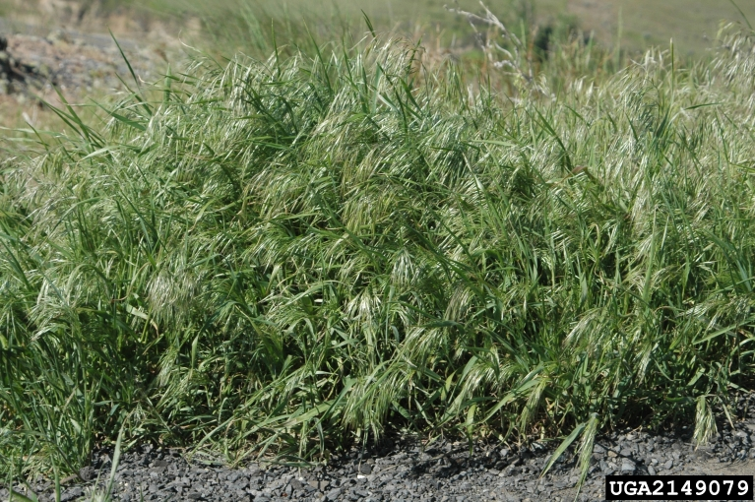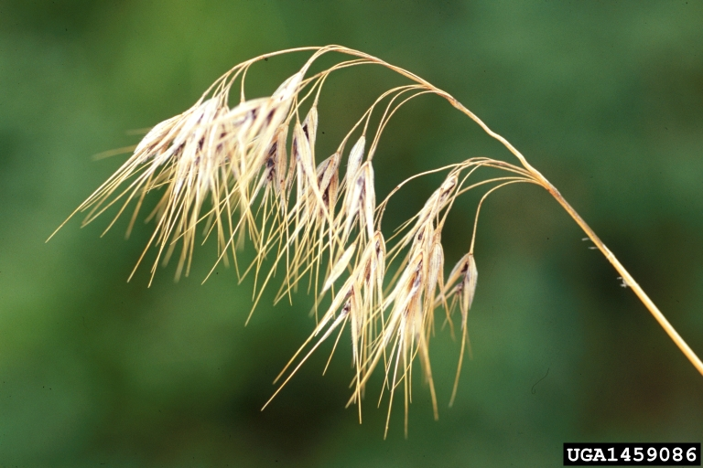
Images 1 and 2: Bromus tectorum up-close by Chris Evans (left) and Steve Dewey (www.invasive.org).

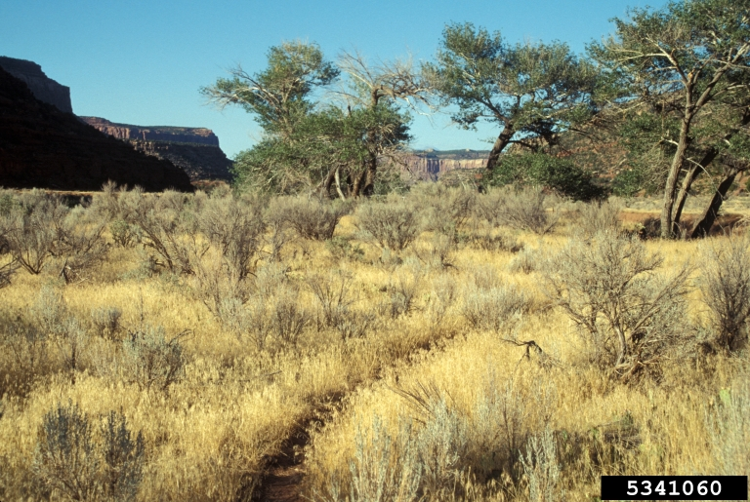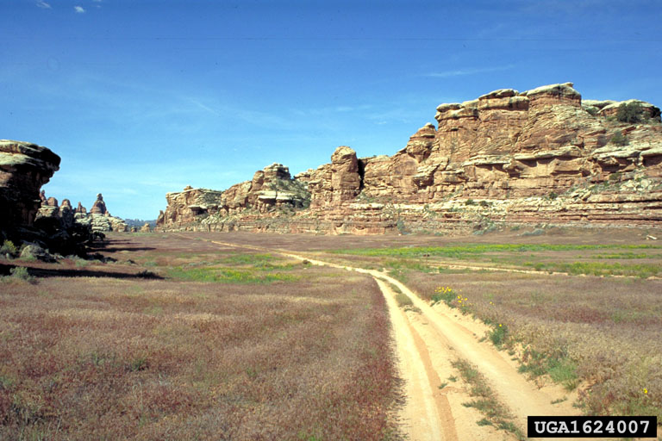
Images 3 and 4: Bromus tectorum infestation by John M. Randall (www.invasive.org).

Dataset descriptions

i. Snake River Plains data

Data from the Snake River Plains on fire frequency, fuel characteristics, and species that make up those fuels are provided from a paper published by Whisenant in 1990. See the original paper for a description of the sampling methods and a description of the site locations. The data file can be opened and analyzed in the Excel sheet (students.xlsx).
ii. MODIS burned area product

NASA has a satellite called the Moderate Resolution Imaging Spectroradiometer, or MODIS, which produces a global burned area product. The MODIS monthly burned area product is a geotiff file that gives information on whether or not each 500-m pixel burned within a given month, or a code indicating snow, water, or lack of data.

There are five files that will be used for this exercise, which have already been clipped and projected in a standard projection (NAD_1927_UTM_Zone_11N). They have also been resampled, so the pixel size matches the cheatgrass landcover map below. There is one file for each month: May-September 2005.

Files:

May 2005: monthly_bd_UTMClip_A2005121.tif
June 2005: monthly_bd_UTMClip_A2005152.tif
July 2005: monthly_bd_UTMClip_A2005182.tif
August 2005: monthly_bd_UTMClip_A2005213.tif
September 2005: monthly_bd_UTMClip_A2005244.tif

The values of the numbers in the file indicate the following:

0 = unburned
1-366 = approximate Julian day of burning
900 = snow or high aerosol
9998 = water bodies, internal
9999 = water bodies, seas and oceans
10000 = not enough data to calculate

iii. Cheatgrass Distribution Map

This unpublished cheatgrass map is from a single MODIS scene of northern Nevada. The projection is the same as for the MODIS burned area product. This classification was done by Bethany Bradley using methods similar to the map produced for Bradley and Mustard (2008). This map is based on inter-annual variability in cheatgrass phenology between 2002-2005 springs. (Phenology is the scientific study of periodic biological phenomena, such as flowering, leaf changes, etc., in relation to climatic conditions.) The map detects 75% of cheatgrass 'presence' points with a 20% false positive rate. Overall accuracy is around 78%.

File: cheatgrass_map.tif

The values of the numbers in the file indicate the following:

0 = no cheatgrass
1 = cheatgrass presence

iv. State Outlines of Western USA

This shapefile gives the state outlines for the western USA region of interest. Projection matches the cheatgrass map and MODIS burned area product.

File: WesternUSA_ProjectUTM.zip

v. Vegetation classification of the U.S. Great Basin

This shapefile contains the classification map derived by Bradley and Mustard (2008) and is used in the optional third lab.

The values in the GRIDCODE are for the following CLASS vegetation types:

1 – Agriculture
2 – Non-vegetated
3 – Montane Shrub/grass
4 – Pinyon-Juniper
5 – Alkali Meadow
6 – Salt Desert Shrub
7 – Cheatgrass
8 – Sagebrush Shrub

File: decision_tree_classification_avhrr_utm.zip (and companion layer file)

References:

Bradley, B. A. 2009. Regional analysis of the impacts of climate change on cheatgrass invasion shows potential risk and opportunity. Global Change Biology 15:196-208.
Bradley, B. A., and J. F. Mustard. 2008. Comparison of phenology trends by land cover class: a case study in the Great Basin, USA. Global Change Biology 14:334-346.
Brooks, M. L., C. M. D'Antonio, D. M. Richardson, J. B. Grace, J. E. Keeley, J. M. DiTomaso, R. J. Hobbs, M. Pellant, and D. Pyke. 2004. Effects of invasive alien plants on fire regimes. Bioscience 54:677-688.
Chambers, J. C., B. A. Roundy, R. R. Blank, S. E. Meyer, and A. Whittaker. 2007. What makes Great Basin sagebrush ecosystems invasible by Bromus tectorum? Ecological Monographs 77:117-145.
Chambers, J. C., and M. J. Wisdom. 2009. Priority Research and Management Issues for the Imperiled Great Basin of the Western United States. Restoration Ecology 17:707-714.
D'Antonio, C. M., and P. M. Vitousek. 1992. Biological invasions by exotic grasses, the grass-fire cycle, and global change. Annual Review of Ecology and Systematics 23:63-87.
Haubensak, K., C. D'Antonio, and D. Wixon. 2009. Effects of fire and environmental variables on plant structure and composition in grazed salt desert shrublands of the Great Basin (USA). Journal of Arid Environments 73:643-650.
Mack, R. N. 1981. Invasion of Bromus tectorum into western North America - An ecological chronicle. Agro-Ecosystems 7:145-165.
Pyne, S. J. 1982. Fire in America. University of Washington Press, Seattle, Washington.
Pyne, S. J. 2001. Fire: A brief history. Univ. of Washington Press, Seattle.
van Mantgem, P. J., N. L. Stephenson, J. C. Byrne, L. D. Daniels, J. F. Franklin, P. Z. Fule, M. E. Harmon, A. J. Larson, J. M. Smith, A. H. Taylor, and T. T. Veblen. 2009. Widespread increase of tree mortality rates in the western United States. Science 323:521-524.
Westerling, A. L., H. G. Hidalgo, D. R. Cayan, and T. W. Swetnam. 2006. Warming and earlier spring increase western US forest wildfire activity. Science 313:940-943.
Whisenant. 1990. Changing ﬁre frequencies on Idaho’s Snake River plains: ecological and management implications. Symposium on cheatgrass invasion, shrub die-off, and other aspects of shrub biology and management. Intermountain Research Station, Ogden, UT, Las Vegas, NV.

Exercise 1: Data Exploration and Analysis: Snake River Plains Data

In this section, we will explore the relationship between cheatgrass and fire behavior from data published in the research paper by Whisenant (1990) from sites in Idaho’s Snake River Plain. You will need to open the excel file in order to complete this exercise.

Figure: Snake River Plain in Idaho.
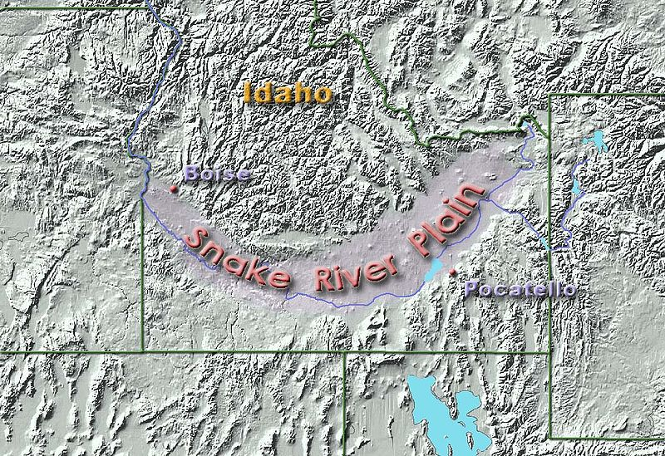

PART I: Relationship between fire frequency and fine fuel cover.

- What methods did Whisenant use to calculate fire frequency and fine fuel cover?

To calculate fire frequency, Whisenant used fire incidence records from the Bureau of Land Management that spanned 31 years, and were available for each site included in the analysis.

To calculate fine fuel cover, Whisenant measured the cover of fine fuel (e.g., fine leaf litter fuels) in 10 x 10 cm quadrats.

- What relationship do you expect between fire frequency and fine fuel cover? How do you think fine fuel cover relates to fuel continuity?

Fire frequency is likely to increase with an increase in fine fuel cover because an increase in fine fuel cover will connect fuels, making fire spread more likely.

- Test your predicted relationship from question #2 given the data provided in the Excel spreadsheet. Try plotting the data. What conclusions can you draw?

Students should try plotting percent cover in quadrats with fires per year (see below example). Using the Chart tool in Excel, you can plot fine fuel cover (x-axis) and fire frequency (y-axis) (Insert > Chart > XY scatter). Then fit a best-fit line through the data points (Select points > Right click > Add Trendline). How well this trend line fits the data is gauged by the R-squared value which is in the summary table output for the trendline.

There is a positive, linear relationship between the two variables. Fire frequency does indeed increase with an increase in fine fuel cover.

The R-squared value is 0.87, meaning that 87% of the variability in the data is explained by the fitted trendline.

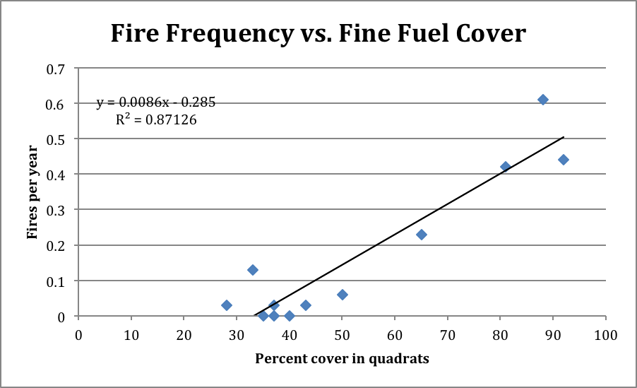

- Do you expect cheatgrass to increase or decrease fuel continuity compared with the fuel structure of native plant species and how then will it change how fire spreads?

Native perennial bunch grasses and shrubs create a fuel structure that is clumped with bare patches in between. As cheatgrass invades, it fills in those interspaces between shrubs, and creates a more continuous fuelbed. A more continuous fuelbed will increase fire spread, and therefore the likelihood of more fires that catch.

PART II: Effect of cheatgrass on fuels and fire behavior

Note to faculty: In this section students should figure out to calculate the mean (or average) and variance of fine fuel cover, fuel mass, and fire frequency where cheatgrass is dominant and where it is not. Plotting the means will help to better visualize the data. Last, students could calculate Student’s t-tests, which compare the means of two sample populations to determine whether they are significantly different from each other.

The first graph has been done as an example (see below).

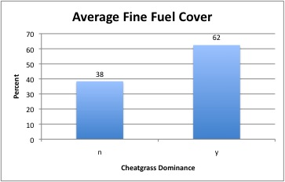

Questions:

- Given the data provided, does cheatgrass dominance change fuel properties that might influence fire frequency? Create a graph to support your answer.

Average fine fuel cover is 62% where cheatgrass is dominant, and 38% where it is not dominant. The null hypothesis for the T-test is that the two sample means are drawn from the same population. If the probability is very low that the two are from the same population (P < 0.05), then we reject the null. In this case however, the P-value is 0.05085, so we cannot reject the null. The two means are not significantly different. However, it is still important to note that cheatgrass does increase fine fuel cover.

Average fuel mass is 629 lbs/acre where cheatgrass is dominant, and 949 lbs/acre where it is not dominant. So cheatgrass, by displacing native bunchgrasses and shrubs, is decreasing the amount of fuel. For the T-test, the P-value is 0.0039, so we reject the null. The two means are significantly different from each other.

So the take-home message here is that cheatgrass increases continuity of fuels (although not significant), but not fuel mass. So, the question still remains a hypothesis about the mechanisms that enables cheatgrass to increase fire frequency.

- Given the answer to the question above, how do you think cheatgrass dominance will change fire frequency? Given the data, how does cheatgrass dominance change average fire frequency. Create a graph to support your answer.

Given the answers to Part I above, where we plotted a strong, positive relationship between fire frequency and fine fuel cover, students should be able to make the prediction that because cheatgrass increases fine fuel cover it will increase fire frequency.

Average fire frequency is 0.27 fires/year where cheatgrass is dominant, and 0.01 fires/year where it is not dominant. So cheatgrass-dominance makes fires 27 times more likely. For the T-test, the P-value is 0.0195, so we reject the null. The two means are significantly different from each other.

The prediction holds that cheatgrass dominance will increase fire frequency.

- How many years will it take to have a fire in cheatgrass dominant areas vs. other areas? (Note, this estimate roughly matches Whisenant’s estimate of fire return interval.)

It will take roughly 4 years (1 divided by 0.27) to have a fire in cheatgrass dominant areas vs. 100 years (1 divided by 0.01) in the other areas.

- Do native perennial bunchgrasses differ from the annual invasive grass in characteristics related to fire ecology? In the Snake River Plain, what factor has the greatest effect on fire frequency?

Perennial bunchgrasses and shrubs in arid and semi-arid zones are typically widely spaced, whereas cheatgrass grows in continuous stands. Further, the native plants have higher fuel mass than cheatgrass-dominated areas. This is likely, in part, due to woody biomass of shrubs and the perennial nature of bunchgrasses, which accumulate biomass every year.

For the Snake River Plain data, fire frequency is more influenced by fuel continuity than fuel mass. This is counterintuitive, but relates back to the fact that fire needs continuous fuels in order to spread (or really hot, dry, and windy conditions that will enable fire to leap across fuels).
Exercise 2: Data Visualization and Processing in ArcGIS (version 9.3):
MODIS burned area and Cheatgrass Satellite Data

Note to faculty: The data extracted from the GIS exercise are available in the third sheet, entitled “MODIS burned area summary,” of the excel file (faculty.xlsx) if you want to skip the GIS exercise or do not have access to this software.

- Data import
  - Add Raster layers of MODIS burned area data for May-September 2005, May file: monthly_bd_UTMClip_A2005121.tif (5 data layers)
  - Add cheatgrass classification map layer, file: cheatgrass_map.tif (1 data layer)
  - Add western USA shapefile, file: WesternUSA_ProjectUTM.shp

Note to faculty: There are several visualization steps needed for ease of viewing the data. For example, the burned area data layers should be displayed by using Unique Values in Symbology of the Layer Properties. A rainbow color scheme is recommended to show the burned area dates in sequences for each month, and a no-color assignment to the values that correspond to unburned, missing data, water bodies, etc. If you do not wish to take the time to conduct this step, you could provide the students with the layers as you desire them.

- Reclassify MODIS burned area data

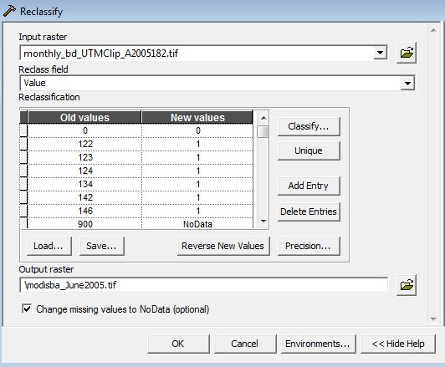

  - Spatial Analyst Tools > Reclass > Reclassify
    - Input raster: a single month of MODIS burned area data
    - Reclass field: Value
    - Click Unique values
    - Input New values so that 0 = unburned, 1 = burned pixel, and NoData = invalid or no data (use metadata below)

MODIS burned area pixel information:
Original MODIS data | New values | Definition
0 | 0 | unburned
1 to 366 | 1 | approximate Julian day of burning
900 | NoData | snow or high aerosol
9998 | NoData | water bodies, internal
9999 | NoData | water bodies, seas and oceans
10000 | NoData | not enough data to calculate

    - Output raster: save as a new .tif file in your file folder (e.g., “modisba_May2005.tif”)

Note to faculty: This step is meant to give students a sense of what the original data look like when downloaded from the MODIS website. Additional steps were clipping, defining and changing the projection, and resampling the pixel size to get a manageable image to process. Also, there are no burned pixels detected for June 2005. Further, May 2005 and September 2005 have very little burning, and therefore burned area is virtually undetectable in the images for those two months, but these are given to provide contrast.

- Using Zonal statistics, calculate by month the number of burned area pixels in cheatgrass and non cheatgrass zones
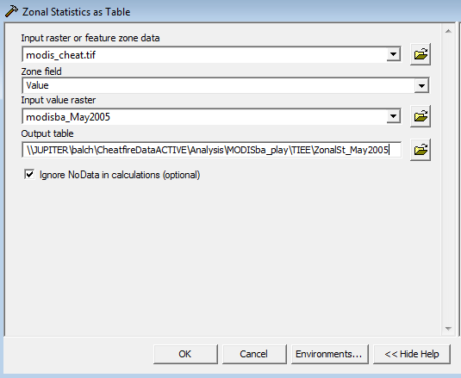

  - Spatial Analyst Tools > Zonal > Zonal Statistics as Table
    - Input raster: cheatgrass map (cheatgrass_map.tif)
    - Zone field: Value (will therefore calculate by 0 and 1 in cheatgrass map)
    - Input value raster: reclassified MODIS burned area data (e.g., modisba_May2005.tif)
    - Output table: name table, e.g., ZonalSt_May2005
    - Check box to Ignore NoData in calculations
    - Open table you just created, SUM column will give you the sum of burned pixels in cheatgrass (1) and no-cheatgrass (0) zones

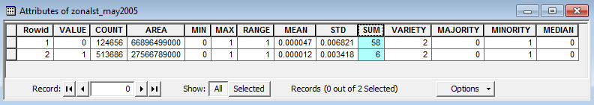

    - Repeat zonal statistics for each month, and fill in the table below, in your Excel sheet.

Number of burned pixels by month, where there is and is not cheatgrass:
 | May 2005 | June 2005 | July 2005 | August 2005 | September 2005
No Cheatgrass (0) | 58 | 0 | 1671 | 2366 | 98
Cheatgrass (1) | 6 | 0 | 2282 | 686 | 70

Data Exploration and Analysis: MODIS burned area and Cheatgrass Satellite Data

Questions:

- How does cheatgrass influence the amount of burning during the fire season of 2005? And how does this compare to the no-cheatgrass areas? Does your answer change if you consider the proportion of the total area that cheatgrass covers? Create graphs to support your answer.

Students should plot the number of burned pixels each month, or the percent area burned for the two landcover types. In order to calculate the percent of the cheatgrass and no-cheatgrass area that burned in a given month, students will need to find out how many pixels the cheatgrass and no-cheatgrass areas cover in the entire image (check the Symbology under the Layer Properties in ArcGIS.)

There is a substantial amount of fire in cheatgrass areas relative to the proportion of landcover that cheatgrass occupies. It is important to calculate the percent of area burned, because cheatgrass occupies only about a third of the image.

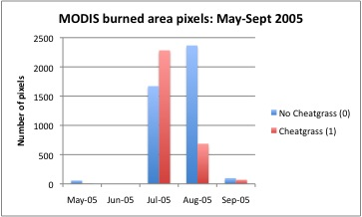
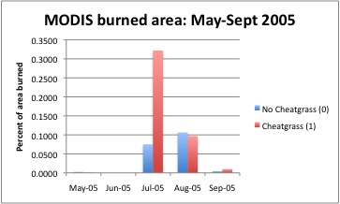

The graphs and tables show the number of burned pixels and percent burned area by month in cheatgrass and no-cheatgrass areas. Using the information in the graphs and a few additional calculations in the Excel sheet, students should be able to answer the following questions.

- Does cheatgrass alter the peak timing of fires? Does it alter the fire return interval? Fire return interval is defined as the number of years it would take to burn the entire area.

The peak timing of fire events for cheatgrass is in July and for no-cheatgrass areas in August. This suggests that cheatgrass shifts the peak fire month earlier. This is likely due to the fact that cheatgrass cures (dries out) earlier than other native perennial grass species.

For cheatgrass, 3044 pixels burned, and for no-cheatgrass 4193 pixels burned. If each pixel is roughly 0.230 km x 0.230 km, the total area that burned in cheatgrass was 161 km², and for no-cheatgrass it was 222 km² burned. For cheatgrass, 0.43% of the area burned, and for no-cheatgrass 0.19% burned. From this, students can calculate the fire return interval for cheatgrass and non-cheatgrass. Assume that your calculation for the percent area that burned during the fire season (May-September 2005) is what burned during the course of the entire year. (Fire return interval is defined as the number of years it would take to burn the entire area.) Therefore, for cheatgrass, the fire return interval is 233 years, and for no-cheatgrass the fire return intverval is 531.

- How does the fire return interval for cheatgrass and no-cheatgrass compare with what Whisenant estimates for how cheatgrass changes fire return intervals in Idaho’s Snake River Plain? Why might these estimates be different? What general conclusion do both sets of data support?

Whisenant (1990) states in the abstract that “Prior to the arrival of white settlers, fire-return intervals in the sagebrush-steppe probably varied between 60 and 110 years, but much of the region now burns at intervals of less than 5 years.”

The estimated fire return interval from satellite data is 233 years in cheatgrass, which is less than half that in no-cheatgrass areas. The estimate from Whisenant is 5 year fire return intervals in cheatgrass areas, which is based on fire frequency information.

These are very different estimates, which could be explained by: i) the scale of analysis (local field study in an area highly invaded by cheatgrass vs. regional-scale study); ii) Whisenant compares fire return intervals in cheatgrass vs. sagebrush-steppe, whereas the satellite data collapses all vegetation types into one “no-cheatgrass”region; iii) Whisenant’s calculation may be more of an observation than a fire return interval per say (he states that “Large areas of the Snake River Plains burn every 3-5 years” but that estimate is not accounting for the total area of the Snake River Plains and how much of it burns in a given year). So in sum, we may be comparing apples to oranges.

But the overall take-home message is that cheatgrass substantially alters native fire regimes by decreasing the fire return interval (i.e., making fires more likely). Local field estimates and regional-scale satellite data analysis both support this conclusion.

Exercise 3: Advanced GIS Lab: Modis Burned Area & U.S. Great Basin Landcover Map

Now that you have explored how cheatgrass alters fire activity in relation to non-cheatgrass areas, we are going to explore the differences in fire activity across vegetation types. Using the Bradley and Mustard (2008) landcover map of the U.S. Great Basin (shapefile name: decision_tree_classification_avhrr_utm.shp), we will explore how fires in cheatgrass, sagebrush, pinyon-juniper, montane shrub, and salt desert shrub vegetation types. Using the previous lab as a model for processing steps in ArcGIS, answer the following questions:

- Explore images of these different vegetation types on the web, and describe how the fuel properties look the same or different? For example, see http://www.fs.fed.us/rm/reno/research/ecosystems/

- What is the effect of vegetation type on the fire regimes in the US Great Basin?

- If the U.S. Great Basin experiences a substantial drought year, do you think fire activity would increase or decrease? If we did our calculations of fire return interval based on that drought year, how would that change our estimates?

Students will be able to explore the 5 months of fire data using this new shapefile of the different landcovers in the U.S. Great Basin. The attributes table of the shapefile gives the CLASS (or vegetation type) and the GRIDCODE (which should be used to make the zonal statistics classification for each vegetation type). Below is an example output table for July 2005, where you can see that cheatgrass (VALUE=7) had 188 burned pixels. The main take-home message with this lab exercise is to see how the fire regime properties differ across vegetation types. Cheatgrass will likely have a higher likelihood of fire than sagebrush, but it will be comparable. Following these two vegetation types will be pinyon-juniper, and then montane shrub and salt desert which will have much lower counts of fire (due to the higher elevations and cooler weather in montane shrub and lower fuels in the salt desert shrubs). A severe drought would lead to higher incidence of fire, and therefore would decrease the calculations of fire return times.

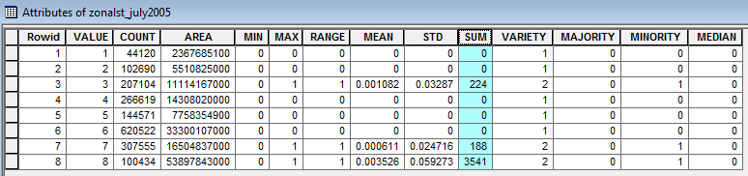

Synthesis Questions

In-class (after Lecture 1): Think-Pair-Share

Think for a minute or two about these questions, then turn to your nearest neighbor and discuss. Last we’ll discuss as a class what you think the answers are.

- How do you expect cheatgrass to change fuels (e.g., mass, continuity, etc.)?
- Then, how might cheatgrass change the fire regime?

In-class (after Lab Exercise Part II): The minute paper

Answer in one minute this two-part question on a 3x5 notecard or piece of paper. Put your answer to the first question on one side of the card, and your answer to the second on the other side. Please do not sign your name, as this will be anonymous. We will discuss a few of the responses in class.

What did you find to be most interesting or meaningful (write that on one side of the card)? What was the most confusing part (write that on the other side of the card)?

Take-home at the conclusion of the module: Write a 1-2 page essay on one of the following questions

- How many different types of data were used in this project? What are some of the differences and similarities in interpretation between field-based data and regional satellite data? Can you identify other sources of fire data that might be available for use to explore questions about how invasive species change fire activity?

Try exploring some of these sites:

MODIS active fire detections: http://modis-fire.umd.edu/Active_Fire_Products.html

Monitoring Trends in Burn Severity: http://mtbs.gov/nationalregional/intro.html

USDA Forest Service: http://activefiremaps.fs.fed.us/googleearth.php

The main point of these questions is to get students to understand some of the different types of data available and how to access them. Here we used data from a field study in the Snake River Plain and regional data for Northern Nevada from MODIS satellite imagery (both a landcover classification and burned area data).

The main similarity is that both sets of analyses came to the conclusion that cheatgrass increases fire activity. The field-based study allowed exploration of the potential mechanism, e.g., that cheatgrass increases fuel cover. Further, this analysis was focused on sagebrush vegetation type. The satellite-based study allowed exploration over much larger spatial scales, but with coarser resolution. Further, satellite observation by month allowed exploration of the seasonality of burning (e.g., peak fire season for cheatgrass was a month earlier than no-cheatgrass areas).

Other sources of data include other satellite fire products, such as the MODIS active fire product, but there are many other satellite-based fire observations. For a review, see Table 1 in Langmann (2009).

- What components do you need to start a fire? What controls how fast, how hot, and how far a fire will burn? How can invasive grass species change fire behavior? Be specific, choose one or two properties of fire behavior such as fire frequency, fire intensity, or fire spread rate?

To start a fire you need: oxygen, fuel, and an ignition source. This is the classic fire triangle.

Fire behavior (e.g., how fast, how hot, and how far) is controlled by another fire triangle: fuel, topography, and weather.

Invasive species can change fire behavior by changing fuels. Many properties of fuels that could be altered, including fuel cover or continuity, fuel mass, fuel chemistry, fuel moisture content, fuel structure, fuel arrangement.
Notes to Faculty
Notes to faculty and answers to the exercise are provided directly in the module in blue font. These notes include tips and strategies, anticipated student responses or misunderstandings, and questions for discussion. An additional handout is provided for the students without these notes so they can fill in answers directly.

Comments on Challenges to Anticipate and Solve:

1. Challenge: Getting students to understand that fuel mass may not be as important as fuel cover.

Solution: Discuss how fuel mass of native species, particularly woody sagebrush, may be much higher than cheatgrass. Emphasize how cheatgrass fills in the spaces between native fuels and creates a continuous fuelbed that doesn’t necessarily have to be high in mass.

- Challenge: Getting students to understand that invasive plants have and can change fire regimes across the globe.

Solution: Describe examples of the effect of invasive species on fire behavior from different parts of the U.S. Examples are given in the lectures.

Comments on Introducing the Activity to Your Students:

The module should be introduced through the use of the two lectures provided. Each one sets up the individual exercise based on the field data and satellite data, respectively.

Comments on how using large datasets can be more effective in teaching selected concepts

The value of the two exercises is that it allows students to test hypotheses using local field-based data and satellite-base burned area data. The ability to scale concepts and ideas offers a great deal in terms of understanding how to test hypotheses and to compare and contrast the results from each analysis. Opportunities exist to ask the students what are the benefits and limitations of analysis at both scales.

COPYRIGHT STATEMENT
The Ecological Society of America (ESA) holds the copyright for TIEE Volume 8, and the authors retain the copyright for the content of individual contributions (although some text, figures, and data sets may bear further copyright notice). No part of this publication may be reproduced, stored in a retrieval system, or transmitted, in any form or by any means, electronic, mechanical, photocopying, recording, or otherwise, without the prior written permission of the copyright owner. Use solely at one's own institution with no intent for profit is excluded from the preceding copyright restriction, unless otherwise noted. Proper credit to this publication must be included in your lecture or laboratory course materials (print, electronic, or other means of reproduction) for each use.
To reiterate, you are welcome to download some or all of the material posted at this site for your use in your course(s), which does not include commercial uses for profit. Also, please be aware of the legal restrictions on copyright use for published materials posted at this site. We have obtained permission to use all copyrighted materials, data, figures, tables, images, etc. posted at this site solely for the uses described at TIEE site.

GENERIC DISCLAIMER
Adult supervision is recommended when performing this lab activity. We also recommend that common sense and proper safety precautions be followed by all participants. No responsibility is implied or taken by the contributing author, the editors of this Volume, nor anyone associated with maintaining the TIEE web site, nor by their academic employers, nor by the Ecological Society of America for anyone who sustains injuries as a result of using the materials or ideas, or performing the procedures put forth at the TIEE web site, or in any printed materials that derive therefrom.

