ISSUES: FIGURE SET
Does captive breeding help or hinder salmon recovery? Evidence from life history evolution

Stacey Halpern (shalpern@pacificu.edu)
Department of Biology, Pacific University, Forest Grove, OR 97116
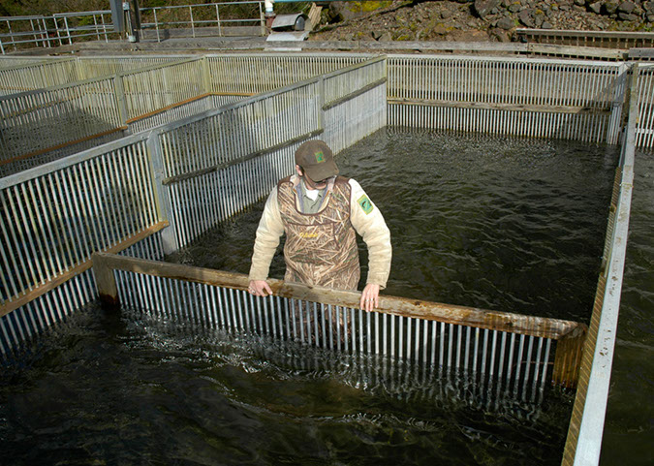

Trask fish hatchery in Tillamook, Oregon. Trask fish hatchery rears Coho and Chinook salmon, as well as steelhead. Photo in the public domain (from the Oregon Department of Fish and Wildlife)
https://www.dfw.state.or.us/images/photo_gallery/photo_gallery_hatchery.asp
THE ISSUE:
Salmon populations are imperiled in many parts of their range. Salmon play critical roles in ecosystems; for example, they provide key food for predatory animals and deposit nutrients in inland ecosystems when their bodies decompose after spawning. They are also culturally important to many indigenous nations in the Pacific Northwest and economically important to some commercial fisheries and indigenous nations. Therefore, management to increase their population sizes receives a great deal of attention and resources. Fish hatcheries have a long history as a central tool in managing salmon populations. They may also affect salmon in unexpected ways by changing the evolutionary pressures during early life stages. This figure set focuses on the evolution of a consequential salmon life history trait (egg size) in hatcheries and implications for salmon management and recovery.

FOUR-DIMENSIONAL ECOLOGY EDUCATION (4DEE) FRAMEWORK
- Core Ecological Concepts:
  - Populations
- Ecology Practices:
  - Quantitative reasoning and computational thinking
  - Data analysis and interpretation
- Human-Environment Interactions:
  - Human impacts on the environment from local to global scales
  - Ecological ethics
- Cross-cutting Themes:
  - Structure & function
  - Evolution
  - Space & time
INTEGRATION ACROSS 4DEE DIMENSIONS
All dimensions are incorporated into this figure set analysis. The key emphasis is on the connections between the core ecological concept of life history evolution (including trade-offs), the ecological practice of data interpretation, and the effects of human activities (namely, fish hatcheries). These inherently incorporate cross cutting themes, especially related to evolution of organismal traits in different locations and across time.

STUDENT-ACTIVE APPROACHES:
- Pre-analysis: team readiness assessment scratch-off quiz
- Figure 1: describe and interpret a figure in small teams, make a prediction
- Figure 2: describe and interpret a figure in small teams, make a management recommendation

STUDENT ASSESSMENTS:
Individual readiness assessment quiz, Team readiness assessment quiz, Team data analysis answers, Management recommendation (written)
CLASS TIME:
one 65-minute class period

COURSE CONTEXT:
Intermediate (second-year) or upper-division (third and fourth-year) courses in Ecology; students should have prior knowledge of basic evolutionary processes from an introductory biology course, or from the course in which the figure analysis occurs. Could be used in Introductory Ecology if students have already learned pre-requisite evolutionary topics. Background in demography and population models helps (e.g., for understanding life history trade-offs such as offspring size vs. number), but the figures could be used in their absence, with modification of some questions or more background provided before the figure analysis.

ACKNOWLEDGEMENTS:
This activity was improved greatly through feedback from years of Ecology students at Pacific University—thanks! The manuscript benefited from feedback from Michelle Prysby, Christopher Beck, and one anonymous reviewer.
OVERVIEW
WHAT IS THE ECOLOGICAL ISSUE?
Managing threatened or endangered species towards recovery is a key conservation goal for many organizations and agencies, as well as society. Understanding population dynamics is an important component of management—for example, using stage-structured models to target stages with highest elasticity/greatest potential payoff for intervention, or to predict population sizes in the future under different management plans (e.g., Crouse et al. 1987, McGraw and Furedi 2005, Crone et al. 2013). These kinds of examples are common in ecology courses and textbooks.
Threatened species also may be affected by evolution, which may then influence these populations’ viability. Issues related to small population size—such as genetic drift or inbreeding depression—are commonly recognized as important by both conservation biologists and students. However, other kinds of evolutionary processes may also affect population recovery. For example, selection by climate change may cause evolution of traits such as phenology or tolerance to drought and temperature increases (Bradshaw and Holzapfel 2001, Pulido et al. 2001, Winkler et al. 2002, Reale et al. 2003, Franks et al. 2007, Nielsen et al. 2023, Rauschkolb et al. 2023). Threatened populations may also face selection on life history traits, especially through human activities such as harvesting, which can affect traits such as size at maturity or growth rate (Uusi-Heikkilä et al. 2015, Han et al. 2025). While some of these evolutionary responses may be adaptive and foster population recovery, others are either maladaptive, or adaptation is constrained by factors such as limited genetic variation or genetic correlations between traits.
One potential source of evolutionary change for threatened species is captive breeding programs, which are central to many species recovery plans (Farquharson et al. 2021). These programs can have direct ecological effects; for example, release of captively-bred offspring into wild populations may affect species distributions, genetic diversity, and interspecific interactions such as disease or predation (Nelson et al. 2019, McMillan et al. 2023). Captive breeding can also affect the evolution of species’ traits. Because captive breeding programs aim to supplement wild populations, thereby boosting population sizes, they usually protect some (or all) stages from threats such as predation, disease, food scarcity, or abiotic stressors. The protected environment could relax selection on traits that normally experience trade-offs such as juvenile growth rate or parental investment in offspring (Blouin et al. 2021). As a result, captivity may inadvertently affect the evolution of characteristics important for population persistence. For example, salmonids reared in fish hatcheries often have lower fitness (measured as relative reproductive success) than those from wild environments (Blouin et al. 2021). Captive breeding can also affect traits related to life history trade-offs, which may differentially influence fitness in captive and wild environments (Lacava et al. 2023, McMillan et al. 2023).
This figure set analysis addresses possible evolutionary changes in an important life history trait—egg size—for Chinook salmon. Many anthropogenic activities have negatively affected salmon populations, including dams, habitat destruction, and overfishing (popular press summary, Schick and Swang 2022). Because of their cultural, economic, and ecological importance in western North America (Governor's Salmon Recovery Office 2022, Columbia River Inter-Tribal Fish Commission 2025, Shelledy and Currens 2025), a vast machinery of governmental, non-governmental, and tribal agencies actively monitor and manage salmon populations. There have been some dramatic restoration successes recently—for example, removal of four dams on the Klamath River in 2024 led to the immediate return of salmon, including to upstream areas where they hadn’t been seen in over a century (Dzombak 2025). However, many salmon populations remain critically threatened, and the role of hatcheries in their recovery remains controversial (Schick and Swang 2022).
This figure set examines data from a study of unintentional selection for smaller egg size in Chinook salmon reared in hatcheries (Heath et al. 2003). In addition to developing student skills in describing, analyzing, and synthesizing data figures, it aims to provide an engaging context for students to apply basic principles of life history evolution (for example, trade-offs and selection on life-history traits in different environments), which is a common topic in ecology courses.

FIGURE SETS TABLE

Figure Set | Student-active Approach | Cognitive Skill
Fig. 1: Selection on salmon egg size (Heath et al. 2003, Fig. 1) | Guided group work to describe and interpret the figure, then make a prediction | Knowledge, comprehension, interpretation, analysis, and application
Fig. 2: Management of salmon egg size evolution in hatcheries (Heath et al. 2003, Fig. 3) | Guided group work to describe and interpret the figure; Science-based management recommendation to a selected audience | Comprehension, interpretation, analysis, and synthesis

Part 1: Selection on salmon egg size
Learning objectives:
- Students will accurately and thoroughly describe a data figure.
- Students will interpret patterns in the figure, applying prior knowledge about life-history traits and selection on them.
- Students will make a prediction about expected evolution of a life history trait in a human-influenced environment.

Student Assessment: Written team answers to figure analysis questions. Optional individual and team quizzes before the figure analysis as part of preparation

Part 2. Management of salmon egg size evolution in hatcheries
Learning objectives:
- Students will accurately and thoroughly describe a data figure.
- Students will interpret patterns in the figure, applying prior knowledge about life-history traits and selection on them.
- Students will evaluate whether data matches their prediction.
- Students will make a management recommendation to mitigate unintended evolution from captive breeding to an audience of their choice, based on the data and their interpretations.

Student Assessment: Written team answers to figure analysis questions. Individual written management recommendation.
Figure Set Background:
This figure set activity occurs in three parts, in a modified Problem Based Learning (PBL) format. Students prepare by reviewing life history evolution as well as basic background information about salmon (see Case Study prep handout in Additional Resources section). In class, the first activity is a short (4 question) multiple choice quiz. Students take the quiz individually. Then, they work in teams to answer the same questions using scratch off answer sheets that provide immediate feedback about the correct answer (and partial credit for answering correctly on the 2nd or 3rd attempt). Note: scratch off forms have become more difficult to find on-line. Currently, I use scratch-off stickers on printer paper, something like this: https://www.amazon.com/Stickers-Scratcher-Creating-Incentives-Rectangle/dp/B0FMJ98S1Z/ref=sr_1_20_sspa. The quiz is available from the author by request.
Second, teams of students describe and interpret patterns in a figure related to selection on egg size, including egg size-number trade-offs. These data come from juveniles growing in the hatchery environment. This section ends with students predicting how selection might differ in the wild where predators are present.
Third, teams of students receive the second figure, which shows how egg size has changed in a commercial aquaculture population over 13 years, and how egg size has changed in 4 wild populations with different levels of hatchery supplementation. To apply what they’ve learned from the figure analysis, students use the evidence and background on the cultural and economic importance of salmon to propose management strategies for hatcheries.
STUDENT INSTRUCTIONS:
For many threatened and endangered species, conservation strategies include captive breeding programs. These programs are intended to bolster declining populations by rearing individuals (often juveniles) to a size or age that has a higher probability of survival in the wild. For example, one component of salmon conservation includes collecting spawning adults from the wild, rearing their offspring in hatcheries, and releasing hatchery-bred smolt back into their parents’ rivers of origin. Note: for salmon, captivity is just for eggs and juveniles—typically, adults are not raised in hatcheries, but collected from individuals migrating back to rivers from the ocean.
Captive breeding programs are critical tools in conservation for a wide range of threatened species, including fish. However, conservationists also want to avoid unintended negative effects of captive breeding programs on the recovery of wild populations. In this case study, we’ll examine results from research (Heath et al. 2003) that reports on possible hatchery-induced evolutionary changes for Chinook salmon in British Columbia. You will review the evidence to answer the question: Has evolution in life history traits occurred, and if so, what are the likely effects on wild populations? At the end, you will make a management recommendation for salmon hatcheries based on the evidence from these figures, your prior knowledge, and the information here about salmon importance.
Salmon have enormous monetary, ecological, and cultural importance. Commercial salmon fishers have livelihoods that depend on catch, as well as catch limits and fisheries closures. Salmon fishing also provides food and recreation activities for non-commercial fishers. In addition, for thousands of years salmon have also been central to the economies of many Pacific Northwest Native American nations, as an important food source and as trading commodity or source of income. Ecologically, salmon contribute to food webs and nutrient cycles, both on land and in the water. Protecting salmon habitat also affects adjacent land activities, often limiting agriculture and development. Culturally, salmon are central to Pacific Northwest Native American nations. This includes, but is not limited to, the important spiritual role of salmon and the religious obligation to protect them.
As you work through the figure analyses, discuss questions in your team and record your group’s answers on the team handout. After you finish the prediction in part 1, collect the 2nd figure from your instructor and complete the next analysis and the management recommendation.

Part 1: General patterns of egg size in chinook salmon—Figure 1:
This figure presents data on egg size from 3-year-old female salmon whose eggs were fertilized and reared in a hatchery. Chinook eggs hatch about 12 weeks after fertilization, and the alvelin stage (during which offspring feed on the yolk sac) lasts 2-3 weeks. After that, the juvenile salmon (fry) are considered “exogenous” feeders, which means they feed on organisms in their environment (larvae, plankton, insects, eggs, etc.). They remain in hatcheries until the smolt stage, when they are released into rivers in the wild, and soon after migrate to the ocean. Figure 1 shows data related to the earliest stages—egg size and survival through the alvelin stage.

- In a figure, what does it mean to have a linear relationship between two variables on log vs. linear y axis? Give an example where we’ve seen log scale on the y axis.

- Look at the equations for the lines on Figure 1A vs. 1B.

- How does the relationship between the x and y variables differ between the two sides? Sketch how you would expect those different relationships to appear in a figure.

- Is that difference easy to see in the figure? YES NO Briefly explain.

- Describe the figure by completing the table below. Review the x- and y-axes in parts A and B of this figure. Describe the units and scale on each axis, and the pattern without interpretation. Also identify the general life history trade-off represented by the axes in part B.

 | Units & scale (e.g., linear or log; numerical, categorical, proportion, %, etc.) | Describe the pattern/ relationship between variables | Life history trade-off
Part A | x:  y: |  | Leave blank
Part B | x:  y:

- Interpret the pattern in part A of the figure. How does selection act on egg size?

- Interpret the pattern in part B of the figure. Is there evidence for a trade-off? Explain your reasoning, including how the pattern does or does not fit the expected relationship if there is a trade-off.

- These data were collected from hatchery-reared fish. In the wild, alvelins are vulnerable to predators because they are small; the longer an alvelin is small, the longer it’s vulnerable. How would wild conditions affect the pattern you’d expect to see in part A? Why? Hint: Remember that alvelins feed on the egg yolk.

- Predict: How would you expect selection due to captive breeding to act on egg size for hatchery-bred fish? Carefully explain your reasoning, including how it would affect the best “strategy” for females. Relate your prediction to life-history trade-offs in different environments.

Figure 1

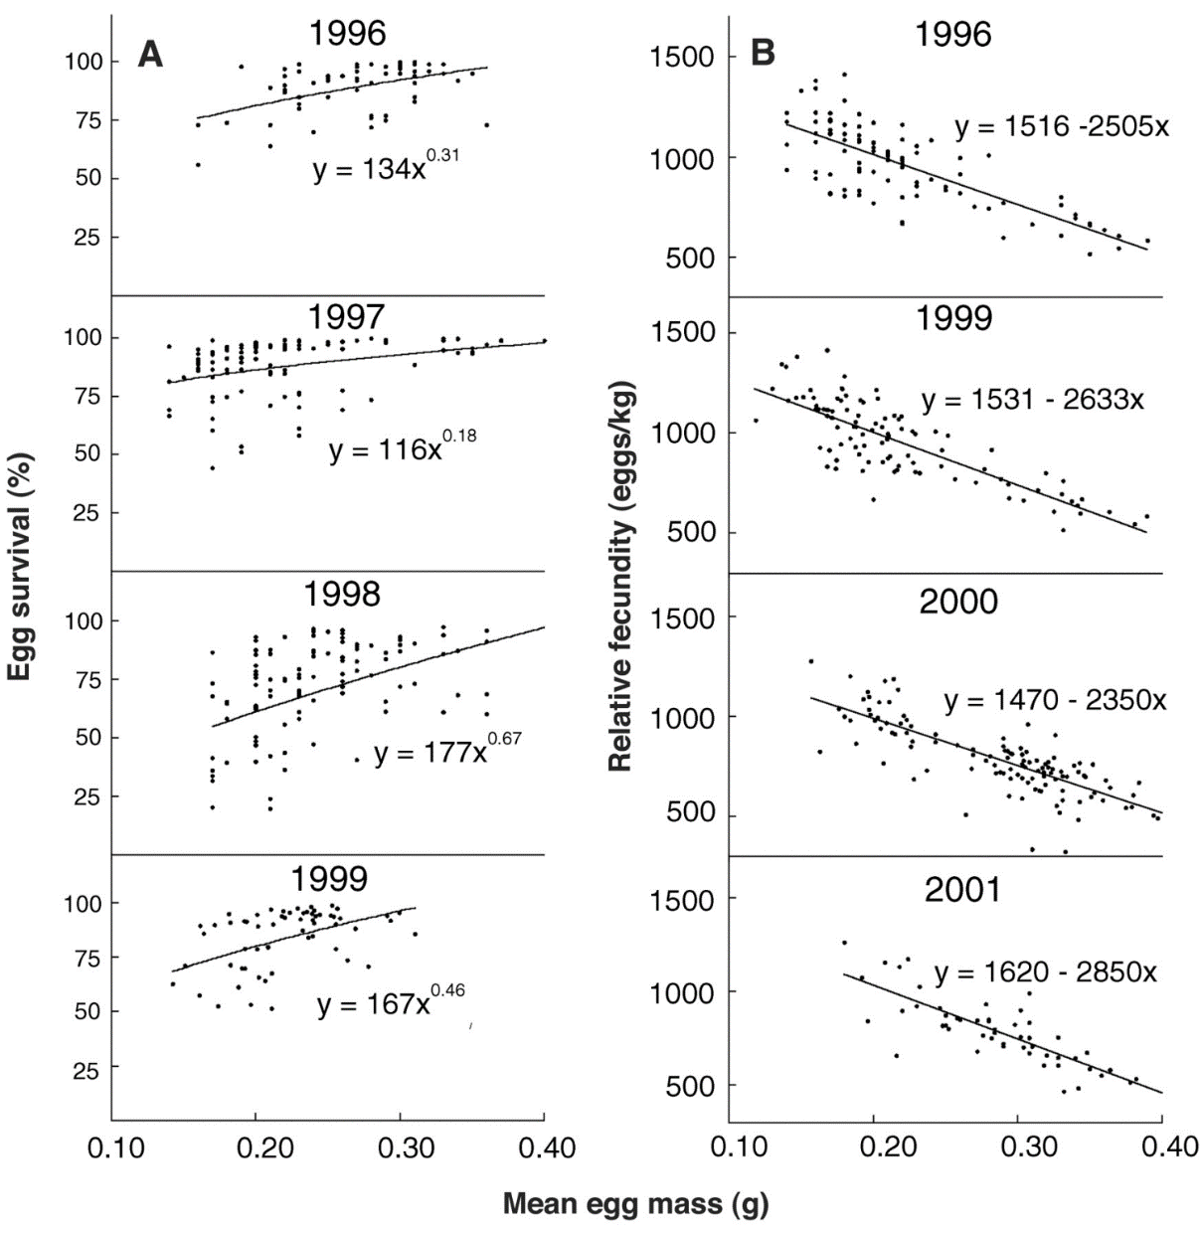
Figure 1. Relationships between egg mass and (A) early juvenile survival and (B) relative fecundity in chinook salmon; each point represents a full-sibling (same mother and father) family from a single female. (A) Egg mass was measured as the mean mass of 20 to 50 unfertilized eggs. Early survival was measured by counting eggs at fertilization and documenting mortality in the hatchery until juveniles began to feed on their own. All relationships were significant at the P < 0.01 level. (B) Relative fecundity was calculated as the total number of eggs produced by a single female divided by the total body mass of the female (this removes the effect of body size, where larger females produce more eggs). All relationships were significant at the P < 0.0001 level. (Heath et al. 2003). Reprinted with permission from The American Association for the Advancement of Science.

Part 2: Effects of captive breeding on egg size in salmon populations—Figure 2
After finishing your team’s prediction in part 1, get Figure 2 from your instructor. In this figure, there are two types of salmon populations, described below.

Figure 2a comes from YIAL, a commercial aquaculture population. Adult fish are held in pens in the ocean. Three-year-old fish are brought to the hatchery for spawning; the offspring are reared there until they are ready to transition to the ocean pens. YIAL represents a fully captive (non-wild) population.

- Describe the pattern in Figure 2a only.

- Interpret the pattern in Fig. 2a. Do these data match your prediction? What do they suggest about the effects of captive breeding on the life history trait of egg size in salmon?

Figure 2b comes from wild populations of chinook returning to rivers on Vancouver Island, British Columbia, Canada. These populations include fully wild fish (hatched from eggs laid in the wild) and supplemented fish (hatched from eggs reared in the hatchery and released as fry). All adults live free in the ocean.

- Describe the structure of Figure 2b in your group. What are the x- and y-axes? What are the units and scale on each axis? What are the 4 parts of the figure? Why do some parts have one line and some 2 lines?

- Describe the pattern in Figure 2b.

- Interpret the pattern. What effect does supplementation have on the wild populations?

- What conclusions would you draw from both parts of this figure about the effects of captive breeding on salmon populations and their life history traits? Explain why we might see these effects.

- Make a management recommendation to a specific audience (see below) based on these results and your general understanding of salmon and life history evolution. In your recommendation be sure to:
  - Briefly identify the monetary and cultural value of salmon to different stakeholders (see introduction on this handout, and background material used in preparing for today).
  - Describe salmon hatcheries and any evolution that has occurred in them.
  - Explain whether any evolution in hatcheries is likely beneficial or harmful to the recovery of wild salmon populations
  - Propose strategies hatcheries could implement to mitigate any problems.
  - Identify any additional information you want before finalizing your recommendations
Discuss with your team, and then individually write a management recommendation on the separate page. In your recommendation, refer to specific evidence from this case study (e.g., cite figures or parts of figures, facts from your case study preparation materials, etc.) that supports your recommendation.

Name:

Teammates:

Management recommendation
Write a 1-3 paragraph recommendation for hatcheries trying to help restore wild populations of salmon. Remember to address each of the points on the previous page, and to refer to specific case study evidence that supports your recommendation.

Identify your audience (circle one below):

general public

elected officials who set policy

fish and wildlife biologists knowledgeable generally about salmon and hatcheries, but who have not seen this study

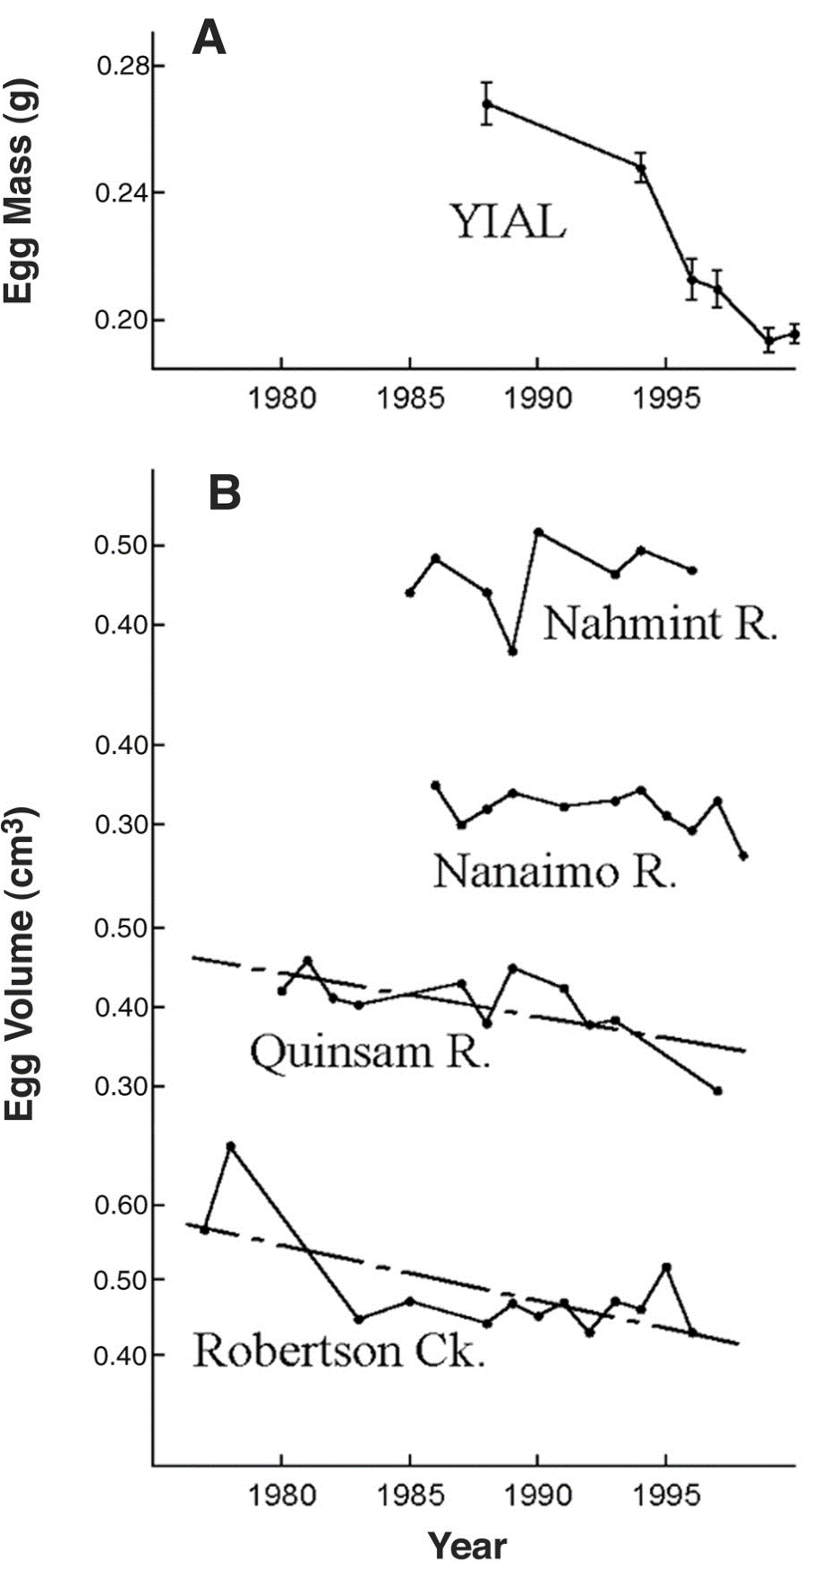
Figure 2. Change in egg size over time for (A) the captive population (YIAL) and (B) four river populations of chinook salmon on Vancouver Island, B.C. (A) Mean egg mass over 13 years. Eggs collected from chinook salmon reared entirely in the YIAL commercial aquaculture environment. (B) Mean egg volume (a non-destructive measure of size correlated with egg mass) for 4 populations of chinook salmon on Vancouver Island. Supplementation effort was quantified as the number of females originally reared in the hatchery divided by the total number of females returning to the system, averaged over the years that have egg size data. Mean supplementation efforts were as follows: Robertson Creek, 28%; Quinsam River, 43%; Nanaimo River, 16%; and Nahmint River, 4%. The fitted (linear) regression lines are for the populations that show significant decreases in egg size (P < 0.01). (Heath et al. 2003). Reprinted with permission from The American Association for the Advancement of Science.

NOTES TO FACULTY
I recommend students work in consistent teams of 3-4 for all activities in this figure set; I have used teams of up to 5, but it’s harder for all students to participate fully in larger groups.
I have a 65-minute class period. The timing of the case administration is approximately:
- 8 minutes for the (4-question multiple choice) individual quiz
- 5-10 minutes for the team quiz (some groups agonize over answers)
- 20 minutes for Figure 1
- 20 minutes for Figure 2
- Some students can finish their management recommendation in class, while some complete it as homework. I expect it to take about 10 minutes to write, after they’ve already talked in their groups.
There are a couple places where students can get off track. In the answer key below, I’ve noted where I’ve seen these occur, and indicate some of the hints I use to guide them.

Answers for Fig. 1 student questions
- In a figure, what does it mean to have a linear relationship between two variables on log vs. linear y axis? Give an example where we’ve seen log scale on the y axis.
Linear axes show the absolute differences, while log scales show proportional change. Thus, a linear relationship between two variables plotted on a log scale indicates exponential growth; increasing the x value has a multiplicative effect on the y value. On linear axes, the relationship is absolute — increasing the x value has a constant effect on the y value. One example where we’ve seen log axes is plotting survivorship in age-structured populations. Note: Example will vary depending on your course—and you might need to drop this part of the question if you haven’t had examples. Considering log vs. linear scales is important in my course because we do see both and I want students to practice explaining the difference. If this is not central to your course, you could drop this question—students should be able to describe and interpret the figure without explicitly thinking about this context.
- Look at the equations for the lines on Figure 1A vs. 1B.
- How does the relationship between the x and y variables differ between the two sides? Sketch how you would expect those different relationships to appear in a figure. In 1A, it’s a power relationship (x raised to a fraction—like ¼ to ½ power, approximately). In 1B it’s a linear relationship. A should look like a positive curve that levels off; B should look like a straight positive line. Note: Students often struggle with knowing what power relationships with fractional exponents look like—or power relationships in general. To help them visualize this more easily, you could have them use a spreadsheet to plot one or more of these equations or some examples of different power relationships (e.g., exponents <1, >1, etc.). This will take more class time and require students to have devices available. While not central to this case study, it would help students develop deeper understanding of power relationships, which are important in many contexts.
- Is that difference easy to see in the figure? YES NO Briefly explain. Looks like a straight line in both—curve isn’t obvious in part A. Note: If you have time constraints, you could drop question 2. Before I included it, students simply interpreted both sides of Fig. 1 as having linear (positive) relationships and did not notice the power function. Overlooking the power function does not substantially change the interpretation of the figure.
The table below provides answers for question 3.

 | Units & scale (e.g., linear or log; numerical, categorical, proportion, %, etc.) | Describe the pattern/ relationship between variables | Life history trade-off
Part A | x: size of eggs in g, linear  y: performance of eggs (survival), no units, % | in all years, larger eggs have higher survival; there is a positive relationship between egg size and survival | Leave blank
Part B | x: size of eggs in g, linear  y: offspring #, eggs/kg, linear | in all years, females that produce larger eggs make fewer of them (scaled to their body size); there is a negative relationship between offspring size and number. | size vs. # of offspring

- Interpret the pattern in part A of the figure. How does selection act on egg size? Selection favors larger eggs (though strength varies from year to year).
- Interpret the pattern in part B of the figure. Is there evidence for a trade-off? Explain your reasoning, including how the pattern does or does not fit the expected relationship if there is a trade-off. There is evidence for a trade-off. Females that produce more eggs (scaled to body size) produce smaller eggs. This fits the expected pattern, where individuals can either produce many smaller or few larger offspring—the resources for reproduction are limited, so you can’t have many large offspring. Note: Students sometimes get hung up on what it means to scale egg production to body size. I check in with groups to make sure they understand this is just a way to account for larger females producing more eggs in general, so that you can actually discern a separate relationship between egg number and size. You could also add this hint to the text.
- These data were collected from hatchery-reared fish. In the wild, alvelins are vulnerable to predators because they are small; the longer an alvelin is small, the longer it’s vulnerable. How would wild conditions affect the pattern you’d expect to see in part A? Why? Hint: Remember that alvelins feed on egg yolk. We expect a stronger relationship between egg size and survival because the presence of predators means there’s more risk associated with being small (small egg small juvenile fish size). Because smaller eggs have lower survival (those alvelin would get eaten more), there should be stronger selection for larger eggs. Notes: 1) Students sometimes have trouble connecting egg size to how long alvelins are vulnerable to predation; I sometimes provide an additional hint that explicitly says: Think about how you expect egg size to affect alvelin size, given that they feed on yolk. 2) In the past, students sometimes argue that there should be selection for smaller egg size because small fish would escape predation more easily (a misunderstanding). I revised the question prompt to provide more key information about size-predation vulnerability, but you may still see this answer.
- Predict: How would you expect selection due to captive breeding to act on egg size for hatchery-bred fish? Carefully explain your reasoning, including how it would affect the best “strategy” for females. Relate your prediction to life-history trade-offs in different environments. We predict reduced selection for large eggs/selection for smaller eggs. The hatchery environment instead will select for a large number eggs with smaller size (because there is less of a disadvantage for small offspring in the absence of predators). In other words, selection on females for the small size/large number of offspring end of the trade-off. Notes: a) I often check predictions, but don’t “correct” them here—I let the data address that in the next section. b) If you want to include ideas about r and K selection, add that to the last sentence of the question. A reasonable answer is that selecting for small size/large number of offspring is a more r-selected suite of traits. (Note that while all salmon are likely r-selected because they produce so many small offspring without parental care, hatcheries would shift to even stronger r selection.).

Answers for Fig. 2 student questions
- Describe the pattern in Figure 2a only (from hatchery fish). Egg size decreases as the number of years of hatchery breeding increases: the longer time of captive breeding, the smaller the eggs.
- Interpret the pattern in Fig. 2a. Do these data match your prediction? What do they suggest about the effects of captive breeding on the life history trait of egg size in salmon? Probably will match prediction, but may not. Results suggest the trade-off between offspring # and size has changed to favor more smaller eggs rather than fewer larger ones. This could happen if the captive environment no longer gives a selective advantage to larger eggs (e.g., for predator escape). Note: If students made a different prediction, they may need feedback to understand why there’s a different pattern here than they expected.
- Describe the structure of Figure 2b in your group. What are the x- and y-axes? What are the units and scale on each axis? What are the 4 parts of the figure? Why do some parts have one line and some 2 lines? I usually have students just discuss this without recording their answers. If they write down answers, they should include: x-axis is year, y-axis is egg size (measured as volume instead of mass, so not exactly the same as size measure in other figures). Both scales are linear, but note that the range for the y-axis varies for the 4 panels. The 4 parts represent 4 different rivers with different levels of supplementation—the top two have low supplementation (16% or less) while the bottom two have higher supplementation (28% or more). The straight lines represent linear relationships between year and egg size for populations where egg size decreased over the time period. If there isn’t a second (linear) line, the egg size didn’t change significantly over the time period.
- Describe the pattern in Figure 2b. Egg size (measured as egg volume) decreased from over 15 years in two rivers (Quinsam and Robertson) but not two other rivers (Nahmint and Nanaimo). The rivers where egg size decreased had higher levels of hatchery fish in their populations (28% and 43%). The ones where egg size didn’t decrease had lower levels of hatchery fish (16% and 4%). Note: Students sometimes get confused about why they are measuring egg size differently in this figure than the other ones. I discuss with them the challenges of collecting data in the field (hard to weigh eggs), and remind them that egg volume is strongly correlated with egg mass.
- Interpret the pattern. What effect does supplementation have on the wild populations? Likely evolution for smaller eggs in hatcheries leads to smaller size in the total population. This means that hatchery supplementation is leading to maladaptive traits in the wild.
- What conclusions would you draw from both parts of this figure about the effects of captive breeding on salmon populations and their life history traits? Explain why we might see these effects. Captive breeding leads to the evolution of reduced egg size in populations in the wild—it adds fish to the population who have been selected for smaller egg size in the hatchery environment, which then draws down the average egg size for that total population. This means egg size is now not only selected by the wild river environment. Because selection on egg size differs between hatcheries and wild environments, captive breeding is likely leading to fish with maladaptive traits for the wild environment—the smaller eggs will produce smaller alvelins, who will be more vulnerable to predation. This suggests that captive breeding may introduce an unintended harm by selecting for juveniles that are more vulnerable to predation in the wild environment, which could further depress wild populations of salmon.
- Make a management recommendation to a specific audience (see below) based on these results and your general understanding of salmon and life history evolution. In your recommendation be sure to:
- Briefly identify the monetary and cultural value of salmon to different stakeholders (see introduction on this handout, and background material used in preparing for today).
- Describe salmon hatcheries and any evolution that has occurred has occurred in them.
- Explain whether any evolution in hatcheries is likely beneficial or harmful to the recovery of wild salmon populations
- Propose strategies hatcheries could implement to mitigate any problems.
- Identify any additional information you want before finalizing your recommendations
Discuss with your team, and then individually write a management recommendation on the separate page. In your recommendation, refer to specific evidence from this case study (e.g., cite figures or parts of figures, facts from your case study preparation materials, etc.) that supports your recommendation.

Name:

Teammates:

Management recommendation
Write a 1-3 paragraph recommendation for hatcheries trying to help restore wild populations of salmon. Remember to address each of the points on the previous page, and to refer to specific case study evidence that supports your recommendation.

Identify your audience (circle one below):

general public

elected officials who set policy

fish and wildlife biologists knowledgeable generally about salmon and hatcheries, but who have not seen this study

Student assessments
I assess teams using their (team) answers to the questions above. Note that grading team answers encourages collaboration and reduces the grading load. I provide a separate answer sheet (1 per team) so that each student has the questions in front of them. Sometimes I only grade a subset of questions as well.
Groups work at different paces in my small class, so I only collect answers at the end. If your class is larger, it might work better to have set times for each section of the activity. Then, you could do an individual minute paper at the end of the first figure analysis, either summarizing the pattern and interpretation in the figure or explaining their prediction.
In the past, I have assigned the management recommendation to groups instead of individual students. This provided an opportunity for collaborative problem solving and synthesis and also lessens the grading load in large classes. However, I have found it useful to be able to assess student understanding and their ability to interpret and apply the data to the management questions. The case study presented here is written with individual instructions but could easily be adapted for a group recommendation.

Additional Resources
I introduce salmon as a recurring example in the first unit of the class (Populations—which includes species distributions, age-structured models, exponential and logistic models, and life history evolution). Thus, students have already learned about the life history of salmon and some of the threats facing them before working on this case study. Some of the background resources I’ve used for this earlier introduction include examples related to salmon distribution and species distribution models for them (Rubenson and Olden 2020, Shelton et al. 2021) and background on basic salmon biology (Delaney 2008).
Below is the handout I provide to students to prepare for this figure set case study. I use the Ecology textbook by Hacker and Bowman. For context, I do three of these figure-based case studies during the semester (one per unit). The “grand finale” mentioned in the handout is an extended case study that occurs during our 2.5-hour final exam period, in lieu of a traditional final exam; the three smaller case studies are designed to familiarize students with this format before the grand finale. The salmon example described here is the first in-class case study in the course, so their first time working with this format.

Case study 1: Life history evolution in salmon
For this case study, we will study the role of life history evolution in Pacific Northwest salmon populations. This case study will model the activities we’ll do during the grand finale (held during the final exam period).

To prepare for class, review the resources below and be sure you are comfortable with (i.e., ready to take a multiple-choice quiz about) the learning objectives. The case study will run in this way:
- Class will start with a short individual multiple-choice quiz (4 points) related to these objectives.
- Next you will take a group multiple choice quiz (2 points), using a scratch-off answer form that gives you partial credit if you get the correct answer on the 2nd or 3rd try.
- Finally, you will analyze data in your group. You will describe and interpret figures. At the end, you write a 1-2 paragraph individual management recommendation based on the case study information. The group data analysis is worth 4 points. You will also write an individual management recommendation based on the data in the case study and your background knowledge (including information in the resources below) about the economic, ecological, and cultural importance of salmon.

Resources
- Read or listen to the OPB report about salmon hatcheries (link also on Moodle). This story gives a great overview of salmon hatcheries--it's very long, so only read the first section (or listen to the two radio stories, each about 5 minutes long) and look at the graphs in the second section ("Finger in the dike") if you have limited time. That said, the entire article is full of great information, data, and stories!
- If desired, review video lectures on life history evolution, r and K selection, and optimal clutch size (playlist on Moodle), including any topics announced in class that we don’t get to.
- Review Chapter 7 in textbook
- Re-review Chapter 6 in textbook if you want to review principles of evolution

Learning objectives
- Describe what happens in fish hatcheries.
- Explain the threats facing salmon populations, and the role that fish hatcheries play in ameliorating or exacerbating some of those threats.

(from class daily learning objectives)
- Define semelparous and iteroparous reproduction, give examples, and identify the traits associated with each kind of reproduction. (Be able to determine which term applies to a description of a reproductive strategy.)
- Define life history and life history strategies.
- Define clutch size.
- Describe Lacks’ experiments on optimal clutch size.
- Evaluate evidence for an optimal clutch size and explain how selection creates that optimum.
- Define trade-offs and explain why they occur.
- Identify typical life history trade-offs in graphs (offspring size vs. number, reproduction now vs. the future, reproduction vs. survival, reproduction vs. growth).
- Define r and K selection and give examples of r- and K-selected species.
- Describe the conditions that lead to r-selected vs. K-selected life histories, and predict which applies to a scenario.
- Interpret data or graphs to identify life history strategies (such as r or K selection) or trade-offs.

LITERATURE CITED
Blouin, M. S., M. C. Wrey, S. R. Bollmann, J. C. Skaar, R. G. Twibell, and C. Fuentes. 2021. Offspring of first-generation hatchery steelhead trout (Oncorhynchus mykiss) grow faster in the hatchery than offspring of wild fish, but survive worse in the wild: Possible mechanisms for inadvertent domestication and fitness loss in hatchery salmon. PLoS One 16:e0257407.
Bradshaw, W. E., and C. M. Holzapfel. 2001. Genetic shift in photoperiodic response correlated with global warming. Proceedings of the National Academy of Sciences 98:14509-14511.
Columbia River Inter-Tribal Fish Commission. 2025. Tribal Salmon Culture. https://critfc.org/salmon-culture/tribal-salmon-culture/ Accessed 30 December 2025.
Crone, E. E., M. M. Ellis, W. F. Morris, A. Stanley, T. Bell, P. Bierzychudek, J. Ehrlén, T. N. Kaye, T. M. Knight, P. Lesica, G. Ooostermeijer, P. F. Quintana-Ascencio, T. Ticktin, T. Valverde, J. L. Williams, D. F. Doak, R. Ganesan, K. McEachern, A. S. Thorpe, and E. S. Menges. 2013. Ability of matrix models to explain the past and predict the future of plant populations. Conservation Biology 27:968-978.
Crouse, D. T., L. B. Crowder, and H. Caswell. 1987. A stage-based population model for loggerhead sea turtles and implications for conservation. Ecology 68:1412-1423.
Delaney, K. 2008. Chinook Salmon. https://www.adfg.alaska.gov/static/education/wns/chinook_salmon.pdf. Accessed 1 December 2025
Dzombak, R. 2025. A River Restoration in Oregon Gets Fast Results: The Salmon Swam Right Back. New York Times. https://www.nytimes.com/2025/10/29/climate/klamath-salmon-recovery.html
Farquharson, K. A., C. J. Hogg, and C. E. Grueber. 2021. Offspring survival changes over generations of captive breeding. Nature Communications 12:3035.
Franks, S. J., S. Sim, and A. E. Weis. 2007. Rapid evolution of flowering time by an annual plant in response to a climate fluctuation. Proceedings of the National Academy of Sciences 104:1278-1282.
Governor's Salmon Recovery Office. 2022. State of Salmon in Watersheds. https://stateofsalmon.wa.gov/wp-content/uploads/2023/02/SOS-ExecSummary-2022.pdf. Accessed 30 December 2025
Han, K. Y., R. S. Brennan, C. T. Monk, S. Jentoft, C. Helmerson, J. Dierking, K. Huessy, E. E. Kokubun, J. Fuss, B. Krause-Kyora, T. B. Thomsen, B. D. Heredia, and T. B. H. Reusch. 2025. Genomic evidence for fisheries-induced evolution in Eastern Baltic cod. Science Advances 11:eadr9889.
Heath, D. D., J. W. Heath, C. A. Bryden, R. M. Johnson, and C. W. Fox. 2003. Rapid evolution of egg size in captive salmon. Science 299:1738-1740.
Lacava, M. E. F., J. S. Griffiths, L. Ellison, E. W. Carson, T. C. Hung, and A. J. Finger. 2023. Loss of plasticity in maturation timing after ten years of captive spawning in a delta smelt conservation hatchery. Evolutionary Applications 16:1845-1857.
McGraw, J. B., and M. A. Furedi. 2005. Deer browsing and population viability of a forest understory plant. Science 307:920-922.
McMillan, J. R., B. Morrison, N. Chambers, G. Ruggerone, L. Bernatchez, J. Stanford, and H. Neville. 2023. A global synthesis of peer-reviewed research on the effects of hatchery salmonids on wild salmonids. Fisheries Management and Ecology 30:446-463.
Nelson, B. W., A. O. Shelton, J. H. Anderson, M. J. Ford, and E. J. Ward. 2019. Ecological implications of changing hatchery practices for Chinook salmon in the Salish Sea. Ecosphere 10:e02922.
Nielsen, M. E., S. Nylin, C. Wiklund, and K. Gotthard. 2023. Evolution of butterfly seasonal plasticity driven by climate change varies across life stages. Ecology Letters 26:1548-1558.
Pulido, F., P. Berthold, G. Mohr, and U. Querner. 2001. Heritability of the timing of autumn migration in a natural bird population. Proceedings of the Royal Society of London Series B-Biological Sciences 268:953-959.
Rauschkolb, R., W. Durka, S. Godefroid, L. Dixon, O. Bossdorf, A. Ensslin, and J. F. Scheepens. 2023. Recent evolution of flowering time across multiple European plant species correlates with changes in aridity. Oecologia 202:497-511.
Reale, D., A. G. McAdam, S. Boutin, and D. Berteaux. 2003. Genetic and plastic responses of a northern mammal to climate change. Proceedings of the Royal Society of London 270:591-596.
Rubenson, E. S., and J. D. Olden. 2020. An invader in salmonid rearing habitat: current and future distributions of smallmouth bass (Micropterus dolomieu) in the Columbia River Basin. Canadian Journal of Fish Aquatic Science 77:314-325.
Schick, T., and I. Swang. 2022. The US has spent more than $2B on a plan to save salmon. The fish are vanishing anyway. Oregon Public Broadcasting. https://www.opb.org/article/2022/05/24/pacific-northwest-federal-salmon-hatcheries-declining-returns/ Accessed 1 December 2025.
Shelledy, K. N., and K. P. Currens. 2025. Indigenous and Western frameworks reveal bias in the scientific literature on salmon's contributions to social-ecological systems. People and Nature 7:2602-2621.
Shelton, A. O., G. H. Sullaway, E. J. Ward, B. E. Feist, K. A. Somers, V. J. Tuttle, J. T. Watson, and W. H. Satterthwaite. 2021. Redistribution of salmon populations in the northeast Pacific Ocean in response to climate. Fish and Fisheries 22:503-517.
Uusi-Heikkilä, S., A. R. Whiteley, A. Kuparinen, S. Matsumura, P. A. Venturelli, C. Wolter, J. Slate, C. R. Primmer, T. Meinelt, S. S. Killen, D. Bierbach, G. Polverino, A. Ludwig, and R. Arlinghaus. 2015. The evolutionary legacy of size-selective harvesting extends from genes to populations. Evolutionary Applications 8:597-620.
Winkler, D. W., P. O. Dunn, and C. E. McCulloch. 2002. Predicting the effects of climate change on avian life-history traits. Proceedings of the National Academy of Sciences 99:13595-13599.

