ISSUES: DATA SET
Remote Sensing Assessment of Tree Canopy Disturbance Caused by the May 2024 Tornado in North Florida Using Google Earth Engine
Rosny Jean¹, Justin St. Juliana², and Nancy Nthiga¹
¹ School of the Environment, Florida Agricultural and Mechanical University, Tallahassee, FL 32307
² Department of Ecology and Evolutionary Biology, Cornell University, Ithaca, NY 14853
Corresponding author: Rosny Jean (rosny.jean@famu.edu)
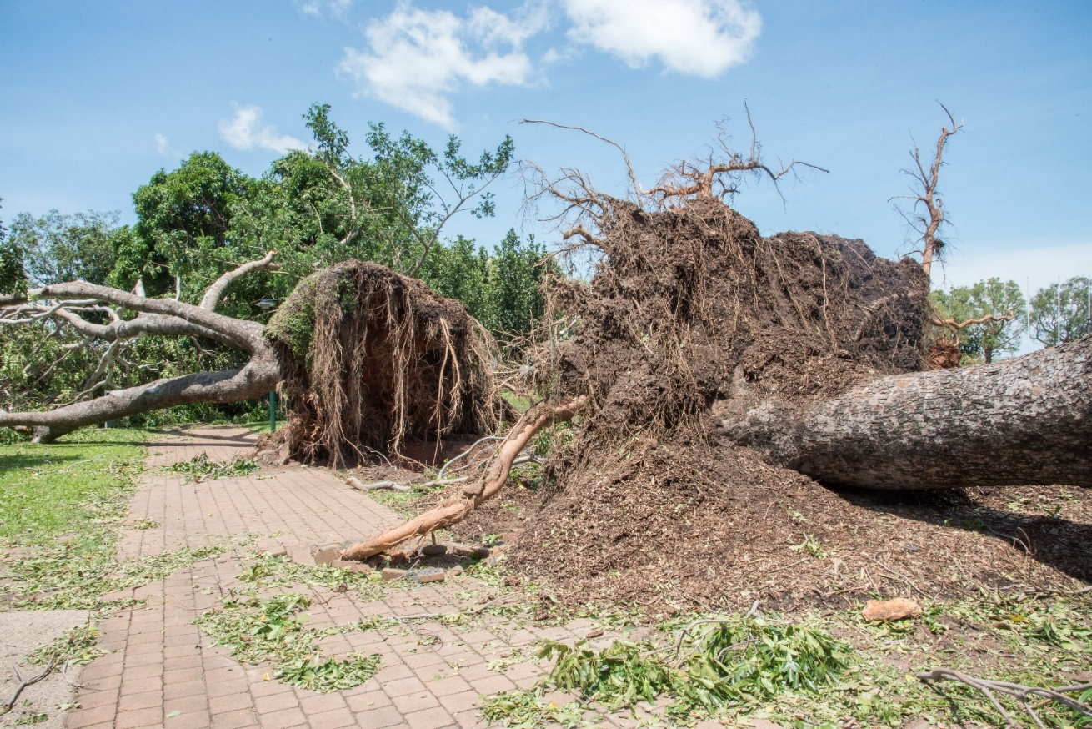
Uprooted trees and canopy disturbance resulting from tornado activity (Photo credit: EA Givens)

THE ECOLOGICAL QUESTION:
Extreme weather events, such as tornadoes, can cause rapid and widespread disruption to ecosystems, with tree canopy loss being one of the most immediate and ecologically significant effects. The May 10, 2024, tornado outbreak in North Florida included two EF-2 tornadoes that converged over Tallahassee, providing a clear, real-world case study of these impacts. Canopy reduction affects biodiversity, limits carbon sequestration, and disrupts ecosystem functions, while increasing sensitivity to future climate extremes. Assessing the extent of this disturbance is essential for understanding ecological consequences and informing restoration efforts. This case study employs remote sensing in ecological research, providing an efficient way to monitor landscape changes across large areas. By comparing satellite data from before and after the tornado, students can explore how such events reshape ecosystems and better understand the role of forests in climate resilience. This figure set provides visual insight into canopy loss, helping students analyze spatial and temporal patterns while considering broader ecological implications.

FOUR-DIMENSIONAL ECOLOGY EDUCATION (4DEE) FRAMEWORK
- Core Ecological Concepts:
- Landscapes
- Ecosystems
- Ecology Practices:
- Designing, conducting, and critiquing investigations
- Quantitative reasoning and computational thinking
- Data analysis and interpretation
- Human-Environment Interactions:
- Human impacts on the environment from local to global scales
- Cross-cutting Themes:
- Space & Time

Integration across 4DEE Dimensions
Understanding the ecological impacts of severe weather events like tornadoes requires an integrative approach that incorporates multiple dimensions of ecological education. This dataset and associated activities foster integration across the four dimensions of the 4DEE framework:
- Core Ecological Concepts & Ecology Practices:
- Students engage with the concepts of disturbance and recovery by analyzing how tornadoes impact tree canopy cover and the subsequent ecological consequences.
- The activity involves quantitative reasoning and computational thinking through remote sensing and geospatial analysis, allowing students to measure and visualize spatial and temporal changes in canopy cover.
- Ecology Practices & Human-Environment Interactions:
- The integration of remote sensing and geospatial analysis equips students with tools to assess environmental change, an essential skill for applied ecological research and disaster response.
- Cross-cutting Themes & Core Ecological Concepts & Human Environment Interactions
- The spatial and temporal nature of tornado impacts is central to the dataset, allowing students to examine landscape-scale changes over time, and how they impact people.

WHAT STUDENTS DO:
Students work with remote sensing data and geospatial analysis tools to quantify and visualize the impacts of tornadoes on tree canopy cover. They:
- Utilize Google Earth Engine software to map spatial changes in forest cover.
- Conduct quantitative analysis on the extent of disturbance and recovery patterns.
- Interpret results and discuss implications for ecosystem services and climate resilience.
- Engage in verbal class discussions on ecological restoration and human-environment interactions related to severe weather events.

STUDENT-ACTIVE APPROACHES:
Think-pair-share, hands-on image analysis, designing experiments to assess ecological impacts, using remote sensing software tools (i.e. Google Earth Engine), and exploring computational methods for change detection in forested landscapes.
STUDENT ASSESSMENTS:
Answering questions on a worksheet, sharing interpretations of pre- and post-event data with the class, creating classification maps, performing Normalized Difference Vegetation Index (NDVI) and change detection, as well as answering questions about ecological disturbances.

CLASS TIME:
This Data Set is designed to span one 75-minute class or split over two 50-minute class sessions.

COURSE CONTEXT:
This Data Set is recommended as part of advanced courses in environmental science, ecology, geography, or remote sensing at undergraduate and graduate levels.
SOURCES:
- North Florida Shapefile: FWC (Florida Fish and Wildlife Conservation Commission) https://geodata.myfwc.com/datasets/myfwc::fwc-regions/about
- Software used: Google Earth Engine, which offers free access to all users without license restrictions (https://code.earthengine.google.com/)

OTHER RESOURCES:
- Video tutorial [Tornado Project video.mp4]

ACKNOWLEDGEMENTS:
The authors acknowledge the use of Google Earth Engine for data access and analysis. Special thanks are extended to Christopher Beck and the anonymous reviewers for their thoughtful reviews and constructive comments, which helped strengthen this work. The authors also acknowledge the School of the Environment at Florida A&M University and the Department of Ecology and Evolutionary Biology at Cornell University for their institutional support.

OVERVIEW OF THE ECOLOGICAL BACKGROUND
WHAT IS THE ECOLOGICAL ISSUE?
Tornadoes are a natural phenomenon with significant ecological consequences, especially for forest ecosystems. During the May 10, 2024, North Florida tornado outbreak, two EF-2 tornadoes crossed paths in Tallahassee, causing widespread tree canopy damage and disrupting the region’s ecosystems. Tree canopy loss due to such extreme weather events can lead to long-term environmental impacts, including reduced carbon sequestration (a regulating service), loss of habitat (a supporting service), and increased vulnerability to soil erosion and water quality degradation (both regulating and provisioning services).
Assessing the extent of canopy damage is critical for understanding the tornado's ecological impacts and informing restoration efforts. Remote sensing technologies and imagery can provide valuable tools for quantifying changes in tree canopy cover over large areas and time periods. By leveraging these technologies, researchers can evaluate both the immediate impacts of the tornado and the subsequent recovery of the forest ecosystem.
RESEARCH CONTEXT AND METHODS
Forest ecosystems play a vital role in maintaining ecological stability by providing habitats for wildlife, regulating local climate, and mitigating carbon emissions. The tree canopy, a key component of forests, offers shade, reduces surface runoff, and improves air quality. When a tornado strikes, the destruction of the canopy can lead to a cascade of negative ecological effects that compromise these ecosystem services. This project aims to analyze the impact of the May 10, 2024, tornado on North Florida's tree canopy using remote sensing data, focusing on changes in canopy extent and condition.
Traditional methods of assessing canopy loss often rely on field surveys, which are time-intensive and limited in scope. Remote sensing enables comprehensive analysis across large areas. For this project, we will use two satellites, Landsat 9 and Sentinel-2, to compare pre- and post-event conditions. Using both provides complementary strengths. Sentinel-2 offers finer spatial detail at 10 m for mapping small canopy gaps, while Landsat 9 provides 30 m data with long-term continuity for regional trend analysis. Sentinel-2’s shorter revisit interval improves the chance of cloud-free imagery near the event date, and Landsat’s consistent surface-reflectance products support robust change detection over time. The sensors also differ spectrally, with Sentinel-2 red-edge bands sensitive to vegetation condition and Landsat’s SWIR bands aiding moisture and burn-scar assessment. Processing each dataset independently and then cross-validating the outputs increases confidence, reduces sensor-specific bias, and yields a more reliable canopy-loss estimate.
To quantify changes in vegetation health and canopy cover, we will use the Normalized Difference Vegetation Index (NDVI), which uses near-infrared (NIR) and red reflectance and is calculated as (NIR − Red) ÷ (NIR + Red) from surface reflectance (Landsat 9: Red = Band 4, NIR = Band 5; Sentinel-2: Red = Band 4, NIR = Band 8). Here, a “band” is a sensor channel that records reflectance over a specific wavelength range, and higher NDVI values indicate healthier, denser foliage. This is because healthy vegetation strongly absorbs red light for photosynthesis while reflecting more near-infrared light, whereas stressed or sparse vegetation reflects more red light and less NIR.
IMPLICATIONS AND APPLICATIONS
Understanding the ecological impact of tornadoes on tree canopy cover is essential for effective forest management and conservation planning. Through this activity, students will explore the spatial extent and severity of canopy loss in North Florida, learning how these analyses can support reforestation and habitat restoration efforts. In doing so, students will also recognize the importance and value of leveraging remote sensing technologies to monitor and respond to environmental disturbances caused by extreme weather events.
Students will learn about proactive measures to enhance forest resilience, such as planting diverse tree species and protecting critical habitats. Through canopy monitoring activities, they will see how remote sensing methods can be applied to assess forest health. In doing so, students will gain an understanding of how these tools connect to broader efforts to mitigate the ecological impacts of natural disasters and promote sustainable forest management practices

LEARNING OBJECTIVES
Students will be able to:
- Explain the concept of multispectral satellite imagery (e.g., Landsat, Sentinel-2) and its relevance in remote sensing for ecological assessments.
- Use Google Earth Engine to access and preprocess Landsat 9 and Sentinel-2 surface reflectance, including cloud and shadow masking (e.g., Landsat QA_PIXEL, Sentinel-2 SCL), reflectance scaling, and compositing.
- Calculate NDVI for pre- and post-event scenes and compute NDVI difference maps to identify canopy loss.
- Compare sensor characteristics and implications for analysis, including spectral bands, spatial resolution (10 m vs 30 m), and revisit frequency.
- Summarize affected areas with simple metrics such as mean NDVI change and estimated area of canopy loss based on a threshold.
- Interpret results and discuss implications for ecosystem services and climate resilience. Engage in verbal class discussions on ecological restoration and human-environment interactions related to severe weather events.

STUDENT ASSESSMENT
Students engage in reflective exercises through methods such as think-pair-share, discussion groups, or online forums. A worksheet is provided with targeted questions focusing on the data requirements for remote sensing analysis, including segmentation, feature extraction, and classification techniques. This assessment encourages students to critically analyze the processes and challenges involved in quantifying changes in tree canopy cover after extreme weather events. Please note that some prior experience with GEE, GIS, and basic programming will be helpful for completing this lab, but students without this background can still follow along with guidance.

DATA SETS
Data sets for students include:
    - Shapefile of North Florida [zip]
Data sets for faculty include:
    - Shapefile of North Florida [zip]
- Landsat 9 imagery for North Florida [png]
- Sentinel-2 imagery for North Florida [png]
- NDVI before the tornado using Landsat 9 imagery [png]
- NDVI after the tornado using Landsat 9 imagery [png]
- NDVI Change map after the tornado using Landsat 9 imagery [png]
- NDVI before the tornado using Sentinel-2 imagery [png]
- NDVI after the tornado using Sentinel-2 imagery [png]
- NDVI Change map after the tornado using Sentinel-2 imagery [png]

STUDENT INSTRUCTIONS
WHAT IS THE ECOLOGICAL ISSUE?
Natural ecosystems in North Florida have been significantly impacted by extreme weather events, including a tornado that occurred on May 10, 2024. Tornadoes can cause widespread damage to tree canopy cover, disrupting ecosystems and diminishing their ecological services. Tree canopy cover provides critical benefits such as carbon sequestration, stormwater management, air quality improvement, and habitat for wildlife. Quantifying the impact of tornadoes on canopy cover is essential for understanding the extent of damage, planning recovery efforts, and developing strategies to mitigate future impacts.

Remote sensing provides a powerful tool for assessing changes in canopy cover over large areas. Landsat and Sentinel satellite imagery, with their moderate to high spatial resolution and temporal coverage, enable researchers to detect and monitor vegetation changes over time. These datasets are freely available, making them accessible for ecological studies and disaster impact assessments. Traditional vegetation assessment methods, such as manual surveys, are labor-intensive and often infeasible over large or inaccessible areas. By leveraging remote sensing and vegetation indices like the NDVI I (Normalized Difference Vegetation Index) and NBR (Normalized Burn Ratio), researchers can analyze changes in vegetation health and canopy cover quickly and effectively.

Background
Tornadoes are known to cause severe damage to forested landscapes, leading to deforestation, habitat fragmentation, and loss of ecosystem services. The May 10, 2024, tornado in North Florida provides a case to examine short-term changes in tree canopy cover with satellite imagery. Comparing pre- and post-event scenes reveals the extent and spatial pattern of damage.

Landsat 9 and Sentinel-2 provide multispectral imagery well suited for canopy analysis. Landsat 9 delivers 30 m spatial resolution and offers a long, consistent archive for monitoring vegetation over time. Sentinel-2 provides higher resolution (10–20 m) and includes additional red-edge and shortwave infrared bands, which enable more detailed vegetation assessments. These bands are used to calculate indices such as NDVI and NBR, which map changes in canopy condition and the extent of tornado disturbance. NDVI (Normalized Difference Vegetation Index) reflects vegetation “greenness” by comparing red and near-infrared reflectance, serving as an indicator of overall plant health. NDVI values close to 1 suggest dense, healthy vegetation, values near 0 indicate bare soil or sparse cover, and negative values often represent water or built surfaces. NBR (Normalized Burn Ratio), in contrast, combines near-infrared and shortwave infrared reflectance to capture structural and moisture changes in vegetation, making it especially useful for detecting canopy disturbance and stress.

Part 1

Objective
Acquire the shapefile of North Florida to be used for data processing and analysis. This will allow students to define the spatial extent of the study area, ensuring that subsequent remote sensing analyses are focused on the region affected by the May 10th, 2024, tornado. Students will also gain experience with spatial data acquisition and management, a foundational skill in geospatial analysis.

Skills Developed
- Locating and downloading spatial data from reliable sources, such as government databases or GIS repositories.
- Importing shapefiles into Google Earth Engine (GEE) for geospatial analysis.
- Understanding the importance of defining a study area in ecological research.
- Familiarity with file formats and metadata associated with geospatial data.

Knowing the appropriate source to acquire a desired shapefile is important as this improves accuracy and saves time spent browsing different websites. Some of the websites that have a wide range of shapefiles free for public use include US Census Bureau TIGER Shapefiles, USGS Earth Explorer, Natural Earth and Global Forest Watch. Shapefiles with a small spatial extent (e.g., state, counties, towns and neighborhoods) can be found on the respective website of the state. The Florida shapefile was acquired from FWC (Florida Fish and Wildlife Conservation Commission) at https://geodata.myfwc.com/datasets/myfwc::fwc-regions/about. Since the focus of this study is only North Florida, the shapefile was clipped to include only the northern regions of the state.

The workflow involves the following steps:
- Create an account with Google Earth Engine (GEE)
- Download the Florida Shapefile from FWC
- Import the shapefile to Google Earth Engine.
- Clip the shapefile to only include North Florida

To create an account with Google Earth Engine (GEE), users should visit https://signup.earthengine.google.com/. They must sign in using a Google account and complete a short form requesting some basic information. Account approval typically takes a few days and is confirmed via email. Once approved, users gain access to the GEE Code Editor at https://code.earthengine.google.com/ and can begin uploading and analyzing geospatial data.

To import the shapefile to GEE after downloading it, go to the “Assets” tab on the top left side of the screen and click it. Select “New” “Table Upload” “Shapefile”. It is important to note that the shapefile should have either of these file extensions .shp, .shx, .dbf, .prj or .zip. After importing the shapefile, it needs to be loaded to enable viewing on the console. Files that have been successfully imported can be found under the “Tasks” tab on the top right. Copy the code below and paste it on the console. This code entails loading the uploaded shapefile into your workspace, centering the map view over the shapefile’s geographic extent, and rendering the shapefile with a specified color for visualization purposes:

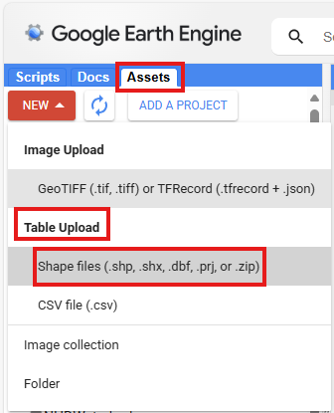
Figure 1: GEE ‘Assets’ tab used to import shapefiles

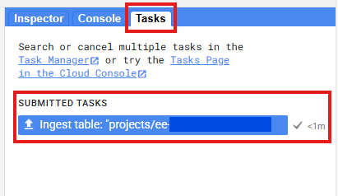
Figure 2: GEE Task tab on the top right where uploaded assets can be located

Step1: Import shapefile into GEE Assets

// Merge the selected regions into one polygon
// Replace with your actual shapefile project path
var floridaRegions = ee.FeatureCollection(‘shapefile_project_path’);

var floridaRegions = floridaRegions.filter(ee.Filter.inList('OBJECTID', [1, 3]));

var NFRegions = floridaRegions.union();

// Add the merged regions to the map for visualization
Map.centerObject(NFRegions, 8);
Map.addLayer(NFRegions, {color: 'blue'}, 'Merged Regions 1 and 3');

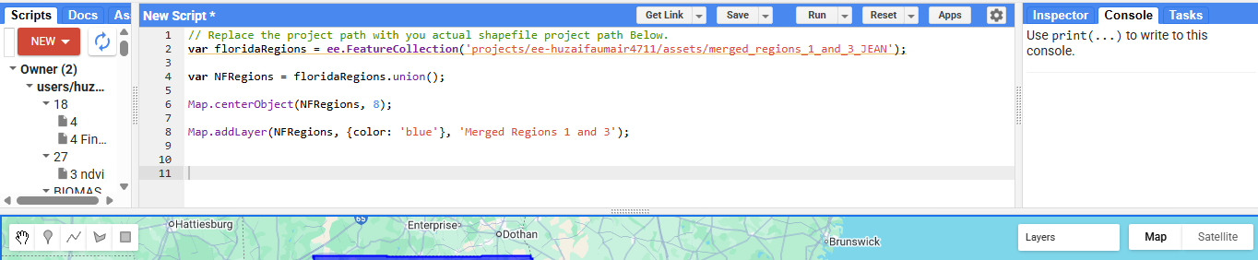

Figure 3: GEE console with code used to import and view the shapefile of North Florida

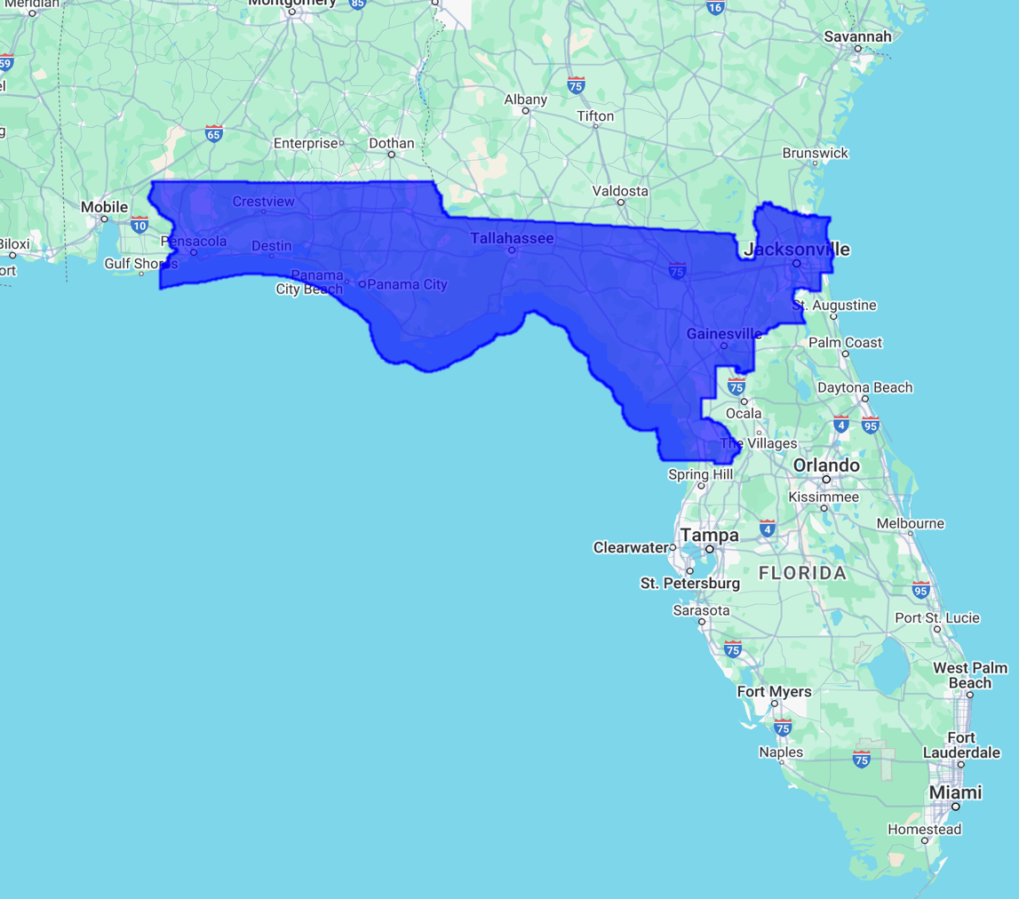

Legend
North Florida
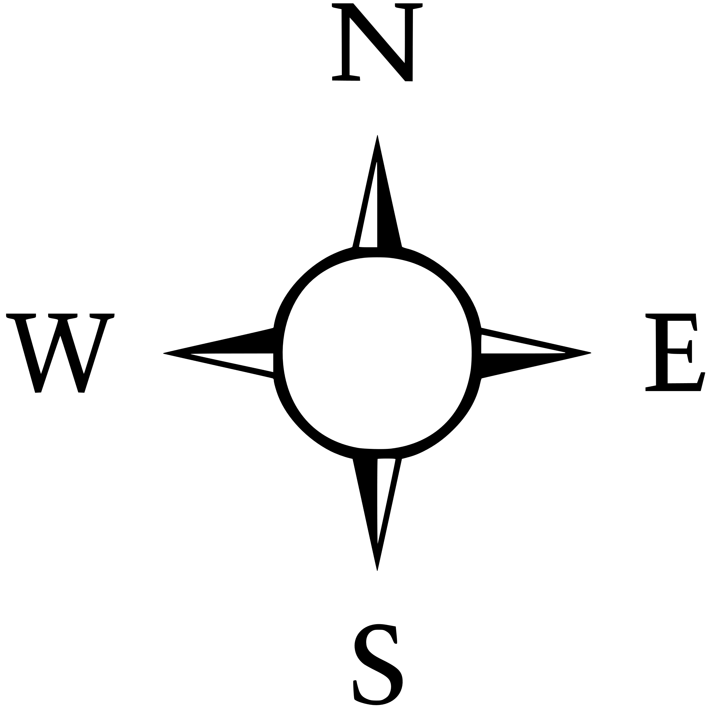
Figure 4: Shapefile of North Florida on Google Earth Engine

After carrying out this step, answer the following questions:
1. Why is it important to use authoritative data sources?
2. What challenges, if any, did you encounter while importing and loading the shapefile to GEE?
3. What file formats are required to successfully import a shapefile into GEE?
4. What additional information/attributes can be derived from the shapefile once it is imported to GEE?

Part 2: Processing Landsat-9 and Sentinel-2 Imagery

Objective
The objective of this exercise is twofold:
- Acquire Landsat-9 and Sentinel-2 imagery for North Florida to analyze vegetation health and canopy cover changes caused by the May 10, 2024 tornado.
- Calculate and analyze NDVI (Normalized Difference Vegetation Index) using the pre-event and post-event imagery to quantify vegetation health and assess tornado impacts.
Students will gain hands-on experience in accessing and preparing remote sensing data, calculating vegetation indices, and interpreting ecological changes in response to extreme weather events.

Skills Developed
- Searching for and filtering satellite imagery datasets in Google Earth Engine (GEE).
- Understanding key parameters of satellite imagery, such as spatial resolution, temporal coverage, and spectral bands.
- Using the GEE code editor to filter imagery by date range, cloud cover, and region of interest.
- Preparing satellite data for vegetation index calculations.
- Calculating NDVI from Landsat-9 and Sentinel-2 datasets.
- Comparing pre- and post-event NDVI imagery to assess vegetation disturbance.
- Visualizing NDVI results in GEE and interpreting vegetation patterns.

Background
Satellite imagery is freely available through organizations such as NASA, ESA, and Google. The Landsat program, managed by NASA and the USGS, provides a long-term archive of medium-resolution imagery, with Landsat-9 particularly suited for vegetation monitoring. Sentinel-2, operated by the European Space Agency, offers higher spatial resolution and additional spectral bands useful for vegetation analysis.
Google Earth Engine serves as the platform for this exercise, enabling access, processing, and analysis of satellite imagery without requiring local downloads.

NDVI Overview
NDVI is a widely used vegetation index calculated as:
NDVI = (NIR-Red)
(NIR+Red)

Values range from -1 to 1. Higher values indicate healthy, dense vegetation, while lower values represent sparse, stressed, or absent vegetation. NDVI maps are typically visualized using a red–yellow–green scale, with red indicating negative values, yellow near 0, and green representing healthy vegetation.
By comparing NDVI before and after the tornado, areas of significant vegetation loss or recovery can be identified.

Workflow
- Search for datasets: Locate Landsat-9 and Sentinel-2 collections in GEE, reviewing spectral bands, spatial resolution, and temporal coverage.
- Filter imagery: Select imagery within the study region and desired date ranges, applying filters for cloud cover and other quality indicators.
- Load and visualize imagery: Display Landsat-9 and Sentinel-2 images in GEE for initial inspection.
- Calculate NDVI: Use the red and NIR bands to compute NDVI for each satellite and time period.
- Visualize NDVI maps: Generate NDVI layers for pre-event and post-event periods.
- Create change maps: Subtract pre-event NDVI from post-event NDVI to highlight areas of vegetation loss, recovery, or stability.
- Interpret results: Examine NDVI outputs to assess canopy disturbance caused by the tornado.

Data Considerations
Cloud-free imagery may be limited due to weather conditions and sensor constraints. Filtering for dates with minimal cloud coverage is essential, and multiple scenes may be merged to improve results. Cloud masks are applied to remove clouds, shadows, and haze, ensuring reliable NDVI calculations.

Part 2.1: Landsat-9
To select the appropriate Landsat 9 imagery, use the search bar at the top of the screen and type in the exact image collection required. Search for ‘LANDSAT/LC09/C02/T1_L2’ to acquire Landsat 9 data. A pop-up screen will appear with a complete description of the selected collection. Before proceeding, take a moment to review the collection’s available bands and properties to understand what type of data it provides. Then, copy the file path provided on the left-hand side and load it into the GEE work pad.
Step 1: Select Land Areas Using ESA WorldCover 2021
The ESA WorldCover 2021 map is used to exclude water bodies from the analysis. This keeps the focus on land regions, which is essential when studying vegetation and land cover changes.

// Load ESA WorldCover 2021 landcover map to mask out water regions
var landcover = ee.Image("ESA/WorldCover/v200/2021").select('Map');

// Create mask to exclude water pixels (class 80)
var landMask = landcover.neq(80);

Step 2: Define Cloud and Artifact Removal Function
A custom function is applied to remove clouds, shadows, snow, and cirrus clouds using the QA_PIXEL band. This process cleans the Landsat imagery so that only clear, usable pixels remain.

// Function to mask clouds, cirrus, shadows, and snow using QA_PIXEL bitmask band.

function maskL8sr(image) {
var qa = image.select('QA_PIXEL');
var DilatedCloud = (1 << 1);
var Cirrus = (1 << 2);
var cloudShadowBitMask = (1 << 3);
var snowBitMask = (1 << 4);
var cloudBitMask = (1 << 5);
var cirrusBitMask = (1 << 7);

// Keep only clear pixels (bits = 0)
var mask = qa.bitwiseAnd(cloudShadowBitMask).eq(0)
.and(qa.bitwiseAnd(snowBitMask).eq(0))
.and(qa.bitwiseAnd(cloudBitMask).eq(0))
.and(qa.bitwiseAnd(cirrusBitMask).eq(0))
.and(qa.bitwiseAnd(DilatedCloud).eq(0))
.and(qa.bitwiseAnd(Cirrus).eq(0));

// Apply cloud mask + water mask to remove clouds and water bodies
return image.updateMask(mask).updateMask(landMask);
}

Step 3: Set Time Range for Pre- and Post-Event
Two date ranges are defined before and after the event of interest. These periods provide a basis for comparing land conditions and detecting changes that occurred between them.

// Define pre- and post-event time ranges
var pre_from = '2024-01-01';
var pre_to = '2024-05-09';
var post_from = '2024-05-10';
var post_to = '2024-10-31';

Step 4: Extract and Prepare Landsat-9 Imagery
A function is applied to collect Landsat-9 imagery for the defined region and time range. It uses cloud and water masks, filters scenes by cloud cover, and generates a clean composite image. The filter (filterMetadata('CLOUD_COVER', 'less_than', 50)) is used to select images with less than 50% clouds.

// Function to create median Landsat composite images collection with cloud and water masking

function getComposite(from, to) {
return ee.ImageCollection('LANDSAT/LC09/C02/T1_L2')
.filterBounds(NFRegions) // AOI filter
.filterDate(from, to) // Date range
.filterMetadata('CLOUD_COVER', 'less_than', 50) // Cloud cover filter
.filterMetadata('CLOUD_COVER_LAND', 'less_than', 50) // Cloud cover filter
.map(maskL8sr) // Apply mask function
.median() // Composite image with median
.clip(NFRegions) // Clip to AOI
.multiply(0.0000275).add(-0.2); // Apply reflectance scaling
}

Step 5: Generate Pre- and Post-Event Composites
The image extraction function is used to create two composite images: one for the pre-event period and another for the post-event period. These composites provide clean datasets ready for further analysis.

// Build pre- and post-event composites and apply function on it
var pre = getComposite(pre_from, pre_to);
var post = getComposite(post_from, post_to);

Step 6: Calculate NDVI for Both Periods
NDVI is computed for the pre-event and post-event composite images. This index measures vegetation health by comparing reflectance in the red and near-infrared bands, allowing changes in canopy condition to be quantified.

// Compute NDVI for pre- and post-event composites
var ndvi_pre = pre.normalizedDifference(['SR_B5','SR_B4']).rename('NDVI_pre');
var ndvi_post = post.normalizedDifference(['SR_B5','SR_B4']).rename('NDVI_post');

Step 7: Detect NDVI Change
A change map is generated by subtracting pre-event NDVI values from post-event NDVI values. This highlights areas where vegetation has either increased or decreased over time, providing clear insights into disturbance and recovery patterns.

// Compute NDVI change (post − pre) post subtract to pre
var ndvi_change = ndvi_post.subtract(ndvi_pre).rename('NDVI_change');

Step 8: Set Visualization Parameters
Color settings are applied to the RGB composites, NDVI layers, and NDVI change map. These visualization parameters ensure that the outputs are clear, interpretable, and effective for highlighting vegetation conditions and changes.

// Visualization parameters for RGB, NDVI, and change detection
var rgbVis = {bands: ['SR_B4','SR_B3','SR_B2'], min: 0, max: 0.3};
var ndviVis = {min: -1, max: 1, palette: ['red','yellow','darkgreen']};
var changeVis = {min: -0.5, max: 0.5, palette: ['darkred', 'red', 'firebrick', 'yellow', 'green', 'darkgreen']};

Step 9: Display Layers on the Map
All layers, including pre- and post-event composites, NDVI, and the NDVI change map, are added to the map and centered over the region of interest. This provides an integrated view for easy visualization and interpretation.

// Adding all layers on map of composites, NDVI, and NDVI change
Map.centerObject(NFRegions, 8);
Map.addLayer(pre, rgbVis, 'Pre Landsat RGB (masked)');
Map.addLayer(ndvi_pre, ndviVis, 'NDVI Pre (Landsat)');
Map.addLayer(post, rgbVis, 'Post Landsat RGB (masked)');
Map.addLayer(ndvi_post, ndviVis, 'NDVI Post (Landsat)');
Map.addLayer(ndvi_change, changeVis, 'NDVI Change (Landsat)');

Step 10: Calculate Vegetation Area Before and After the Event
A script is created to estimate the area of vegetation and non-vegetation for both the pre-event and post-event periods. A threshold value of NDVI > 0.3 is used to classify healthy vegetation, while NDVI < 0.3 is classified as no vegetation. This threshold can be adjusted for specific study requirements, but 0.3 is commonly applied as an indicator of healthy vegetation.

// Threshold NDVI: 1 = vegetation, 0 = non-vegetation
var veg_pre = ndvi_pre.gte(0.3).rename('veg_pre');
var veg_post = ndvi_post.gte(0.3).rename('veg_post');

// Pixel area in hectares
var pixelArea = ee.Image.pixelArea().divide(10000).rename('area'); // ha

// Vegetation area images
var area_pre = veg_pre.multiply(pixelArea).rename('veg_area_pre');
var area_post = veg_post.multiply(pixelArea).rename('veg_area_post');

var totalArea = pixelArea.reduceRegion({
reducer: ee.Reducer.sum(),
geometry: NFRegions,
scale: 30,
maxPixels: 1e13,
}).getNumber('area');

// Vegetation area pre-event
var stats_pre = area_pre.reduceRegion({
reducer: ee.Reducer.sum(),
geometry: NFRegions,
scale: 30,
maxPixels: 1e13,
}).getNumber('veg_area_pre');

// Vegetation area post-event
var stats_post = area_post.reduceRegion({
reducer: ee.Reducer.sum(),
geometry: NFRegions,
scale: 30,
maxPixels: 1e13,
}).getNumber('veg_area_post');

// Percentages
var vegPct_pre = stats_pre.divide(totalArea).multiply(100);
var vegPct_post = stats_post.divide(totalArea).multiply(100);

print('Vegetation % Pre-event:', vegPct_pre);
print('Vegetation % Post-event:', vegPct_post);
print('Non-vegetation % Pre-event:', ee.Number(100).subtract(vegPct_pre));
print('Non-vegetation % Post-event:', ee.Number(100).subtract(vegPct_post));
Take a moment to explore the map, turn layers on and off, zoom in etc. Then answer the following questions:

5. Why is it necessary to filter imagery by date range and cloud cover?
6. Why were specific bands chosen leaving out others?
7. What does NDVI reveal about vegetation health in the pre- and post-tornado periods?
8. What patterns or trends are evident in the NDVI change map?
9. Why are we seeing more green in some areas even after the tornado?

Output for Landsat-9 Results
The processed Landsat-9 imagery provides composite outputs for both the pre-event and post-event periods. After applying cloud and water masking, NDVI was calculated to assess vegetation health. The resulting maps highlight areas of vegetation loss and recovery, with NDVI > 0.3 classified as healthy vegetation and NDVI < 0.3 classified as no vegetation.
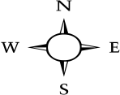
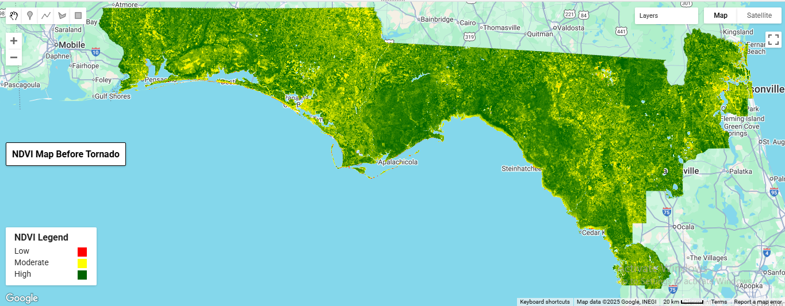
Figure 5: NDVI map from Landsat-9 before the tornado event in North Florida.
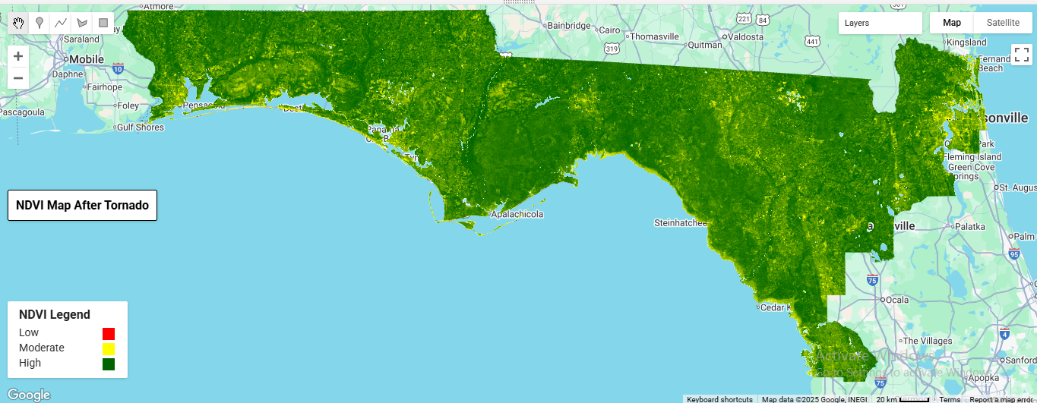
Figure 6: NDVI map from Landsat-9 after the tornado event in North Florida.

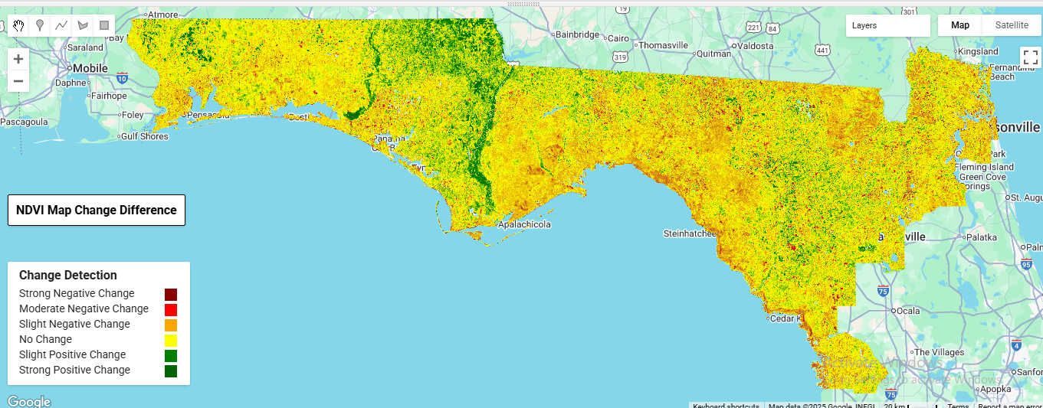
Figure 7: NDVI change difference map from Landsat-9 before and after the tornado event in North Florida.

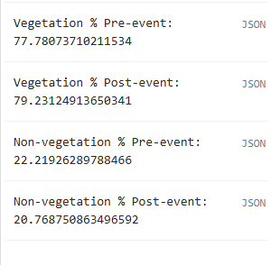
Figure 8. Percentage of vegetation and non-vegetation before and after the tornado event in North Florida, derived from NDVI analysis.
Part 2.2: Sentinel-2
To select the appropriate Sentinel-2 imagery, use the search bar at the top of the screen and type in the required image collection. Search for ‘COPERNICUS/S2_SR_HARMONIZED’ to access Sentinel-2 surface reflectance data. A pop-up screen will display a full description of the collection. Copy the file path shown on the left-hand side and load it into the GEE workpad.

Step 1: Select Land Areas Using ESA WorldCover 2021
The ESA WorldCover 2021 map is used to exclude water bodies from the analysis. This ensures that only land regions are included, which is essential when studying vegetation and land cover changes.

// Load ESA WorldCover 2021 landcover map to mask out water regions
var landcover = ee.Image("ESA/WorldCover/v200/2021").select('Map');

// Create mask to exclude water pixels (class 80)
var landMask = landcover.neq(80);

Step 2: Define Cloud and Artifact Removal Function
A custom function is applied to remove clouds, shadows, snow, and cirrus clouds using the QA60 band. This step ensures that the Sentinel-2 imagery is cleaned so that only clear and usable pixels remain for analysis.

// Function to mask Cloud using Sentinel-2 QA60 band (cloud and cirrus bits)

function maskQA60(image) {
var qa = image.select('QA60');
var cloudBitMask = 1 << 10; // bit 10 = clouds
var cirrusBitMask = 1 << 11; // bit 11 = cirrus
var maskCloud = qa.bitwiseAnd(cloudBitMask).eq(0)
.and(qa.bitwiseAnd(cirrusBitMask).eq(0));
// Apply cloud mask + water mask to remove clouds and water bodies
return image.updateMask(maskCloud).updateMask(landMask).divide(10000);
}

// Additional cloud/shadow mask using Sentinel-2 Scene Classification (SCL)

function sclmask (image) {
var scl = image.select('SCL');
// Mask out clouds, shadows, cirrus, and snow (classes 3,8,9,10)
var cloudMask = scl.neq(3).and(scl.neq(8)).and(scl.neq(9)).and(scl.neq(10));
// Apply SCL-based mask
return image.updateMask(cloudMask);
}
Step 3: Set Time Range for Pre- and Post-Event
Two date ranges are defined before and after the event of interest. These periods provide the temporal basis for comparing land conditions and detecting changes that occurred between them.

// Define pre- and post-event time ranges
var pre_from = '2024-01-01';
var pre_to = '2024-05-09';
var post_from = '2024-05-10';
var post_to = '2024-10-31';

Step 4: Extract and Prepare Sentinel-2 Imagery
A function is applied to collect Sentinel-2 imagery for the defined region and time range. It uses cloud and water masks, filters scenes by cloud cover, and generates a clean composite image. The filter (filterMetadata('CLOUDY_PIXEL_PERCENTAGE', 'less_than', 50)) is applied to select images with less than 50% cloud coverage.

// Function to create median Sentinelcomposite images collection with cloud and water masking

function getComposite(from, to) {
return ee.ImageCollection('COPERNICUS/S2_SR_HARMONIZED')
.filterBounds(NFRegions) // AOI filter
.filterDate(from, to) // Date range
.filterMetadata('CLOUDY_PIXEL_PERCENTAGE', 'less_than', 50)// Cloud cover filter
.map(maskQA60)// mask out clouds
.map(sclmask)// mask out clouds
.median().clip(NFRegions);// Composite image with median
}

Step 5: Generate Pre- and Post-Event Composites
The image extraction function is used to create two separate composite images: one for the pre-event period and another for the post-event period. These composites provide clean datasets that are ready for further analysis.

// Build pre- and post-event composites and apply function on it
var pre = getComposite(pre_from, pre_to);
var post = getComposite(post_from, post_to);

Step 6: Calculate NDVI for Both Periods
NDVI is calculated for the pre-event and post-event composite images. This index measures vegetation health by comparing reflectance in the red and near-infrared bands, allowing changes in vegetation condition to be quantified.

// Compute NDVI for pre- and post-event composites

var ndvi_pre = pre.normalizedDifference(['B8','B4']).rename('NDVI_pre');
var ndvi_post = post.normalizedDifference(['B8','B4']).rename('NDVI_post');

Step 7: Detect NDVI Change
A change map is generated by subtracting pre-event NDVI values from post-event NDVI values. This highlights areas where vegetation has increased or decreased over time, providing a clear picture of disturbance and recovery patterns.

// Compute NDVI change (post − pre) post subtract to pre
var ndvi_change = ndvi_post.subtract(ndvi_pre).rename('NDVI_change');

Step 8: Set Visualization Parameters
Color settings are applied to the RGB composites, NDVI layers, and the NDVI change map. These visualization parameters make the outputs clear and easy to interpret, ensuring that vegetation conditions and changes are effectively highlighted.

// Visualization parameters for RGB, NDVI, and change detection
var rgbVis = {bands: ['B4','B3','B2'], min: 0, max: 0.3};
var ndviVis = {min: -1, max: 1, palette: ['red','yellow','darkgreen']};
var changeVis = {min: -0.5, max: 0.5, palette: ['darkred', 'red', 'firebrick', 'yellow', 'green', 'darkgreen']};

Step 9: Display Layers on the Map
All layers, including pre- and post-event composites, NDVI, and the NDVI change map, are added to the map and centered over the region of interest. This provides an integrated view for straightforward visualization and interpretation.

// Adding all layers on map of composites, NDVI, and NDVI change
Map.centerObject(NFRegions, 8);
Map.addLayer(pre, rgbVis, 'Pre True Color',false);
Map.addLayer(ndvi_pre, ndviVis, 'NDVI Pre',false);
Map.addLayer(post, rgbVis, 'Post True Color',false);
Map.addLayer(ndvi_post, ndviVis, 'NDVI Post',false);
Map.addLayer(ndvi_change, changeVis, 'NDVI Change',false);

Step 10: Calculate Vegetation Area Before and After the Event
A script is created to estimate the area of vegetation and non-vegetation for both the pre-event and post-event periods. An NDVI threshold of >0.3 is used to classify healthy vegetation, while values < 0.3 are classified as no vegetation. This threshold can be adjusted depending on the specific study, but 0.3 is commonly applied as a benchmark for healthy vegetation.

// Threshold NDVI: 1 = vegetation, 0 = non-vegetation
var veg_pre = ndvi_pre.gte(0.3).rename('veg_pre');
var veg_post = ndvi_post.gte(0.3).rename('veg_post');

// Pixel area in hectares
var pixelArea = ee.Image.pixelArea().divide(10000).rename('area'); // ha

// Vegetation area images
var area_pre = veg_pre.multiply(pixelArea).rename('veg_area_pre');
var area_post = veg_post.multiply(pixelArea).rename('veg_area_post');

var totalArea = pixelArea.reduceRegion({
reducer: ee.Reducer.sum(),
geometry: NFRegions,
scale: 30,
maxPixels: 1e13,
}).getNumber('area');

// Vegetation area pre-event
var stats_pre = area_pre.reduceRegion({
reducer: ee.Reducer.sum(),
geometry: NFRegions,
scale: 30,
maxPixels: 1e13,
}).getNumber('veg_area_pre');

// Vegetation area post-event
var stats_post = area_post.reduceRegion({
reducer: ee.Reducer.sum(),
geometry: NFRegions,
scale: 30,
maxPixels: 1e13,
}).getNumber('veg_area_post');

// Percentages
var vegPct_pre = stats_pre.divide(totalArea).multiply(100);
var vegPct_post = stats_post.divide(totalArea).multiply(100);

print('Vegetation % Pre-event:', vegPct_pre);
print('Vegetation % Post-event:', vegPct_post);
print('Non-vegetation % Pre-event:', ee.Number(100).subtract(vegPct_pre));
print('Non-vegetation % Post-event:', ee.Number(100).subtract(vegPct_post));

Output for Sentinel-2 Results
The processed Sentinel-2 imagery provides composite outputs for both the pre-event and post-event periods. After applying cloud and water masking, NDVI was calculated to assess vegetation health. The results highlight differences in vegetation cover and condition before and after the tornado event in North Florida, using the same NDVI threshold (> 0.3 for healthy vegetation and < 0.3 for no vegetation).

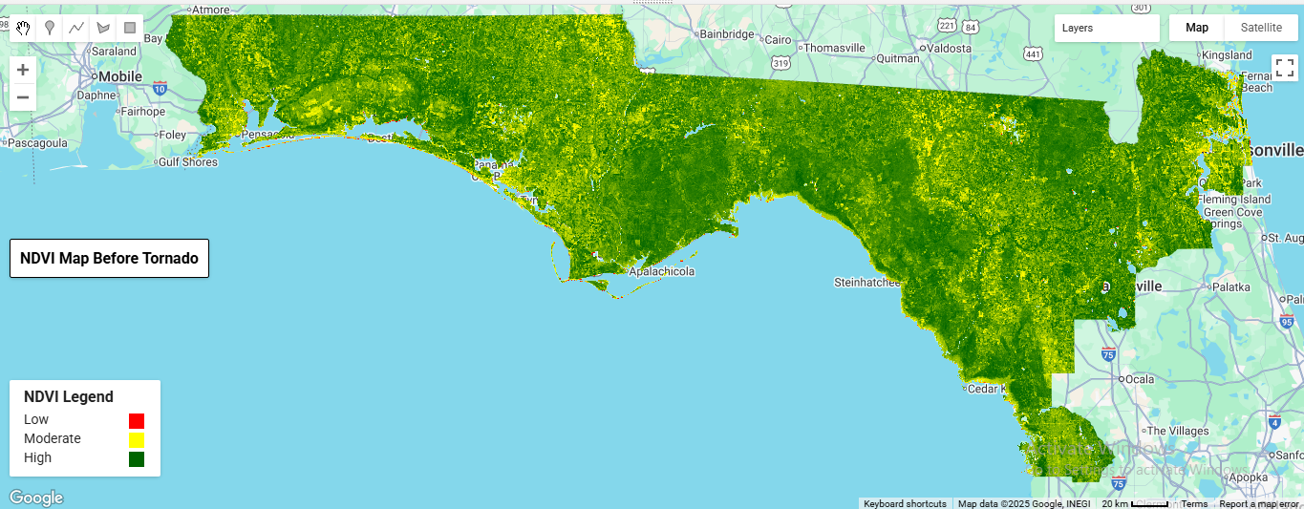
Figure 9: NDVI map from Sentinel-2 before the tornado event in North Florida.

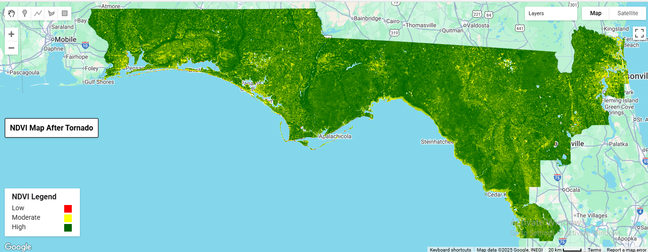
Figure 10: NDVI map from Sentinel-2 after the tornado event in North Florida.

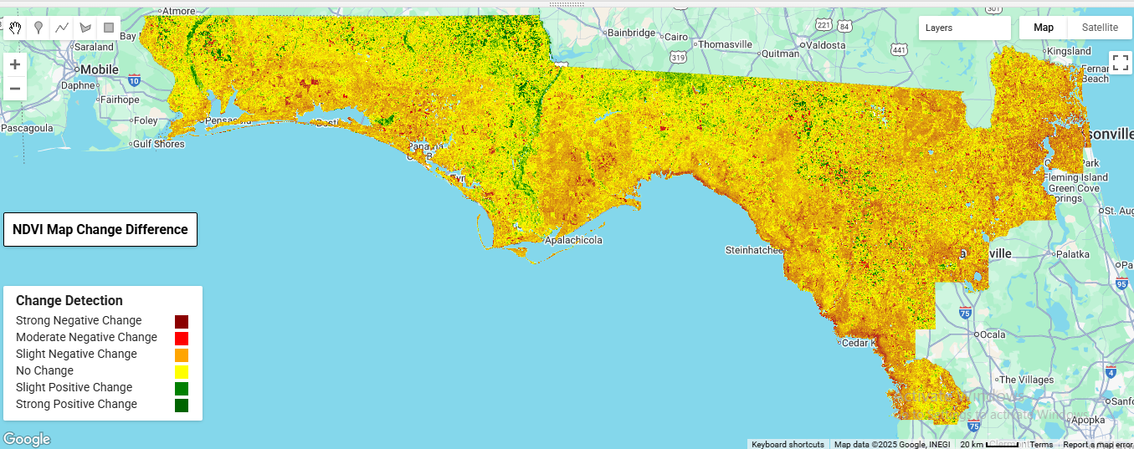
Figure 11. NDVI change map from Sentinel-2 before and after the tornado event in North Florida.

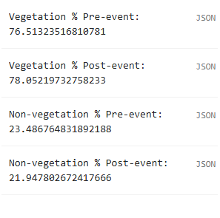
Figure 12: Percentage of vegetation and non-vegetation before and after the tornado event in North Florida, derived from Sentinel-2 NDVI analysis.

Take a moment to explore the map, turn layers on and off zoom in etc. then answer the following questions:

10. What does NDVI reveal about vegetation health in the pre- and post-tornado periods?
11. What patterns or trends are evident in the NDVI change map?
12. How does NDVI greenness differ between Landsat-9 and Sentinel-2 imagery?
13. How do the resolution differences between Landsat-9 and Sentinel-2 influence the results?
14. What are the advantages and limitations of using Landsat-9 and Sentinel-2 for tornado damage assessment?

End of activity questions
15. How could you use what you learned to work on disaster response to gauge recovery in the years after a tornado?
16. Given what you have learned, how could you evaluate the impact of fires over 1 year in a larger region like the state of California?
17. What are the implications of this change in vegetation for ecosystem services and climate resilience.
18. What are the ways tornados may impact people through their influence on forest communities?
19. Look at your maps. Does it appear that all areas were equally impacted by tornados, or were some regions impacted more than others? Who are some possible stakeholders, and how might spatial variation impact stakeholders differently?

Notes to Faculty
Part I
This part explores the acquisition of shapefiles of study areas to aid in further data acquisition, processing and visualization. Faculty should make sure that students have a strong understanding of credible sources to use for acquiring shapefiles and that the shapefiles contain all the required file extensions required for successful integration into various processing software. To evaluate students at this level, look for skills such as identifying and sourcing shapefiles from credible sources, verifying that shapefiles include essential components (.shp, .shx, .dbf, .prj) and successfully importing shapefiles into Google Earth Engine for further analysis. It is important to note that faculty are required to have prior experience with GEE and GIS. It would also be beneficial for faculty to have coding experience so they can effectively support students when troubleshooting code that doesn’t run correctly on the first attempt. However, for first time users, a GEE account needs to be created to facilitate successful access to the platform’s full functionality. Faculty should guide students through the process of creating a Google Earth Engine (GEE) account by visiting https://signup.earthengine.google.com/. Account approval usually takes a few days and is sent via email. Once approved, access to the GEE Code Editor at https://code.earthengine.google.com/ will be granted and instructors can begin uploading and analyzing geospatial data. Instructors should ensure that students do this well in advance since the approval takes a few days.

Recommendations
Use date ranges close to the tornado event to isolate storm impacts; longer windows tend to capture seasonal vegetation dynamics rather than tornado effects. Focus analysis on regions directly hit by the tornado instead of comparing the entire county. Expect that some areas may appear greener after the event because of crop cycles or early vegetation recovery, while other areas will show loss of NDVI consistent with tree fall and vegetation damage. If too few images are available because of clouds and cloud masking, you may expand the date range slightly to fill gaps, but balance this carefully to avoid seasonal bias.

ADDITIONAL RESOURCES
Chuvieco, E. 2020. Fundamentals of Satellite Remote Sensing, CRC Press eBooks. Informa. Available at: https://doi.org/10.1201/9780429506482.

Suggested answers to the questions posed in this activity are below:
1. Why is it important to use authoritative data sources?
Authoritative sources are usually vetted for validity and accuracy ensuring that the data acquired is correct and trustworthy.
2. What challenges, if any, did you encounter while importing and loading the shapefile to GEE?
This is open-ended but some possible issues could include: file size limitations, file format, projection mismatch, corrupted files etc.
3. What file formats are required to successfully import a shapefile into GEE?
All shapefiles should include the following formats to be successfully uploaded on Google Earth Engine; extensions .shp, .shx, .dbf, .prj or .zip.
4. What additional information/attributes can be derived from the shapefile once it is imported to GEE?
Additional information/attributes that can be derived from shapefiles once imported to GEE include buffer zones, spatial relationships, statistical summaries, area/perimeter and classifications.
5. Why is it necessary to filter imagery by date range and cloud cover?
It is important to filter imagery by date range and cloud cover because clouds can significantly obstruct the view of the Earth making the acquired data inaccurate. Date ranges on the other hand enable the capture of changes and seasonal variations over specific times.
6. Why were specific bands chosen leaving out others?
For Landsat, the bands used were B2, B3, B4 and for Sentinel these were 'SR_B4', 'SR_B2’ and 'SR_B3’. These bands were filtered leaving out the rest because they are close to the visible spectrum, meaning that they can create natural color images that resemble what the human eye sees. Also, these bands are useful in vegetation monitoring and calculation of vegetation indices such as the Normalized Difference Vegetation Index (NDVI).
7. What does NDVI reveal about vegetation health in the pre- and post-tornado periods?
A visual analysis of the Landsat 9 and Sentinel-2 NDVI maps shows a decline in greenness following the tornado. This suggests a loss of canopy cover, indicating a negative impact on vegetation health.
8. What patterns or trends are evident in the NDVI change map?
The NDVI change maps for both Landsat-9 and Sentinel-2 imageries reveal there was negative change after the tornado in some part of North Florida signifying canopy cover loss as well.
9. Why are we seeing more green in some areas even after the tornado?
The main factor is the date range selected.
If the pre- and post-event periods are too long, the results mainly reflect seasonal NDVI changes (e.g., vegetation growth from spring to summer) rather than tornado damage.
To properly capture tornado impact, the pre/post windows should be kept short and close to the event date, minimizing seasonal influence.
Additionally, some areas may genuinely show an increase in NDVI after the tornado due to rapid regrowth of vegetation, crop cycles, or seasonal leaf expansion, which can mask localized damage in the composite.
10. What does NDVI reveal about vegetation health in the pre- and post-tornado periods?
A visual analysis of the Landsat 9 and Sentinel-2 NDVI maps shows a decline in greenness following the tornado. This suggests a loss of canopy cover, indicating a negative impact on vegetation health.
11. What patterns or trends are evident in the NDVI change map?
-The NDVI change maps for both Landsat-9 and Sentinel-2 imageries reveal there was a negative change after the tornado in some parts of North Florida, signifying canopy cover loss as well.
12. How does NDVI greenness differ between Landsat-9 and Sentinel-2 imagery?
-Landsat 9 NDVI maps appear to have a darker shade of green compared to Sentinel-2 NDVI maps.

13. How do the resolution differences between Landsat-9 and Sentinel-2 influence the results?
Sentinel-2, with its higher resolution, captures finer details and smaller vegetation patches, leading to more mixed pixels and potentially lower overall NDVI values in some areas. Given this, the Sentinel-2 NDVI maps have a lighter green pigment compared to the Landsat 9
14. What are the advantages and limitations of using Landsat-9 and Sentinel-2 for tornado damage assessment?
An advantage of Landsat 9 is that it has improved data quality and resolution compared to the previous Landsat satellites. Also, it has an additional band, B9, specifically designed to detect cirrus clouds, improving cloud masking. However, Landsat 9 (just like the other Landsat satellites) has a 30m spatial resolution, which is not sufficient for investigating the effects of natural disasters such as tornadoes. Lastly, Landsat 9 lacks very high spectral resolution bands useful for detecting specific atmospheric gases.
An advantage of Sentinel 2 is that it has a finer spatial resolution of 10m making it ideal for monitoring natural disasters like tornadoes. Also, it has more spectral bands (13 in total) useful for vegetation health assessment using indices such as NDVI. Nonetheless, Sentinel 2 is heavily affected by clouds and haze, making it unreliable during days affected by natural disasters. Lastly, unlike Landsat 9, Sentinel 2 lacks a thermal infrared band effective for land surface temperature monitoring and analysis of natural disasters.
Given the shortcomings of Landsat 9 and Sentinel, advancements have enabled the integration of both satellites to create the Harmonized Landsat Sentinel-2 (HLS) with enhanced capabilities for environmental studies.
15. How could you use what you learned to work on disaster response to gauge recovery in the years after a tornado?
You could basically follow the same procedure in this activity but check back over time. For example, every month.
16. Given what you have learned, how could you evaluate the impact of fires over 1 year in a larger region like the state of California?
You could find the correct map files with many time small spans, you would then need to explore for changes in NDVI, which could be indicative of a fire event. (If you could use more than 1 data set, like in this activity it would be helpful.) You would need to verify that those changes in reflectance are due to fires at that time.
17. What are the implications of this change in vegetation for ecosystem services and climate resilience.
Some of the implications include:
    - Damaged vegetation directly affects habitats, threatening local species that depend on forest cover for shelter, food, and migration corridors.
    - Increased soil erosion because without plant roots to anchor soil, wind and rain erode topsoil, decreasing soil fertility and increasing sedimentation in rivers and wetlands.
    - Tornado-induced vegetation loss reduces the ability to absorb atmospheric CO₂, weakening its role in carbon sequestration.

18. What are the ways tornadoes may impact people through their influence on forest communities?
There are many possible answers. For example, there could be a loss of ecosystem services (like carbon storage), destruction of a park, the loss of timber, loss of habitat for animals, etc. Students should recognize the effects of tornadoes on forest communities are very localized and therefore have localized impacts on people.
19. Look at your maps. Does it appear that all areas were equally impacted by tornadoes, or were some regions impacted more than others? Who are some possible stakeholders, and how might spatial variation impact stakeholders differently?

There are many possible answers. Some regions were impacted more by tornadoes than others. Logistics and socioeconomic factors may also play a role in the impact a tornado has on people. For example, the trees being decimated in a park in an urban area might have a greater impact on the quality of life for people there than losing an area of national forest outside of town. The effects of tornadoes on forest communities will have different implications for different stakeholders.

EF-2 tornadoes are classified on the Enhanced Fujita (EF) scale with wind speeds of 111–135 mph, capable of uprooting large trees, damaging roofs, and causing considerable structural impacts.

