ISSUES: FIGURE SET
Patterns and processes in landscape ecology: land use interactions with stream fish communities across scales
Lauren Stoczynski
Department of Biological Sciences, Purdue University, West Lafayette, IN 47907
Corresponding author: Lauren Stoczynski (lstoczyn@purdue.edu)

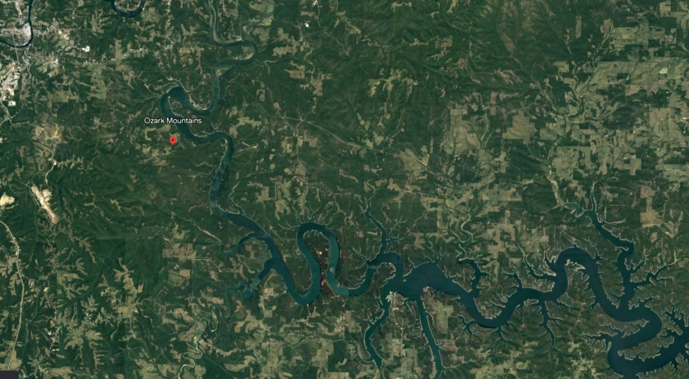

Screenshot from Google Earth that shows the Ozark mountains, streams, and surrounding landscape
THE ISSUE:
One fourth of vertebrate species are found in freshwaters and over half of known fish species (~18,000) are found in freshwaters. However, freshwater is limited with less than 1% of all water on the globe being freshwater. Thus, human pressures imperil aquatic life for use of freshwater and the surrounding landscape. What land use pressures are most impactful to freshwater streams? How do these land use pressures change the diversity of fish communities?
FOUR DIMENSIONAL ECOLOGY EDUCATION (4DEE) FRAMEWORK
- Core Ecological Concepts:
  - Organisms
    - Life histories
  - Communities
    - Aquatic
    - Biodiversity
- Ecology Practices:
  - Quantitative reasoning
    - Data analysis and interpretation
    - Computer skills: spreadsheets
  - Designing investigations
    - Question development
- Human-Environment Interactions:
  - How humans shape the environment
    - Land use gradients
- Cross-cutting Themes:
  - Spatial & Temporal

STUDENT-ACTIVE APPROACHES:
Think-pair-share, gallery walk, sketching conceptual figures
STUDENT ASSESSMENTS:
Comparison of conceptual figures, short answer for synthesis and application questions

CLASS TIME:
The figure set could be broken up between two class periods, used in one class period, or within a lab setting. The background information and pre-class activity could be used for one day or as homework before the in-class activity. The in-class activity can work with one class period or adjusted as needed. There is a homework assignment that could be included in the in-class activity if using the figure set with a longer time frame such as a lab setting.

COURSE CONTEXT:
This Figure set is suggested for undergraduate students who are towards the end of an introductory ecology course or within an upper-level general ecology, freshwater ecology, ichthyology, or related topic course. The readings and exercises draw on ecological concepts that students should have already learned and provide a chance for critical thinking and analysis skills in understanding how landscape and scale can affect stream fish communities. A glossary is given for students to refresh any terminology knowledge. In this figure set, students examine data from studies in Hungary and the Ozark region (Southern Missouri, Northern/Central Arkansas) to examine land use effects on stream fish. The homework assignment focuses on road crossings as a proxy for urban land cover. The questions guide students to think about the human environment interface throughout the figure set.

ACKNOWLEDGEMENTS:
I would like to thank Chris Beck for his comments on my initial draft, and the reviewer for their thoughtful comments on improving the final version of this figure set. I would also like to thank the students of my Introduction to Ecology and Evolution summer course for being the first to try out the figure set questions to see where improvements need to be made. Inspiration for this figure set stems from (1) my dissertation work on landscape effects on stream fish metacommunities and (2) my postdoc work on students’ abilities to create and interpret graphs in a biological context. This Figure Set was developed as a part of the Teaching with Figures in Ecology Faculty Mentoring Network, which was supported by ESA's Transforming Ecology Education to 4D (TEE) Project with funding from the National Science Foundation (DBI-2120678).
OVERVIEW
WHAT IS THE ECOLOGICAL ISSUE?
One fourth of vertebrate species are found in freshwaters, and over half of known fish species (~18,000) are found in freshwaters. However, freshwater is limited, with less than 1% of all water on the globe being freshwater. Freshwater systems are highly imperiled ecosystems on earth mainly due to their disproportionate use by plants and animals along with the encroachment of human activity through overexploitation, pollution, flow modification, habitat degradation, and invasive species (Dudgeon et al. 2007). Understanding how stream fish communities can differ over varying land use types is of high priority because streams/rivers are complex, scale dependent, and the interactions between fish and the environment are often non-linear (Dudgeon et al. 2007).
Landscape ecology seeks to understand the interactions between ecological patterns and processes across varying spatial scales (Turner, 2005). Within a landscape, patterns can be nested within each other. Many ecological patterns are scale dependent and some properties of communities can change across spatial scales (Heffernan et al. 2014). Stream fishes are great for studying community structure at different spatial scales because streams are linear systems that are structured hierarchically, and the nature of streams creates naturally delineated units (catchments). Thus, spatial scales in streams can be investigated in multiple ways, such as local, riparian, and catchment scales. This lesson includes student investigation with how land use characteristics change stream fish communities, investigation of land use patterns across scales, and investigation for moving beyond land use in understanding how road crossings can be used as a proxy for urbanization impacts on stream fish.

FIGURE SETS TABLE

Figure Set | Student-active Approach | Cognitive Skill
This figure set combines landscape ecology and multiple scales to understand how humans influence stream fish communities. Three sections ask students to examine broad connections between environmental characteristics within different land use types, how scale effects fish communities within land use types, and how specific man-made structures can affect fish communities at a small scale. The study regions are broadly Europe and the United States and Hungary streams and Ozark streams more specifically. | Think-Pair-Share  Gallery Walk | Comprehension, Application, Evaluation, Synthesis

Learning Objectives:
  - Predict how humans cause changes in diversity across the landscape for aquatic organisms.
  - Explore how a multi-scale approach can create a different interpretation of patterns across the landscape.
  - Analyze figures to describe concepts related to human effects on aquatic communities.
  - Develop additional questions based on scientific reasoning.

Student Assessment:
  - Pre-Class reading: Students have a reading that gives background on ecological terminology and study areas used within the figure set.
  - Pre-class activity: Students use Google Earth to complete an activity looking at patterns across the landscape in relation to a body of water near their hometown. Students start at a local scale and will zoom out twice, thinking about the importance of the patterns they see at each scale.
  - In-Class activity: Students analyze and make predictions on how land use can affect freshwater stream fish diversity within two study systems, one in Europe and one in the USA.
    - Draw graphical predictions for how different land use would change fish community composition.
    - Analyze graphs from data taken over three spatial scales to determine how scale affects interpretation of freshwater fish diversity.
  - Homework assignment: Students dive deeper into how land use affects stream fish by using figures to determine how road crossings affect seasonal fish movement. Could be included in the in-class activity if used in a longer class session such as a lab setting.

FIGURE SET BACKGROUND
This Figure set is suggested for undergraduate students who are towards the end of an introductory ecology course or within an upper-level general ecology, freshwater ecology, ichthyology, or related topic course. The readings and exercises draw on ecological concepts that students should have already learned and provide a chance for critical thinking and analysis skills in understanding how landscape and scale can affect stream fish communities. A glossary is given for students to refresh any terminology knowledge. In this figure set, students examine data from studies in Hungary and the Ozark region (Southern Missouri, Northern/Central Arkansas) to examine land use effects on stream fish. The homework assignment focuses on road crossings as a proxy for urban land cover. The questions guide students to think about the human environment interface throughout the figure set.
Study Areas
Freshwater fish diversity varies greatly around the world and the United States offers diverse freshwater ecosystems, with the Southeastern United States having over 200 species (Jenkins et al. 2015). Europe contains fewer species compared to areas in the United States, but land use impacts can still be compared between the regions.
Within Hungary, the main watershed is from the Danube River, the second largest river in Europe with a catchment area of 796,250 km² and length of 2847 km (Tóth et al. 2019). The river comprises three sections, the upper section is fed by snowmelt from Alpine tributaries. The middle section is fed via some snowmelt, but rainfall is important. The lower section is not fed by snowmelt and relies on upstream flow and rainfall. The river is additionally used for movement of freight, hydroelectricity, water supply, irrigation, and fishing. The land use types within Hungary are predominantly arable fields, followed by orchards, pastures, deciduous forests, and urban areas near villages and cities in smaller portions. The different land use types within this watershed result in differing habitat characteristics throughout the watershed with variation in stream substrate from rocky to silt to concrete. Instream vegetation, slope, and flow also show variation within the Danube watershed (Tóth et al. 2019).
The Ozarks are a region containing several isolated plateaus surrounded by major rivers including the Arkansas River, Missouri River, and Mississippi River. This region covers roughly 130,000 km², representing the largest mountainous region between the Appalachians and Rocky Mountains. Located within five states including Arkansas and Missouri, all Ozark streams exhibit similar cool water characteristics in having high slope with gravel/cobble substrate, low turbidity, and considerable groundwater input (Sievert et al. 2016). The Army Corps of Engineers constructed many dams throughout the Ozarks from 1911 through 1960 for flood control and hydropower generation (Matthews 1982). Roughly 50% of the Ozark’s land is still reported as forested, though agriculture in the form of pastures and urbanization are still found in this region. Species found in the Ozarks also have populations in Appalachia, but the Ozark populations are disjunct from these populations after the end of the last ice age where the northern Ozarks was the southern extent of the glaciers. Thus, this region contains a unique fish assemblage with several endemic species, with recent splits of several species thought to have distribution throughout the Ozark showing three distinct populations based on the watershed (Sievert et al. 2016).

STUDENT INSTRUCTIONS
B
OVERVIEW
WHAT IS THE ECOLOGICAL ISSUE?
One fourth of vertebrate species are found in freshwaters and over half of known fish species (~18,000) are found in freshwaters. However, freshwater is limited, with less than 1% of all water on the globe being freshwater. Freshwater systems are highly imperiled ecosystems on earth mainly due to their disproportionate use by plants and animals along with the encroachment of human activity through overexploitation, pollution, flow modification, habitat degradation, and invasive species (Dudgeon et al. 2007). Understanding how stream fish communities can differ over varying land use types is of high priority because these streams/rivers are complex, scale dependent, and the interactions between fish and the environment are often non-linear (Dudgeon et al. 2007).
Landscape ecology seeks to understand the interactions between ecological patterns and processes across varying spatial scales (Turner, 2005). A pattern also may only be apparent at the appropriate scale. Within a landscape, patterns can occur at many scales and be nested within each other. Many ecological patterns are scale dependent and some properties of communities can change across spatial scales (Heffernan et al. 2014). Stream fishes are great for studying community structure at different spatial scales because streams are linear systems that are structured hierarchically (meaning smaller watersheds are nested within larger watersheds), and the nature of streams creates naturally delineated units (Figure 1). Thus, spatial scale in streams can be investigated in multiple ways. This lesson includes investigation with how land use characteristics change stream fish communities, investigation of land use patterns across scales, and investigation for moving beyond land use in understanding how road crossings can be used as a proxy for urbanization impacts on stream fish.

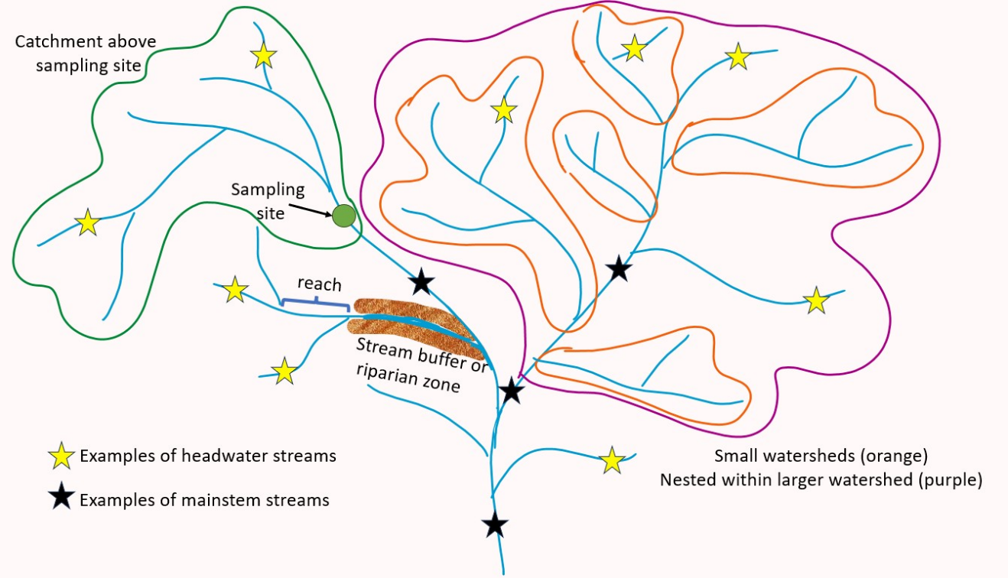
Study Areas
Figure 1: Conceptual figure showing parts of a watershed. Watersheds are hierarchical with smaller watersheds (shown in orange) being nested within a larger watershed (shown in purple), which is nested within the entire watershed shown. Headwaters are where streams originate, examples are marked with yellow stars. Streams come together to form mainstems, which are marked with black stars. The reach scale is a small section of a stream. A buffer zone around a stream can also be referred to as the riparian zone. A catchment above a sampling site is all area of the watershed that drains into that point.
Within Hungary, the main watershed is from the Danube River, the second largest river in Europe with a catchment area of 796,250 km² and length of 2847 km (Tóth et al. 2019). The river comprises three sections, the upper section is fed by snowmelt from Alpine tributaries. The middle section is fed via some snowmelt, but rainfall is important. The lower section is not fed by snowmelt and relies on upstream flow and rainfall. The river is additionally used for movement of freight, hydroelectricity, water supply, irrigation, and fishing. The land use types within Hungary are predominantly arable fields, followed by orchards, pastures, deciduous forests, and urban areas near villages and cities in smaller portions. The different land use types within this watershed result in differing habitat characteristics throughout the watershed with variation in substrate from rocky to silt to concrete bottoms. Instream vegetation, slope, and flow also show variation within Danube watershed (Tóth et al. 2019).
The Ozarks are a region containing several isolated plateaus surrounded by major rivers including the Arkansas River, Missouri River, and Mississippi River. This region covers roughly 130,000 km² representing the largest mountainous region between the Appalachians and Rocky Mountains. Located within five states including Arkansas and Missouri, all Ozark streams exhibit similar cool water characteristics in having high slope with gravel/cobble substrate, low turbidity, and considerable groundwater input (Sievert et al. 2016). The Army Corps of Engineers constructed many dams throughout the Ozarks from 1911 through 1960 for flood control and hydropower generation (Matthews 1982). Roughly 50% of the Ozark’s land is still reported as forested, though agriculture in the form of pastures and urbanization are still found in this region. Species found in the Ozarks also have populations in Appalachia, but the Ozark populations are disjunct from these populations after the end of the last ice age where the northern Ozarks was the southern extent of the glaciers. This region contains a unique fish assemblage with several endemic species, with recent splits of several species thought to have distribution throughout the Ozark showing three distinct populations based on the watershed (Sievert et al. 2016).
Background
Land use and scale
When we study landscape patterns, we use grain and spatial extent to characterize our data. The grain is the resolution of the data (i.e. smallest area of measurement). For example, the grain might be a 0.25 m² quadrat or 100 km² in a study using satellite images. The spatial extent refers to the total area occupied by the dataset. Together the grain and extent of a dataset makeup the scale of the data. Researchers should match the scale of the data with the question of interest. Too coarse a grain might miss the important elements of a pattern, while too small an extent may not capture enough of the pattern of interest for analysis.
Ecologists recognize that global, regional, and fine-scale processes should be integrated to understand community assembly across spatial scales (Fei et al. 2016). Studies investigating multiple scales have suggested the intermediate scale should be investigated to bridge the gap between regional and local processes (Dala-Corte et al. 2019). Studies have used increasing buffer distance around a waterbody (Declerck et al. 2006), the reach, segment, catchment structure of watersheds (Dala-Corte et al. 2019), or uneven scaling between waterbodies and continental scale (Birk et al. 2020). Researchers commonly use the reach (local), segment (riparian buffer), catchment spatial scale classification with streams and rivers, (Figure 1; see also Figure 3 in Allan 2004). The variables across the landscape that directly tie to land use types can vary depending on the scale. At the reach scale, shade from riparian vegetation and water quality parameters might be the most important. As you move to the riparian buffer scale, movement of nutrients can depend on the land use within these buffers. At the catchment scale, land use can dictate the amount of pollution or sediment entering via runoff. How closely the land use in the riparian matches the land use of the catchment can also impact instream conditions (Allan 2004).
You will analyze a series of graphs from Sickler et al. (2018). They investigated how land use is associated with stream fish communities in the Missouri Ozarks. In 2016, 45 sites were sampled in which they found 58 fish species from 12 families. They used the common multiscale approach to assess how land use was associated with fish communities: local scale, which was land use within a few hundred meters of the site, riparian scale, which was the land immediately surrounding the stream segment, and catchment scale, which was land use within the whole watershed that drained into that site. Sites reported between 0 and 75% urbanization at the local scale and 5 to 95% urbanization at the riparian scale and catchment scale. Agriculture ranged between 0 and 70% at all three scales. The graphs show beta diversity between communities using a metric known as Bray Curtis, which takes into account species abundances when measuring differences between communities. Directions for interpreting the plots for this section can be found below.
Land use and environmental gradients
Within stream ecosystems, habitat heterogeneity and water quality strongly influence stream communities. Streams with more heterogenous habitat, such as many microhabitats with varying flow, substrate, vegetation, and woody debris that create more niches for species, thus increasing species diversity. Land use surrounding the stream can disrupt natural processes leading to degraded and more homogenous habitat such as microhabitats with similar flow, depth, and substrate. Within any catchment, agriculture can occupy a large fraction of land, which can degrade stream habitat by removing riparian vegetation, channelizing the stream bed, altering flow, and providing increased input of sediments, nitrogen, phosphorous, and pesticides (Allan 2004). Decreasing riparian vegetation can increase water temperatures by reducing shading. Altered flow in combination with increased siltation can reduce the diversity in substrate types within streams. Species relying on flow to prevent siltation of their eggs could be especially affected. Increased nutrients could result in increased algae growth, though with flowing water there is less a concern for hypoxia. Urban land use can degrade stream habitat and water quality through increased pollution in runoff, removal of riparian vegetation, channelization, and substrate alteration. Cement bottoms and stabilization of banks can create homogenous habitat and decrease invertebrate populations that fish may be relying on for food (Allan 2004).
Tóth et al. (2019) explored the effects of land use to stream habitat characteristics on stream fish communities in Hungary. They were interested in characterizing the important environmental variables for streams found in forested, agricultural, and urban land use types. Species richness was found to be higher in forested sites and lowest in urban sites. You will explore how the environmental variables differed between the land use types.
Land use and stream fish biodiversity
Biodiversity represents the total diversity in a community. Species diversity can be measured in different ways. Alpha diversity measures the number of species within a single community. Beta diversity measures the difference in species identities between two or more communities. Two communities could have the same species richness, but if different species are present between the two communities, beta diversity increases. As mentioned in the ecological issue, freshwater systems hold over 40% of global fish diversity and paired with other vertebrates, around a third of all vertebrate species live in freshwater (Dudgeon et al. 2007). Freshwater fish diversity varies greatly around the world and the United States has diverse freshwater ecosystems, especially within the southeast, with over 200 fish species (Jenkins et al. 2015). Europe contains fewer species compared to areas in the United States, but land use impacts can still be compared between the regions.
Across the biodiversity of fishes, there are different life history strategies and certain strategies can be more susceptible to changes in land use than others. Winemiller (2005) developed a triangular model for life histories in fishes. Fishes showing periodic life histories are large bodied, maximize fecundity, have longer generation times, have low juvenile survivorship, and are found in systems with predictable (seasonal) environmental changes. Opportunistic fishes have the shortest generation time, are small bodied, have low juvenile survivorship, and are found in systems with high environmental variability. Equilibrium fishes are small to medium in size, with intermediate generation time, low fecundity, and high juvenile survivorship due to parental care. These fish live in environments with low environmental variation over time. While fish species can be placed broadly into the three life history categories, fishes can also be broadly grouped as generalists or specialists based on characteristics within their life histories. Generalist species can use a variety of habitats and have a wide range of tolerances to both water quality parameters and pollutants. Specialist species, as the name implies, are specialized in their life history. They may require a specific microhabitat, flow conditions, diet, or spawning conditions, etc. Their tolerance to changes in the environment is low.
Interpretation of ordination figures
Ecologists use a wide range of figures outside of the “traditional” bar, line, and scatter plots. One group of figures commonly used to analyze ecological data includes ordination figures. You will interpret two such figures today. The first ordination you will analyze is a Constrained Analysis of Principal Coordinates (CAP) plot. The figure below shows an example CAP plot. Each of the dots represents one fish community, color coded by the watershed. The arrows represent vectors for four different habitat variables that were sampled at each site. Points closer together are more similar to each other than those that are further apart. To interpret these figures, you want to pay attention to the directionality of the vectors. For example, the blue watershed is characterized by coarser substrate than the pink watershed, while the pink watershed has higher values of dissolved oxygen compared to the blue watershed. In this figure, which watershed has the highest levels of aquatic vegetation?
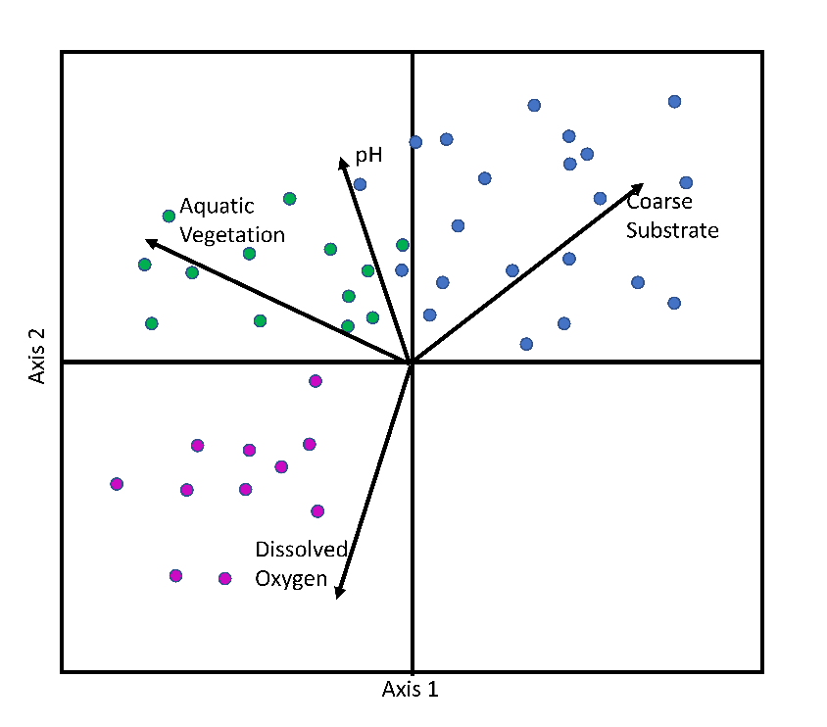

The second type of ordination plot you will interpret is a non-metric multidimensional scaling (NMDS) plot. The figure below shows an example of what these plots can look like. You may also encounter plots that use alternative shapes such as “firework bursts” or polygons that encircle each of the groupings. Here the different colors (or fireworks or polygons) represent species community assemblages from different watersheds. To read these plots, you want to focus on any groupings, or lack of groupings, seen between the community samples. Points closer together are more similar to each other than those that are further apart. Groupings that are more spread out in NMDS space show more variability within that grouping than groups that are more clustered in NMDS space. NMDS plots are based on values of beta diversity between communities. The blue and green watersheds are in separate clumps from the other watersheds suggesting those communities contain distinct species (e.g., the blue watershed has high beta diversity with the pink and black/orange watersheds). The black and orange watersheds have overlapping points suggesting these two watersheds have similar species compositions (there is low beta diversity between the black and orange watersheds).
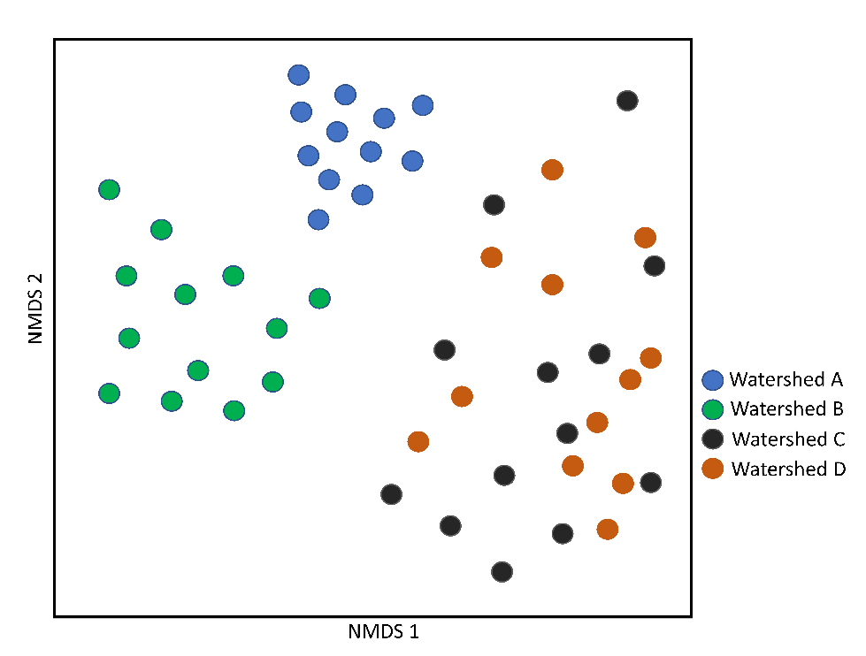

Pre-Class Activity
Use this activity to think about how variable choice should match with the spatial scale represented. Before coming to class, look up your hometown on Google Earth (http://www.google.com/earth/) and find the nearest body of water, this could be a stream, river, pond, lake, wetland etc. Answer the following questions making sure to record the scale at which you are viewing:
For each scale make sure to take a screenshot of what you see when answering the questions. Place your images, one on a page, and print them out in color and bring to class with your answers for discussion. For the scale, record the number, in meters, associated with the scale bar in the lower right-hand corner (circled in the image below).

- Zoom in to a local scale, this would be where your scale is somewhere between 15 to 75m (record your scale). Based on the features in view across the landscape, what potential human impacts do you see, how might those impact your body of water?
- Zoom out so you can see more of the surrounding landscape, somewhere between 100 to 200 m (record your scale), what additional human influences are now in your field of view, and how might those human influences impact the communities within your aquatic habitat.
- Zoom out a third time so you can see a greater portion of the surrounding landscape, somewhere between 400-1,000m (record your scale), are there any additional features that should now be considered regarding human influences on your chosen aquatic habitat?
- As you zoomed out, do any of the human impacts you wrote down on a smaller scale now seem unnecessary?

In-Class Activity
Land use and environmental gradients
Instructions: A study was completed looking at stream fish communities in Hungary. The researchers were interested in how habitat variables structured fish communities from stream sites within different land use types from urban, agricultural, and forested. Based on the interpretation of the graph below answer the following questions.
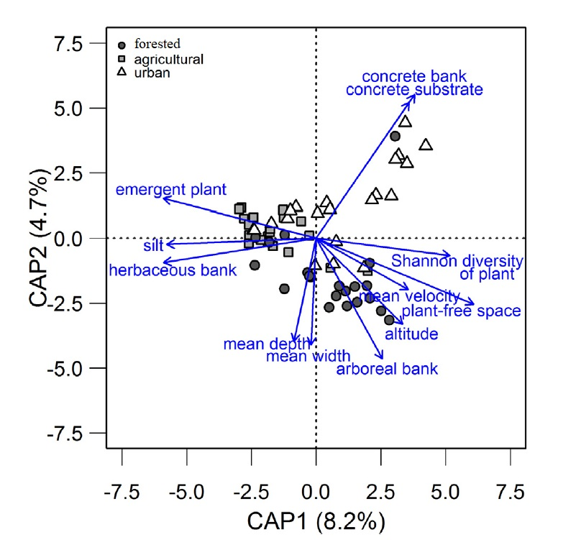

Figure 2: Constrained Analysis of Principal Coordinates (CAP) investigating land use influences on habitat characteristics within streams. Fish communities from streams in forested lands are shown by circles, fish communities from streams in agricultural lands are shown by squares, fish communities from streams in urban lands are shown by triangles. Directionality of the vectors associated with the habitat variables point towards the land use that habitat is most associated with. Figure adapted with permission from Tóth, R., Czeglédi, I., Kern, B., & Erős, T. (2019). Land use effects in riverscapes: Diversity and environmental drivers of stream fish communities in protected, agricultural and urban landscapes. Ecological indicators, 101, 742-748.

- For each land use type, what environmental variables are likely to be found at those sites?
- Based on what you read about generalist and specialist species, which types of fishes might be more vulnerable to the habitat found in streams associated with each land use type and provide rationale for your answer.
- Make predictions for how species richness for stream fish would change across a gradient of each land use type. Blank graphs are provided on the next page to get you started. Your predictions do not have to be linear. After you have finished your graphical predictions, find a partner, and compare predictions. How similar or different were the predictions you made?

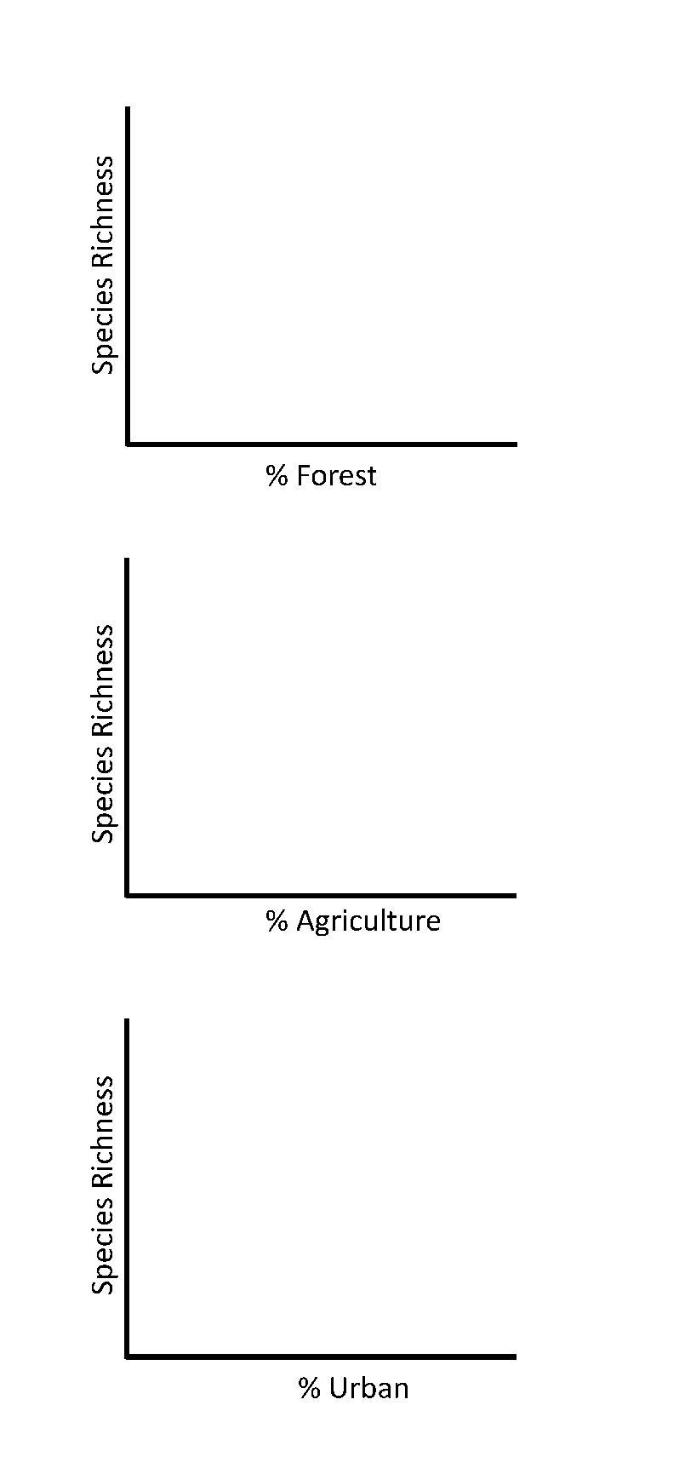

Land use and scale
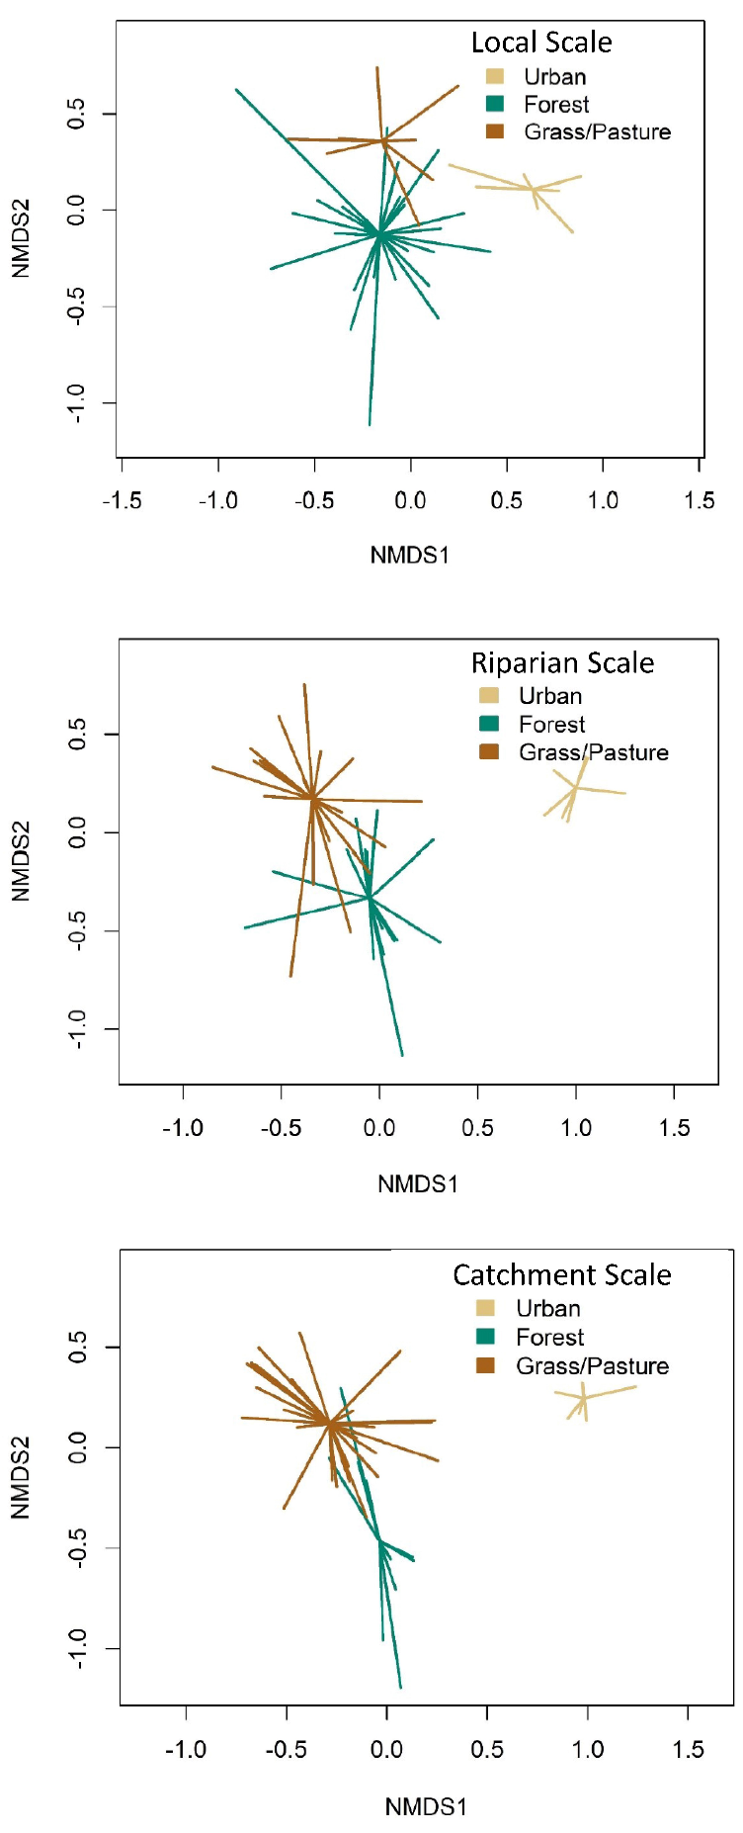
Figure 3: Non-Metric Multidimensional Scaling (NMDS) of Missouri Ozark stream fish. Investigating how fish beta diversity is influenced by land use at three different scales: local scale (A), riparian scale (B), and catchment scale (C). In these plots, the tips of the lines represent a sampled community. The lines of the same color converge on the centroid, which is the equivalent to the “average” community for a particular land use type. Figures adapted with permission from Sickler, S. M. (2018). Long-Term Trends of Stream Fish Community Assemblages in Southern Missouri with Contemporary Land Use Impacts.

Instructions:
Remember that beta diversity is a measure of the differences in species identity and richness between two or more communities. In the NMDS example above, groupings were distinguished by points with different colors, here “firework” shapes indicate one grouping. The closer groupings are together the more similar they are. When making comparisons, consider which types of land cover had fish communities that were more similar to one another or more different from each other.

- At each scale, describe the overall pattern you see between beta diversity and land use type. What do you notice about the patterns within and between each land use type.
- Which two scales show similar patterns? Hypothesize why you think that is the case.
- Which two land use types show similar patterns? Hypothesize why you think that is the case.
- Provide two additional scientific questions that you would be interested in investigating related to stream fish and land use and/or scale.

Homework Activity- Moving beyond land use
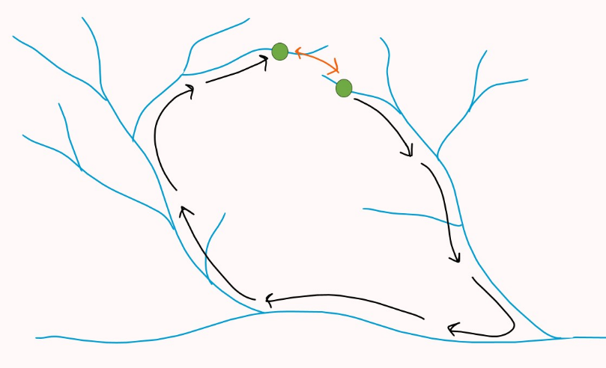
With increasing knowledge of the diversity of freshwater systems, we need to understand how the landscape surrounding these systems aids and impedes the preservation of diversity. The dispersal ability of fishes and the connectivity of the watershed they reside in are two important characteristics that can indirectly result in reduced biodiversity in the presence of different land use types. The structure of river networks restricts movement of fishes within the stream, so because fish can’t disperse over land, two stream locations may be relatively near one another on a map but might be far away for a fish that must swim through the river network to get there (Figure 4; see also Figure 1 in Tonkin et al. 2017). A connectivity gradient exists between isolated headwaters and more connected mainstem river reaches, which creates a distinct dispersal route for restricted aquatic organisms (Heino et al. 2015). An exception is when a small stream flows directly into a larger river, typically resulting in communities with higher diversity than an isolated headwater stream (Denison et al. 2021). Watersheds are arranged hierarchically where small watersheds are nested within larger watersheds separated by discrete spatial boundaries such as other watersheds and oceans (Figure 1).
Figure 4: Conceptual diagram showing how two communities (green dots) can be close in overland distance, but far apart in network distance (how far a fish would need to swim to get from one community to the other).
While land use can give some insight into how communities are structured across the landscape, there is evidence that land use does not explain all the variation we see in aquatic communities (Tóth et al. 2019). We can use other more specific variables as a proxy for different land use types. Road crossings create disconnection through channel erosion, sediment deposition, change in channel depth, and flow regime shifts (Benton et al. 2008). Disconnected habitat divided by road crossings can still contain diverse community assemblages (Chisholm et al. 2011), but loss of species due to connectivity issues even with the availability of suitable habitat can increase community differences. Connectivity also differentially affects species depending on their dispersal abilities; fish with high dispersal traits were more impacted by barriers compared to more sedentary species (Perkin et al. 2013). When highly mobile species cannot persist due to movement restrictions, those species may be lost from the community. Headwater streams may also be disproportionally affected by fragmentation due to barriers. These streams are more isolated than communities farther downstream and decreased connectivity due to barriers can cause some species to go locally extinct.
Warren and Pardew (1998) completed a study investigating the effect of road crossings on stream fish movement. They examined how stream fish movement for 26 species over eight families were affected by four types of road crossings using a mark recapture study. There was an inverse relationship between stream flow and movement of fishes during the summer. You will look at the effect of daily movement because there were no observed differences in movement between seasons.
Instructions: Land use is a broad way to categorize the landscape and how it may affect stream fish communities. We learned that there are many other variables that describe how urbanization or agriculture change stream habitat and thus fish communities. One of these variables is road crossings. Warren and Pardew (1998) investigated whether road crossing type affects daily movement of stream fishes. One of their graphs is presented below. Use the graph to answer the following questions:
- Describe how daily proportional movement differs between natural reaches and reaches with a road crossing.
- Find a pictorial example for open box, ford, and culvert crossings and explain how each may help or impede fish movement.
- When road crossings impede fish movement, how is that detrimental to fish communities?
- What other variables could be used instead of land use besides road crossings? Based on the specific variables you came up with, provide two additional research questions you would be interested in researching.
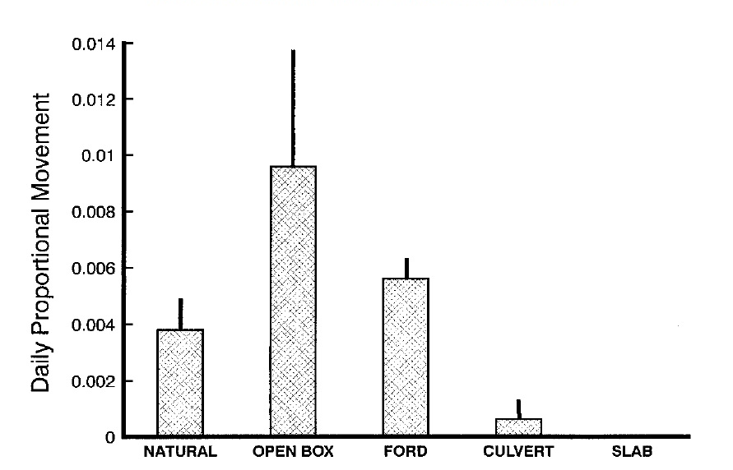
Figure 5: Mean (error bars are standard error) daily proportional movement of fishes through four road crossing types and natural reaches. Sampling completed in the Ouachita National Forest in west/central Arkansas. Sampling took place over nine road crossings on eight streams. The sampling included over 6,000 individuals of 26 fish species from eight families. Figure used with permission from Warren and Pardew 1998 – Road Crossings as Barriers to Small-Stream Fish Movement.

Glossary

Alpha diversity | Species richness within one local community.
Beta diversity | Differences in species identify and richness between two or more communities.
Biodiversity | The total diversity in a community including species richness and evenness.
Buffer | A zone surrounding a designated area.
Catchment | Land which is bounded by natural features where water flows to a low point (could be a sampling site).
Community | An assemblage of interacting populations of species that occur in the same area.
Connectivity | The link between two or more communities by dispersal of individuals.
Dispersal | The one-way movement of an individual.
Disturbance | A change in environmental conditions that may disrupt some ecological processes.
Generalist | A species that uses a variety of habitats and/or eats a variety of foods.
Headwater | Small first order streams at the beginning of a watershed.
Heterogenous | Having a diversity of different habitat types within one area.
Homogenous | Having few or the same habitat within one area.
Hypoxia | State in which oxygen in not available in sufficient amounts.
Landscape ecology | The science of studying and improving relationships between ecological processes in the environment.
Life history | A description of the life cycle.
Mainstem | Larger streams that are the result of headwater streams converging.
Reach | A section of stream along with similar hydrologic conditions exist.
Riparian | The interface between land and a stream.
Runoff | Excess liquid flows across the surface of the land, both a natural process and human activity.
Scale | The spatial extent and grain of a dataset.
Specialist | A species that uses a relatively small proportion of the available resources.
Species diversity | The number of species in a defined area.

NOTES TO FACULTY
In this figure set, students will start by reading through the overview information. Aside from the conceptual figures provided with the introductory material, there are some additional figures from the references noted in the background information that would be good to supplement into your lectures if you think students just reading the text is not enough. This figure set is designed for the end of an introductory ecology or upper-level general ecology or related topic course because the figures used include ordination figures. These figures are common in ecology and exposing students to them within a course setting will make encountering them in reading primary literature less stressful. There is a section in the background information that walks students through the two types of ordination plots they will be analyzing and what to focus on.
I suggest having students read the background information and complete the pre-class activity as homework prior to the in-class activity day. You could also choose to take the information in the background sections and create a PowerPoint to go over at the end of class the day before doing the activity, this would make the figure set a two-session activity. Then have students complete just the pre-class activity as homework.
The pre-class activity should introduce students to patterns in the landscape at different scales. This exercise is meant to have a completion grade associated with it to encourage students to finish and bring their thoughts to class to stimulate discussion. By looking at different scales, students should be thinking about the relationship between grain and extent and the importance of spatial scale depending on the question of interest. Ranges are given to help students pick their scales and can be adjusted, but I do suggest giving scale ranges, so students have some say in what scales they are choosing. Starting out the in-class activity with a gallery walk will allow students to compare their thoughts about scale and potential influences across the landscape. To start the gallery walk, have students tape their printed-out landscape images and their answers around the room, leaving enough space between students to be able to tell each other apart. Students would take 5-10 minutes and walk around the room observing each other’s work. You could choose to give students sticky notes to write comments on each other’s answers or bring everyone together for a group discussion afterwards. Answers to the pre-class activity will vary depending on what type of waterbody they choose and how far out they zoom each time. Hopefully, students will recognize that small details described at the smallest scale will likely not be as meaningful at the largest scale. Having them think about ways to aggregate those small details would be a good avenue for discussion.
For the in-class activity you can choose to have students work alone or in groups, there is an instance with the “Land use and environmental gradients” questions where students are prompted to do a pair-share and discuss their drawn graphs. Let students work at their own pace and walk around to make sure students are staying on task and are not confused. You could choose to bring everyone together here to talk about student predictions a class.
For land use and environmental gradients, students are learning to recognize which habitat variables coincide most closely with each of the land use types. Streams in forested land use had more altitude (increased water flow), water depth, and trees along the bank. Streams in agriculture land use had more silt, emergent vegetation, and herbaceous bank vegetation. Streams in urban land use had more concrete on the bank and as substrate on the bottom. Students may make note of the variation and incomplete separation of the sites within each land use type, which shows that there was great variation among sites within each of the land use types. Good discussion could come about thinking what that means for the results because high variation in characteristics might make land use types too broad of a category for these stream sites. Students should recognize that generalist species would likely be more present in agriculture and urban sites with characteristics that would potentially homogenize the habitat and cause higher disturbance. Here students draw graphs for their predictions on how species richness might change across a gradient of each land use type. Make sure students discuss results with a neighbor and write down their thoughts on the comparison. If you are concerned with students having the correct predictions before moving to the next section, bring the class back together after this point and have some groups share out their predictions. Provided are suggestions for predictions. In general, as the percentage of forest increases, there will be greater species richness because natural areas contain the habitat to support more species, both specialists and generalists. As percentage agriculture increases, I think there are two predictions that can be argued for. In black, the richness could initially decrease and then increase a bit with a shift from specialists to generalists, some of which might not have been present with less agriculture (invasive species). The orange line shows a prediction where an increase in the percentage of agriculture results in a steady decline that levels out above zero because there are generalist species that can tolerate streams in high agricultural areas. As the percentage of urban cover increases, a similar trend could be seen where species richness declines, likely from the loss of specialist species, but generalists and invasive species can swap for and still give some richness in these settings.
For land use and scale, students should recognize that there are slightly different patterns in beta diversity across the spatial scales. The local scale shows the smallest differences while the riparian and catchment scale show more differences but similar differences. Forest and grass/pasture also do not separate in the multivariate space suggesting that some species that live in forested areas can also live in grass/pasture areas. The communities living in the urban settings are very different from the other two. Students might talk about generalists vs specialists or life history strategies. Not talked about in the background information but also pertinent includes invasive species being more likely in urban areas. Here students are asked to provide additional scientific questions. Let them be creative but remind students that their questions should be asking about some ecologically related topic for stream fish and land use and/or scale that is testable (even if my testable would mean a crazy expensive experiment).
With the gallery walk to wrap up the pre-class activity, I suggest using the last graph as a homework activity to bring in the idea of how land use variables might not be the best way to tackle these questions (all that environmental variation in the second exercise). If you have a longer class period or are using this figure set in a lab setting, you can choose to include this as part of the in-class activity. Here they are looking at the effects of road crossings on stream fish movement, which also has students thinking more about dispersal and connectivity. These are two important concepts for stream fish communities across the landscape. Students would also get the opportunity to brainstorm other variables that could be used instead of land use types. Students should recognize that not all road crossings are detrimental and for this study the open box and ford crossings had more movement than natural crossings. When road crossings do decrease movement that can decrease connectivity between nearby communities. Students should recognize that this deceased connectivity is more severe for headwater streams than for streams further downstream. Depending on the images they find to represent each stream crossing will depend on how they explain why each type helps or impedes fish movement.
The instructor can give point values to questions as they see fit. This figure set could be used in two consecutive sessions, one to introduce the material and the pre-class activity and one for the in-class activity and homework. The figure set might also be applicable for a longer 1.5-hour lecture or a lab setting where more of the activities could be completed in person.
LITERATURE CITED
Allan, J. D. 2004. Landscapes and riverscapes: the influence of land use on stream ecosystems. Annual Review of Ecology, Evolution, and Systematics 35:257-284.
Benton, P. D., W. E. Ensign, and B. J. Freeman. 2008. The effect of road crossings on fish movements in small Etowah Basin streams. Southeastern Naturalist 7:301-310.
Birk, S., D. Chapman, L. Carvalho, B. M. Spears, H. E. Andersen, C. Argillier, S. Auer, A. Baattrup-Pedersen, L. Banin, M/ Beklioğlu, and E. Bondar-Kunze. 2020. Impacts of multiple stressors on freshwater biota across spatial scales and ecosystems. Nature Ecology & Evolution 4:1060-1068.
Chisholm, C., Z. Lindo, and A. Gonzalez. 2011. Metacommunity diversity depends on connectivity and patch arrangement in heterogeneous habitat networks. Ecography 34:415-424.
Dala-Corte, R. B., L. F. Sgarbi, F. G. Becker, and A. S. Melo. 2019Beta diversity of stream fish communities along anthropogenic environmental gradients at multiple spatial scales. Environmental Monitoring and Assessment 191:1-17.
Declerck, S., T. De Bie, D. Ercken, H. Hampel, S. Schrijvers, J. van Wichelen, V. Gillard, R. Mandiki, B. Losson, D. Bauwens, and S. Keijers. 2006. Ecological characteristics of small farmland ponds: associations with land use practices at multiple spatial scales. Biological Conservation 131:523-532.
Denison, C. D., M. C. Scott, K. M. Kubach, and B. K. Peoples. 2021. Incorporating network connectivity into stream classification frameworks. Environmental Management 67:291-307.
Dudgeon, D., A. H. Arthington, M. O. Gessner, Z. Kawabata, D. J. Knowler, C. Lévêque, R. J. Naiman, A. H. Prieur-Richard, D. Soto, M. L. Stiassny, and C. A. Sullivan. 2006. Freshwater biodiversity: importance, threats, status and conservation challenges. Biological Reviews 81:163-182.
Fei, S., Q. Guo, and K. Potter. 2016. Macrosystems ecology: novel methods and new understanding of multi-scale patterns and processes. Landscape Ecology 31:1-6.
Heino, J., A. S. Melo, T. Siqueira, J. Soininen, S. Valanko, and L. M. Bini. 2015. Metacommunity organisation, spatial extent and dispersal in aquatic systems: patterns, processes and prospects. Freshwater Biology 60:845-869.
Jenkins, C. N., K. S. van Houtan, S. L. Pimm, and J. O. Sexton. 2015. US protected lands mismatch biodiversity priorities. Proceedings of the National Academy of Sciences 11216:5081-5086.
Matthews, W. J. 1982. Small fish community structure in Ozark streams: structured assembly patterns or random abundance of species? American Midland Naturalist 107:42-54.
Perkin, J. S., K. B. Gido, O. Al-Ta’ani, and C. Scoglio. 2013. Simulating fish dispersal in stream networks fragmented by multiple road crossings. Ecological Modelling 257:44-56.
Sickler, S. M. 2018. Long-Term Trends of Stream Fish Community Assemblages in Southern Missouri with Contemporary Land Use Impacts. Thesis. Missouri State University.
Sievert, N. A., C. P. Paukert, Y.-P. Tsang, and D. Infante. 2016. Development and assessment of indices to determine stream fish vulnerability to climate change and habitat alteration. Ecological Indicators 67:403-416.
Tonkin, J. D., F. Altermatt, D. S. Finn, J. Heino, J. D. Olden, S. U. Pauls, and D. A. Lytle. 2018. The role of dispersal in river network metacommunities: Patterns, processes, and pathways. Freshwater Biology 63:141-163.
Tóth, R., I. Czeglédi, B. Kern, and T. Erős. 2019. Land use effects in riverscapes: Diversity and environmental drivers of stream fish communities in protected agricultural and urban landscapes. Ecological Indicators 101:742-748.
Turner, M. G. Landscape ecology: what is the state of the science? 2005. Annual Review of Ecology, Evolution, and Systematics 36:319-344.
Warren, Jr., M. L. and M. G. Pardew. Road crossings as barriers to small-stream fish movement. 1998. Transactions of the American Fisheries Society 127:637-644.

