ISSUES: FIGURE SET
Figure Set update: An inquiry-based module aligned with the 4DEE framework for teaching about functional responses and biological control

Rosny Jean¹, Linda Auker², Suann Yang³, and Jeremy Hsu⁴

¹School of the Environment, Florida A&M University, Tallahassee, FL 32307

²Department of Biology, Misericordia University, Dallas, PA 18612

³Department of Biology, State University of New York Geneseo, Geneseo, NY 14454

⁴Schmid College of Science and Technology, Chapman University, Orange, CA 92866

Corresponding Author: Rosny Jean (rosny.jean@famu.edu)

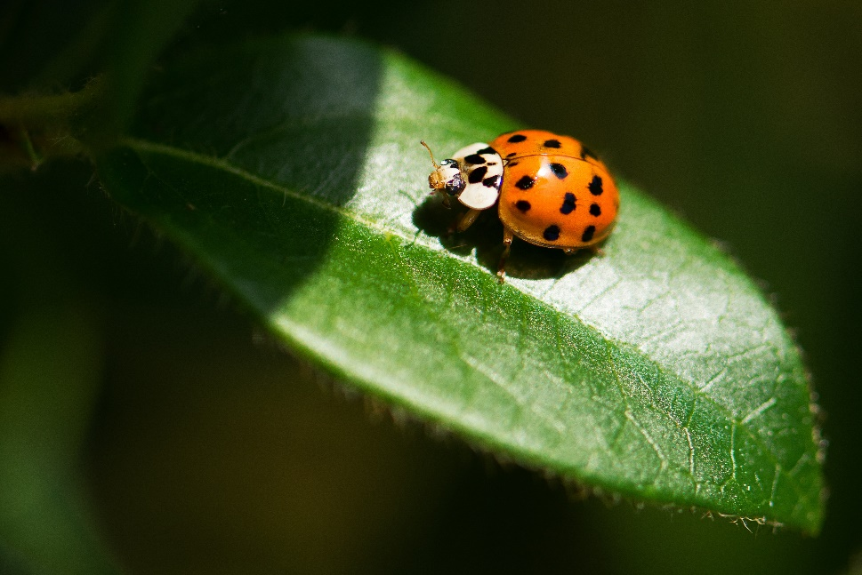

Ladybug on a leaf (Photo by Vincent van Zalinge on Unsplash)

THE ISSUE:
Biological control agents are used in a wide range of contexts to limit damage from pests. However, the broader ecological consequences of such agents often are unclear before ecological risk assessments are performed. This Figure Set guides students to think through potential consequences of using biological control agents, and then uses a specific study to challenge students to interpret results from laboratory and caged field experiments. This Figure Set also introduces the concept of functional responses to students.
FOUR DIMENSIONAL ECOLOGY EDUCATION (4DEE) FRAMEWORK
- Core Ecological Concepts:
  - Organisms
    - Resources and regulators
  - Communities
    - Predation
- Ecology Practices:
  - Quantitative reasoning and computational thinking
    - Data analysis and interpretation
  - Designing and critiquing investigations
    - Study design, familiarity with basic modes of ecological inquiry (description, comparison, experimentation, modeling)
    - Evaluating claims
    - Argument from evidence
  - Working collaboratively
- Human-Environment Interactions:
  - How humans shape and manage resources/ecosystems/the environment
    - Natural resource management (biological control agents, ecological risk assessments)
- Cross-cutting Themes:
  - Systems
  - Biogeography
    - alien/invasive species

STUDENT-ACTIVE APPROACHES:
Think-pair-share, drawing predicted results, designing experiments
STUDENT ASSESSMENTS:
answering questions on a worksheet, sharing responses with the class, and completing post-class homework that assesses understanding of key concepts
CLASS TIME:
This Figure Set is designed to span one 75-minute class or split over two 50-minute class sessions.

COURSE CONTEXT:
This Figure Set is designed for upper-division undergraduate ecology courses.

ACKNOWLEDGEMENTS:
This is an adaptation of a figure set originally developed by Jeremy Hsu in 2018 (Teaching Issues and Experiments in Ecology, Vol. 13: Figure Set #1 [online]. https://tiee.esa.org/vol/v13/issues/figure_sets/hsu/abstract.html). We thank the Ecological Society of America for support of this project, as well as the leaders and participants of ESA's Transforming Ecology Education Faculty Mentoring Network. This network is funded by the National Science Foundation (DBI 2120678).
OVERVIEW
WHAT IS THE ECOLOGICAL ISSUE?
Biological control agents, organisms released in order to control pests, are often promoted as an alternative to the use of pesticides, which are seen as damaging to both the environment and human health (Louda et al. 1997). However, the release of such biological control agents can have unintended consequences on the target organism and local ecosystems (Reilly and Elderd 2014). In particular, releases of such biological control agents can influence non-target species, detrimentally impacting not only populations of the target pest but those of other non-targeted organisms co-occurring in the same area as the target organism (Louda et al. 2003). Given this, it is critical to understand how such biological control agents may influence the broader ecosystem before the release of such control agents. In addition, this issue is of particular concern given that the impact of biological control agents on non-target organisms is expected to increase as global climates continue warming (Lu et al. 2014).

This topic is also highly relevant as it presents an issue at the intersection of ecology and society, i.e., Human-Environment Interactions (4DEE Framework). Students may already be familiar with this issue given the frequent coverage of biological control agents in the news and popular media. For instance, Google’s release of two million sterile, non-biting mosquitoes to control the spread of Zika and other mosquito-borne diseases was covered in major media outlets (e.g., May 2017, Wang 2017), and local newspapers often have articles covering local uses of biological control agents.

Students will explore this issue through this Figure Set by thinking critically about functional responses, another important ecological concept. Functional responses define the relationship between the rate of a given consumer eating its food as compared to the density of its food, and can be classified as type I, type II, or type III responses depending on how the rate of consumption changes as the density of the food source changes (Holling 1965). Understanding such functional responses is critical not only for assessing the impacts of biological control agents, but also for analyzing a range of other ecologically relevant behaviors such as foraging and predation (Durant et al. 2003, He et al. 2012).

FIGURE SETS TABLE

Figure Set and Ecological Question | Student-active Approach | Cognitive Skill | Class Size/Time
Non-target impacts of the biological control agent Harmonia axyridis on Danaus plexippus  (Koch et al. 2003) | Experimental design, think-pair-share, interpreting data and results | Know, comprehend, interpret, analyze, synthesize | One 75-minute class period or two 50-minute class periods

Part I
Learning Objectives:
Students will be able to:
- Design experiments to measure the impact of predators on prey populations
- Identify independent and dependent variables in experiments and explain the importance of controlling for other conditions.
- Offer feedback on an experiment’s design and revise an experiment after receiving feedback.
Student Assessment:
  - Answering questions on a worksheet, sharing responses with the class

Part II
Learning Objectives:
Students will be able to:
- Make quantitative predictions for predator-prey relationships and interpret graphs that show such functional responses
- Communicate and explain the significance of functional responses and biocontrol agents
- Justify advantages and disadvantages of using biological control agents, including potential ethical concerns
Student Assessment:
- Answering questions on a worksheet, sharing responses with the class

Part III
Learning Objectives:
Students will be able to:
- Identify the type of functional response that is depicted in a graph.
- Support or refute a claim about the type of functional response depicted in a graph.
- Propose hypotheses to explain differences in functional responses of a predator on different prey types.
- Make a recommendation about the conservation of ecological resources using knowledge of ecological concepts.
Student Assessment:
- Answering questions on a worksheet, sharing responses with the class

Part IV
Learning Objectives:
Students will be able to:
- Interpret patterns and variables within a figure
- Create a testable hypothesis and an experimental design to test the hypothesis about patterns observed in the figure.
- Compare and contrast type I and II functional response impact on prey populations.
- Identify and explain additional factors that affect predator-prey interactions.
Student Assessment:
- Answering questions on a worksheet, sharing responses with the class

FIGURE SET BACKGROUND
Harmonia axyridis, known as the Asian ladybeetle or Asian ladybug, has been used as a biological control agent with increasing frequency for at least the past two decades (Koch 2003). Native to Asia, the species was first introduced to North America in the 1980s and has spread across the continent as well as to South America and Europe (Brown et al. 2008; Koch 2003; Koch et al. 2006). The species preys upon aphids and other agricultural pests. However, the broader ecological consequence of these introductions, and in particular, the impact on non-target species, was only investigated decades after the first recorded use of ladybeetles as biological control in the late 1800s and the first use of H. axyridis in 1916 (Roy and Wajnberg 2008). Indeed, the use of H. axyridis as a biological control agent has led to many unintended consequences, including its decimation of populations of native aphid-eating species, its consumption of certain agricultural fruits, and its high aggregations in human-dwelling areas (Koch et al. 2004; Kovach 2004; Majerus et al. 2006; Roy and Wajnberg 2008). Consequently, the species is now itself considered a pest (Kovach 2004; Roy and Wajnberg 2008).
Here, students will explore a series of laboratory and caged field experiments published in 2003 to investigate if H. axyridis is having a specific impact on monarch butterflies (Danaus plexippus). Monarchs are a charismatic species that many students will immediately recognize; the species is also widely perceived as an icon for conservation (Gustafsson et al. 2015). Thus, this study focuses on two common insect species that will be immediately familiar to many students, which should help facilitate understanding and discussion of the experiments. This study also allows for a broader discussion of monarch butterfly conservation following this Figure Set, as monarch populations worldwide continue to decrease due to habitat loss and climate change exacerbated by anthropogenic activities (Inamine et al. 2016; Vidal et al. 2013).
In addition to investigating non-target impacts, this Figure Set will also introduce the concept of functional responses to students. The study features four experiments, depicted in three figures. The first set of experiments are done in the laboratory and test the functional response of adult or third instar (larvae) H. axyridis feeding on either D. plexippus eggs or first instar (small, immature larvae) D. plexippus. The number of D. plexippus provided was varied in these experiments, and the amount of prey consumed within 24 hours was recorded. Through guided inquiry questions, students will predict trends, analyze the data, and also compare and contrast different types of functional responses. The second set of experiments was conducted in the field, with researchers tracking the survival of D. plexippus over time in a cage with varying numbers of H. axyridis placed in the cage.

STUDENT INSTRUCTIONS
B
Background Information
Biological control agents are organisms released in order to control pests. Such agents offer an important alternative to pesticides, which can be damaging to both environment and human health. These biological control agents can help prevent pests from destroying agricultural crops, or even help limit the spread of disease among humans. For instance, you may have heard about Google’s July 2017 release of two million sterile, non-biting mosquitoes in California to control the spread of Zika, an infectious disease that has had multiple recent outbreaks.

In class, you will be learning more about biological controls and will be thinking through the ecological implications of using such controls. First, however, it is important to understand the broad range of what constitutes biological control. For your pre-class assignment, find a recent (from the past year) news article that features biological control and is not the same example as the one mentioned above. Read this article, bring in a copy for class, and be prepared to share your article with your peers. We will use your articles to illustrate the diversity of biological control and the importance of understanding such ecological principles.
During class:
We have explored a range of biological controls in the news and will now focus on a specific example. Harmonia axyridis, or the Asian ladybeetle (alternatively known as the Asian ladybug), was first used in the 1900s as a form of biological control, where organisms are introduced to control the spread of pests. The species preys upon aphids, a destructive agricultural pest. Native to Asia, the H. axyridis was first introduced to North America in the 1980s. However, the introduction of this species has produced many unintended consequences, including the decimation of many native species of insects in North America, as well as high aggregations of the ladybeetle becoming a human nuisance in many cities. Consequently, this Asian ladybeetle has itself been labelled as a pest! In this module, you will investigate what impacts, if any, this species has on the monarch butterfly, Danaus plexippus, a charismatic insect native to North America.

Part I:
In this study, scientists were interested in examining potential non-target impacts stemming from the introduction of H. axyridis as biological control. In other words, they wondered if H. axyridis has the potential to impact populations of other organisms besides the aphids they were meant to help control. More specifically, they were interested in seeing if H. axyridis adults or larvae (described as being in the third instar, a stage of development) could be preying on the eggs of the monarch butterfly (D. plexippus) or eating immature monarch larvae (small caterpillars).

- Design an experiment that tests the potential impact of H. axyridis adults or larvae on D. plexippus populations. Be sure to note what your independent and dependent variables are, and what conditions might be controlled in your experiment. Sketch your experimental design below.
- Sketch a revised experimental design after discussing your respective experiments with your group.

Part II:
To test their question of if the Asian ladybeetle, once introduced, would impact monarch butterfly populations, the authors conducted two sets of experiments. The first set of experiments was conducted in the lab, where they placed 1, 5, 10, 20, 30, 40, or 50 monarch eggs in a petri dish, and then introduced a single H. axyridis larva that had been starved. They then observed how many monarch eggs were eaten over a 24-hour period and repeated this experiment several times. For each series of experiments conducted with the same initial number of monarch eggs, they calculated the average (mean) number of monarch eggs eaten in these experiments by the single H. axyridis larva, which thus represents an estimate of the predator’s per capita rate of consumption.

- Predict what you think the results would look like if the Asian ladybeetle has an impact on the monarch butterfly population by sketching in the graph below. Explain your prediction.

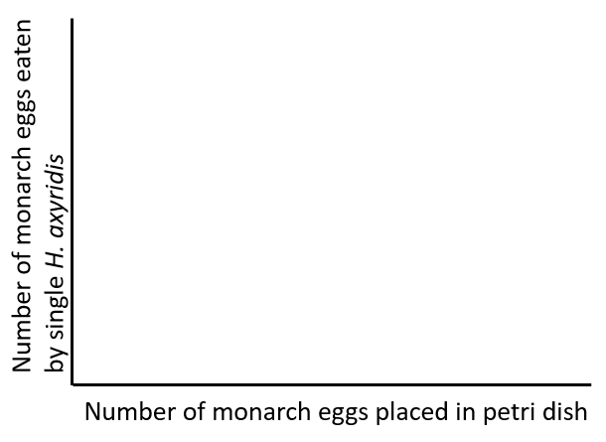

Now, examine the actual results from the experiment.

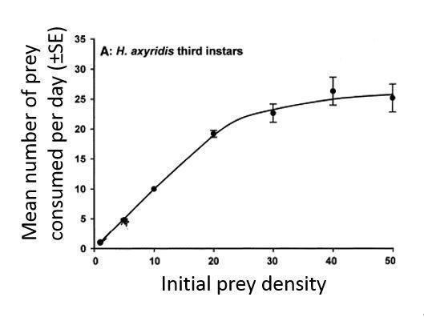
Reprinted from Biological Control, Volume 28, R.L. Koch,W.D. Hutchison,R.C. Venette,G.E. Heimpel, Susceptibility of immature monarch butterfly, Danaus plexippus (Lepidoptera: Nymphalidae: Danainae), to predation by Harmonia axyridis (Coleoptera: Coccinellidae), Copyright 2003, with permission from Elsevier.

- Compare your prediction to the results shown in the graph. Was your prediction accurate or not? If not, what surprises you about the actual results?
- Why do you think the number of eggs eaten after 24 hours started to plateau off after a certain number of monarch eggs was made available?
- The research question asks if Asian ladybeetles, if introduced, would influence monarch populations. What do these data suggest about the answer to this question? Explain your reasoning.
- Given these data, would you support introducing Asian ladybeetles as a biological control for aphids? Why or why not?

This graph shows a functional response, which charts the predator’s per capita rate of consumption depending on the initial density of prey or vegetation. Functional responses can be classified into three specific types; the graph you see here represents a Type II functional response where the rate of prey or vegetation eaten remains constant at low prey or vegetation densities, gradually decreases as the density of prey or vegetation increases, and then eventually asymptotes at a high prey or vegetation density.

The second experiment was extremely similar to the first experiment but offers the single H. axyridis larva monarch butterfly larvae (small caterpillars) instead of monarch eggs as food.

- Using Figure 1A above, draw in a dashed line to predict what you think this functional response will look like. Explain your reasoning.

Part III

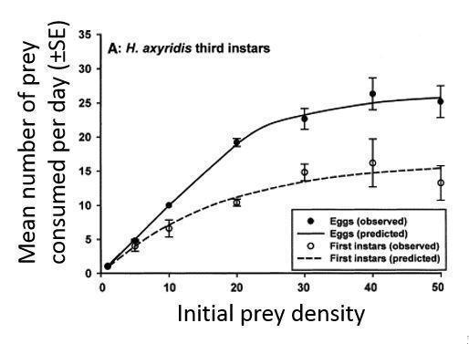
Reprinted from Biological Control, Volume 28, R.L. Koch,W.D. Hutchison,R.C. Venette,G.E. Heimpel, Susceptibility of immature monarch butterfly, Danaus plexippus (Lepidoptera: Nymphalidae: Danainae), to predation by Harmonia axyridis (Coleoptera: Coccinellidae), Copyright 2003, with permission from Elsevier.

Use the figure above to compare the two functional responses of H. axyridis larvae feeding on monarch eggs (filled circles and solid line) and larvae (open circles and dotted line).

- Does the functional response of H. axyridis larva on monarch larvae also fall under type II? Why or why not?
- Based off these data, are monarch eggs or larvae more susceptible to H. axyridis larvae? At the end of the experiment, about how many more times are the more susceptible stage consumed compared to the less susceptible stage? Show your calculation.
- Why do you think there is a difference in the functional response graph between H. axyridis feeding on monarch eggs and larvae?
- An H. axyridis individual appears to have a limit to the mean number of D. plexippus larvae or eggs consumed per day. Should a local conservation group that works to preserve the habitat for a large monarch population be worried if they find H. axyridis in their habitat preserve? Make a recommendation to this local conservation group. Support your recommendation using your knowledge of predator-prey interactions, functional responses, and the regulation of predator and prey population sizes.

Part IV
In the third experiment, the researchers investigated the functional response of adult H. axyridis on D. plexippus eggs by measuring the number of D. plexippus eggs consumed by a single H. axyridis adult in a day.

- What H. axyridis life stage is shown in this figure, compared to the figure in Part III?

- Based on your answer to question 13, why do you think that this functional response does not asymptote?

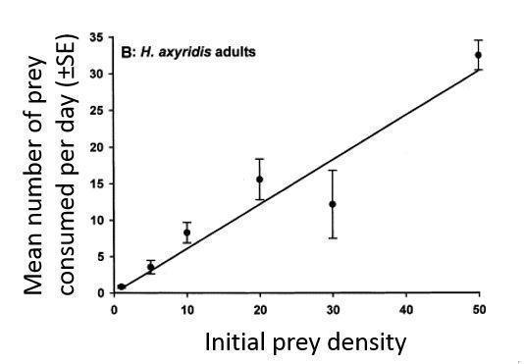

Reprinted from Biological Control, Volume 28, R.L. Koch,W.D. Hutchison,R.C. Venette,G.E. Heimpel, Susceptibility of immature monarch butterfly, Danaus plexippus (Lepidoptera: Nymphalidae: Danainae), to predation by Harmonia axyridis (Coleoptera: Coccinellidae), Copyright 2003, with permission from Elsevier.

This trend, if it holds under further experiments with increased numbers of prey, is known as a Type I functional response. A type I functional response is characterized by a linear relationship between the density of prey or vegetation and the amount of prey or vegetation consumed.

- Look carefully at the graph again. Why do you think there is a recorded decrease in the mean number of D. plexippus eggs that were eaten when the number of eggs available were increased from 20 to 30? State a testable hypothesis to describe why you see this decrease.
- How might you test your hypothesis from the previous question?
- Contrast the differences in impact on the prey populations between a type I and type II functional response. Would predators exhibiting type I or type II functional responses be more effective at controlling prey populations? Why?
- Consider everything you know about predation so far. What factors could limit predation rates other than prey availability?

Part V
The last experiment in this study was conducted in the field, where researchers set up several cages to control how many H. axyridis larvae and D. plexippus individuals would be able to enter or exit the system. The cage ensured that no other larvae would be present in the system. Each cage started with eight D. plexippus larvae, and the researchers set up cages with no H. axyridis larvae, 4 H. axyridis larvae, and 16 H. axyridis larvae. They then tracked each system for a week, recording the number of D. plexippus larvae surviving in the cage.

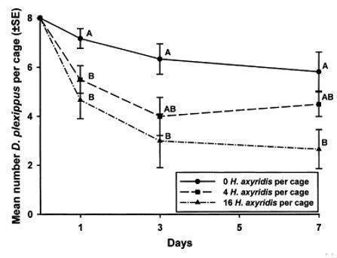

Reprinted from Biological Control, Volume 28, R.L. Koch,W.D. Hutchison,R.C. Venette,G.E. Heimpel, Susceptibility of immature monarch butterfly, Danaus plexippus (Lepidoptera: Nymphalidae: Danainae), to predation by Harmonia axyridis (Coleoptera: Coccinellidae), Copyright 2003, with permission from Elsevier.

- Why was it important to use cages to control the number of individuals of each species that entered or exited the system?
- What was the purpose of including a cage with no H. axyridis present?
- There are error bars in the figure, denoting variation in the data. What factors do you think contribute to the variability shown in the data?

- Besides consumption by H. axyridis larvae, what other ways might H. axyridis larvae affect the survival of D. plexippus larvae? How can these alternative explanations be ruled out in a follow-up experiment?
- What additional insight did this experiment provide over the previous experiments conducted in the lab?
- How might the results of this experiment be extrapolated to predict the impact of H. axyridis on D. plexippus populations in a natural setting?

Part VI
Now that you have seen the results from each of the experiments, we will consider the data together to infer conclusions.

- Do you think that releasing H. axyridis as a biocontrol agent may have non-target impacts on D. plexippus? Explain.
- D. plexippus is just one species that could be impacted by H. axyridis in a natural (nonexperimental) ecological community. What other species could be impacted by a smaller D. plexippus population, and why?
- How realistic do you think these experiments are in reflecting natural populations?
- What other information would you want in order to determine the ecological impact of H. axyridis on D. plexippus?
- What additional experiments would you recommend conducting to gather the information you identified in question 28?
- How did the experiment you designed in part I compare to the experiments presented here? What strengths and weaknesses do you see in the experimental design for your experiment compared to that of the study’s experiments?

Post-class assessment:
Please complete the following questions for homework.

- In your own words, explain how we know that H. axyridis may have an impact on D. plexippus. Be sure to provide a complete explanation so that someone who has not seen this Figure Set is able to understand the experiments and data.
- Research other non-target impacts of H. axyridis, and provide a brief paragraph summarizing what you found.
- In class, we discussed both Type I and Type II functional responses. There are also Type III functional responses. Do some research on type III functional responses, then draw a type III functional response and describe the difference between each of the three types of functional responses.

NOTES TO FACULTY
The activity includes a pre-class assignment, where students are asked to find a news article that discusses biological control. This pre-class activity is designed to engage students in thinking about how ecological issues play a key role in society, and to pique their interest on this topic. Depending on class size and time allotted for this module, you may wish to have a general discussion on the ethics of using biological control agents, particularly genetically modified organisms. For large classes, you may have students share their articles with their neighbors and have smaller discussions, and for small classes, you may be able to have a class-wide discussion. Depending on your chosen format, you may wish to have students turn in their news articles to you before class so that you may review the articles and facilitate the discussion accordingly.

The in-class activity is divided into six parts, which should be handed out separately in sequential order. Parts III, IV, and V can be combined together and handed out in one packet if needed, but the other parts are written so that students should not have access to future parts while working on another section since there are multiple questions that ask students to make predictions and inferences before they see the actual figures and data. (Alternatively, you can also make a packet, put each part on a separate page, and ask students not to turn ahead to the next part until they are finished with the previous part.) There are 30 inquiry-based questions throughout these parts that challenge students to design experiments, interpret and assess graphs, and synthesize the information to draw conclusions. Before beginning these parts, you may wish to briefly introduce the study systems of H. axyridis and D. plexippus. Students should work in small groups to answer these questions.

Part I uses a think-pair-share approach and asks students to design an experiment to test if H. axyridis has an impact on D. plexippus. After students are done sketching their experimental designs, instructors should ask students to pair with other students and share their ideas. During this time, instructors should check in with groups to get a sense of students’ experiments and to help guide the conversation. Note that this question is intentionally left open-ended in order to allow students creativity in designing experiments. Consequently, some students may design field-based experiments, while others may rely on lab-based experiments similar to what was performed in Koch et al. (2003). Instructors should focus on providing feedback on the experimental design of student experiments, ensuring that student-designed experiments are able to answer the posed question, are well-controlled with clear dependent and independent variables, and are feasible, and may also wish to mention these criteria for students to consider while they are answering question 2 in small groups. After students have had the chance to share within their small groups, instructors should facilitate a class-wide discussion of the experiments that students designed, and then introduce the design behind the first experiment included in Koch et al. (2003), which is covered in part II.

After reading about the first experiment, students are then challenged to predict the results in part II by filling in the graph in question 3. Most students will draw a linear relationship here (a Type I functional response) and justify it by saying that the more prey that are available, the more that the predator will eat, although some students may draw a Type II curve. Students are then asked to compare their prediction with the actual data in the study and explain why they think the per capita rate of consumption begins to asymptote at a higher prey density (question 5). Students may respond that the single predator is “full” or “done eating”, and instructors should use this opportunity to ask students to formalize their thoughts in more appropriate ecological terminology. In other words, instructors should guide students toward the concept that as the single H. axyridis becomes satiated it will thus decrease its rate of prey consumption. Students are then introduced to the concept of functional responses before they are asked to predict the functional response for the second experiment, where they will likely draw another Type II curve. Instructors may wish to survey the room to gauge student predictions and see how their predicted per capita rate of consumption of D. plexippus larvae varies as compared to the data for consumption of D. plexippus eggs. It is also recommended that instructors check in with the class at this point and explain the concept of functional response and indicate that the future experiments will continue building upon this concept. The next question (question 6) challenges students to connect these results to the original research question and hypothesis that Asian ladybeetles, if introduced, would impact monarch butterfly populations. Students should respond affirmatively after examining their results. The final question (question 7) asks students to consider if they would support using the Asian ladybeetle as a biological control agent. Instructors can encourage students to consider both the positive and negative impact of using Asian ladybeetles as a biological control agent and discuss the ethical concerns that have been raised regarding the introduction of non-native species. This question can be extended into a broader exercise, such as a class debate or activity where students write a persuasive argument supporting their position.

In part III, students interpret results from the second experiment and compare and contrast the functional responses between H. axyridis and D. plexippus larvae versus D. plexippus eggs. This new curve is still considered a Type II curve (question 9) since there is a decreasing rate of consumption as the density of prey increases. Despite this, it appears that starved H. axyridis larvae will eat more (about double) D. plexippus eggs than D. plexippus larvae, meaning that D. plexippus eggs are more susceptible than D. plexippus larvae (question 10). Asking students to provide the effect size and show their calculation is a check on their ability to translate the symbology of the plot into tangible values. Students may provide a range of explanations for why this is (question 11), including potential differences in energy provided between a single D. plexippus egg and larva or differences in level of ease in obtaining the prey. Instructors may wish to ask students how likely they think their explanations are and how they might test their ideas to provide more practice for students in thinking about designing experiments. The final question (question 12) of part III asks students to integrate what they have learned so far and apply that to management practice. Instructors can encourage students to consider the context-dependence of predator satiation to recommend careful monitoring of the D. plexippus and H. axyridis populations. The population-level effects of a predator depend on that population’s size relative to that of the prey population. Students may apply the Lotka-Volterra model to explain how prey and predator population sizes are regulated by each other. In addition, H. axyridis “in the wild” is a generalist, and their functional response curve is likely to be Type III when prey choices are available. Because there is not necessarily a single correct answer here, instructors may wish to grade on the presence of lateral thinking rather than thoroughness of responses.

Students examine the last functional response graph in part IV. Question 13 encourages students to carefully compare this figure with the figure in Part II. However, unlike the previous functional responses, we only see a linear trend between the density of prey and the amount consumed. This is presented as a possible Type I functional response, but some students may note (in question 14) that the trend may not stay the same if the authors had tested greater numbers of D. plexippus eggs being present. As such, if the rate of consumption begins to decrease with an increase in eggs, then this may become a Type II functional response, a possibility that the authors of the paper suggest is the likeliest outcome: “The linearity of the functional response of adult H. axyridis on D. plexippus eggs was likely due to the predators not being exposed to high enough prey densities to induce satiation” (Koch et al. 2003). The next two questions (questions 15 and 16) ask students to analyze why there might be a decrease in the number of D. plexippus eggs consumed when the number of eggs present is increased from 20 to 30, and to think of an experiment to test those ideas. Students need to write a hypothesis before designing the experiment. Students will likely come up with a range of responses here, and instructors should encourage any idea that appears to be ecologically feasible. Like before, instructors should evaluate the merits of proposed experiments by ensuring that experiments are capable of answering the posed question, are well-controlled, and have clear independent and dependent variables.

Following this discussion, the instructors may wish to bring up how the authors of the paper (Koch et al. 2003) approached this decrease. Although this decrease may not be statistically significant, the authors attribute this change to the potential of area-restricted search, where the predator may temporarily slow down its intake after finding an area with high densities of prey:

There is a peculiar dip in observed predation by adult H. axyridis on D. plexippus eggs at the initial prey density of 30 eggs per dish. Heimpel and Hough-Goldstein (1994a) found a similar response for the stink bug Perillus bioculatus (F.) preying on neonate Leptinotarsas decimlineata (Say) and attributed the response to successful area-restricted search following subsatiation feeding at high prey densities (Heimpel and Hough-Goldstein, 1994b), but not at low densities.

While not explicitly included in the student questions, if the course includes learning outcomes for statistics, instructors may want to ask a supplemental question: “Would you describe the line in this graph as a good fit for the data? Without conducting a regression analysis, do you think the R² value is closer to 0 or 1? What evidence leads you to your answer?” . This question focuses on the fit of the line in the graph and estimating a regression coefficient for this line. If students decide on an R² value closer to 1 (good fit), they should describe the close fit of points to the line. Students should also mention the variation in the data and the deviation from the line of the point. Faculty may also want to discuss the error bars in this figure and variation in the data.

Question 17 asks students to explicitly consider how predators who exhibit type I or type II functional responses may differentially impact the respective prey populations. The previous questions have focused on asking students to think through type I and type II functional responses through examining the impact on the predators; this question thus is designed to encourage students to reflect on how such relationships impact the prey populations. The second part of this question asks students to consider now whether predators exhibiting type I or type II functional responses would be more effective at controlling prey populations. The effectiveness of such biological controls would depend on the precise per capita rates of consumption, but in general predators exhibiting a type I functional response would be more effective than predators exhibiting a type II functional response. This is because predators exhibiting a type I functional response would not see a decrease in per capita rate of consumption with increasing prey densities, as would be observed in predators exhibiting a type II functional response. Instructors may wish to emphasize this point and discuss the importance of understanding type I and type II functional responses when using biological control.

Finally, in this part, students are asked to consider other limiting factors for predation than prey availability. This question is meant to encourage students to think about the abiotic and other biotic factors that might play a role in predation rates. Answers may include phenological biotic or abiotic changes in the environment that affect biology of the predator, reproduction, parasite and disease, other symbiotic factors, or human-generated impacts on the environment. Faculty may wish to encourage students to create an experiment to test these factors and discuss with the class if there is a heavy focus on hypothesis testing in the course.

The last experiment, conducted in the field, is analyzed in part V. Students are asked about the value of running this experiment with no H. axyridis present, testing their understanding of controls, and then are challenged to think about what additional information this experiment provides over the previous set of experiments. Instructors may need to remind students that this is the only experiment done in the field with host plants, rather than being done in the lab in a petri dish like the earlier experiments. This distinction is important to point out for question 23, given that the previous series of experiments did not attempt to replicate natural field conditions, while this last experiment is the only one discussed here that attempts to replicate natural conditions with both predator and prey living on host plants. Question 20 evaluates students' grasp of experimental design and the role of controlling variables in ensuring that observed effects can be attributed to the tested variable. Question 21 assesses students' comprehension of how different variables can influence experiment outcomes and how researchers can control those variables. Question 22 tests students' critical thinking skills by prompting them to consider alternative explanations for observed results. It also evaluates their knowledge of how researchers can eliminate alternative explanations through additional experimentation or analysis. Lastly, Question 24 measures students' ability to apply experiment results to a broader context and consider the study's limitations when making predictions.

The final section of the in-class activity, part VI, has students synthesize all the information presented to draw conclusions. After thinking about these conclusions in question 25 (that H. axyridis can prey on D. plexippus and that there thus is likely non-target impact on D. plexippus from introductions of H. axyridis as biological control), students are asked to think of the broader ecological significance of these conclusions (question 26). Instructors may wish to ask follow-up questions about what other organisms may be impacted by declining D. plexippus populations. For instance, D. plexippus feeds on milkweed (genus Asclepias); how might declining D. plexippus populations impact milkweed? Similarly, many ants, wasps, spiders, and various birds prey on D. plexippus; how might these predator populations be impacted if H. axyridis is introduced and now preys upon D. plexippus? Students might cite these potential corresponding increases in milkweed and decreases in D. plexippus predator populations as additional downstream impacts of introducing H. axyridis, and instructors should encourage discussion and connect any other ecological principle that may have been discussed in the course already (e.g., direct and indirect effects of predation).

The next two questions (questions 27 and 28) ask students to assess the relevance and limitations of this study. Instructors may wish to facilitate a class-wide discussion on the responses here and highlight the importance of conducting field-based experiments to corroborate results from laboratory experiments. Responses may vary to these questions, and students may point out that the study does not provide information on the actual densities of either D. plexippus or H. axyridis in natural populations, nor how likely H. axyridis is to prey on D. plexippus eggs or larvae if there are aphids and other prey available. Question 29 then asks students to think of other information or experiments they would want to fully investigate the non-target impacts of H. axyridis on D. plexippus; students may propose experiments where they introduce D. plexippus and aphids as potential prey in varying densities, or design predator choice experiments to test H. axyridis predation preferences. In the final question (question 30), students return to the original experiment they had designed in part I and reflect on their own experimental design by comparing it to the study’s experiments. These questions should allow students the opportunity to strengthen their ability to design well-controlled experiments. Instructors may want to discuss these questions and ask students what they put as strengths and weaknesses of their own experiments and use this discussion to reinforce lessons on experimental design.

The post-class assessment consists of three questions that may be assigned for homework. The first question asks students to write a short statement to summarize their findings, allowing them to synthesize this information and practice their scientific communication skills. The second question tests student understanding of non-target impacts by asking students to find other potential non-target impacts of H. axyridis. The final question assesses student understanding of functional responses and Type I and Type II curves, and also asks students to research Type III curves. Instructors may wish to briefly cover Type III curves and emphasize the differences between these functional responses in a future lesson.

ADDITIONAL RESOURCES
- Link to the study used in this Figure Set: Koch, R.L., W.D. Hutchison, R.C. Venette, and G.E. Heimpel. 2003. Susceptibility of immature monarch butterfly, Danaus plexippus (Lepidoptera: Nymphalidae: Danainae), to predation by Harmonia axyridis (Coleoptera: Coccinellidae). Biological Control 28:265-270. http://www.sciencedirect.com/science/article/pii/S1049964403001026

- Review paper of functional impacts on non-target species of H. axyridis: Koch, R.L. 2003. The multicolored Asian lady beetle, Harmonia axyridis: A review of its biology, uses in biological control, and non-target impacts. J Insect Sci 3:32. https://academic.oup.com/jinsectscience/article/doi/10.1093/jis/3.1.32/854074/The-multicolored-Asian-lady-beetle-Harmonia

- Suggested papers that involve biological control agents or functional responses:
  - Batzli, G.O., Jung, H.G., and G. Guntenspergen. 1981. Nutritional ecology of microtine rodents: linear-foraging rate curves for brown lemmings. Oikos 37:112-116. http://www.jstor.org/stable/3544080
  - Buckel, J.A. and A. W. Stoner. 2000. Functional response and switching behavior of young-of-the-year piscivorous bluefish. J Exp Marine Bio and Ecol. 245:25-41. http://www.sciencedirect.com/science/article/pii/S0022098199001550#BIB23
  - Claver, M.A., B. Ravichandran, M.M. Khan, and D.P. Ambrose. 2003. Impact of cypermethrin on the functional response, predatory and mating behavior of a non-target potential biological control agent Acanthaspis pedestris (stal) (Heet., Reduviidae). J Applied Entomology 127:18-22. http://onlinelibrary.wiley.com/doi/10.1046/j.1439-0418.2003.00654.x/full
  - Hu, Y.S., Z.M. Wang, C.L. Ning, Z.Q. Pi, and G.Q. Gao. 1989. The functional response of Harmonia (Leis) axyridis to their prey of Cinara sp. Nat. Enemies Insects 11:164-168. https://www.cabdirect.org/cabdirect/abstract/19931168062
  - Lee, J. and T. Kang. 2004. Functional response of Harmonia axyridis (Pallas) (Coleoptera: Coccinellidae) to Aphis gossypii Glover (Homoptera: Aphididae) in the laboratory. BioControl 31: 306-310. http://www.sciencedirect.com/science/article/pii/S1049964404000714
  - Řezáč, M., S. Pekár, and J. Stará. 2010. The negative effect of some selective insecticides on the functional response of a potential biological control agent, the spider Philodromus cespitum. BioControl 55:503-510. https://link.springer.com/article/10.1007/s10526-010-9272-3
  - Sarmento, R.A., A. Pallini, M. Venzon, O. de Souza, A. Molina-Rugama, and C. de Oliveira. 2007. Functional response of the predator Eriopis connexa (Coleoptera: Coccinellidae) to different prey types. Braz. Archives Biol and Tech. 50: doi10.1590. http://www.scielo.br/scielo.php?script=sci_arttext&pid=S1516-89132007000100014
  - Sharma, P.L., S.C. Verma, R.S. Chandel, M.A. Shah, and O. Gavkare. 2017. Functional response of Harmonia dimidiate (fab.) to melon aphid, Aphis gossypii Glover under laboratory conditions. Phytoparasitica 45:373-379. https://link.springer.com/article/10.1007/s12600-017-0599-5

LITERATURE CITED
Brown, P.M.J., T. Adriaens, H. Bathon, J. Cuppen, A. Goldarazena, T. Hagg… H.E. Roy. 2008. Harmonia axyridis in Europe: spread and distribution of a non-native coccinellid. BioControl 53:5-21.

Durant, D., H. Fritz, S. Blais, and P. Duncan. 2003. The functional response in three species of herbivorous Anatidae: effects of sward height, body mass and bill size. J. Anim. Ecol. 72:220-231.

Gustafsson, K.A., A. Agrawal, B.V. Lewenstein, and S.A. Wolf. 2015. The monarch butterfly through time and space: The social construction of an icon. BioScience 65:612-622.

He Y., J. Zhao, Y. Zheng, N. Desneux, and K. Wu. 2012. Lethal effects of imidacloprid on the coccinellid predator Serangium japonicum and sublethal effects on predator voracity and on functional response to the whitefly Bemisia tabaci. Ecotoxicology 21:1291-1300.

Heimpel, G.E. and J.A. Hough-Goldstein. 1994a. Components of the functional response of Perillus bioculatus (Hemiptera: Pentatomidae). Environ. Entomol. 23:855-859.

Heimpel, G.E. and J.A. Hough-Goldstein. 1994b. Search tactics and response to cues by predatory stink bugs. Entomol. Exp. Appl. 73:193-197

Holling, C.S. 1965. The functional response of predators to prey density and its role in mimicry and population regulation. Entomol. Soc of Canada 97:5-60.

Inamine, H., S.P. Ellner, J.P. Springer, and A.A. Agrawal. 2016. Linking the continental migratory cycle of the monarch butterfly to understand its population decline. Oikos 125:1081-1091.

Koch, R.L. 2003. The multicolored Asian lady beetle, Harmonia axyridis: A review of its biology, uses in biological control, and non-target impacts. J. Insect Sci. 3:32.

Koch, R.L., W.D. Hutchison, R.C. Venette, and G.E. Heimpel. 2003. Susceptibility of immature monarch butterfly, Danaus plexippus (Lepidoptera: Nymphalidae: Danainae), to predation by Harmonia axyridis (Coleoptera: Coccinellidae). Biological Control 28:265-270.

Koch, R.L., E.C. Burkness, S.J.W. Burkness, and W.D. Hutchison. 2004. Phytophagous preferences of the multicolored Asian lady beetle (Coleoptera: Coccinellidae) for autumn-ripening Fruit. J. Econ. Entomol. 97:539-544.

Koch, R.L., R.C. Venette, and W.D. Hutchison. 2006. Invasions by Harmonia axyridis (Pallas) (Coleoptera: Coccinellidae) in the Western Hemisphere: Implications for South America. Neotrop. Entomol. 35:421-434.

Kovach, J. 2004. Impact of multicolored Asian lady beetle as a pest of fruit and people. Amer. Entomol. 50:159-161.

Louda, S.M., D. Kendall, J. Connor, and D. Simberloff. 1997. Ecological effects of an insect introduced for the biological control of weeds. Science 277: 1088-1090.

Louda, S.M., R.W. Pemberton, M.T. Johnson, and P.A. Follett. 2003. Nontarget effects – the Achilles’ heel of biological control? Retrospective analyses to reduce risk associated with biocontrol introductions. Ann. Rev. Entomol. 47:365-396.

Lu, X., E. Siemann, M. He, H. Wei, X. Shao, and J. Ding. 2014. Climate warming increases biological control agent impact on a non-target species. Ecology Letters 18:48-56.

Majerus, M., V. Strawson, and H. Roy. 2006. The potential impacts of the arrival of the harlequin ladybird, Harmonia axyridis (Pallas) (Coleoptera: Coccinellidae), in Britain. Ecol. Entomol. 31:207-215.

May, P. “Google sister company to Fresno: Take our mosquitoes – please!” The Mercury News [San Jose, CA] July 18, 2017. http://www.mercurynews.com/2017/07/18/heres-the-real-buzz-google-releases-20-million-mosquitos-in-fresno/ Accessed July 21, 2017.

Reilly, J.R. and B.D. Elderd. 2014. Effects of biological control on long-term population dynamics; identifying unexpected outcomes. J. Applied Ecology 51:90-101.

Roy, H. and E. Wajnberg. 2008. From biological control to invasion: the lady bird Harmonia axyridis as a model species. BioControl 23:1-4.

Vidal, O., J. Lopez-Garcia, and E. Rendon-Salinas. 2013. Trends in deforestation an degradation after a decade of monitoring in the monarch butterfly biosphere in Mexico. Conserv. Biol. 28:177-186.

Wang, A.B. “Scientists plan to trick Zika-carrying mosquitoes into breeding themselves out of existence” The Washington Post July 19, 2017. https://www.washingtonpost.com/news/to-your-health/wp/2017/07/19/scientists-plan-to-trick-zika-carrying-mosquitoes-into-breeding-themselves-out-of-existence/?utm_term=.6b1d235c9611 Accessed July 21, 2017.

