ISSUES: DATA SET
Investigating effects of climate change on the phenology of subalpine wildflowers using a 45-year dataset
David W. McNutt^{1,2}, Nora Underwood², and Brian D. Inouye²
¹Division of Science and Mathematics, Tallahassee Community College, Tallahassee, FL 32304
²Department of Biological Science, Florida State University, Tallahassee, FL 32306
Corresponding author: David W. McNutt (David.McNutt@tcc.fl.edu)

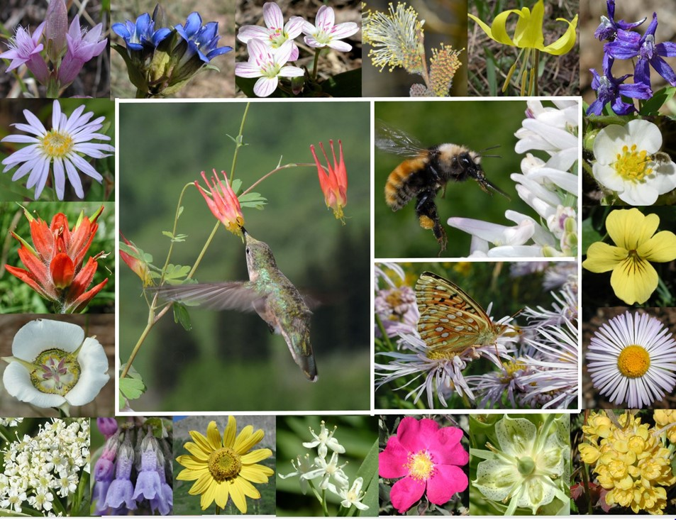
Examples of the many species of wildflowers and pollinators found at the Rocky Mountain Biological Laboratory. Image by D.W. Inouye.

THE ECOLOGICAL QUESTION:
How have long term changes in climate affected the phenology of wildflowers growing in subalpine habitats?
FOUR DIMENSIONAL ECOLOGY EDUCATION (4DEE) FRAMEWORK
- Core Ecological Concepts:
- Organisms
      - Biotic and abiotic features of the environment
- Resources and regulators
- Phenology
- Life history
- Community
- Mutualism (pollination)
- Biosphere
- Global climate change
- Ecology Practices:
- Quantitative reasoning and computational thinking
- Data skills - data visualization
- Computer skills - spreadsheets
- Data analysis and interpretation
- Designing and critiquing investigations
- Working collaboratively
- Communicating and applying ecology
- Human-Environment Interactions:
- Human accelerated environmental change
- Global climate change
- Cross-cutting Themes:
- Spatial & Temporal
- Scales
- Stability and change
WHAT STUDENTS DO:
This is a three-part project. In part I, students research the natural history of one subalpine plant species (e.g., Delphinium nuttallianum, Erigeron speciosus, Helianthella quinquenervis, Lupinus bakeri). In part II, they are given a data set consisting of > 45 years of climate data (1976-2022) from a location where flowering of these plants has been surveyed yearly over that same time period (Rocky Mountain Biological Laboratory in Gothic, CO). The students use the data to graph and analyze trends in snow and temperature and develop hypotheses about how the phenology and fitness (e.g., interactions with pollinators) of their assigned plant species will respond to these changes. In part III, the students receive > 45 years of data on the flowering phenology of their plant species at the same site (1974-2020) and make graphs to test their hypotheses. The students communicate their findings with a written scientific report, conference-style poster, or oral presentation.

STUDENT-ACTIVE APPROACHES:
Guided inquiry, collaborative learning, project-based learning, peer instruction
STUDENT ASSESSMENTS:
- A worksheet where students report their research on basic life history features of their assigned plant species, including habitat, mode of reproduction, ecological interactions with other species (predators, prey, and mutualists), and how it is classified. The worksheet is to be completed individually, outside of class.
- A worksheet where students create and interpret graphs of climate data over time, as well as create and explain predictions about plant and pollinator phenological responses to climate change (to be completed in pairs or groups, in class)
- One of the following: a lab-report style scientific report, conference-style poster, or oral presentation explaining how the phenology of their assigned plant species has changed over 45 years, in response to climate change (to be completed either individually or in groups, at home or in class)
CLASS TIME:
1 hour and 15 minutes for Part II; 1 hour and 15 minutes for Part III
COURSE CONTEXT:
This lesson has been conducted in a second-semester introductory biology course for Freshman and Sophomore science majors, at a community college. The class contains a maximum of 35 students each semester.
SOURCES:
billy barr. 2023. Gothic Weather: https://www.gothicwx.org/ (data from the Rocky Mountain Biological Laboratory)
Prather, R.M., N. Underwood, R.M. Dalton, b. barr, and B.D. Inouye. 2023. Climate data from the Rocky Mountain Biological Laboratory (1975-2022). Ecology 104:e4153. https://doi.org/10.1002/ecy.4153
Underwood, N., B.D. Inouye, R.E. Irwin, A. Classen, and D.W. Inouye. 2023. RMBL Flowering Phenology Project. (data from the Rocky Mountain Biological Laboratory, by request from https://rmblphenologyproject.weebly.com/data.html)
ACKNOWLEDGEMENTS:
We thank billy barr for providing long-term climate data, and the many people who have contributed to gathering and curating the flowering phenology data, particularly Dr. Rebecca Prather. Funding for the flowering phenology dataset was provided by NSF LTREB grants DEB-0922080, DEB-1354104, DEB-1912006, and DEB-2016749. Funding for the development of this lesson provided by an NSF ROA supplement to NSF LTREB grant DEB-2016749 supporting D. McNutt.

OVERVIEW OF THE ECOLOGICAL BACKGROUND
Phenology, the timing of life history events, can affect the fitness of individuals and ecological interactions. For example, plant fitness should be maximized if plants grow during periods when abiotic factors (i.e., sunlight, temperature, and soil moisture) are at optimal levels and flowering peaks during peak pollinator activity. Studies involving many kinds of organisms have demonstrated that aspects of phenology (e.g., first, peak, and last appearance of flowers) can change with climate (e.g., Zhang et al. 2015). For example, some plants flower earlier when snow melts earlier (e.g., Inouye et al. 2003) and pollinator emergence can be earlier with higher spring temperatures (Forrest 2016). However, not all species in a community respond to climate change equally (Prather et al. 2022), creating the potential for phenological mismatches between interacting species. Because there is naturally large year-to-year variation in variables like snow and temperature, long term data sets are required for understanding the effects of climate change on organisms’ phenology and thus their fitness.
These two long-term datasets were gathered at the Rocky Mountain Biological Laboratory (RMBL) in Gothic, CO. At this high elevation site in the West Elk range of the Rocky Mountains, billy barr, the winter caretaker at RMBL, has been collecting climate data at RMBL daily since the winter of 1974-1975. These data include daily low and high temperature, daily snowfall, snowpack depth, and the timing of spring snowmelt. Over the same years, a research team originally led by the ecologist Dr. David Inouye, and currently headed by Drs. Nora Underwood and Brian Inouye, has sampled flowering plants in 23 2m x 2m permanent field plots. Each plot is surveyed three times a week during the flowering season, and the number of open flowers on each plant species in the plot is recorded. This allows for the calculation of several phenology variables for each plant species per plot per year: first and last appearance of flowers, peak flower timing and count, and total flower number and duration of flowering across the season. Plant phenological variables can thus be compared to climate variables to understand how plants are responding to climatic changes.
References
Forrest J. R. 2016. Complex responses of insect phenology to climate change. Current Opinion in Insect Science 17:49–54 https://doi.org/10.1016/j.cois.2016.07.002
Inouye, D. W., F. Saavedra, W. Lee-Yang. 2003. Environmental influences on the phenology and abundance of flowering by Androsace septentrionalis (Primulaceae). American Journal of Botany 90:905–910 https://doi.org/10.3732/ajb.90.6.905

Prather, R. M., R. M. Dalton, b. barr, D. T. Blumstein, C. L. Boggs, A. K. Brody, D. W. Inouye, R. E. Irwin, J. G. Martin, R. J. Smith, D. H. Van Vuren, C. P. Wells, H. H. Whiteman, B. D. Inouye, and N. Underwood. 2023. Current and lagged climate affects phenology across diverse taxonomic groups. Proceedings of the Royal Society B 290:20222181 https://doi.org/10.1098/rspb.2022.2181
Zhang, H., W. Yuan, S. Liu, W. Dong, and Y. Fu. 2015. Sensitivity of flowering phenology to changing temperature in China, Journal of Geophysical Research in Biogeosciences 120:1658–1665 https://doi.org/10.1002/2015JG003112

LEARNING OBJECTIVES
After completing this lesson, students should be able to:
- Create scatterplots in a spreadsheet program and use trendlines to determine and describe the nature of a relationship between independent and dependent variables, accounting for variability in the data.
- Use evidence (graphical analysis of data) to describe temporal trends in specific climatic variables (e.g., temperature, snow) in subalpine environments, which may be affected by climate change.
- Define phenology and use evidence (graphical analysis of data) to predict and explain how climate change has (or has not) affected the phenology of plants growing in subalpine environments.
- Effectively communicate the results of a scientific investigation using a scientific paper, poster, or oral presentation that includes an introduction to the research question, methods of gathering and analyzing data, a clear visualization and interpretation of results, and a discussion of the implications of findings.
- Use evidence (graphical analysis of data) to predict how climate-mediated changes in phenology will affect the fitness of plants and their pollinators in future years.

DATA SETS
- RMBL climate data 1976-2022 FOR STUDENTS
- RMBL climate data 1976-2022 FOR FACULTY
- RMBL phenology summary data 1974-2020 FOR STUDENTS
- RMBL phenology summary data 1974-2020 FOR FACULTY

STUDENT INSTRUCTIONS
Student worksheets
Part I Worksheet: Natural History of Study Species
Introduction:
In this project, you will investigate the potential effects of climate change on flowering plants that live in subalpine meadows, which are open fields at high elevation but not above the treeline. You will be assigned a species of plant that is found growing near the Rocky Mountain Biological Laboratory in Gothic, Colorado. In future assignments, you will analyze data to see whether the climate has changed at this location since the 1970s, and whether these changes are associated with shifts in the phenology (timing of growth and reproduction) of this plant.
First, you will get to know your assigned plant species by researching basic natural history information about it. The natural history of a species includes observations of where that species lives, its mode of reproduction, behavioral and ecological interactions with other species (predators, prey, and mutualists), and how it is classified.
Assigned species:
The species you will investigate with the project will be assigned according to the first letter of your last name- see the following chart:
First letter of last name: | Assigned species:
A-H | Delphinium nuttallianum
I-P | Erigeron speciosus
Q-S | Helianthella quinquenervis
T-Z | Lupinus bakeri

Instructions:
Use a web search to look up the following information about your assigned species and write your findings below. One good place to start is the PLANTS database, which is provided by the USDA: https://plants.sc.egov.usda.gov/java/. Another good resource is https://www.swcoloradowildflowers.com/
*Note: if you can’t find a particular piece of information for your exact species, try broadening your search to research the genus. This might help for sections III, V and VI.

- Classification - broader:
- Is this plant a vascular or non-vascular plant?
- Is this plant a seed or seedless plant?
- Is this plant a flowering or non-flowering plant?
- Based on the above three criteria, is this plant a bryophyte, fern, gymnosperm, or angiosperm?

- Classification – narrower:
- Is this plant a moncot or dicot?
- What family is this plant in?
- What is the common name of this plant (the non-scientific name)?

- Growth characteristics and life history
- What type of “growth habit” does this plant have (e.g., herb, bush, tree, etc.)? See the following webpage for a list of growth habits: https://plants.sc.egov.usda.gov/growth_habits_def.html
- Is this plant annual, biennial, or perennial?

- Distribution
- Is this plant native to the US?
- Where in the US does this plant live (what regions or states?)
- What range of elevation does this plant live in?
- What type(s) of habitat does this plant live in? (fields, forest, woods, roadside, etc.)

- Reproductive biology
- What color flowers does the plant have?
- How many flowers per plant, on average?
- What are physical characteristics of the flowers (floral morphology)? (for example: number of petals and sepals, characteristics or numbers of stamens/anthers, or stigmas/styles/ovaries?)
- What type of fruit does the plant produce (remember, all flowering plants produce fruits)?
- Is the fruit dry or fleshy?
- Is the fruit simple, multiple, or aggregate?

VI. Ecological/human interactions
- What are the main pollinators of this plant?
- Does the plant possess any adaptations, such as nectar, that may attract mutualists (pollinators or seed dispersers)?
- Who might eat it? What are the main mammalian or insect herbivores of this plant?
- Does the plant possess any adaptations, such as toxins, that may protect the plant and deter herbivores?
- How do you think one or more of the biotic interactions that you listed above (pollination, seed dispersal, or herbivory) could be affected by climate change? You might think about the effects of climate change on the plant and/or animal species’ abundance, life cycle, physical traits, or behavior.
- What do you find most interesting about this plant species or the genus it is in (for example, interesting adaptations, ways it interacts with humans or other animals, medicinal or economic importance, etc.?

- Copy and paste a picture of your plant species below.

Part II Worksheet: Rocky Mountain Climate Analysis
Introduction:
This is Part II of a project in which you will investigate potential changes in climate at the Rocky Mountain Biological Laboratory (RMBL) in Gothic, Colorado and associated changes in the flowering of plants that live in subalpine meadows around this site. RMBL is about 9500 feet above sea level and has snow cover for half the year; snow can accumulate to several feet deep in winter. In this assignment, you will analyze data to see how the climate has changed at this location since 1976.
The data you will analyze was collected by billy barr, the RMBL accountant/winter caretaker, who has lived at this site for the entire time and collects climate data each day of the year near his cabin. His dataset is publicly available here: http://www.gothicwx.org/
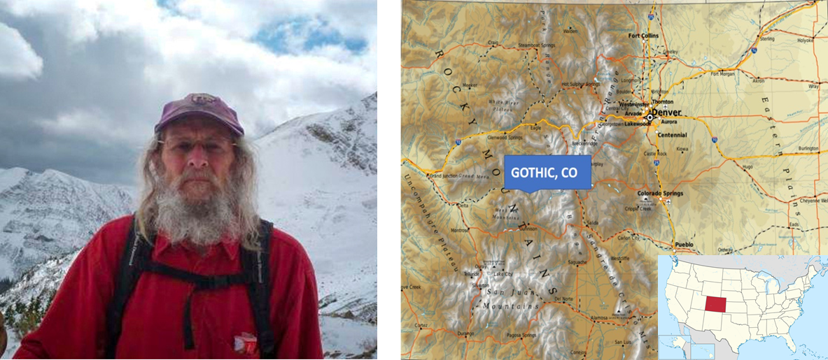
billy barr photo courtesy of RMBL.org; Colorado map image by Ikonact on Wikimedia Commons
Instructions:
- Download/access the dataset
- On the course website, there is a link to an Excel file containing a climate dataset that has been assembled from billy’s website.
*Note that this file contains two spreadsheets – data from the entire winter (Nov-May) and just before the plants start growing (May)
- First you will think about what type of graph will most clearly show trends in the average climate at RMBL over time. Start with the spreadsheet called Winter data (Nov-May). Look through the variables, then choose one of the climate variables that you think has likely been affected by climate change. By hand, draw a rough graph of how you estimate this variable has changed over time, from 1976 to 2022. Make sure that you label the x- and y-axes of your graph, that your axes are drawn at the proper scale, and that the predicted trend (relationship between the climate variable and year) is clear. You don’t have to plot every number in the dataset, but you should plot a few actual values from whichever data column you choose, to show the estimated trend over time.
- Now you will use the spreadsheet program to plot and analyze changes in snow and temperature variables over time. Using the first spreadsheet (entire winter data), make graphs of the relationships between year (1976-2022) and the climate variables that you think might be affected by global climate change. Using your graphs as evidence, answer the following question:
Has the average climate at this location changed over these years? If so, how (warmer vs cooler, more vs. less snow, snow appears or melts earlier or later in the year, etc.)? Your answer must include both a written response (at least 4-5 sentences) and at least two graphs – one involving temperature and one involving snow – that back up your response. Make sure your graphs have x- and y-axis labels and that your data are graphed on the proper scale (data points are spaced so that trends are clearly visible).
- May is usually when the first plants emerge from their underground roots at RMBL. Using the second spreadsheet (May data), make graphs of the relationships between year (1976-2022) and climate variables in May. Using your graphs as evidence, answer the following question:
Have the climatic conditions in May at this location changed in a consistent way over these years? If so, how (earlier vs. later snowmelt? more or less snow? warmer or cooler? etc.)? Your answer must include both a written response (at least 4-5 sentences) and at least two graphs – one involving temperature and one involving snow – that back up your response. Make sure your graphs have x- and y-axis labels and that your data are graphed on the proper scale (data points are spaced so that trends are clearly visible).
Generating hypotheses for the next assignment:
- Each spring, after the snow melts, the plant species you have been assigned start sprouting from underground roots, grow for a while, and then produce flowers. Based on your answers/graphs to the above questions, how do you think the plants’ timing of these events might respond to the changing climate? Explain your reasoning behind your answers to each of the following questions. You might think about the timing of snow melt, the temperature, the amount of snow, and what other environmental variables (ex: soil moisture) might be related to the things you graphed above.
- As the climate changes, will the plants start flowering earlier or later in the year, compared with previous years?
- As the climate changes, will the plants stop flowering earlier or later in the year, compared with previous years?
- As the climate changes, will the plants produce more flowers or fewer flowers each year over their lifetime, compared with previous years?
- To reproduce (make seeds) the plant species you have been assigned for this project must all be pollinated by animals, such as bees, hummingbirds, and butterflies. Like the plants, the animals are not active until the snow melts, and then they start visiting flowers to gain resources for survival and reproduction. Based on your answers/graphs to the above questions, how do you think the pollinators’ timing might respond to the changing climate? Explain your reasoning behind your answers to each of the following questions.
- As the climate changes, will the pollinators start being active (flying around) earlier or later in the year, compared with previous years?
- As the climate changes, will the pollinators stop being active earlier or later in the year, compared with previous years?
- As the climate changes, will the pollinators produce more or fewer offspring over their lifetime, compared with previous years?

Part III Worksheet: Natural History of Study Species
Introduction:
Phenology is defined as the timing of events in an organism’s life cycle. For example, many plants emerge in the spring, grow and flower in the summer, and then die or go into dormancy in the fall and winter. Phenology can refer to any aspect of the organism's life cycle, such as the phenology of leafing out, flowering, making fruits, or turning color and going dormant. A plant’s phenology is often adapted to its local environment in order to best match the timing of these events with seasonal cycles in resources, light, temperature, or precipitation.
Plants and animals may also change their phenology in response to longer-term changes in their environment. In Part I of this project, you researched a specific plant species that lives in subalpine meadows around the Rocky Mountain Biological Laboratory (RMBL) in Gothic, Colorado. In Part II, you analyzed climate data and found that some aspects of climate (snow and temperature) have changed over the years at this site. In Part III, you will investigate whether the phenology of your plant species has also changed over this time span at this location.
The data you will analyze was collected by a team of researchers originally headed by Dr. David Inouye, an ecologist who works at RMBL. He and the current leaders of this project (Drs. Nora Underwood and Brian Inouye of Florida State University) have been surveying the same 23 plots (2 x 2 m areas in the field) every year since 1974. Each plot is sampled three times per week during the summer, and the number of open flowers on each plant in the plot is recorded each time. Their data are publicly available, by request. See this website for more information: https://rmblphenologyproject.weebly.com/data.html
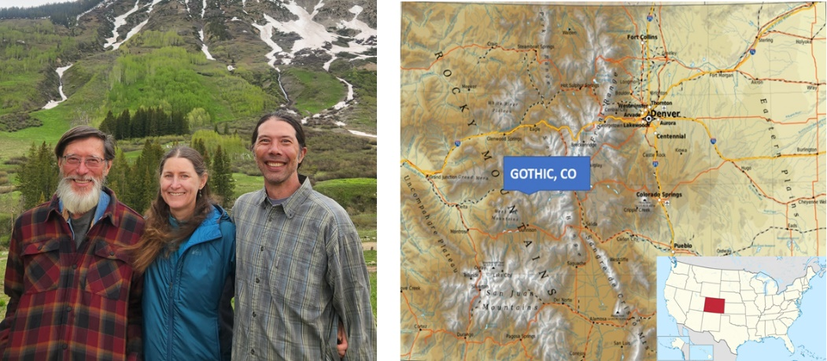

L to R: David Inouye, Nora Underwood, Brian Inouye (photo by M. Inouye). Colorado map image by Ikonact on Wikimedia Commons
Instructions:
- Download/access the dataset
- On the course website, there is a link to an Excel file containing a plant phenology dataset that was obtained from the researchers.
*Note that this file contains several different spreadsheets – you will need to find the sheet that corresponds with the plant species you researched in Part I of this project.
- Familiarize yourself with the data
Each data set contains several columns that represent the variables measured on plants of one particular species in each plot. Here is what each column in the dataset contains:

Variable | Definition
plot | specific area within the field where the plants were measured
firstfl.doy | day of the year when the first flowers on the plants opened
lastfl.doy | day of the year when the last flowers on the plants were open
peakfl.count | the largest number of flowers observed at once in the plot
peakfl.doy | day of the year when the largest number of flowers were observed at once in the plot
fl.duration | the total of number of days the plants in that plot had flowers

- Analyze the data
Like you did in Part II, make graphs of relationships between year (1974-2020) and the five different phenology variables listed above (first flower day of year, last flower day of year, peak flower count, peak flower day of year, and flowering duration). Add trend lines to these graphs, so you can see how the plant’s phenology might be changing over time.
*Note: you may need to adjust the y-axis to better see the trend, even if this hides some of the larger values in the data.
- Test your hypotheses/make conclusions
In Part II of the project, you developed three hypotheses about how climate change might affect plant phenology. Use your graphs to test these hypotheses. In other words, use your graphs to answer all of the following questions that were posed in the last assignment.
(Note: the answer to any of these questions could of course be that the plant’s phenology didn’t change - that there was no discernable difference in their life cycle over time.)
Question 1: As the climate changed, did the plants start flowering earlier or later in the year, compared with previous years? Copy and paste the graph that best answers this question, then describe the graph in words in a way that answers the question. Make sure your graph has a trendline and both x- and y-axis labels.
Question 2: As the climate changed, did the plants stop flowering earlier or later in the year, compared with previous years? Copy and paste the graph that best answers this question, then describe the graph in words in a way that answers the question. Make sure your graph has a trendline and both x- and y-axis labels.
Question 3: As the climate changed, did the plants produce more or fewer flowers each year, compared with previous years? Total flower number is not a variable in the dataset, but other variables may help get at this question. Copy and paste the graph that best answers this question, then describe the graph in words in a way that answers the question. Make sure your graph has a trendline and both x- and y-axis labels.
- Interpret your results
Now that you know how your plant has responded to climate change (or not) (i.e., what variables changed or not), explain your results by thinking about reasons for observed changes, or a lack of changes, in flowering. First, review your graphs and responses from Part II of this project to see how the climate has been changing at RMBL since 1976. Then answer the following questions:
Question 4: How did your plant species respond to climate change? Which specific phenology variables changed over time, and which didn’t?
Question 5: For each of the variables that did change over time: why do you think the changes in temperature or snow that you analyzed in Part II of this project caused changes in the flowering of your plant species?
Question 6: For each of the variables that did not change over time: why do you think changes in temperature or snow did not cause changes in the flowering of your plant species? Think about why a plant might not respond, or not be able to respond, to a specific factor in its environment.
- Think about future implications of your results
You analyzed over 45 years of flowering and climate data in this experiment, which should help you predict how continued changes in climate may affect the survival and reproduction of your plant species in the future. Review your answers to Part I of this project to remind yourself of the abiotic conditions and biotic interactions that are important to the growth and reproduction of your plant species, including interactions with herbivores and pollinators. Then answer the following questions:
Question 7: Assume that the climate at this site will continue to change in the same way it has since 1976. Discuss, based only on the data from this project, whether you think that continued climate change will benefit, harm, or not affect the fitness (survival and reproduction) of your plant species. Explain your reasoning.
Question 8: In class, we discussed other environmental variables that have been changing over time as part of global climate change. How might other biotic or abiotic environmental variables besides snowfall and temperature affect the fitness your plant species in Colorado due to climate change? Which variables do you think should be measured in the future as part of this project to test for these effects?
- Report your findings
Now that you have analyzed your data and come to some conclusions, you will write up your findings in the form of a scientific paper (i.e., primary literature article). In particular, your paper should contain the following information in the following labeled sections (see rubric for more details):
Title: You must include a sentence-length title that describes what was done in the study (including specific names of the study site and study species). Your title should mention what variables were measured on your species.
Introduction: This section should, in this order:
- Introduce the reader to the topic of climate change: explain how and why the climate is changing on Earth, and how climate change may affect particular species or ecosystems.
- Define phenology and explain how climate change may affect the phenology of particular plants or animals, such as the plants living in subalpine meadows (give specific examples).
- Explain the specific objectives of your study (Part III of this project), including each of your three hypotheses (from Part II of this project). Then, give a 1-2 sentence overview of how you met these objectives/tested these hypotheses. Provide names of study site and the specific plant species and what phenology variables you analyzed for this plant.
Methods:
- Using the information you found for Part I of this project (plant natural history), provide basic natural history information about your plant species. This would include the scientific and common name of the plant and a summary of its growth characteristics and life history, its distribution, its basic reproductive biology, and relevant ecological interactions.
- Introduce the reader to the study site where this research was performed (Rocky Mountain Laboratory in Gothic, CO) and explain how the climate has been changing here over the years. This is where you will discuss what you found in Part II of this assignment – you don’t need to show graphs, just describe trends.
- Explain where the phenology dataset you analyzed in Part III came from originally (not just from the course website), including names of the researchers, a brief description of their research methods, and how you personally obtained the data.
- Describe how you analyzed the data to answer your research questions. This should include:
  - The computer program you used
  - The types of graphs you made
  - The specific variables and relationships you graphed
  - How you used/interpreted the graphs to answer your research questions (i.e., how you determined whether each flowering variable changed over time, or not)
Results:
- Copy and paste the graphs that you think best answer or relate to your research questions into the results section. There should be at least 3 graphs - the graphs you included in your answers to Questions 1, 2, and 3 above in Part III. Make sure that all graphs have x- and y-axes with correct units, figure numbers, descriptive captions, and are referred to in the text of your paper.
- In writing, describe each trend that is shown in the graphs you included in your report, and reference the graph that shows that trend, in parentheses. When doing so, explain how the phenology variable that you graphed changed over time. For example:
On average, the peak number of flowers produced by Delphinium nuttallianum has decreased over time from 1974 to 2020 (Figure 1).
Discussion:
- Summarize the results you found in Part III of your project – which specific variables changed over time? Which didn’t? (your answer to Question 4 above in Part III)
- Discuss potential biological reasons for your results – how do you think the climate changes you documented in Part II led to the patterns you observed in the data. In other words:
  - If specific flowering variables changed over time, why? Why might changes in temperature or snow cause changes in the flowering of your plant? (your answer to Question 5 above in Part III)
  - If specific flowering variables didn’t change over time, why not? Why might a plant not respond, or not be able to respond, to a specific factor in its environment? (your answer to Question 6 above in Part III)
- Assume that the climate at this site will continue to change in the same way it has for the past few decades. Discuss, based on the data from this project, whether you think that continued climate change will benefit, harm, or not affect the fitness (survival and reproduction) of your plant species. Explain your reasoning. (your answer to Question 7 above in Part III)
- In class, we discussed other environmental variables that have been changing over time as part of global climate change. How might other environmental variables besides snowfall and temperature affect the fitness of your plant species in Colorado due to climate change? Which variables do you think should be measured in the future as part of this project to test for these effects? (your answer to Question 8 above in Part III)

Notes to Faculty
This lesson is designed to be a three-part project, where the students complete Part I on their own as a preparatory assignment, Part II in class in groups or pairs (with instructor guidance on how to create and interpret graphs), and Part III on their own (either in groups, pairs, or individually). Below are instructions for implementation of each part, as well as a suggested timeline and additional materials such as powerpoint slides and images you can use to introduce and guide the students through each assignment.
Suggested timeline (elements with asterisks not included in this publication):
Lesson/project element | When to implement or assign | Due date for students | When to provide feedback
- Plant biology/ecology unit (including plant-pollinator interactions)* | Before students begin Part I | N/A | N/A
- Part I of project: Natural History of Study Species | Directly after or during the last week of the Plant biology unit | Before students begin Part II | Before assigning Part III
- Lecture(s) on climate change (human causes; effects on species/ecosystems)* | Before students begin Part II | N/A | N/A
- In class - Part II of project: Rocky Mountain Climate Analysis | Directly after climate change lecture(s) | Before students begin Part III | Answers provided in class; give students individual feedback at least one week before Part III is due
- Assign Part III of project: Plant Phenology Analysis and Scientific Report | Directly after students complete Part II | 2-3 weeks after assigned | Before the end of the semester

Part I: Natural History of Study Species – Implementation Notes
Background
This assignment is designed to help students use web resources to learn more about the plant they will be studying for the overall project, and it is more exploratory. The knowledge gained from this assignment will help students interpret their results and provide necessary information for writing their scientific report/poster/oral presentation.
The plants studied in this lesson generally live in the Western United States, in mountainous regions (the elevation of the Rocky Mountain Biological Laboratory (RMBL) is ~9500 ft. above sea level). All are perennial forbs/herbs that overwinter and reemerge from belowground storage organs. They are all pollinated by insects or hummingbirds (which are numerous at the field site). The plots in Colorado where these plants grow contain > 100 species of flowering plants; for this lesson, we chose species that are more uniformly present across plots and years (to increase sample size), but you will notice that the datasets are not all the same length because some plants are found across more plots each year. The species also differ in their flowering times across the season. For example, in these plots, Delphinium nuttallianum tends to flower earlier (early to mid-June), while Lupinus bakeri flowers later (late June, early July), followed by Helianthella quinquenervis and Erigeron speciosus.
Prior Knowledge
We start this overall lesson at the end of a unit on plant biology/ecology and before a lesson on climate change (see above timeline). The plant unit concludes with plant-pollinator interactions. Therefore, Part I is partially designed to assess students’ knowledge of broad plant classification. However, prior knowledge of plant taxonomy, biology, or pollination biology is not necessary for successful completion of this assignment, as long as students understand the basics of plant growth and reproduction and the nature of interactions between species (i.e., predation vs. mutualism vs. competition).
Implementation
Part I of this lesson is mostly self-guided, but we suggest you start with a brief overview of the entire project and suggest some resources to the students that they can use to find information, such as the USDA PLANTS database: https://plants.sc.egov.usda.gov/home. To be efficient with class time, we use an introductory video that the students can watch before starting the assignment. This video is found here, for your reference: https://youtu.be/84Z3n05Z1s8.
We set the due date for this assignment to correspond with the beginning of Part II of the lesson, so that it helps them prepare for the next set of content. Students typically do very well on this assignment; we find they miss the most points on the questions about fruit types because none of these plants have fruits that resemble their vision of a fruit – so it helps to remind them that any ripened ovary is considered a fruit, including something like a sunflower seed or a bean.

Part II: Rocky Mountain Climate Analysis – Implementation Notes
Background
In part II of this lesson, students will graphically analyze 45 years of climate data at the Rocky Mountain Biological Laboratory (RMBL) to see what aspects of the climate are changing at this site. This part of the overall project is designed to give the students experience with graphing actual climate data and interpreting these graphs to reinforce what they have learned in class about climate change. It also helps set up Part III of the assignment, because they will use their Part II results to create hypotheses about and interpret their plant species’ response to climate change in Part III.
RMBL is located at 9500 ft. in elevation, so winters are long – the average date of the first snowpack at this site is Nov 2 and the average date of first bare ground (snowmelt) is May 19, although with wide variation among years. Because the growing season is short, the flowering duration for each plant species can also be short (sometimes less than two weeks). Previous work has shown that the date of snow melt is important for the phenology of many plants, particularly those blooming early in the season. Early snowmelt generally causes plants to grow and flower earlier in the year, and later snowmelt leads to flowering later in the year, but not all plant species are equally responsive to snowmelt. The overall amount of snow is also critical for plant growth and flowering; snowier winters (with lots of snowmelt making the soil wet) tend to lead to greater numbers of flowers in the following summer. Less is known about the conditions that influence a plant to stop flowering, although some species seem to have a set flowering duration so that the length of flowering time stays consistent from year to year but just shifts earlier or later depending on the snow melt date.
The climate data set for Part II is provided by billy barr (names not capitalized by his choice), who maintains a publicly accessible database at https://www.gothicwx.org/. billy is the accountant and winter caretaker at RMBL, where he collects climate data each day of the year near his cabin. His food/supplies are skied in during the winter or grown in the greenhouse attached to his cabin. The following short video contains more information about billy: https://www.youtube.com/watch?v=ZsZDHTTtSIg
Our dataset was created using the data found under the “Data” and “Monthly Data” tabs on his website; other variables such as rainfall or snow depth can be added to the data set if you want to expand student options. For even more climate variables, his data are combined with nearby government weather stations in this publicly available dataset (Prather et al. 2023): https://doi.org/10.17605/OSF.IO/8EZKA.
Note: when creating our dataset, we defined “Year” as the year a particular winter ended (e.g., the data for year 1976 covers the winter that began in 1975 and ended in 1976). Some of these variables were thus measured in 1975 (e.g., first day of year of snowpack; Nov. average high and low temps) and others in 1976 (e.g., first day of snowmelt; Jan. average high and low temps).

References
Prather, R.M., N. Underwood, R.M. Dalton, b. barr, and B.D. Inouye. 2023. Climate data from the Rocky Mountain Biological Laboratory (1975-2022). Ecology 104:e4153. https://doi.org/10.1002/ecy.4153
Prior Knowledge
We recommend starting Part II directly after a lesson on the causes and consequences of climate change. In our climate change lesson (not included here), we cover a) evidence of human-caused increases in greenhouse gases, b) the greenhouse effect (relationship between greenhouse gas concentration and temperature), c) what humans can do to reduce the severity of climate change, and d) how individuals, populations, or species are affected by climate change. This sets Part II of the project up nicely because students are generally aware of well-published examples such as coral bleaching, wildfires, or melting polar icecaps, but less aware of changes in organisms’ traits, behaviors, or life history (including phenology).
Part II will go most smoothly if students have some experience using Microsoft Excel or Google sheets (particularly for making graphs like scatterplots), but this is not required. Since Part II is designed to be completed in class with guidance from the instructor, students can be paired based on self-efficacy using spreadsheets, with more experienced students helping those with less experience.
Students will probably need an introduction to the idea of phenology and may need an introduction to what seasons look like in a mountainous area (see below for ideas on how to scaffold this). For example, our students in Florida experience seasonality very differently than in Colorado; some students grew up in a sub-tropical climate, where plant phenology depends on a completely different set of factors.
Implementation
This part of the lesson is designed to be conducted within a single 1 hour and 15 minute class period. We start this period by having a brief discussion about plant phenology in annuals vs. perennials, how plants have adapted their phenology to a local environment, and how climate change may affect plant phenology (see below images); example slides are provided in supplementary materials.

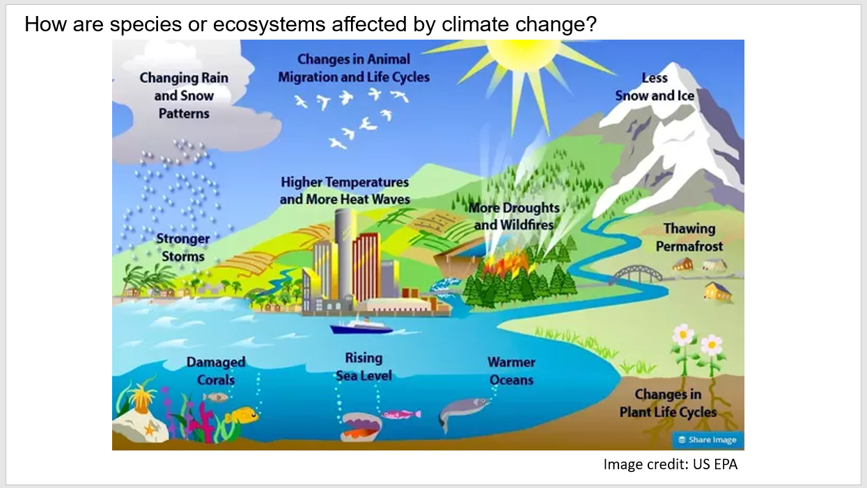

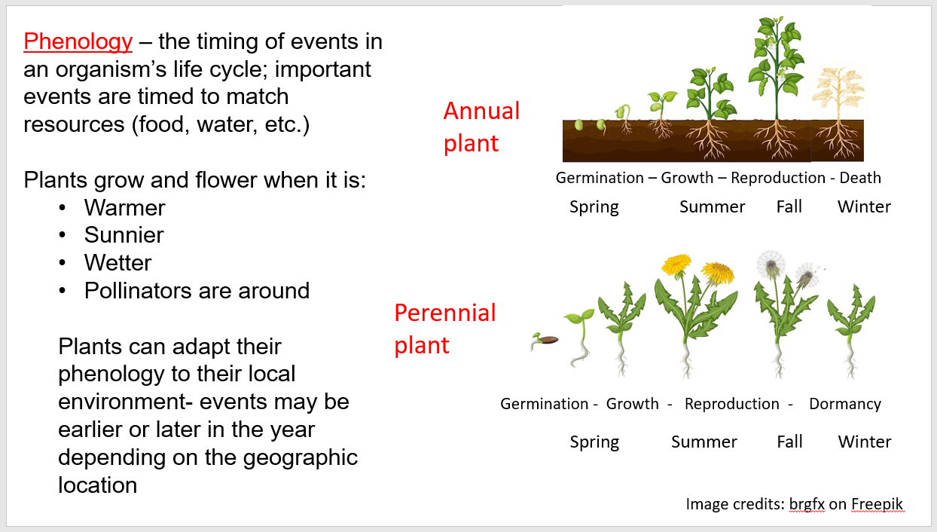
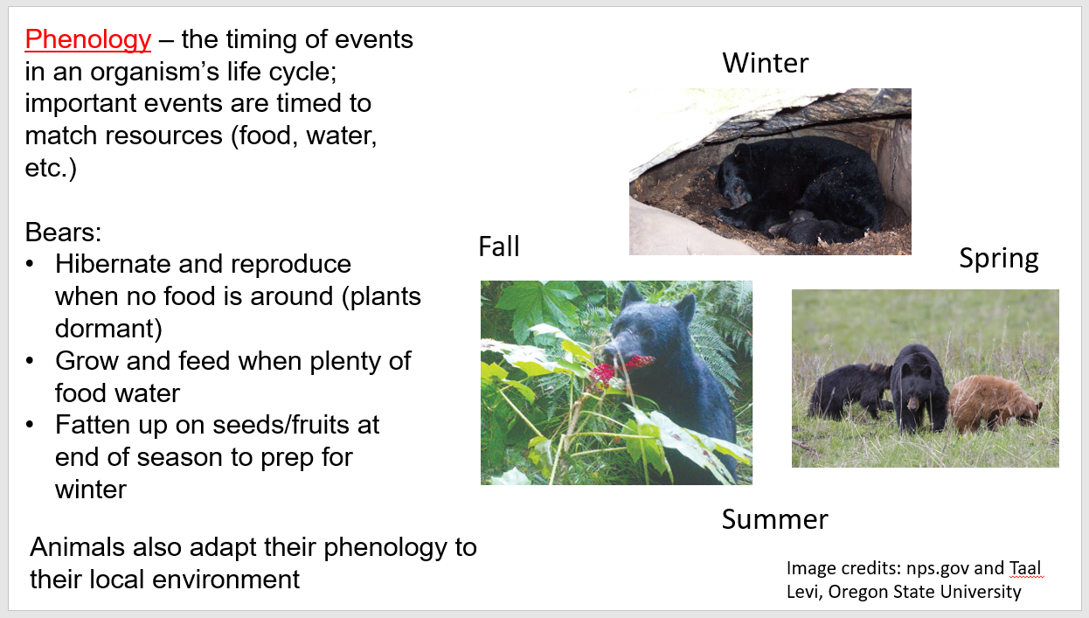

We then introduce the students to the RMBL study site, what the seasons look like at that site, and how the data for Part II were collected (see below slides). You can learn more about the lab here: https://www.rmbl.org/. A simple web search will show that billy barr is somewhat of a celebrity with many articles about him in national publications such as The Washington Post, The Atlantic, etc., which the students could read as supplemental material. There are also good photos of winter at RMBL here: https://coloradosun.com/2023/03/19/snow-research-gothic-colorado/

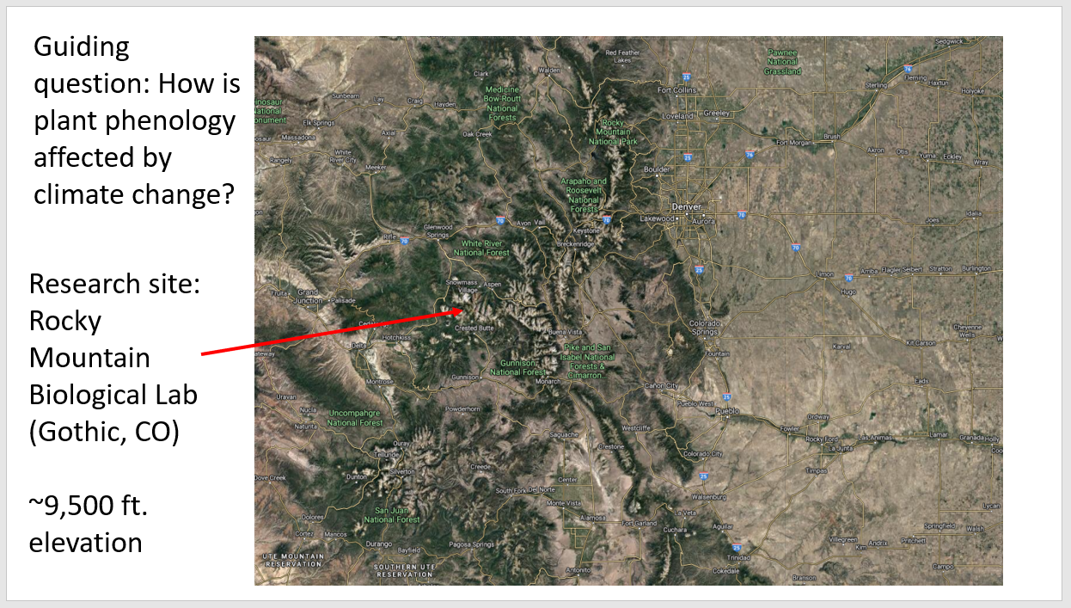

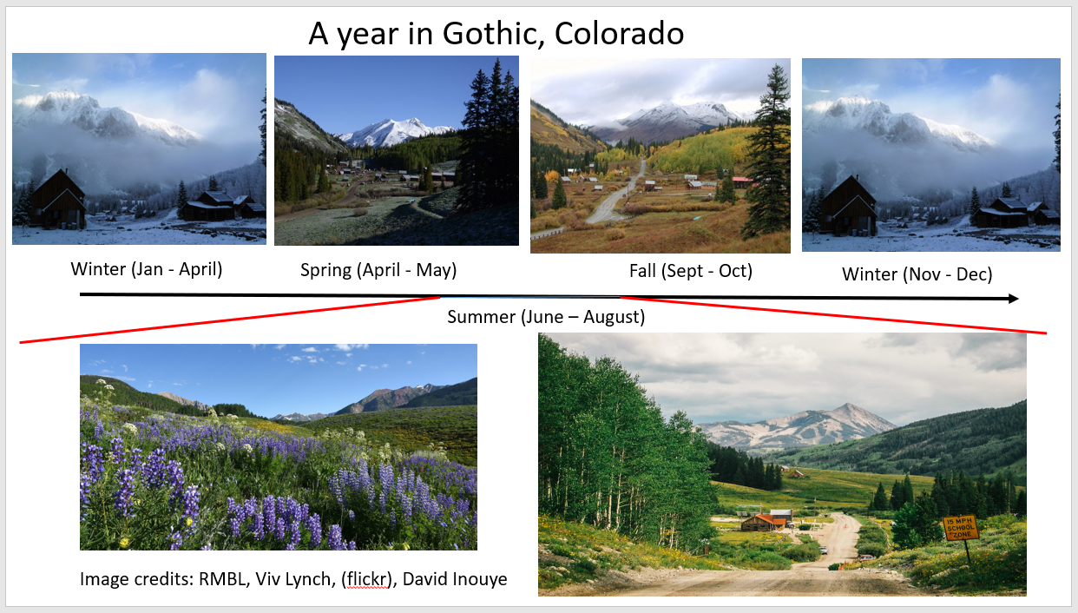

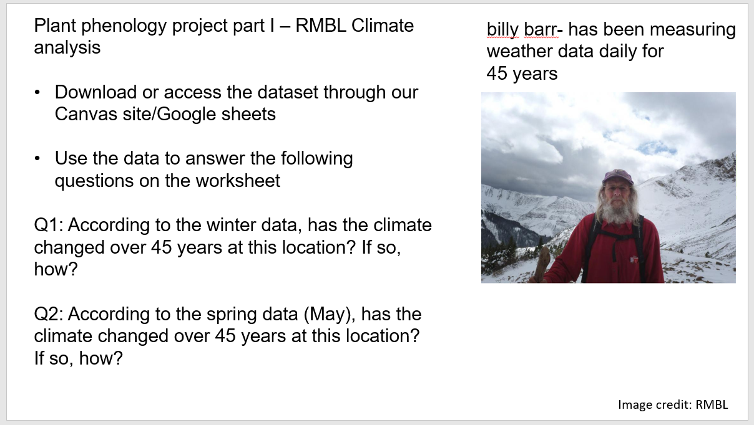

Finally, we have the students download the RMBL climate data 1976-2022 Excel file and the Part II worksheet from our course website (i.e., Canvas). We first introduce them to the data, including what each column/variable means and how the data are organized. Note the two tabs on the file – one for the entire winter (Nov – Mar) and one for May (right before plants will start to emerge from the ground).
We begin the analysis phase by asking the students what type of graph would best show average changes in these climate variables over the years they were measured and having them sketch a hypothetical trend for one of the variables (e.g., snowfall). This is a good time to address misconceptions about graphing issues like independent vs. dependent variables, graph types appropriate for continuous variables (line graph vs. scatterplot with trendline), etc. After reviewing their drawn graphs and discussing which is most appropriate for this analysis, we show the students how to make scatterplots in Excel and adding linear trendlines. To do this, we plot snowfall amount (y-axis) vs. year (x-axis) and add a linear trendline (see the following website for a brief refresher on how to do this: https://www.youtube.com/watch?v=jN3TzoOc1wU). We also show the students how to add x- and y-axis labels and adjust the scale of the axes to best show trends in the data. Note that the steps will be slightly different for students using a Mac computer or Google Sheets.
Next, we instruct the students to complete question 2 on the Part II worksheet by working in pairs or groups using the skills they just learned. To complete this question, they should open the Winter (May-Nov) tab and graph at least one snow-related variable over time (blue columns) and at least one temperature-related variable (orange columns) over time. Instructors and/or TAs should circulate around the room, helping resolve errors and making sure they are using correct axis labels, titles, and scales. Common student errors include using incorrect graph types (connecting points instead of using a trendline), forgetting to add the trendline, or graphing on an incorrect scale so that data points are too close together to see a trend. See examples of correct graphs in the Faculty version of the data file.
After completing their graphs, students should describe the trends in writing, to explain how the climate variables are changing over time (most are in fact changing as expected, if viewed at the correct scale). After most students/groups have completed their graphs and answers, we ask the students to share their answers while we write their statements on the front board, divided between snow results and temperature results while discussing the relationships between the two. In short, snowfall is decreasing and temperatures are increasing, which means less time covered in snow and earlier snowmelt. Two points could be important to make here. First, scale matters – a shift of 10 days in a climate event may not seem like much, but a week in the life of these plants is substantial, considering their brief flowering times and the brevity of the summer at RMBL. Second, there is considerable year-to-year variation, but the trendline enables us to see how things are changing on average over time. For some courses, a discussion of patterns seen at different time scales (days, weeks, months, years) may be useful.
After discussing the answers to question 3, the students should switch over to the May data set (second tab). Emphasize that these data are separate since this is what the plants will experience as they emerge – these are the variables they can essentially respond to when initiating growth, flowering, etc. Briefly introduce them to these data, then have them make the graphs required to answer question 4 on the Part II worksheet. This should take less time since the graphs and skills required will be similar to question 3. As before, the students will describe the trends in writing on the worksheet. Then you can review the students’ answers in class, with the instructor writing their verbal answers on a front board or computer. At this point, make sure that you have discussed that the date of snowmelt has gotten earlier over the years, since that is a very important cue for plant emergence and growth.
After discussing the answers to question 4, we have the students think about how the plants might respond to the changes in climate that they observed in their data analysis. With a partner or group, they will answer question 5A, B, and C. Note that these will be the hypotheses they will test in Part III of this project; there are no “wrong” answers as long as they explain their statements with sufficient logic/reasoning. When introducing these questions, we refer to the images of the perennial plant life cycle on the slide shown above and ask how specific stages might shift over time; for example, the blooming dandelion for start of flowering and the fruiting dandelion for end of flowering. This gives them something more specific to think about when developing hypotheses.
In past versions of this lesson students have struggled with the nested time-scales involved in questions 5A and 5B (and similar questions 6A and 6B), focusing only on the progression of flowering and seasonal environmental changes within a single year rather than discussing how climate and flowering time change across years. Addressing climate change requires thinking about both within-year and across year patterns. For example, here are one student’s answers to questions 5A and 5B that do not address climate change:

5A: Will the plants start flowering earlier or later in the year?
Student response: The plants would start flowering earlier because this is when the snow begins to dry up.
5B. Will the plants stop flowering earlier or later in the year?
Student response: The plants would stop flowering later in the year which would be during the winter period, late October, which is normally when it starts to get cold and snow begins falling.
Here are examples of student answers that do address climate change by implying a comparison of flowering and climate across years:
5A: Will the plants start flowering earlier or later in the year?
Student response: The plants will start flowering earlier in the year because the snow is melting sooner, there’s less snow on the ground, and there are higher temperatures earlier in the year.
5B: Will the plants stop flowering earlier or later in the year?
Student response: The plants will stop flowering earlier in the year because they are programmed to flower for only a certain amount of time and they started earlier, so they will stop earlier. Also, the increasing temperature could be causing the plants to become stressed and therefore not grow and flower as long.
The versions of the questions presented in the Part II Worksheet shown above in Student Worksheets have been changed to better scaffold a focus on across-year patterns, but if you notice continued problems with the time scale of answers to these questions, it would be an opportunity to discuss the general concept of different temporal scales (i.e., environmental variables changing within vs. among years) and the difference between the phenology of a species (timing within a year) versus changes in that phenology from year to year.
When answering question 5B, students also might reason that the plants will stop flowering later because winter (i.e., snow) is starting later; while this makes logical sense, you might point out that all of these plants will stop flowering long before the first snowfall. In fact, harsh summer conditions may be also a limit on organismal activity at this site.
Before proceeding to question 6, discuss the students’ answers as a class, encouraging them to explain their reasoning. We type or write out their answers on a projected computer screen for all students to reference during the discussion. If only one answer is given to a question, we often encourage students to think of why another answer might be possible, to generate alternative hypotheses for each question. For example, students often predict that plants will stop flowering later since it will be warmer longer during the year. If this is the only response, you could ask what would happen if floral duration is a genetic trait that is fixed, if plants have only a fixed amount of resources to devote to flowering, or whether conditions will become harsh earlier in the year due to climate changes (getting the students to think that plants may shift their entire phenology earlier – both the start and end of flowering). However, they only need to write down one hypothesis for each answer, since this will give them something specific to test in Part III of this lesson.
Finally, ask the students to answer questions 6A, B, and C in pairs or groups – this requires them to think about how the plants’ pollinators (and therefore their fitness) will respond to climate change. They will not test these hypotheses in Part III of the project, but they will be asked to think about pollinator responses when writing the discussion of their paper. As before, there are no “wrong” answers as long as they explain their statements with logic/reasoning. Students will typically answer these questions in the same way they answered question 5, with the same misconceptions, since they predict the pollinators will try to stay in sync with the plants, their food source. When discussing the answers as a class, you might again try to get them to come up with alternative hypotheses for each question. If you run out of time before getting to question 6, this is something the students can finish on their own because you have already given them the framework for thinking about this during the discussion of question 5.

Part III: Plant Phenology Analysis and Scientific Report – Implementation Notes
Background
In Part III of the lesson, students will analyze 45 years of plant phenology data collected at RMBL (the same location as the climate data) in order to explore how their plant species has responded to the climatic changes explored in Part II. This final part of the lesson is designed to allow the students to investigate the consequences of climate change for actual organisms by analyzing long-term phenology data collected in the field, and in doing so testing the hypotheses they created in Part II. Therefore, we recommend assigning Part III of the project directly after the students complete Part II. This assignment will also help develop students’ scientific communication skills by helping them to create and/or present a scientific paper, conference-style poster, or oral presentation. Finally, this assignment will allow students to apply the natural history knowledge and data analysis/interpretation skills developed in Parts I and II of this project, connecting all parts of the assignment. Depending on the instructor’s choice of implementation, Part III can be done individually or in groups, potentially developing students’ ability to collaborate with their peers.
The data for Part III comes from a Long-Term Research in Environmental Biology (LTREB) project funded by the National Science Foundation (NSF) that was initiated by Dr. David Inouye and is now run by Drs. Nora Underwood and Brian Inouye of Florida State University. These ecologists and their research team have surveyed flowering plants at RMBL in the same 23 2m x 2m plots over the course of the project. These plots have been surveyed each summer, every week, for over 45 years (there are no data for 1978 or 1990). See below for image of an example plot and the plot setup – the second image is an overhead view of RMBL and its surrounding lands. Most of the plots are located within the red-circled area on this image; lab buildings are in the center of the image.
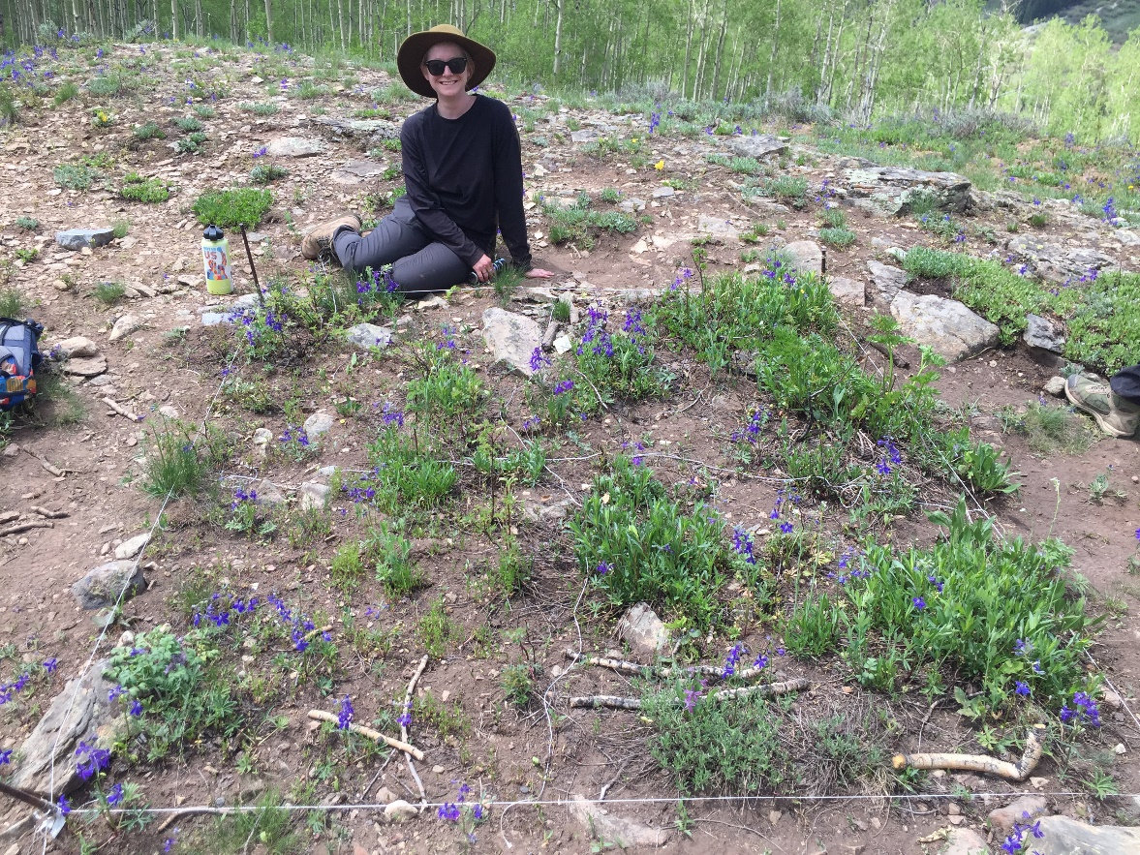

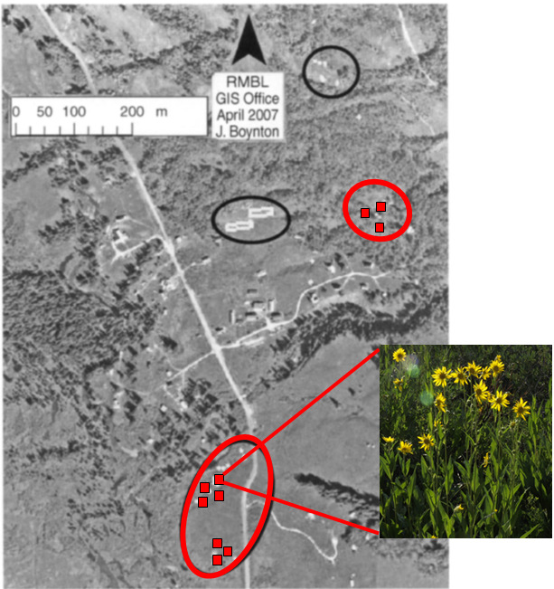
Above image modified from Inouye (2008), figure 1; Aspen sunflower image by Jim Morefield, licensed under the Creative Commons Attribution-Share Alike 2.0 Generic license.
Over the course of the summer, each plot is surveyed 3 times a week (currently every Monday, Wednesday, and Friday) and the total number of open flowers or inflorescences from each plant species is recorded each time. Therefore, for a given plant species in a given year and field plot, it is possible to calculate the first day the species was observed with open flowers in that plot (firstfl.doy on the dataset), the last day the species was observed with open flowers in that plot (lastfl.doy on the dataset), the highest number of flowers observed at once in that plot (peakfl.count on the dataset), the day the highest number of flowers were observed (peakfl.doy on the dataset) and the total number of days that species was observed to be flowering (fl.duration on the dataset) (see below image). A thorough description of the plots, sampling methods, and each flowering species found on the plots is available here, under metadata: https://www.rmbl.org/scientists/resources/data-catalog/data-catalog-entry/?catalog-id=11

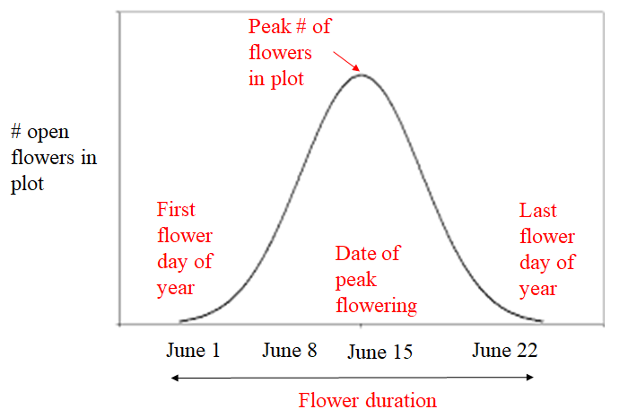

As stated above, we have designed this lesson to have the students analyze data from one of several plant species. The flowering phenology of a single species across one growing season can be represented using a phenological distribution such as the example shown above. Other forms of the distribution are possible, depending on the plant species and year observed. The students will not be creating phenological distributions in this project, but instructors can show an example to help students understand each variable in the phenology dataset. For faculty who want to dig into a deeper understanding of phenology, and particularly of the relative merits of different measures of phenology (firsts, peaks, etc.), see Inouye et al. 2019 – citation below.
The plant species that the students will investigate all grow in a good portion of the study plots and vary in their peak flowering times over the growing season. All of these species are perennials that overwinter underground. If you would like to explore the phenological response of other species, the above data variables for other species are available via request at the above link or the project website: https://rmblphenologyproject.weebly.com/data.html
In April 2023, a National Geographic article was written about the RMBL phenology project (Welch & Ross, 2023) – this could be a good resource for students or instructors as in introduction to the project. See below for citation. Many people have been involved in counting flowers over the years, including teachers, high school and college students, and scientists from all over the US and abroad. A lot of people have gotten their start in research counting these flowers (see below image); if your students are interested in working on this project or pursuing a paid summer REU internship at RMBL, they can be directed to the following website: https://www.rmbl.org/education-program-reu/.

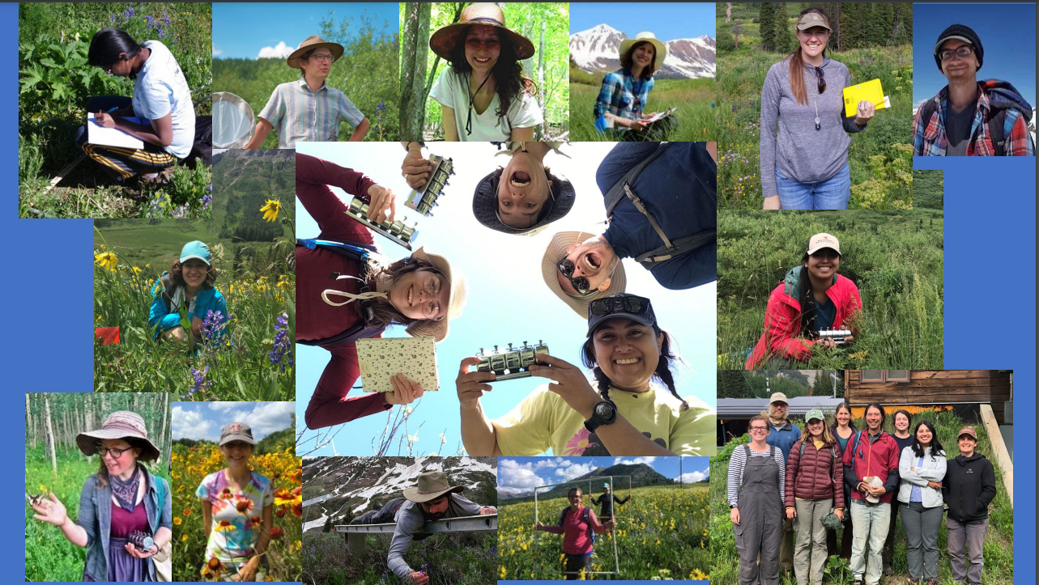

References
Inouye, B.D., J. Ehrlen and N. Underwood. 2019. Phenology as a process rather than an event: from individual reaction norms to community metrics. Ecological Monographs 89:e01352. https://doi.org/10.1002/ecm.1352
Inouye, D. W. 2008. Effects of climate change on phenology, frost damage, and floral abundance of montane wildflowers. Ecology 89:353-362. https://doi.org/10.1890/06-2128.1
Welch, C. and E. Ross. 2023. Seasons out of sync. National Geographic Magazine 243:92-117.
Prior Knowledge
After completing Parts I and II of the project, students should have most of the plant natural history knowledge (from Part I) and graphical/analytical skills (from Part II) they need to successfully complete this assignment. Depending on their academic history, students may or may not have developed the scientific communication skills required to present the instructor’s choice of final assessment for this project (a scientific report, conference-style poster, or oral presentation). To help students create these end-products:
- In semesters where we have had the students write a paper (individually), we assigned this paper after the students had already read and written a full peer-reviewed lab report in the corequisite lab course, so they already knew the structure and general content of a scientific paper. Students were also provided with a rubric and detailed checklist of what should go in each section of the paper (shown above at the end of the Part III worksheet).
- In semesters where we have had the students give a presentation (either in groups or individually), we had the TAs give examples of “bad” and “good” presentations on a topic previously covered in the class, having the students first critique the bad presentation and explain what could be improved.
- In semesters where we have had the students create a poster (either in groups or individually), we provided the students with a poster template, along with a detailed checklist of what should go in each section of the poster (both on the poster and a separate assignment sheet). This template is shown below and was originally obtained from the following website, which provides other design options: https://colinpurrington.com/tips/poster-design/.
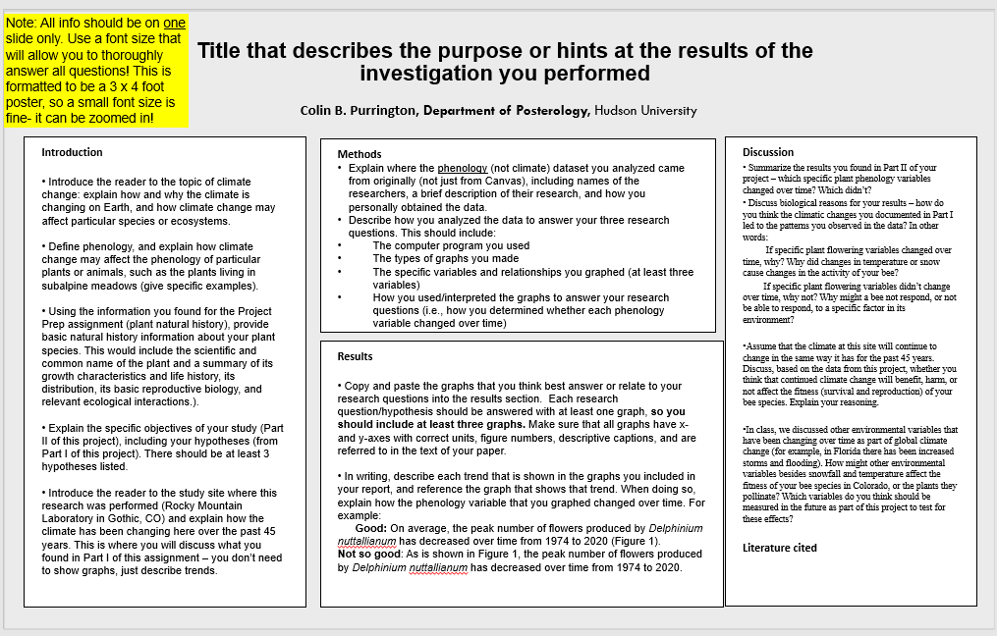

Implementation
The Part III worksheet provided above is designed for the students to do this entire assignment – including making graphs, analyzing the data, and writing a scientific paper – individually, outside of class. They do not turn in the worksheet, instead using their answers to help them write the paper. Since this is completed outside of class, to help the students get started on this, we created a video introducing the students to the data and the objectives of the Part III assignment: https://youtu.be/WL1F1rBuNEs. We have designed the paper to be turned in via Canvas or other Learning Management System; see the rubric below. If the instructor has a large class or no teaching assistants, grading student papers may be too time intensive – we recommend having the students create posters or oral presentations in groups, to reduce grading load. Whatever the end product, we recommend that that the instructor take some class time to wrap up the assignment, in which the similarities or differences in the responses of different plant species can be compared, with some attention given to the fact that these different species typically flower at different times during the growing season. We also use the wrap-up as an opportunity to discuss published findings showing effects of other climate variables on plant fitness, such as snowpack depth, late frost events, and summer precipitation.

Criteria | Ratings |  |  |  | Points
Title | 6 pts | 4 pts | 2 pts | 0 pts | 6 pts
 | Full Marks | Fair | Poor | No Marks
 | Includes a descriptive title that concisely captures the purpose of the lab experiment. The title contains biologically relevant names for the study organisms, including the scientific name of species or higher taxa (i.e., genus, family, etc.) or larger functional groups (e.g., herbivores, aquatic invertebrates, herbaceous plants) | One of the following: Title refers to topic of lab but is not descriptive; no reference to scientific name; no reference to location of the study. | Two of the following: Title refers to topic of lab but is not descriptive; no reference to scientific name; no reference to location of the study. | No title
Motivation for study | 12 pts | 8 pts | 4 pts | 0 pts | 12 pts
 | Full Marks | Fair | Poor | No Marks
 | Explains how and why the climate is changing on Earth, and how climate change may affect particular species or ecosystems | One of the following: patterns of climate change not accurately described; reasons for climate change not accurately described; effects of climate change not mentioned | Two of the following: patterns of climate change not described; reasons for climate change not described; effects of climate change not mentioned
Importance of research | 12 pts | 8 pts | 4 pts | 0 pts | 12 pts
 | Full Marks | Fair | Poor | No Marks
 | Defines phenology and fully explains how climate change might affect the phenology of species | One of the following: phenology is not defined; effects of climate change on phenology not mentioned; some content inaccurate | Two of the following: phenology is not defined; effects of climate change on phenology not mentioned; some content inaccurate
Questions and Purpose | 12 pts | 8 pts | 4 pts | 0 pts | 12 pt
 | Full Marks | Fair | Poor | No Marks
 | States the exact objectives of the study, including the specific questions and hypotheses being tested along with a brief summary of the approach to testing those questions. Study site and species are named, along with the phenology variables measured at this site. | One of the following: objectives are stated but incomplete; hypotheses are not included; no overview that mentions name of study site, plant species, and variables analyzed. | Two of the following: objectives are stated but incomplete; hypotheses are not included; no overview that mentions name of study site, plant species, and variables analyzed.
Natural history - plant species | 12 pts | 8 pts | 4 pts | 0 pts | 12 pts
 | Full Marks | Fair | Poor | No Marks
 | Provides relevant natural history information for the plant species analyzed in the project. Includes scientific and common name of the plant and a summary of its growth characteristics and life history, its distribution, its basic reproductive biology, and relevant ecological interactions. | Natural history is given, but is incomplete, not relevant, or incorrect. A limited description of the study species is included. | Little to no relevant natural history is included; environmental conditions or field site characteristics are not adequately discussed.
Natural history - study site | 12 pts | 8 pts | 4 pts | 0 pts | 12 pts
 | Full Marks | Fair | Poor | No Marks
 | Provides relevant background information for study site, including location. Describes how climate has been changing at this site for 45 years. | Site information is given, but is incomplete, not relevant, or incorrect. A limited description of climate change is included. | One of the following: site information not included, or description of climate change at this site not included
Experimental methods | 10 pts | 5 pts | 0 pts - No Marks |  | 10 pts
 | Full Marks | Poor
 | Fully explains where the dataset that was analyzed came from. | Incomplete description of dataset origin.
Data analysis methods | 12 pts | 8 pts | 4 pts | 0 pts | 12 pts
 | Full Marks | Fair | Poor | No Marks
 | The method of data analysis used to answer each question in the lab experiment is fully described, including which exact data were analyzed, including the computer program used, the types of graphs constructed, the specific variables and relationships graphed, and how the graphs were used to answer the research questions. | One of the following: computer program not mentioned, type of graphs and variables/relationships not described, no mention of how graphs were interpreted | Two of the following: computer program not mentioned, type of graphs and variables/relationships not described, no mention of how graphs were interpreted
Reporting trends | 12 pts | 8 pts | 4 pts | 0 pts | 12 pts
 | Full Marks | Fair | Poor | No Marks
 | Trends in the graphs produced during data analysis are full described in writing, explaining how the phenology variables changed over time. | One of the following: at least one of the trends relating to an objective not described or incorrect, i.e, effect of climate on: • Start of flowering • End of flowering • Number of flowers produced | Two of the following: at least two of the trends relating to an objective not described or incorrect; i.e, effect of climate on: • Start of flowering • End of flowering • Number of flowers produced
Figures - trends | 18 pts | 12 pts | 6 pts | 0 pts | 18 pts
 | Full Marks | Fair | Poor | No Marks
 | Easily interpretable graphs are used to summarize each of the major trends in the data and are referred to in the written results section. The graphs address the original question/hypothesis and does not consist of tables of raw data without summary or average. | No graph of effect of climate change on one of the following: • Start of flowering • End of flowering • Number of flowers produced | No graph of effect of climate change on two of the following: • Start of flowering • End of flowering • Number of flowers produced
Figures - logistics | 12 pts | 8 pts | 4 pts | 0 pts | 12 pts
 | Full Marks | Fair | Poor | No Marks
 | All figures contain: • a figure number referred to in the text • a description caption that summarizes what the figure shows, including what data is being shown in the graph or table (means, medians, etc.) • axis labels or column/row titles with units of an appropriate scale • text/formatting/graphics that are clear and easy to read | One or two of the following: Figure not referred to in the text; incomplete or inaccurate descriptive caption; no figure number; missing or incorrect column, row, or axis labels; missing or incorrect units on columns, rows, or axes; table or graph; graph difficult to read | Three or four of the following: Figure not referred to in the text; incomplete or inaccurate descriptive caption; no figure number; missing or incorrect column, row, or axis labels; missing or incorrect units on columns, rows, or axes; table or graph; graph difficult to read
Discussion- results summary | 12 pts | 8 pts | 4 pts | 0 pts | 12 pts
 | Full Marks | Fair | Poor | No Marks
 | The author states their conclusion about effects of climate change on all plant phenology variables tested in this experiment. | No conclusion about effects of climate change on one of the following variables: • Start of flowering • End of flowering • Number of flowers produced | No conclusion about effects of climate change on two of the following variables: • Start of flowering • End of flowering • Number of flowers produced
Discussion- results interpretation | 12 pts | 8 pts | 4 pts | 0 pts | 12 pts
 | Full Marks | Fair | Poor | No Marks
 | Results are explained with direct reference to biological processes. Reasons for patterns in the plant phenology data are fully explored using logic and scientific knowledge. | Lack of or illogical interpretation about effects of climate change on one of the following variables: • Start of flowering • End of flowering • Number of flowers produced | Lack of or illogical interpretation about effects of climate change on two of the following variables: • Start of flowering • End of flowering • Number of flowers produced
Larger context and application of results | 12 pts | 8 pts | 4 pts | 0 pts | 12 pts
 | Full Marks | Fair | Poor | No Marks
 | Implications for plant fitness at this site in the future are fully discussed. This includes effects of changes in climate variables analyzed in this project as well as climate variables not analyzed in this project. | One of the following: no discussion of implications of climate change on plant fitness using either variables from this project or other environmental variables; implications not logically correct. | Two of the following: no discussion of implications of climate change on plant fitness using either variables from this project or other environmental variables; implications not logically correct.
Organization and sentence fluency | 12 pts | 8 pts | 4 pts | 0 pts | 12 pts
 | Full Marks | Fair | Poor | No Marks
 | The writing has a sense of purpose and structure. Content is found in the proper sections with correct headings. | Some content is found in the incorrect sections. Logic within sections occasionally hard to follow. | Poor structure makes ideas difficult to understand; substantial content in incorrect sections; lack of headings
Word choice | 10 pts | 7 pts | 4 pts | 0 pts | 10 pts
 | Full Marks | Fair | Poor | No Marks
 | The writing includes a broad range of words that have been carefully chosen. All terminology is correctly used. | The writing includes a variety of generic words with some misused or inappropriate terminology; | The writing includes many misused words and/or phrases not used in scientific writing such as “it’s proven”
Conventions | 12 pts | 8 pts | 4 pts | 0 pts | 12 pts
 | Full Marks | Fair | Poor | No Marks
 | The author used appropriate grammar, spelling, punctuation, paragraphing, capitalization and formatting (superscripts and subscripts), and tense (first person, past tense). | The author made multiple (2-5) technical writing errors | The author made several (> 5) technical writing errors

We recently converted this lesson into a group project in which the students analyzed the phenology data together and created a conference-style poster in groups. In this format, the data analysis stage was done within a single 1 hour and 15 minute class (with the instructor present to help), and the students collaborated outside of class to create the poster. We found that when working in groups, students typically divided up the poster sections so that each student wrote a separate section. This meant the end-product frequently lacked some flow and organization. One solution could be to assign a group leader that is responsible for making sure the entire poster is cohesive. We have had the groups turn in the poster file to the course website, to be graded by the instructor using a rubric similar to the paper rubric above (with additional criteria for visual clarity); it would also be possible to have students present the posters individually or in pairs/groups like they would at a conference. Posters can be printed out in sections and reassembled if poster printers are not available: https://libguides.humboldt.edu/poster/printing. During a poster walk, students could peer review each other given a rubric – see example below.
An oral presentation could be implemented using the same approach as the poster – having students work in groups inside or outside of class to analyze data and complete the worksheet then create a Powerpoint or Google Slides presentation to be given in class or recorded and uploaded to Canvas. As discussed above with the poster, students could peer review each other’s work, given a rubric. See example rubric below.

Oral or poster presentation rubric
Category Score:  0 = Poor  2.5 = Average  5 = Excellent | Category criteria: The criteria below must be met to receive all points in each category. Missing or incomplete portions may result in fractional points. | Comments: Critiques and suggestions for improving the talk.
Introduction (5)  ____.___pts. | - Explains the causes and consequences of climate change  - Defines phenology and describes how climate change may affect the phenology of organisms  - States the specific objectives of the study and all three hypotheses being tested | Comments:
Methods (5)  ____.___pts. | - Provides basic natural history information about the plant being studied (common name, growth and reproductive features, species interactions  - Describes the location of the study site (RMBL) and how the climate has been changing at this site for 45 years.  - Explains where the data set came from and how the data was analyzed to answer each of the three research questions | Comments:
Results (5)  ____.___pts. | - Includes three graphs can be used to answer each of the three research questions posed in the introduction  - Describes trends in these graphs in a way that addresses each research questions | Comments:
Conclusion/take-home message (5)  ____.___pts. | - Clearly summarizes the research findings, including which phenology variables changed or didn’t change over time  - Explains biological reasons for why specific phenology variables changed or didn’t  - Discusses what the results mean for the fitness of the plant species, and which other variables should be measured in the future. | Comments:
Presentation quality (5)  ____.___pts. | - Clarity of slides or other visual aids: appropriate images and amount text  - Logical organization  - Information is scientifically accurate  - Arguments based on scientific evidence  - Presentation delivered professionally  - Presentation under 15 min | Comments:

Most common student errors
Our experience is that with a clear introduction, instructions, and scaffolding, students are very successful at writing the paper, even when working alone to analyze the data. The most common error is that students often do not address all three hypotheses in their paper (i.e., did climate change affect the first day of flowering, last day of flowering, or flower number/duration). They often fail to provide and/or interpret the three or more graphs needed to evaluate each hypothesis, or they do not properly give a biological explanation why each of their three chosen variables changed (or did not change) over the years. We have modified the Part III worksheet to make instructions clearer, but we predict this will still be an issue for some of the students.
The second most common error is that students often confuse the Part II (climate variable) analysis with the Part III (phenology variable) analysis. The students are asked to summarize their results from Part II in the methods of their Part III paper and use the climate variable trends to help explain their phenology research findings in the discussion of their paper. However, in Part III they are not asked to show graphs of climate variables or extensively describe climate changes in their paper – this paper should be focused on the methods or results of the phenology analysis. Instead, students often include climate graphs in their Part III paper (not required), discuss how the climate data was obtained (instead of the phenology data), and present/explain the climate results in the results section and discussion (again, we want them focusing on the phenology results here).
Extensions
The lesson is constructed so that the students do not directly compare the climate data to the plant phenology data on the same graph (both are graphed over time, which is always the x-axis variable). We did this to have students focus on trends over time (i.e., temporal variation) rather than have students attempt to identify specific variables that plants respond to (i.e., relationships between climate and phenology variables). We also wanted to simplify the assignment for our population of students, who do not have much experience making scatterplots or interpreting graphs. An extension of the assignment could be to have students in Part III compare the climate and phenology variables directly, given they have already shown that the climate variables are changing over time in Part II. This would require the students to choose climate variables that they think would most strongly influence each aspect of plant phenology (first and last date of flowering, flower number or duration). They could then hypothesize why plants responded more strongly to certain variables than others.
The RMBL Phenology Project is part of a larger collaborative project that also studies bee phenology at the same location. The bee project is headed by Dr. Rebecca Irwin and has recorded bee activity data at these plots since 2009. In previous semesters, we have had students analyze bee phenology data instead of plant phenology data, to see how four species of native solitary bees at the site have been responding to climate change (like the plants, most bee species - but not all – have been emerging from their nests earlier in the year due to earlier snowmelt). The bee lesson is very similar to the plant lesson – students research bee natural history in Part I, analyze climate data in Part II (same as above), and analyze bee phenology data in part III. An extension could be to have part of the class analyze plant data while others could analyze bee data, to facilitate comparison and examine synchronicity of the mutualists. This site contains a thorough description of the bee sampling methods and plot locations (under the Metadata link), and a link to request data from Dr. Irwin (under Download Dataset link): https://www.rmbl.org/scientists/resources/data-catalog/data-catalog-entry/?catalog-id=10

