Assignment:
How to run Multivariate Ecological Analysis for Unconstrained Non-metric Multidimensional Scaling (NMS) Ordination, perMANOVA, and Indicator Species Analysis using R (4.0.2) and RStudio Desktop

Learning outcomes:
By the end of this activity, students should be able to:
- Recognize what types of data are appropriate for multivariate analysis through visualization of a given primary and secondary dataset.
- Run a Non-metric multidimensional scaling (NMS) ordination in R that visualizes plant community composition patterns between well pads and adjacent reference forests.
  - Export plot as an image and add a detailed figure caption.
- Be able to identify and use permutational multivariate analysis of variance (perMANOVA) to distinguish between plant community groups on the well pad and in the adjacent forest reference sites.
- Use indicator species analysis to identify which species are contributing to separation among a priori groups (well pad vs forest).
- Describe and interpret the output of their multivariate statistical analyses, including their plant community ordination plot, perMANOVA, and indicator species analyses.

Background Information/Metadata:
Ecological succession has been a long-standing area of focus in ecology (Connell and Slatyer 1977, Pickett et al. 1987). However, less studied are the ways in which anthropogenic disturbance agents, such as natural resource extraction, may alter the successional trajectories of ecosystems. Site preparation for oil and gas extraction is a high intensity disturbance agent that removes the vegetation and surface soil on the well pad. After the well pad is decommissioned, subsequent reclamation, which includes requirements to meet criteria to receive certification (e.g., in Alberta - ESRD 2013), then attempts to restore vegetation and soil properties on the well pad. However, the surface stripping often removes the native seedbank, thus resetting the successional pathway for the well pad, and therefore the potential to shift (or even arrest) the well pads successional trajectory is high. This dataset investigates patterns in the understory plant communities (the percent cover of shrubs, herbs, grasses, clubmoss, fern, lichens, including non-native species) as a function of measuring vegetation recovery in clustered study units that include both certified reclaimed well pads and adjacent undisturbed forested reference sites. The study units were located in both the Central Mixedwood (conifer & deciduous; n=15) and Lower Foothills (n=15) Natural Subregions of Alberta (The Natural Regions Committee, 2006).These study units contained reclaimed well pads, ranging from 7-48 years post-certification. Other ecological variables measured included: age post-reclamation, the LFH depth (organic soil layer), soil bulk density, soil pH, organic soil carbon, soil nitrogen, the soil C:N ratio, number of live and dead trees, and live and dead basal area. Detailed sampling methods are described in McIntosh et al. (2019). [For more detailed background information about the study and data files, review WellvsRefMetadata.docx]

Primarydataset.csv file contains a unique identifier column (ID) that indicates the sampling unit that was measured – it is a combination of the Site_ID and the WellorRef fields from Secondataset.csv so there is one row of plant community data for each of the 60 sampling units (30 sites * 2 locations within each site – wellsite (well) or adjacent reference (ref)). The columns after ID are the species codes for each of the 106 understory plant species that were sampled within the 0.25 m² quadrats. The values reported here are the mean percent cover values for all of the quadrats that were sampled within a wellsite or reference forest within a given study unit that was sampled. See Appendix A for species code.
Seconddataset.csv Entity-level Metadata
Table 1. Seconddataset.csv Column Descriptors
Column identifier | Type | Units | Description
ID | Primary Key | n/a | Unique identifier that indicates the sampling unit that was measured – it is a combination of the Site_ID and the WellorRef fields so there is one row and one unique identifier for each of the 60 sampling units (30 sites * 2 locations within each site)
Site_ID | Categorical | n/a | Identification of wellsite (There are 30 total, with 15 in the Boreal Natural region (Bor1-15) and 15 in the Foothills Natural region (Foot1-15).
WellorRef | Categorical | n/a | Whether it is the wellsite (Well) or adjacent reference (Ref) site that was sampled in that row
Bor1Foot2 | Categorical | n/a | Natural subregion within the Boreal or Foothills Natural Regions: 1 = Central Mixedwood Boreal Natural Subregion; 2 = Lower Foothills Natural Subregion
Age_postcert | Quantitative | yrs | The number of years that has passed between when the reclamation certificate was issued after the wellsite was decommissioned and when the wellsite was sampled.
LFHmean_mm | Quantitative | mm | LFH soil horizon depth (organic layer)
BD_0-15cmdepth_cm | Quantitative | g/cm³ | Bulk density of the soil - 0-15 cm depth
pH_0 | Quantitative | n/a | measured pH of the soil - 0-15 cm depth
TOC_0 | Quantitative | % | Total organic carbon in the soil - 0-15 cm depth
TN_0 | Quantitative | % | Total nitrogen in the soil - 0-15 cm depth
CNratio_0 | Quantitative | n/a | Carbon to nitrogen ratio of the soil - 0-15 cm depth
tph_total | Quantitative | #/ha | Number of live and dead trees/ha
LiveBA_m2/ha | Quantitative | m²/ha | Live basal area (BA; m²/ha) for all trees combined.
DeadBA_m2/ha | Quantitative | m²/ha | Dead basal area (BA; m²/ha) for all trees combined.
herb_cover | Quantitative | % | Percent herb cover
shrub_cover | Quantitative | % | Percent shrub cover
graminoid_cover | Quantitative | % | Percent graminoid cover
lichen_cover | Quantitative | % | Percent lichen cover
clubmoss_cover | Quantitative | % | Percent clubmoss cover
fern_cover | Quantitative | % | Percent fern cover
non_native_cover | Quantitative | % | Percent non-native vegetation cover

Assignment:
You will perform a non-metric multidimensional scaling (NMS )ordination, permutational multivariate analysis of variance (perMANOVA), Indicator Species Analysis, and Summary Statistics to explore the effect of the grouping factor in this dataset (i.e., well pad or reference forest) on the plant communities of these research sites.
Use the WellvsRef_RPrimer.docx to guide you through providing answers for the following numbered inquiries.
NMS Ordination (Section 4 of the Primer)
- Export and paste your scree plot here (see section 4.1):
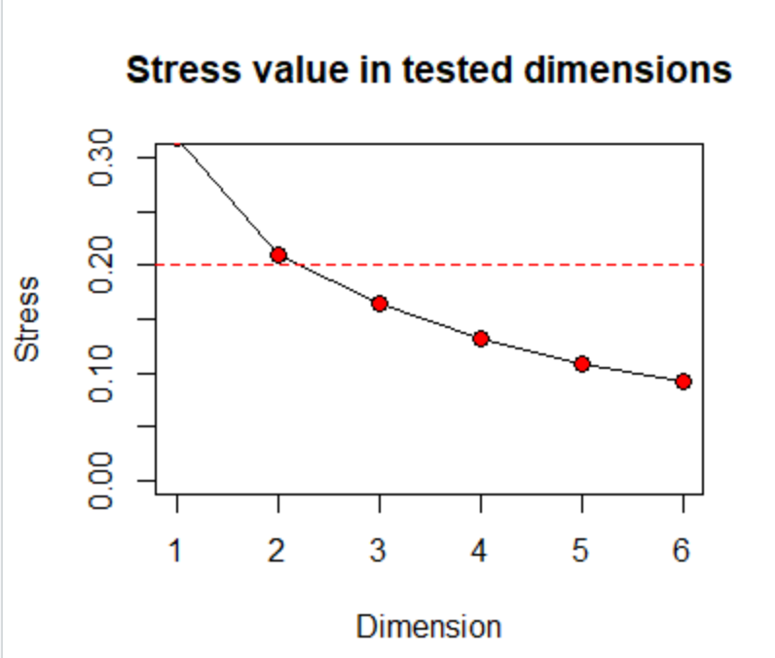
- Export and paste your ordmain output (see section 4.2). This information will be useful for writing your results section (see below).
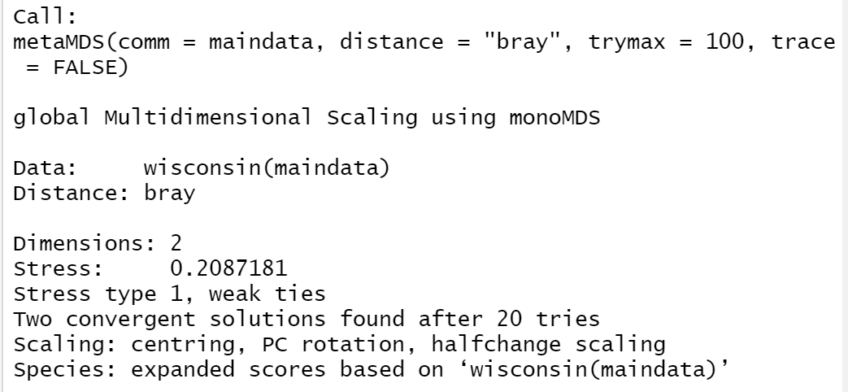

- Run a i) 3-dimensional and ii) a 4-dimensional NMS ordination. Export and paste your output including your stress and number of tries on the 3-dimensional and 4-dimensional NMS ordinations.
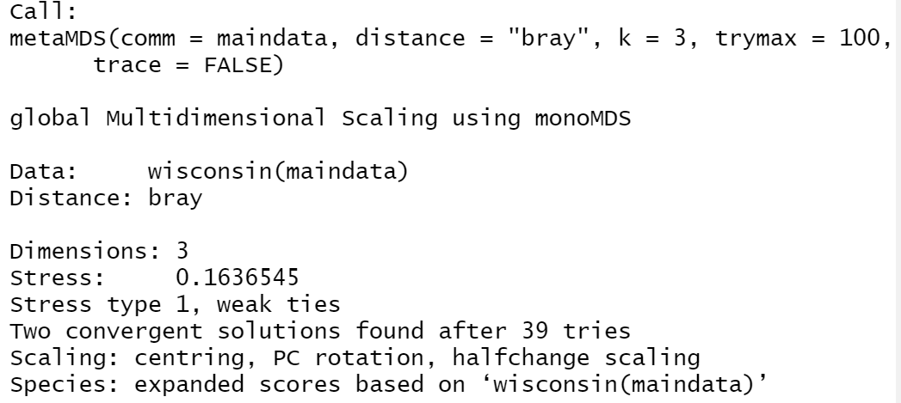
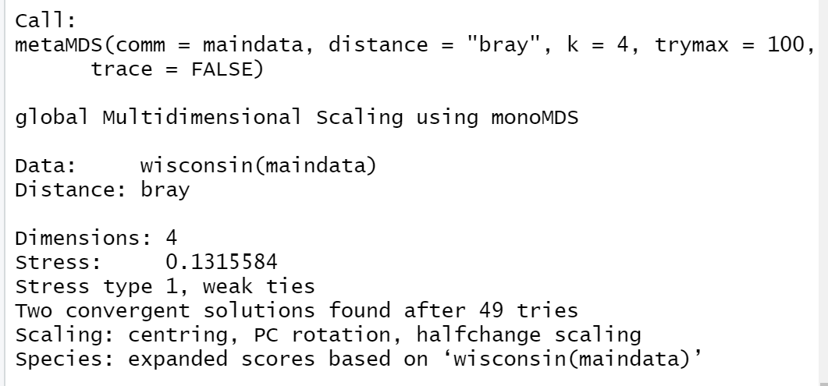

- How much of an improvement in stress was there from the 2-D to the 4-D solution?

Just need to take their value (depending on what seed they use the absolute number could vary) of stress for 2-D solution and subtract the 4-D solution:
= 20.87-13.16 % = 7.71 = 7.7% improvement.

- Export and paste an NMS plot of your choice (section 4.3): While going through the primer, you will notice that you were given various methods on how to produce your ordination plot (i.e., different colors, symbols etc.) For your NMS plot, include only a polygon border and legend, and use a different symbol and color code for your datapoints (cannot be the same ones as in the primer!). No need to include vectors on this ordination plot (but you can if you like – if you do, provide two plots one with the vectors and one without). Be sure to include a detailed figure caption describing your plot.
Here is an example:
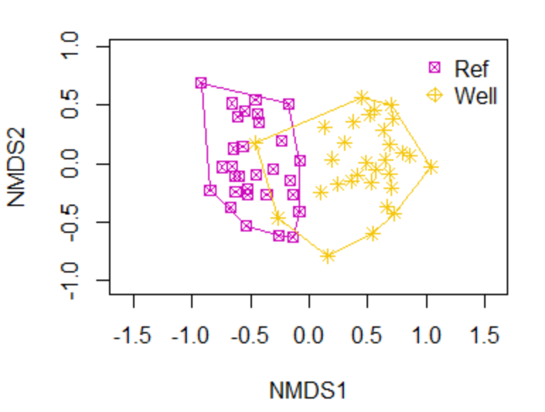
Fig A. NMS ordination for the understory vegetation delineated by site wellsite “Well” or reference site “Ref”.

- Vectors. i) Copy and paste the vector output from your analyses (section 4.4). Hint: Using the snip tool may make the output more user friendly than just copying and pasting from RStudio). ii) Based on the vector output - is age post-certification an important attribute in contributing to the separation of the groups? Why or why not? What about non-native cover?
Note – because it is permutation based the P-value results will vary slightly.
Output using the Snip tool:
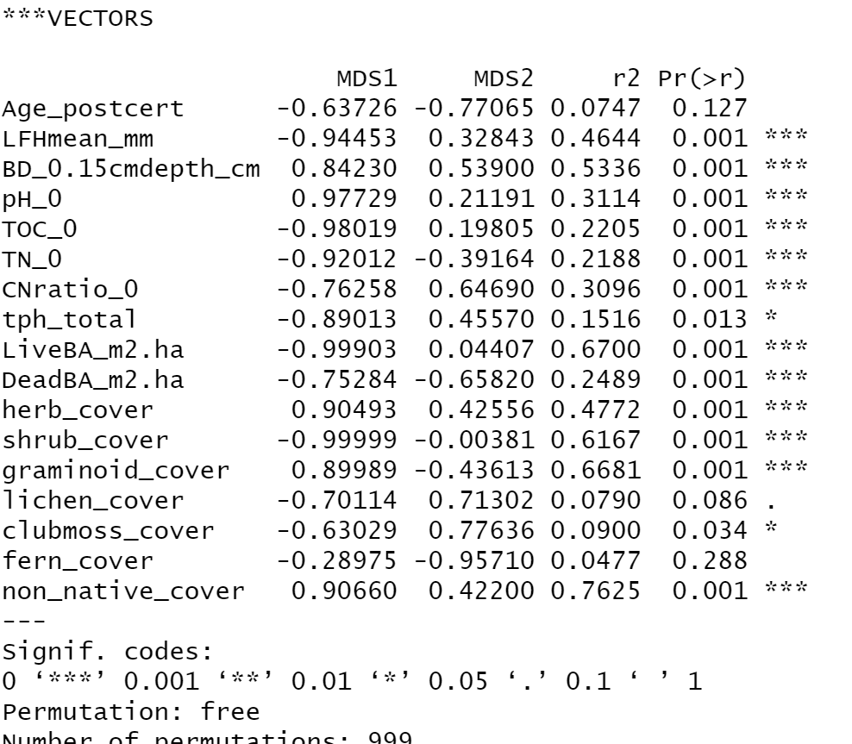
Copy and paste:
***VECTORS

MDS1 MDS2 r2 Pr(>r)
Age_postcert -0.63726 -0.77065 0.0747 0.127
LFHmean_mm -0.94453 0.32843 0.4644 0.001 ***
BD_0.15cmdepth_cm 0.84230 0.53900 0.5336 0.001 ***
pH_0 0.97729 0.21191 0.3114 0.001 ***
TOC_0 -0.98019 0.19805 0.2205 0.001 ***
TN_0 -0.92012 -0.39164 0.2188 0.001 ***
CNratio_0 -0.76258 0.64690 0.3096 0.001 ***
tph_total -0.89013 0.45570 0.1516 0.013 *
LiveBA_m2.ha -0.99903 0.04407 0.6700 0.001 ***
DeadBA_m2.ha -0.75284 -0.65820 0.2489 0.001 ***
herb_cover 0.90493 0.42556 0.4772 0.001 ***
shrub_cover -0.99999 -0.00381 0.6167 0.001 ***
graminoid_cover 0.89989 -0.43613 0.6681 0.001 ***
lichen_cover -0.70114 0.71302 0.0790 0.086 .
clubmoss_cover -0.63029 0.77636 0.0900 0.034 *
fern_cover -0.28975 -0.95710 0.0477 0.288
non_native_cover 0.90660 0.42200 0.7625 0.001 ***
---
Signif. codes:
0 ‘***’ 0.001 ‘**’ 0.01 ‘*’ 0.05 ‘.’ 0.1 ‘ ’ 1
Permutation: free
Number of permutations: 999
ii) Assuming that alpha=0.05, then Age post certification is not an important attribute (P=0.13) whereas non-native cover is an important attribute (P<0.001).

perMANOVA (Section 5 of the Primer)

- Run the perMANOVA and copy and paste your perMANOVA output (reminder: using the snipping tool sometimes gives a better output)
Note to instructor: Because it is permutation based the P-values will vary for each student
Snipping tool:
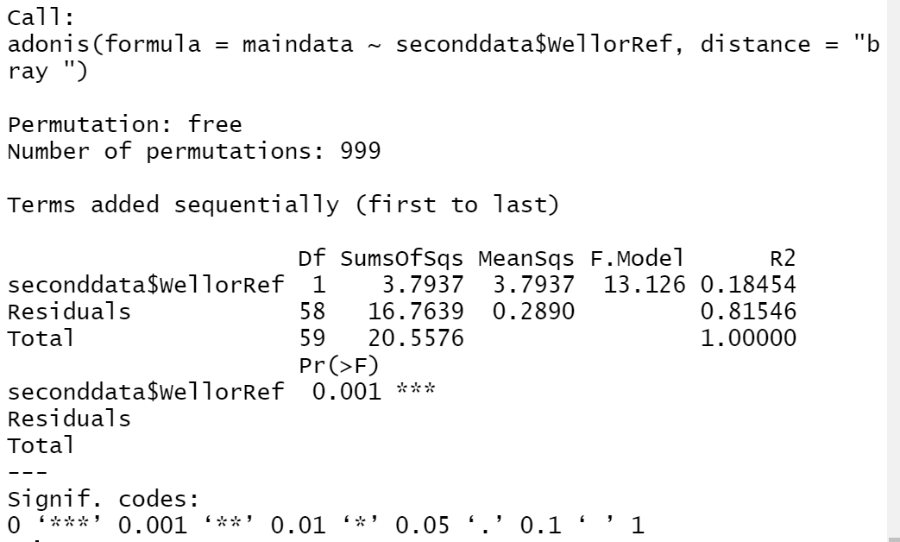

Copy and paste:
Call:
Adonis2(formula = maindata ~ seconddata$WellorRef, distance = "bray ")

Permutation: free
Number of permutations: 999

Terms added sequentially (first to last)

Df SumsOfSqs MeanSqs F.Model R2
seconddata$WellorRef 1 3.7937 3.7937 13.126 0.18454
Residuals 58 16.7639 0.2890 0.81546
Total 59 20.5576 1.00000
Pr(>F)
seconddata$WellorRef 0.001 ***
Residuals
Total
---
Signif. codes: 0 ‘***’ 0.001 ‘**’ 0.01 ‘*’ 0.05 ‘.’ 0.1 ‘ ’ 1

Inidicator species analysis (Section 6 of the Primer)

- i) Run Indicator Species Analysis and export and paste your ISA output, first for just the significant species and then for all species. ii) Is green alder (Alnus crispa – see Appendix for species code) a good indicator for the reference forests? What are you basing your decision on? iii) is Cornus canadensis a good indicator for either group – if so – which one – what are you basing your decision on?
Significant species: Snipping tool:
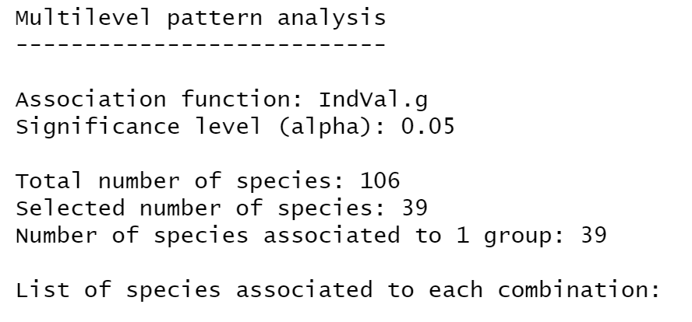
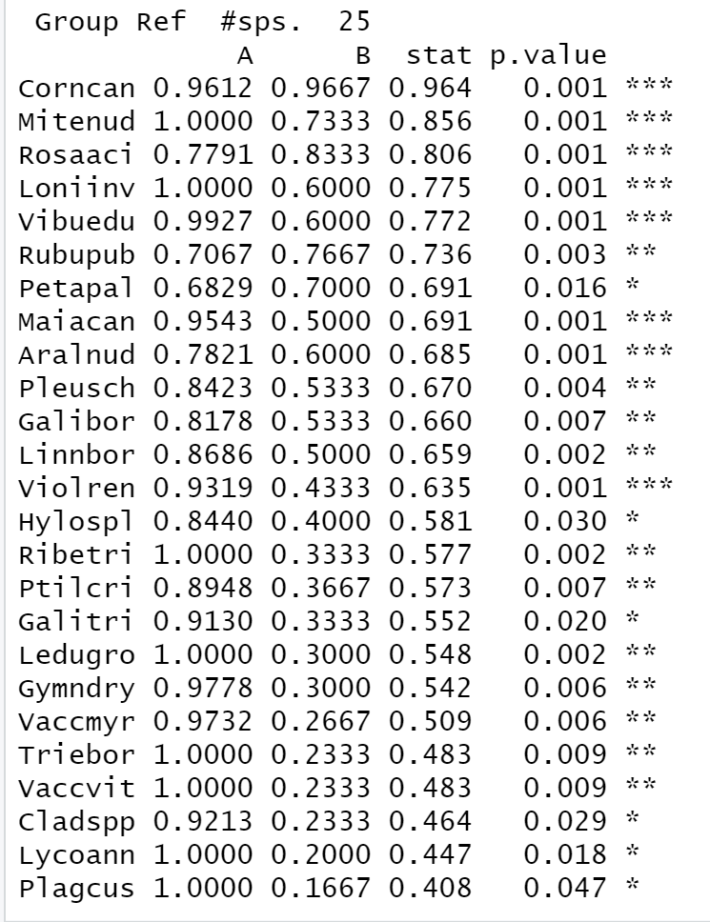
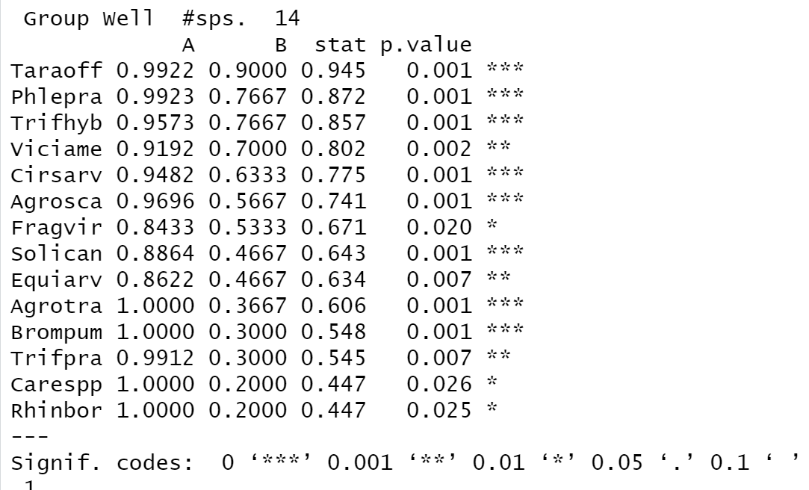

Significant species: Copy and paste
Multilevel pattern analysis
---------------------------

Association function: IndVal.g
Significance level (alpha): 0.05

Total number of species: 106
Selected number of species: 40
Number of species associated to 1 group: 40

List of species associated to each combination:

Group Ref #sps. 25
A B stat p.value
Corncan 0.9612 0.9667 0.964 0.001 ***
Mitenud 1.0000 0.7333 0.856 0.001 ***
Rosaaci 0.7791 0.8333 0.806 0.001 ***
Loniinv 1.0000 0.6000 0.775 0.001 ***
Vibuedu 0.9927 0.6000 0.772 0.001 ***
Rubupub 0.7067 0.7667 0.736 0.009 **
Petapal 0.6829 0.7000 0.691 0.017 *
Maiacan 0.9543 0.5000 0.691 0.001 ***
Aralnud 0.7821 0.6000 0.685 0.007 **
Pleusch 0.8423 0.5333 0.670 0.005 **
Galibor 0.8178 0.5333 0.660 0.009 **
Linnbor 0.8686 0.5000 0.659 0.001 ***
Violren 0.9319 0.4333 0.635 0.001 ***
Hylospl 0.8440 0.4000 0.581 0.033 *
Ribetri 1.0000 0.3333 0.577 0.001 ***
Ptilcri 0.8948 0.3667 0.573 0.003 **
Galitri 0.9130 0.3333 0.552 0.019 *
Ledugro 1.0000 0.3000 0.548 0.002 **
Gymndry 0.9778 0.3000 0.542 0.007 **
Vaccmyr 0.9732 0.2667 0.509 0.008 **
Triebor 1.0000 0.2333 0.483 0.005 **
Vaccvit 1.0000 0.2333 0.483 0.006 **
Cladspp 0.9213 0.2333 0.464 0.028 *
Lycoann 1.0000 0.2000 0.447 0.027 *
Picemar 1.0000 0.1667 0.408 0.047 *

Group Well #sps. 15
A B stat p.value
Taraoff 0.9922 0.9000 0.945 0.001 ***
Phlepra 0.9923 0.7667 0.872 0.001 ***
Trifhyb 0.9573 0.7667 0.857 0.001 ***
Viciame 0.9192 0.7000 0.802 0.001 ***
Cirsarv 0.9482 0.6333 0.775 0.001 ***
Agrosca 0.9696 0.5667 0.741 0.001 ***
Fragvir 0.8433 0.5333 0.671 0.019 *
Solican 0.8864 0.4667 0.643 0.001 ***
Equiarv 0.8622 0.4667 0.634 0.010 **
Agrotra 1.0000 0.3667 0.606 0.002 **
Brompum 1.0000 0.3000 0.548 0.005 **
Trifpra 0.9912 0.3000 0.545 0.008 **
Poapal 0.9716 0.2333 0.476 0.037 *
Carespp 1.0000 0.2000 0.447 0.022 *
Rhinbor 1.0000 0.2000 0.447 0.029 *
---
Signif. codes: 0 ‘***’ 0.001 ‘**’ 0.01 ‘*’ 0.05 ‘.’ 0.1 ‘ ’ 1

All species – snipping tool only included here:
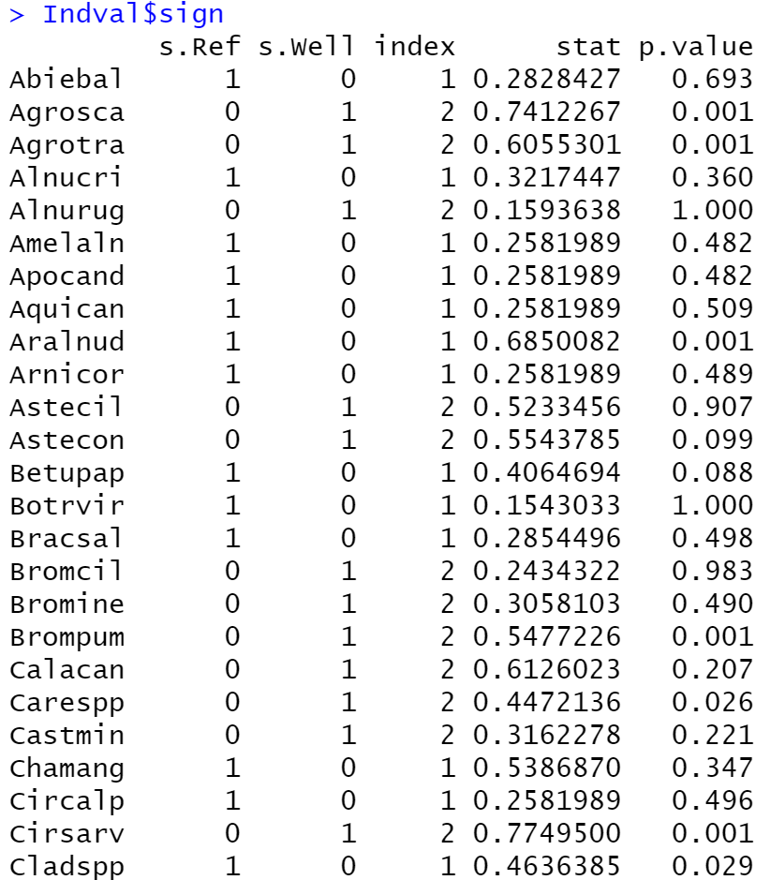
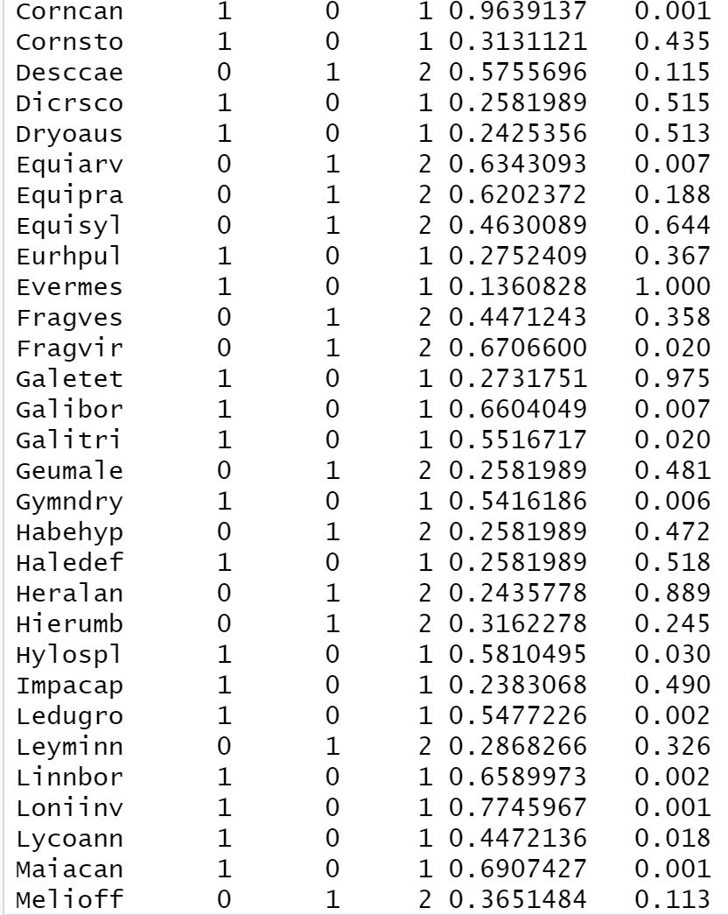
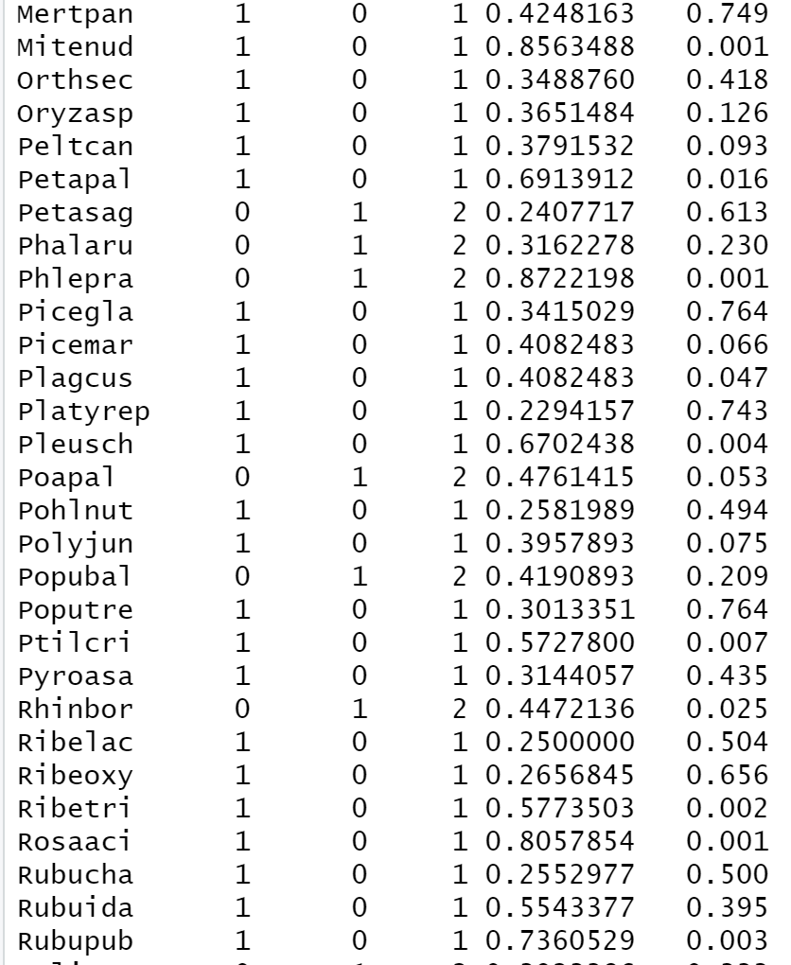
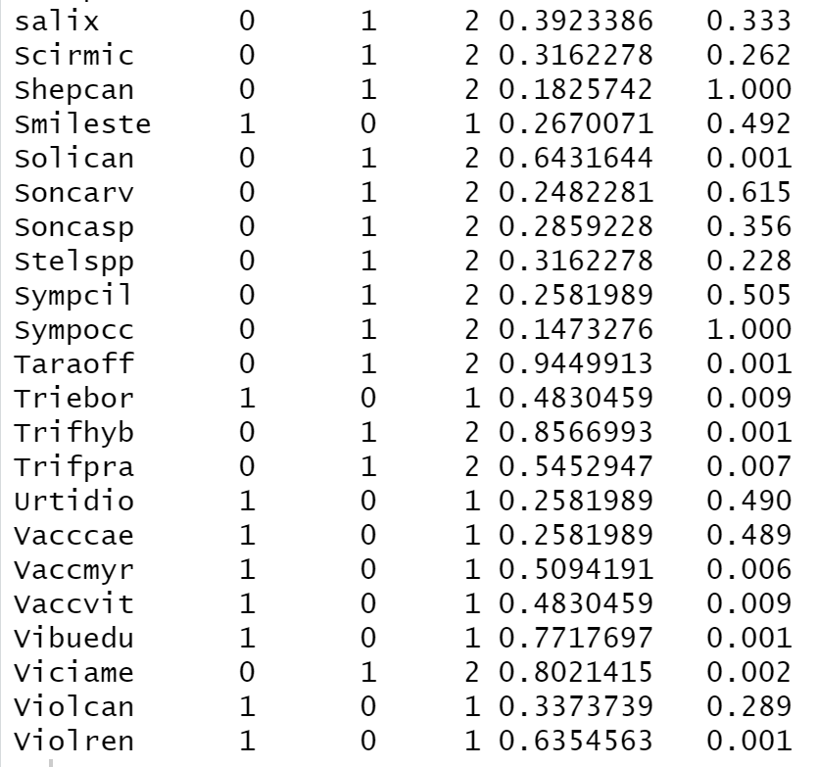

ii) Green alder is not a good indicator for reference forests because P=0.36.
iii) Cornus canadensis (bunchberry) is a strong indicator species for the reference forests (A=0.96, B=0.97, p<0.001).

- Summary Statistics (Section 7): i) Run the summary/descriptive statistics that reports the mean and standard deviation (SD) for all of the plant species, grouped by well pad vs reference and copy and paste your results.
Snipped output (cut and paste not included here – and included some additional components beyond the mean and sd):
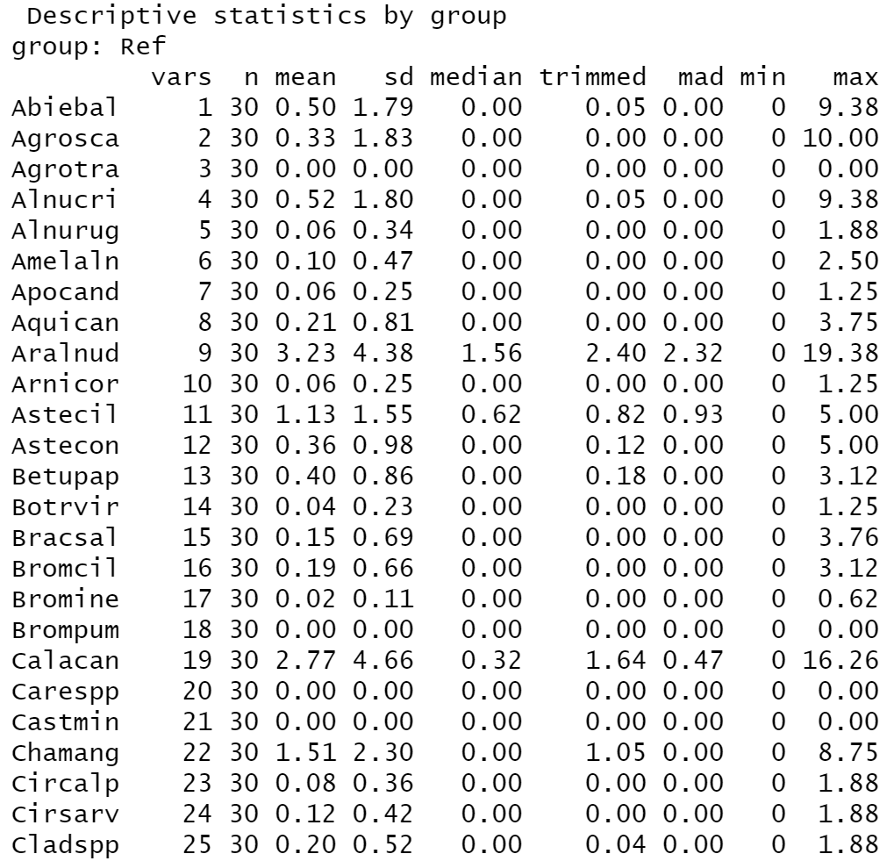
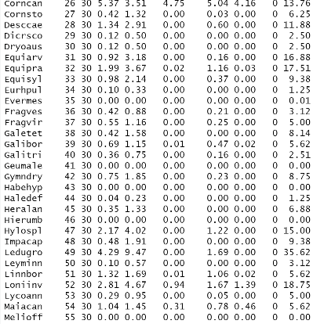
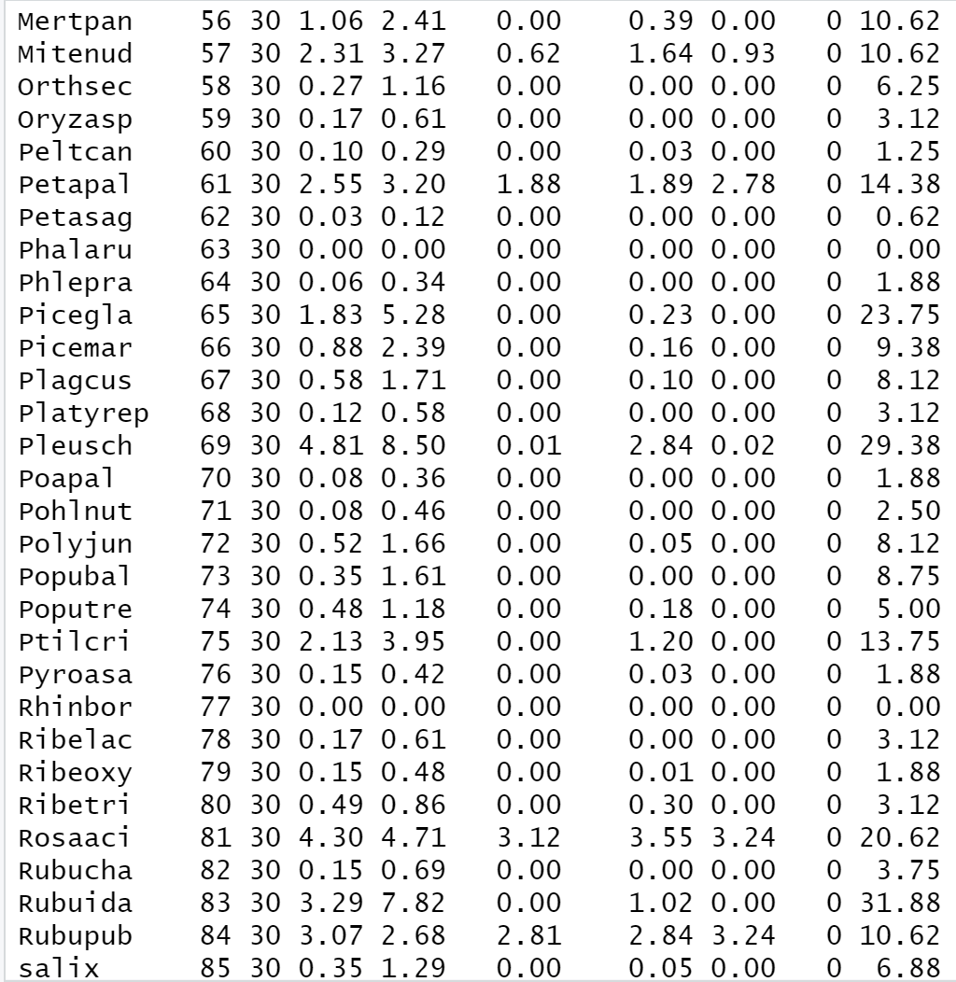
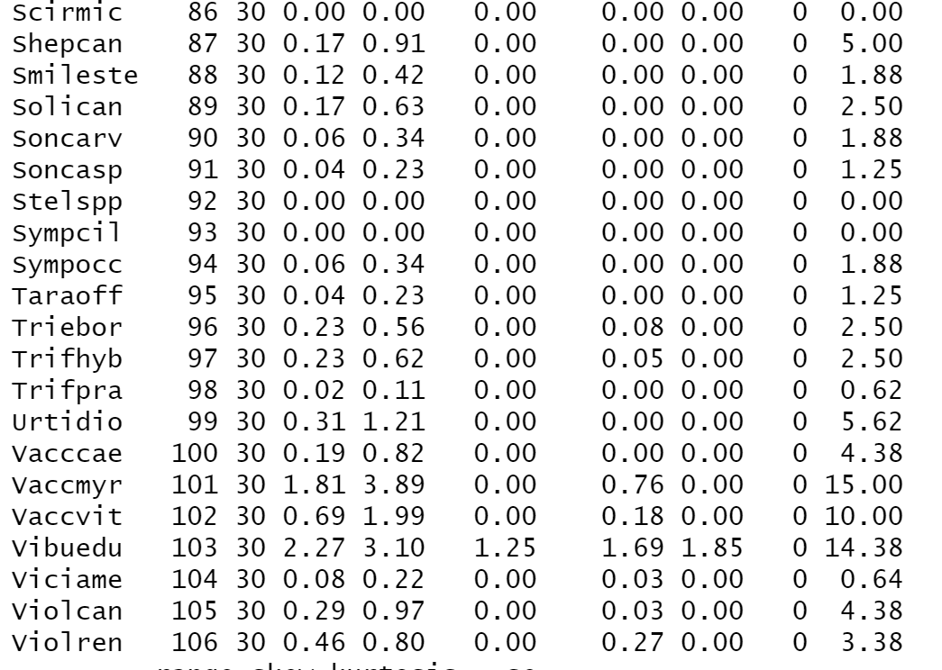

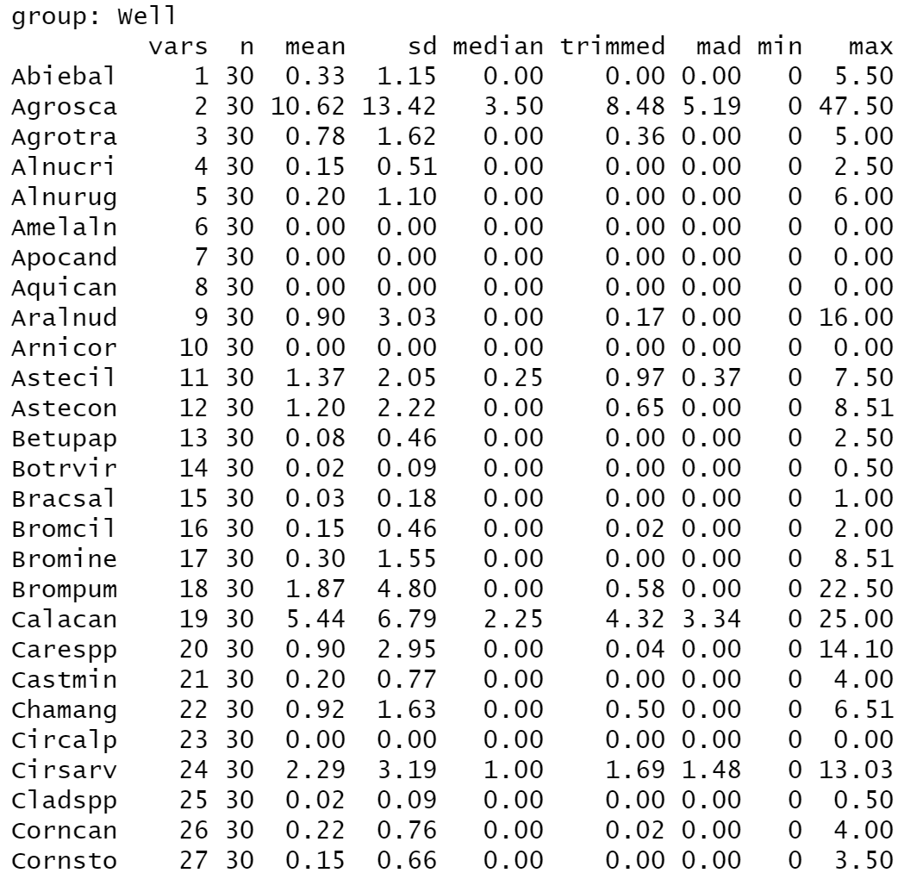
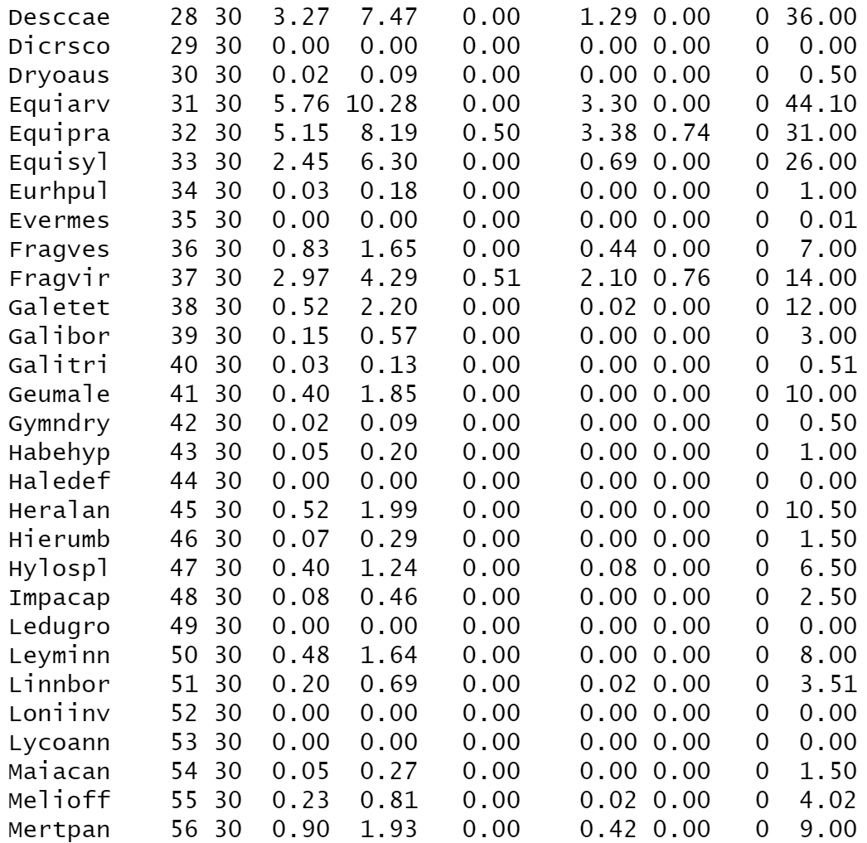
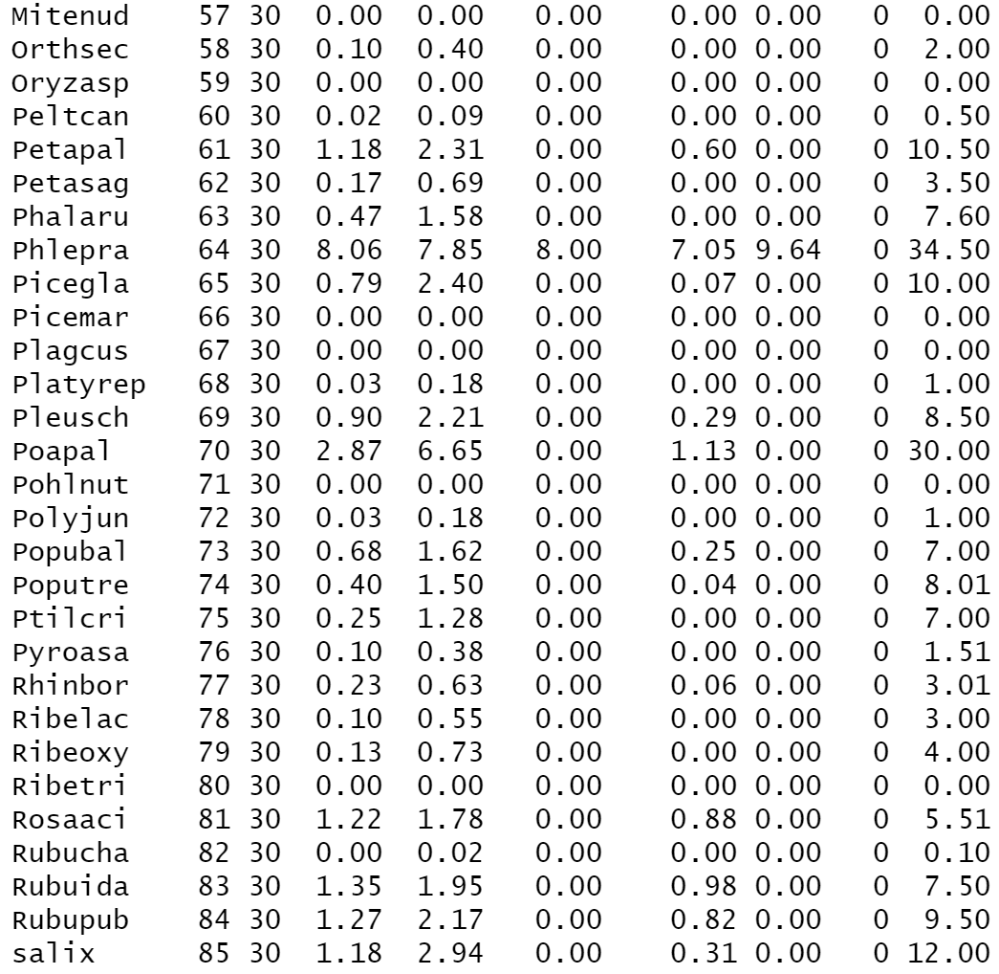
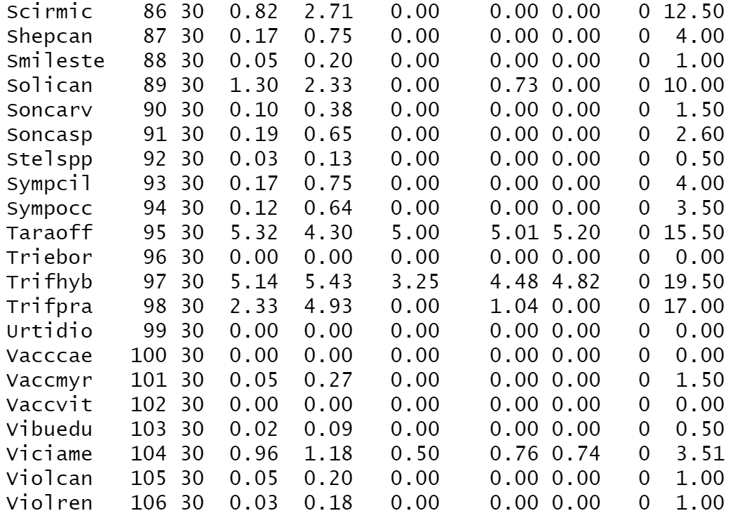
- Write out a results section as if you were going to submit these results as part of a scientific report. Describe and interpret the outcome of the multivariate statistical analysis. Be sure to include your customized plant community ordination plot (vector portion not required), your perMANOVA results and indicator species analysis results (HINT: only need the relevant information in your tables- what is significant? Use alpha = 0.001 and don’t forget to include your A and B values). In addition – include the mean and SD for each of your indicator species in a Table. Refer to the “what to report” (Section 8) section of your primer on how to report results.
Sample results section:
“The NMS two-dimensional final solution had 20.8% stress after 20 tries using the Bray-Curtis distance measure; this level of stress suggests a fair-poor goodness of fit, so it should be interpreted with caution [note to instructor: student may want to report data for 3-D solution ideally if they were going to do this again and you could consider adding a question like this]. Based on their relative positions in the ordination plot, we see some overlap between wellsites and reference forests in the middle of the plot, but mostly there is separation with reference forests grouped to the left of axis 1 and across axis 2 (Fig. A). Conversely, wellsites were loaded towards the right of axis 1, but widely distributed along axis 2 (Fig. A). After 999 permutations, There were significant differences in community composition between the well pads and reference sites (perMANOVA p = 0.001). The indicator species analysis revealed multiple significant indicator species for both sites. At an alpha of 0.001, there were eight wellsite indicator species and eight reference site indicator species (Table A).”
Fig A. Non-metric multidimensional scaling 2-dimensional ordination for the understory vegetation of 30 boreal forest well pads and reference forests in northern Alberta delineated by site wellsite “Well” or reference site “Ref”.

Table A. Results of indicator species analysis. Species that had an indicator value significant at α = 0.001 are listed for each group (wellsite and reference site) in descending order by cumulative A- and B-values. Mean cover values (+ SD) for each of these indicator species for both plant community types are also provided, with the cover values for the plant community a species was an indicator for highlighted in bold. The strength of the indicator species is based on A and B values. A values give insight into how exclusive a species is within a particular treatment, with an A value of 1 meaning a species is solely found in one treatment type. B values indicate the consistency that a species is found across all sample sites of a particular treatment, with a B value of 1 meaning the species was found in all sites within a treatment.
 | Species code | Species Name | Mean cover value wellsite (+/- SD) | Mean cover value reference site | A value | B value
Wellsite
 | Taraoff | Taraxacum officinale | 5.3 (4.3) | 0.0 (0.2) | 0.99 | 0.90
 | Phlepra | Phleum pratense | 8.1 (7.9) | 0.1 (0.3) | 0.99 | 0.77
 | Trifhyb | Trifolium hybridum | 5.1 (5.4) | 0.2 (0.6) | 0.96 | 0.77
 | Cirsarv | Cirsium arvense | 2.3 (3.2) | 0.1 (0.4) | 0.95 | 0.63
 | Agrosca | Agropyron scabra | 10.6 (13.4) | 0.3 (1.8) | 0.97 | 0.57
 | Agrotra | Agropyron trachycaulum | 0.8 (1.6) | 0 (0) | 1.00 | 0.37
 | Solican | Solidago canadensis | 1.3 (2.3) | 0.2 (0.6) | 0.89 | 0.47
 | Brompum | Bromus ciliatus | 1.9 (4.8) | 0 (0) | 1.00 | 0.30
Reference
 | Corncan | Cornus canadensis | 0.2 (0.8) | 5.4 (3.5) | 0.96 | 0.97
 | Mitenud | Mitella nuda | 0 (0) | 2.3 (3.3) | 1.00 | 0.73
 | Rosaaci | Rosa acicularis | 1.2 (1.8) | 4.3 (4.7) | 0.78 | 0.83
 | Loniinv | Lonicera involucrata | 0 (0) | 2.8 (4.7) | 1.00 | 0.60
 | Vibuedu | Viburnum edule | 0.0 (0.1) | 2.3 (3.1) | 0.99 | 0.60
 | Maiacan | Maianthemum canadense | 0.1 (0.3) | 1.0 (1.5) | 0.95 | 0.50
 | Violren | Viola canadensis | 0.0 (0.2) | 0.5 (0.8) | 0.93 | 0.43
 | Aralnud | Aralia nudicaulis | 0.9 (3.0) | 3.2 (4.4) | 0.78 | 0.60

References:
Connell JH, Slatyer RO. 1977. Mechanisms of succession in natural communities and their role in community stability and organization. The American Naturalist, 111: 1119–1144.
Environment and Sustainable Resource Development (ESRD). 2013. 2010 Reclamation criteria for wellsites and associated facilities for forested lands (Updated July 2013). Edmonton, Alberta. https://open.alberta.ca/publications/9780778589846.
McIntosh ACS, Drozdowski B, Degenhardt D, Powter CB, Small CC, Begg J, Farr D, Janz A, Lupardus RC, Ryerson D, Schieck J. 2019. Monitoring ecological recovery of reclaimed wellsites: protocols for quantifying recovery on forested lands. MethodsX. https://doi.org/10.1016/j.mex.2019.03.031
Natural Regions Committee. 2006. Natural regions and subregions of Alberta. Publication Number T/852. Government of Alberta, Canada.
Pickett STA, Collins SL, Armesto JJ. 1987. Models, mechanisms and pathways of succession. Botanical Review, 53: 335–371.

Appendix A:
Table A1. Species list scientific names and common names. Visit plants.usda.gov to get more information on individual plant species.
Species Code | Genus | Species | Common
Abiebal | Abies | balsamea | Balsam Fir
Achimill | Achillea | millefolium | Common Yarrow
Agrosca | Agropyron | scabra | Tickle Grass
Agrotra | Agropyron | trachycaulum | Slender Wheatgrass
Alnucri | Alnus | crispa | Green Alder
Alnurug | Alnus | rugosa
Amelaln | Amelanchier | alnifolia | Saskatoon
Apocand | Apocynum | androsaemifolium | Spreading Dogbane
Aquican | Aquilegia | canadensis | Canada Columbine
Aralnud | Aralia | nudicaulis | Wild Sarsparilla
Arnicor | Arnica | cordifolia | Heart-Leafed Arnica
Astecil | Aster | ciliolatus | Lindley's Aster
Astecon | Aster | conspicuus | Showy Aster
Betupap | Betula | papyrifera | Paper Birch
Botrvir | Botrychium | virginianum | Virginia Grape Fern
Bracsal | Brachythecium | salebrosum | Golden Ragged Moss
Bromcil | Bromus | ciliatus | Fringed Brome
Bromine | Bromus | inermis | Smooth Brome
Brompum | Bromus | pumpellianus | Pumpelly brome
Calacan | Calamagrostis | canadensis | Bluejoint
Carespp | Carex | Spp | Upland Carex Spp
Castmin | Castilleja | miniata | Red Indian Paintbrush
Chamang | Chamerion | angustifolium | Fireweed
Circalp | Circaea | alpina | Small Enchanter's-Nightshade
Cirsarv | Cirsium | arvense | Canada Thistle
Cladspp | Cladonia | spp
Corncan | Cornus | canadensis | Bunchberry
Cornsto | Cornus | stolonifera | Dogwood
Desccae | Deschampsia | caespitosa | Tufted Hairgrass
Dicrsco | Dicranum | scoparium | Broom Moss
Dryoaus | Dryopteris | austriaca | Spinulose Shield Fern
Elymspp | Elymus
Equiarv | Equisetum | arvense | Common Horsetail
Equipra | Equisetum | pratense | Meadow Horsetail
Equisyl | Equisetum | sylvaticum | Woodland Horsetail
Eurhpul | Eurhynchium | pulchellum | Common Beaked Moss
Evermes | Evernia | mesomorpha | Spruce Moss
Fragves | Fragaria | vesca | Woodland Strawberry
Fragvir | Fragaria | virginiana | Wild Strawberry
Galetet | Galeopsis | tetrahit | Hemp-Nettle
Galibor | Galium | boreale | Northern Bedstraw
Galitri | Galium | triflorum | Sweet-scented Bedstraw
Geumale | Geum | aleppicum | Yellow Avens
Gymndry | Gymnocarpium | dryopteris | Common Oak Fern
Habehyp | Habenaria | hyperborea | Northern Green Orchid
Haledef | Halenia | deflexa | Spurred Gentian
Heralan | Heracleum | lanatum | Cow-Parsnip
Hierumb | Hieracium | umbellatum | Narrow-leaved Hawkweed
Hylospl | Hylocomium | splendens | Stairstep Moss
Impacap | Impatiens | capensis | Spotted Touch-Me-Not
Ledugro | Ledum | groenlandicum | Labrador Tea
Leyminn | Leymus | innovatus | Hairy Wild Rye Grass
Linnbor | Linnaeus | borealis | Twinflower
Loniinv | Lonicera | involucrata | Bracted Honeysuckle
Lycoann | Lycopodium | annotinum | Stiff Club-moss
Maiacan | Maianthemum | canadense | Wild Lily-of-the-valley
Melioff | Melilotus | officinalis | Yellow Sweet Clover
Mertpan | Mertensia | paniculata | Tall Lungwort
Mitenud | Mitella | nuda | Bishop's Cap
Orthsec | Orthilia | secunda | One-sided Wintergreen
Oryzasp | Oryzopsis | asperifolia | Rough-Leaved Ricegrass
Peltcan | Peltigera | canina | Dog Lichen
Petapal | Petasites | palmatus | Palmate-Leaved Coltsfoot
Petasag | Petasites | sagitatus | Arrow Leaved Coltsfoot
Phalaru | Phalaris | arundinacea | Reed Canary Grass
Phlepra | Phleum | pratense | Timothy
Picegla | Picea | glauca | White Spruce
Picemar | Picea | mariana | Black Spruce
Plagcus | Plagiomnium | cuspidatum | Woodsy Leafy Moss
Platyrep | Platygyrium | repens | common flat-brocade moss
Pleusch | Pleurozium | schreberei | Big Red Stem
Poapal | Poa | palustris | Fowl Bluegrass
Pohlnut | Pohlia | nutans | Copper Wire Moss
Polyjun | Polytrichum | juniperinum | Juniper Hair-Cap
Popubal | Populus | balsamifera | Balsam Poplar
Poputre | Populus | tremuloides | Trembling Aspen
Ptilcri | Ptilium | crista-castrensis | Knight's Plume
Pyroasa | Pyrola | asarifolia | Common Pink wintergreen
Rhinbor | Rhinanthus | borealis | Yellow Rattle
Ribelac | Ribes | lacustre | Black Gooseberry
Ribeoxy | Ribes | oxycanthoides | Canadian gooseberry
Ribetri | Ribes | triste | Wild Red Currant
Rosaaci | Rosa | acicularis | Prickly Rose
Rubucha | Rubus | chamaemorus | Cloudberry
Rubuida | Rubus | idaeus | Raspberry
Rubupub | Rubus | pubescens | Dewberry
salix | Salix | Spp
Scirmic | Scirpus | microcarpus | Small-Fruited Bulrush
Shepcan | Shepherdia | canadensis | Canada buffaloberry
Smileste | Smilacina | stellata | false Solomon's seal
Solican | Solidago | canadensis | Canada Goldenrod
Soncarv | Sonchus | arvensis | Perennial Sow-thistle
Soncasp | Sonchus | asper | Spiny Annual Sow-thistle
Stelspp | Stellaria | Spp | Chickweed Spp
Sympalb | Symphoricarpos | albus | Common Snowberry
Sympcil | Symphyotrichum | ciliolatum
Sympocc | Symphoricarpos | occidentalis | Buckbrush
Taraoff | Taraxacum | officinale | Common Dandelion
Thuiabi | Thuidium | abietinum | Wiry Fern Moss
Triebor | Trientalis | borealis | Northern Starflower
Trifhyb | Trifolium | hybridum | Alsike Clover
Trifpra | Trifolium | pratense | Red Clover
Urtidio | Urtica | dioica | Stinging Nettle
Vacccae | Vaccinium | caespitosum | Dwarf Bilberry
Vaccmyr | Vaccinium | myrtilloides | Common Blueberry
Vaccvit | Vaccinium | vitis-idaea | Lingonberry
Vibuedu | Viburnum | edule | Mooseberry
Viciame | Vicia | americana | American Vetch
Violcan | Viola | canadensis | Canadian white violet
Violren | Viola | renifolia | Kidneyleaf Violet

