V. US Geological Survey Disease Maps - http://diseasemaps.usgs.gov/: Recent and archived maps of human, bird, mosquito, sentinel, and veterinary WNV cases and tables of cases by week in states.

- On the USGS Disease Maps home page click on West Nile Virus to go to a page with buttons for Bird, Human, Mosquito, Sentinel, and Veterinary cases.

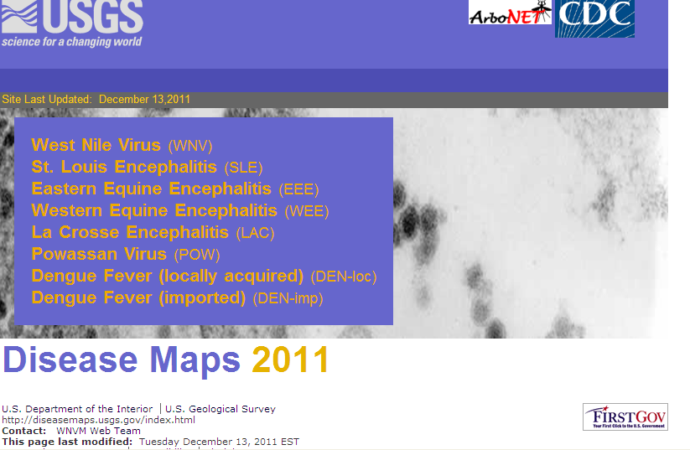

- Choosing a state in the Select a State drop down menu will take you to a page with a state map, a table showing incidence by county, and a graph of cases (for whatever organism you chose) by week in that state for the current year. Clicking Historical Data and then a state will give you archived maps and data for the year you choose.

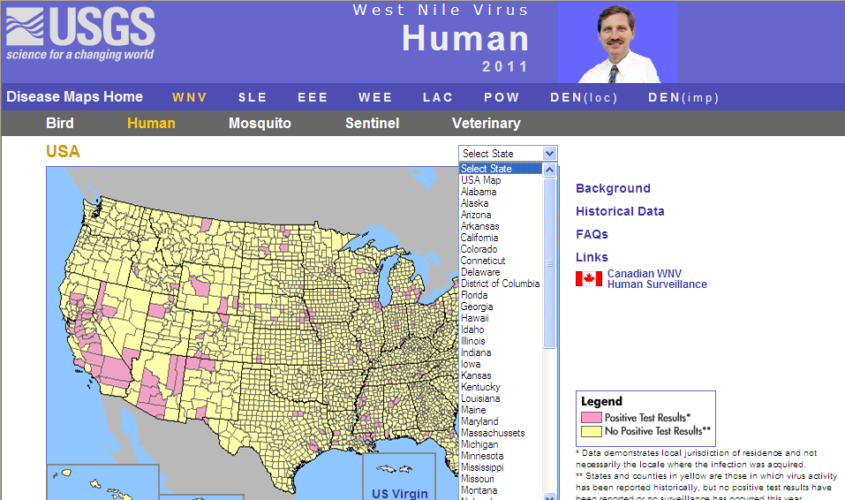

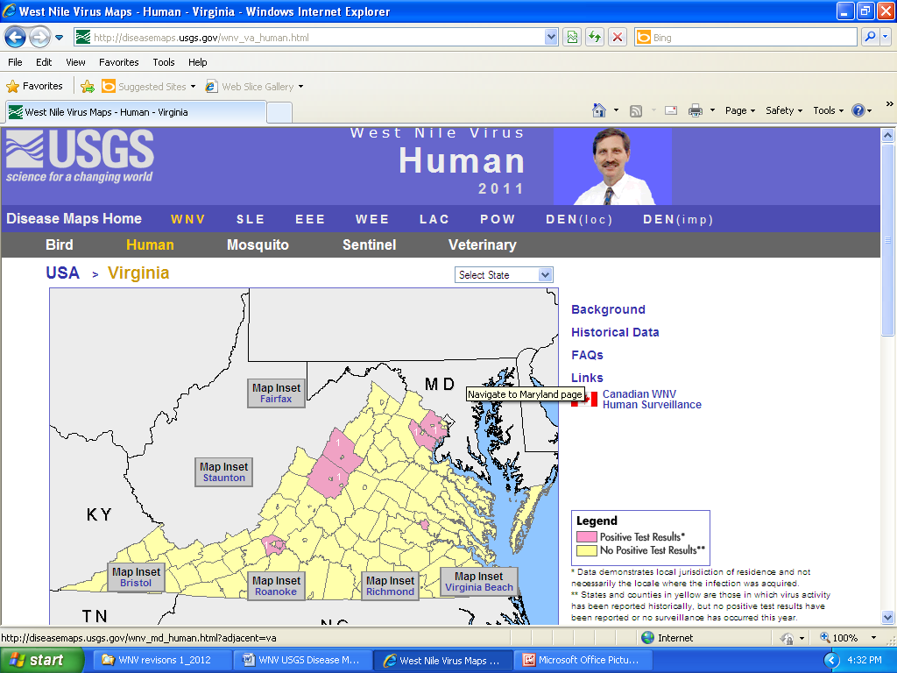

- On this page Links leads to a page with all of the participating organizations in ArboNet, a national arboviral (arthropod-borne virus) surveillance system developed by the CDC. A PowerPoint presentation on the formation and goals of ArboNet can be found at: http://www.cdc.gov/ncidod/dvbid/westnile/conf/2009/Staples/Staples%20WNV%20Conference%202009%20final.pdf.

- Canadian WNV Human Surveillance leads to the Public Health Agency of Canada WNV Monitor - http://www.phac-aspc.gc.ca/wnv-vwn/index-eng.php that contains links to maps and data for WNV incidence in Canada.

