ISSUES: FIGURE SET
Niches and species distribution models
Rylee Smith
Department of Wildlife, Fisheries, and Conservation Biology, University of Maine, Orono, ME 04469
rylee.smith@maine.edu

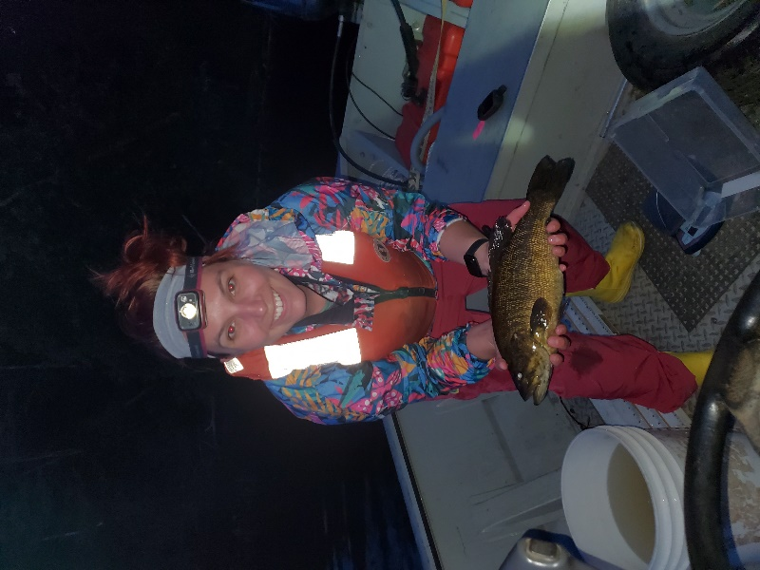

Rylee Smith with a smallmouth bass (Micropterus dolomieu) caught in the Penobscot River, Maine." Photo credit Rylee Smith

THE ISSUE:
Species niches play a fundamental role in species diversity, but modeling species distributions can be challenging. Here we use temperature to quantify the niches of freshwater fish and discuss the benefits and limitations of Species Distribution Modeling using Maximum Entropy (MaxEnt). MaxEnt is a species distribution modeling approach that predicts the probability of a species distribution in a geographic area based on presence only data and environmental variables. In addition, we will discuss the importance of scale and resolution in SDMs, highlighting how these factors may influence the accuracy and applicability of the models.

FOUR DIMENSIONAL ECOLOGY EDUCATION (4DEE) FRAMEWORK
- Core Ecological Concepts:
  - Organisms
  - Ecosystems
- Ecology Practices:
  - Quantitative reasoning and computational thinking
- Human-Environment Interactions:
  - Human accelerated environmental change
- Cross-cutting Themes:
  - Spatial & Temporal

STUDENT-ACTIVE APPROACHES:
The students will be interpreting maps and graphs, engaging in think-pair-share exercises, and reviewing background material related to the figure sets.
STUDENT ASSESSMENTS:
Student understanding can be assessed through their willingness to share responses to the instructor's questions, as well as their answers during think-pair-share exercises and "Test Your Knowledge" questions. Additionally, the instructor can evaluate comprehension through the "Post-Class Assessment." Engagement with the material can also be monitored by observing and listening to the conversations within think-pair-share groups as the instructor circulates around the classroom.
CLASS TIME:
The figure set is designed to span one 120 or two 60-minute class period(s).
COURSE CONTEXT:
The Figure Set is recommended as part of advanced sciences courses such as ecology and conservation for undergraduate students. Suggested course size is 30 students or fewer for one instructor.
ACKNOWLEDGEMENTS:
This was developed as part of a PhD comprehensive exam. I thank numerous people at University of Maine and USGS who have supported the creation of this module. Also, I thank the Maine Department of Marine Resources for providing the data.

OVERVIEW
WHAT IS THE ECOLOGICAL ISSUE?
Temperature is a driving force in nature. Temperature influences where a species lives, the health of an organism and even the resources available to an organism. Birds, mammals, fish, reptiles, and many more are influenced by temperature in a variety of ways including physiologically such as ectotherms sunbathing to warm their body temperature or behaviorally by species movement to areas of thermal refugia (McCue 2004). For many species, temperature is a significant environmental variable that impacts a species niche. A niche is a set of environmental conditions (temperature, precipitation, food) and the constraints (predation and competition) that allow a population to be stable or have positive growth (Hirzel and Lay 2008).
The ecological niche concept is a core concept in ecology; however, quantifying a niche presents a series of challenges. The dynamics of a niche are nearly impossible to measure completely due to data limitations and resources, and there are forces influencing a population that may not be known, and thus cannot be measured. Researchers have taken a more focused approach identifying traits and characteristics that are measurable as a proxy for niche width (Kearney et al. 2010). An ecologically important and universal trait is thermotolerance, the ability of an organism to tolerate and survive various temperatures. Temperature directly affects or is correlated with factors that influence a niche including diet, growth, reproduction, and population size (Kearney et al. 2010). In this figure set, we demonstrate how thermotolerance can affect niches dynamics including competition and distribution between Atlantic salmon (Salmo salar) and smallmouth bass (Micropterus dolomieu).
The state of Maine holds the last population of wild sea run Atlantic salmon (ATS) in the United States. Anthropogenic factors including overfishing, habitat alterations and climate change have played a key role in the severe declines of this endangered species (Fay et al. 2006). Habitat alterations have reduced access to prime spawning habitat and limit the ability of these fish to migrate to and from the ocean. Additionally, habitat alterations have provided new opportunities for nonnative species to thrive, specifically the smallmouth bass (SMB). Both species have been studied in detail. Smallmouth bass are a generalist species with a wide thermal range and occupy slow to swift moving water (Valois et al. 2009). Atlantic salmon are a specialist that are sensitive to thermal changes and occupy swift moving waters. Atlantic salmon are an anadromous species where juveniles will remain in freshwater until juvenile salmon undergo smoltification to make their first seaward migration to the ocean where they will remain in the marine environment as adults. During the freshwater life stages, juvenile Atlantic salmon known as parr, occupy similar habitat conditions as juvenile smallmouth bass. Adult smallmouth bass occupy slow moving pools where salmon may seek thermal refugia during increases in river temperature.
Maine is home to over 500 dams (https://www.maine.gov/mema/hazards/dam-safety) across the state. Dams alter the hydrology, geology, and thermal regime of the river, favoring warm water species such as the smallmouth bass. The impacts of dams on river systems are of great concern for the highly valued Atlantic salmon in regard to suitable habitat availability but also the competitive and predatory influence from species such as smallmouth bass.
Smallmouth bass are an aggressive species and a known predator to salmon (Fritts and Pearson 2006). Is the presence of smallmouth bass influencing the resources used by Atlantic salmon? How does temperature influence where Atlantic salmon may reside?
Students will delve into niche dynamics, learn to interpret species distribution models, and understand the impacts of environmental factors on species. They will also grasp the importance of scale and resolution in modeling practices. By examining figure sets, students will critically analyze how environmental variables, particularly temperature, influence species distribution. They will relate species-specific data to broad-scale modeling techniques and general ecological concepts.
Specifically, students will:
- Niches and Temperature:
  - Interpret species thermal niches and species overlaps using graphs.
  - Delineate the differences between realized and fundamental niches
  - Gain confidence in analyzing and interpreting graphical data
- Species Distribution Model (SDM)
  - Interpret and analyze mapped data
  - Gain a foundational understanding of SDMs, specifically MaxEnt.
  - Learn about the limitations of SDMs and discuss how temperature data (air vs water) may influence fish SDMs.
- Human Interference and Dams
  - Link concepts of human influence on species distributions and interactions
- Scale and Resolution
  - Delineate the difference between scale and resolution and the impact these play on modeling practices
Niches, SDMs, and Human Interference and Dams will be examined through the lens of Atlantic salmon and smallmouth bass, which will serve as our teaching species. However, for the topic of Scale and Resolution, we will broaden our focus to include multiple species. This shift highlights the crucial principles of scale and resolution in modeling. Understanding these principles is essential for accurate and effective ecological modeling.
NOTES TO FACULTY
This figure set is designed to progress sequentially, with each section building upon the previous one. Due to the sequential nature of the figure set, Post-Class Assessment homework should be completed after the completion of each section. The recommended format for this module includes:
- The class begins with a discussion of the pre-class activity as a group.
- For each section there are a few suggested options:
  - Option 1: In this approach, students first spend 10 minutes reading the "Student Instructions". They then proceed to engage with the "Test Your Knowledge" questions individually. Afterward, they discuss their answers in pairs or small groups before participating in a class-wide discussion led by the instructor. This discussion encourages students to volunteer answers, promoting collaborative learning. Each section concludes with a brief debriefing where key concepts are summarized and any final questions are addressed. Students are assigned the "Post-Class Assessment" as homework, which is reviewed at the beginning of the next class to reinforce learning. After the competition of a section, the instructor may continue with the next sequential section.
  - Option 2: This option enhances upon Option 1 by incorporating a PowerPoint presentation on the subject matter. The presentation covers figure sets specific to each section along with background information. This replaces the 10 minutes students would spend reading the "Student Instructions" in Option 1. This approach allows instructors to provide tailored examples that are particularly relevant to the class. It is recommended that students still read the "Student Instructions" before class, as these materials are integral to completing the "Test Your Knowledge" and "Post-Class Assessment" activities effectively.
- Instructors may distribute the “Pre-Class Activity,” Figure Sets, “Student Instructions,” and “Test Your Knowledge” before the class begins. The “Post-Class Assessment” can be given in advance, after each section, or as a comprehensive assignment at the end of the class, which will include questions covering all sections.
FIGURE SETS TABLE

Figure Set and Ecological Issue | Student-active Approach | Cognitive Skill | Class Size/Time
Niches and Temperature | Think-pair-share and report out | Knowledge and comprehension | 30 minutes
Species Distribution Modeling | Think-pair-share, making hypothesis | Knowledge, interpretation and comprehension | 30 minutes
Human Influence and Dams | Think-pair-share | Knowledge, critical thinking, interpretation, application and comprehension | 30 minutes
Scale and Resolution | Think-pair-share | Knowledge, interpretation, and comprehension | 30 minutes

Background Knowledge:
The mainstem and tributaries of 16 rivers in the state of Maine designated by the Maine Department of Marine Resources – Division of Sea Run Fisheries and Habitat are the study area for this project. Habitat surveys were conducted to identify important Atlantic salmon habitat including spawning and rearing habitat. Department of Marine Resources (DMR) conducted electrofishing surveys throughout the state, concentrating heavily on the Downeast Region of Maine. Habitat data was obtained from the Maine GeoLibrary Data Catalog for the MaineDMR Sea Run Fisheries – Atlantic Salmon Habitat. Electrofishing data was obtained from DMR. Average temperatures from 1970-2000 at 30-second- and 10-minute intervals was obtained from WorldClim database. All data used to produce graphs are from the sources listed here.

Part 1: Niches and Temperature in Fish
Purpose: To interpret graphs, link figures to ecological concepts and how niches vary by species.
Teaching Approach: Think-pair-share and report out
Cognitive Skills: Knowledge and comprehension
Student Assessment: Class participation, short answer
Figure Set Background
Niche theory is at the center of understanding where a species lives and how they coexist with other species with similar niches. Species with similar biotic and abiotic conditional requirements are more likely to strongly compete for resources or are less likely to occupy the same spatial area. In contrast, species with different requirements are likely to compete less and are more likely to coexist in the same spatial area. Measuring a species niche and competition is full of challenges, leading to the approach of identifying a trait that acts as a proxy for a niche. This approach allows researchers to identify specific aspects of a niche such as using species thermotolerance thresholds to identify the thermal niche of that species.
Figure 2 illustrates the estimated thermal niches of smallmouth bass and Atlantic salmon, based on their optimal growing temperatures (Stanley and Trial 1995. Middaugh et al. 2016). This figure highlights the thermal niche requirements for each species, providing insights into their potential coexistence in areas where their thermal tolerances overlap. Figure 3 illustrates the temporal thermal relationship between niche requirements and coexistence with thermal change.

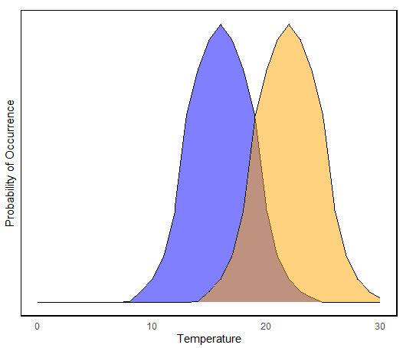
Figure 2. Estimated probability of occurrence for Atlantic salmon (blue) and smallmouth bass (orange) based on optimal growth temperatures. Atlantic salmon optimal temperature is between 14-19 C, having a narrow range of temperatures that Atlantic salmon can sustain for long periods of time. Smallmouth bass are known to tolerate a wide range of temperatures with optimal growth occurring at 22 C. Probability of occurrence was estimated based on optimal growth temperatures and normally distributed with 1 (Atlantic salmon) and 2 (smallmouth bass) standard deviation to account for the window of temperatures each species can tolerate for extended periods of time.

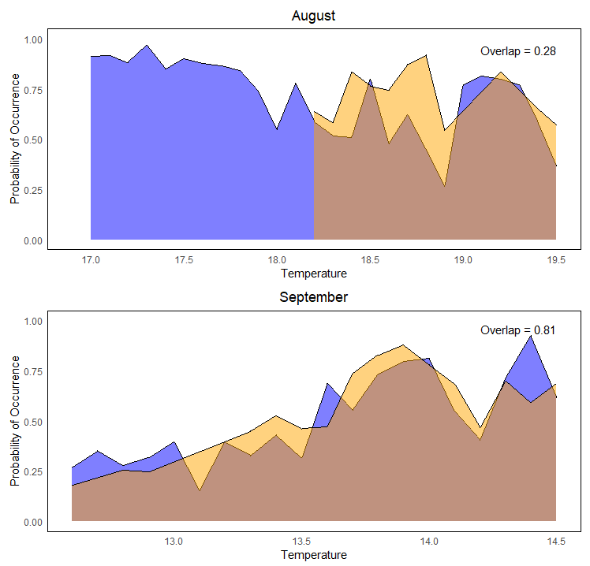
Figure 3. The probability of occurrence of Atlantic salmon (blue) and smallmouth bass (orange) for August (top) and September (bottom) temperatures. Probability of occurrence values were obtained from species distribution models for August and September.
STUDENT INSTRUCTIONS
PRE-CLASS ACTIVITY
Niches: Where and Why?
Think about different places in the world. What are the environmental conditions and different habitats present and what types of organisms would you see? Imagine you are swimming in the Arctic Ocean, do you think you would encounter the same animals that you might if you were swimming in the Indian Ocean? Why might there be different animals in both oceans and why might there be the same animals in both oceans? Why are some animals common in some habitats but absent in others?
IN-CLASS ACTIVITY
There are many reasons why organisms are found in different habitats. Let’s use koala as a way to demonstrate how dispersal affects why koala are only found in Australia. A simple reason is Australia is completely surrounded by saltwater, so koalas never were able to disperse to other continents. Koala diet consists primarily of eucalyptus, which is native to Australia. Proximity to these food resources may be a key driver to understanding where koalas are commonly found.
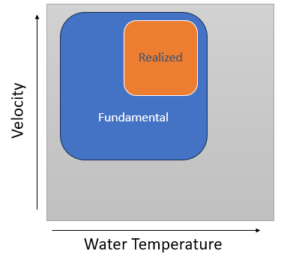
Physiological tolerance, resource availability, dispersal, competition, and predation are all factors that influence where a species lives. Niche theory explains where a species can live and the specific conditions required for the species to thrive. A niche is a species’ abiotic and biotic environmental requirements necessary for a species to persist with positive growth (population overtime is not declining) (Leith and Franklin 2013). Niche explains the conditions a species can tolerate, the limitations of biotic interactions, required resources and dispersal barriers. A niche is recognized in two forms as a fundamental niche and a realized niche. A fundamental niche is the environmental conditions, such as temperature or diet requirements, that allow a species population to persist (Leith and Franklin 2013). A realized niche is a narrowed subset of the fundamental niche where a species can live due to the limitations of biotic interactions (competition), dispersal, or disturbance (Leith and Franklin 2013). For instance, if we look at the plot made for salmon focusing only on water velocity and water temperature, we can see the fundamental niche in the blue square and the realized niche in the orange square. Atlantic salmon thrive in water temperatures between 14°C and 19°C but can survive in temperatures up to 27°C for short periods of time (Trial and Stanley 1995). The fundamental niche of salmon may include temperatures ranging from 0°C to 27°C. While salmon prefer the 14°C to 19°C range, they may occupy areas of lower or higher temperatures due to factors such as habitat accessibility or competition with other species. This necessitates that salmon sometimes reside in less optimal temperatures. Occupying temperatures within, but outside the optimal range, demonstrates the realized thermal niche of the species.
In summertime, when high water temperatures prompt fish to seek cold water refuges, competition between juvenile salmon and juvenile bass may be observed. Both species may seek cooler water refuges, but bass are known for their aggressive nature and may outcompete salmon for these preferred habitats. This competition may lead to juvenile salmon utilizing temperatures higher than their optimal thermal preferences, as they are forced to occupy less favorable habitats due to competition from bass. Additionally, warming water temperatures due to climate change may also cause shifts or expansions in a species' realized niche.
Niches and Coexistence
Niches help us understand where a species lives and how they coexist. Resources are limited when exponential population growth is occurring resulting in competition for resources. Under extreme competition, the potential for local species extirpation can result when species niches are too similar. Reducing similarities between niches can reduce competition and promote coexistence between species. Coexistence in similar niche requirements can be seen in the African lion and the spotted hyena in the African savanna. These species are both predators in their respective habitats and share the same prey preferences resulting in competition for prey items. Despite similarities in diet and social behaviors both living in groups, these species have evolved different hunting strategies that have allowed them to coexist. Hyenas are opportunistic scavengers that hunt in groups that often feed off the remains from other predators or hunt opportunistically. Lions are stealth hunters that have a coordinated group hunting to hunt large prey. The variation in hunting strategies have reduced direct competition for food resources between these similar predators allowing them to coexist in the African savanna.
There are many ways for species to coexist in nature. Corals reefs are biologically diverse with many fish utilizing the reef for food resources and shelters. Damselfish and clown fish are direct competitors for shelter and food resources. Clown fish have an adaptation to live among sea anemone tentacles that may sting other organisms such as the damselfish. This provides shelter for the clown fish, reducing competition with the damselfish and providing protection from predators.
Elements of niches can be easy to conceptualize but challenging to measure. How, for example, would one measure competition as a niche dimension? How can that be measured over time? Ideally, one way to measure a niche is to examine growth rates as a niche requires populations to remain stable or increase in growth with respect to the environmental conditions. Niche hypotheses can be difficult to test. Many use traits to quantify the dimensions of a niche.
Temperature and Niches
Quantifying niches can be approached by measuring a species trait linked to the niche dimensions as this is more realistic to measure and can be done for many species. Temperature is correlated with many traits that affect niche similarities between species. Temperature affects metabolism, species behavior, physiological tolerances, and food resources. The foraging behavior of the Desert Spiny Lizard and Western Fence Lizard differ based on the thermal range of the species. Found in similar desert habitats, the Desert Spiny Lizard is adapted to hot arid temperatures, feeding during the day when temperatures are at its highest. The Western Fence Lizard has a large thermal tolerance, being active during the cooler and hotter periods of the day. Brown trout and rainbow trout are closely related; however, their thermal tolerances vary, affecting their metabolic rates. Both species prefer cold water with brown trout having a colder narrow range of temperature that when exposed to temperatures outside of their optimal range they exhibit slow growth and reduced activity levels. Rainbow trout has a wider thermal tolerance, allowing them to occupy habitats less suitable for brown trout.
Quantifying the temperature niche
How do we compare the thermal preferences of different species to quantify their thermal niches? If we compared the niches of freshwater species, how do we measure the temperature niche when there are individual variations in temperature preference and fluctuations in water temperature? One way is to quantify the probability of observing a species at given temperatures based on a species thermotolerance. Most individuals of a species will occur around a given temperature but if an individual were randomly selected, they may be occupying a temperature that is colder (or warmer) than the average temperature where most individuals are found. We can see that in Figure 2 the probability of observing Atlantic salmon (blue) and smallmouth bass (orange) based on their optimal growing temperature. The y axis is the probability of occurrence or how likely it is to see a species at a given temperature (x axis). A tall skinny peak would indicate a narrow range or variation, meaning that most fish are found within that range. A wider range indicates that there is more variation in the temperatures where fish are found.
Temperature Overlap
We would like to see how similar smallmouth bass and Atlantic salmon are in respect to thermal ranges. Thermotolerance range overlap or temperature overlap quantifies the similarities of the two species’ thermal ranges using probability distributions. We can use overlap values from zero to one to measure the overlap between species. A value of 0.25 indicates that 25% of the area is shared between the species. This shows just how much the two species use the same temperatures. The more overlap, the more similar temperature used by each species and the more likely these species will share a thermal niche and compete!
Test your knowledge
Look at Figure 3 and read the caption. Individually, then with a partner, go through the following step(s) and be ready to share your answers with the class.
Note: In Figure 3, you will see a distinct line of where smallmouth bass probability of occurrence stops with temperature. This is due to the amount of smallmouth data available for the month of August. We will talk about the importance of data used in model variables in a later section.
Step 1: What is a niche? What is the difference between a realized and fundamental niche? What are factors that influence a niche? How can thermal preferences overlap affect a niche?
Step 2: What do the axes represent? What do the different colors mean? What do the two graphs represent? Are the axes the same on both graphs? Why do you think the x axis differs between the graphs? What does the value in the corner represent? Is there a difference between the overlap between the two graphs? Why do you think this might occur? Can you determine the thermal preference for each species (cold water vs warm water)?
Step 3: What does this tell us about each species niche? Suggest a hypothesis why the overlap is different between the months and why this might be occurring.
POST-CLASS ASSESSMENT
Please complete the following questions as homework.
- Expand from the examples of fish shown in this figure set. Think of two similar species that occupy the same thermal range but don’t compete. What factors are in play allowing those species to coexist in the same thermal niche? For example, a squirrel and an American Robin may both be found in a park occupying the same thermal niche. These species may not directly compete due to various foraging strategies and habitat preferences. Name the two species and the factors that allow these species to coexist in the same thermal range but do not compete.
- Imagine you have two species (species A and species B) that do not overlap (overlap= 0). Do these species have similar thermal niches? Now imagine a third species (species C) that overlaps with both species A (overlap = 0.50) and B (overlap 0.10). What does this look like? Draw a plot representing this scenario first with no overlap between species A and B and then add species C. Include axes, labels and a caption.
NOTES TO FACULTY
This work may be useful following lectures on niches, coexistence, competition and temperature but some background information is provided. Students should have some prior knowledge of species interactions, graphical interpretation and statistics such as probability. Students may need help understanding probabilities and probabilities distributions.
The figures may not be familiar to students, but they should be able to grasp the general conceptual idea. These figures are based on real data and real data can be difficult to interpret, find common patterns, etc. It would be worthwhile to explain the complications of interpreting data to help students understand and show examples of species overlap using variables the students are more familiar with such as a simplified diet overlap before looking at the provided graphs. An illustrative example compares the diets of polar bears and black bears. While there is some overlap in their diet, each species exhibits distinct preferences primarily influenced by their respective habitats (see Example Figure 1). Polar bears, inhabiting Arctic environments, primarily rely on marine mammals such as seals, emphasizing a carnivorous diet. In contrast, black bears, found in diverse forested regions, have a more omnivorous diet, consuming berries, nuts, insects, and occasionally small mammals. This example highlights how species overlap in diet can reflect individual species preferences shaped by their unique habitats, setting the stage for examining real-world data in the figure set.

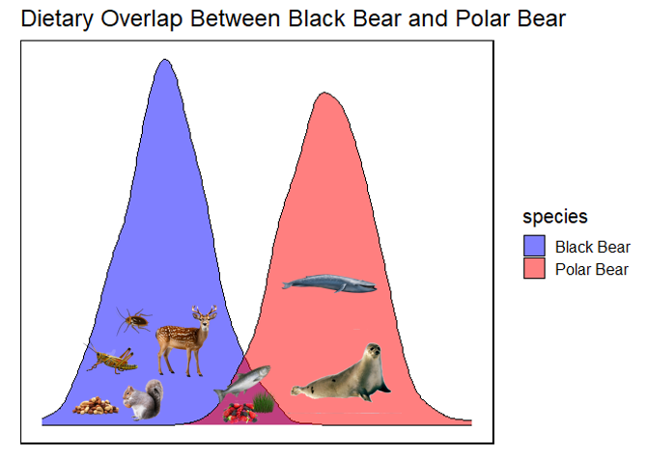
Example Figure 1. This shows the dietary preferences of black bears and polar bears.
Before starting the lecture, it might be engaging to ask a few students about their thoughts on the pre-class activities. Students should have considered why different animals are found in different places and how habitats contribute to their presence in various environments. Additionally, you could ask for a volunteer to define a niche, and more specifically, to explain the difference between a realized niche and a fundamental niche.
Answers and Assessments
Students can be assessed by their contributions in the classroom during the exercises in addition to the short answers from the in-class questions and post assignment. Think-pair-share exercises throughout may provide students the opportunity to come up with the answers independently and then discuss their answers with a partner in a low pressure setting for students. Students may then volunteer or can be called on to share their answers with the class.
Test your knowledge Answers:
Step 1: What is a niche? What is the difference between a realized and fundamental niche? What are factors that influence a niche? How can temperature overlap affect a niche?
Answer: The niche is a set of abiotic and biotic resources and conditions or constraints that determine where a species can live. The fundamental niche is the total area based on environmental conditions (abiotic/biotic resources, conditions, etc.) a species can utilize. The realized niche is a smaller subset of the fundamental niche reflecting the effects of biological interactions (competition or predation) and barriers to dispersal that limit where a species can live. Greater overlap in thermal preferences suggests the greater the niche overlap and the greater potential for competition and predation.
Step 2: What do the axes represent? What do the different colors mean? What do the two graphs represent? Are the axes the same on both graphs? Why do you think the x axis differs between the graphs? What does the value in the corner represent? Is there a difference between the overlap between the two graphs? Why do you think this might occur? Can you determine the thermal preference for each species (cold water vs warm water)?
Answer: The X axis represents temperature and the y axis the probability of occurrence. The colors represent the different fish species with ATS being blue and SMB being orange. The x axis is not the same as the temperatures have a different scale by month due the variation in temperature between the two months. The values in the upper corner represent the degree of overlap between the two species. We see a substantial difference in the overlap between the two months, likely due to Atlantic salmon being a cold-water species and smallmouth bass being a generalist warm-water species that can tolerate a wide range of temperatures.
Step 3: What does this tell us about each species niche? Suggest a hypothesis why the overlap is different between the months and why this might be occurring.
Answer: Based on the information in August and September, we can estimate that Atlantic salmon prefer water temperatures between about 14-19.5 degrees. Smallmouth bass are likely to occur in a similar thermal range from 14-19. This suggests that smallmouth bass and Atlantic salmon do overlap at varying life stages. We could hypothesize that the difference in probability of co-occurrence between the months is going to be greater in September when the overall temperature is lower. However, if we were able to extend the temperatures or have a more accurate dataset for smallmouth bass, we may see a less significant difference between the overlap differences between August and September between the species.
Post-Class Assessment Answers:
- Expand from the examples of fish shown in this figure set. Think of similar two species that occupy the same thermal range but don’t compete. What factors are in play allowing those species to coexist in the same thermal niche? For example, a squirrel and an American Robin may both be found in a park occupying the same thermal niche. These species may not directly compete due to various foraging strategies and habitat preferences. Name the two species and the factors that allow these species to coexist in the same thermal range but do not compete.
Answer: There can be many answers to this question and students may give examples that you may or may not 100% know the answer to. The point is to get them thinking about animals and interactions in the same thermal range. An example could be an arctic fox and arctic hare; these two species are adapted to cold climate but do not compete directly for food resources. The arctic fox will actually prey upon the arctic hare. The diet preference of each species, one being a carnivore and the other being an herbivore is a large factor why these two species do not compete directly. Another example could be an elephant and giraffe in the African Savanna. Both species inhabit a similar thermal range but due to different niches, they do not compete for food.
- Imagine you have two species (species A and species B) that do not overlap (overlap= 0). Do these species have similar thermal niches? Now imagine a third species (species C) that overlaps with both species A (overlap = 0.50) and B (overlap 0.10). What does this look like? Draw a plot representing this scenario first with no overlap between species A and B and then add species C. Include axes, labels and a caption.
Answer: Species A and B with 0% overlap would not occupy the same thermal niche, each has a distinct thermal range than the other species. When species C is introduced overlapping 0.50 with species A and 0.10 with species B this means that there is 10% overlap in thermal range of species B and 50% overlap of thermal range with species A, suggesting that species A and C have a greater similarity in thermal range.
Example graph of species A and species B with 0% overlap indicating distinct thermal niches.
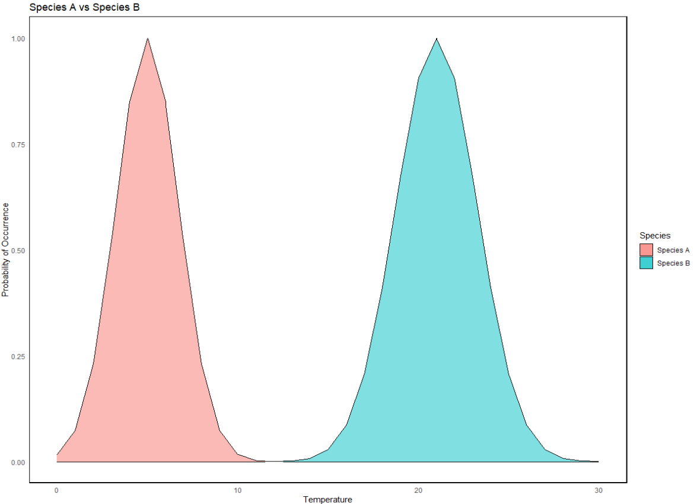
Example plot of Species A and Species C with 50% overlap and Species B and Species C with 10% overlap.
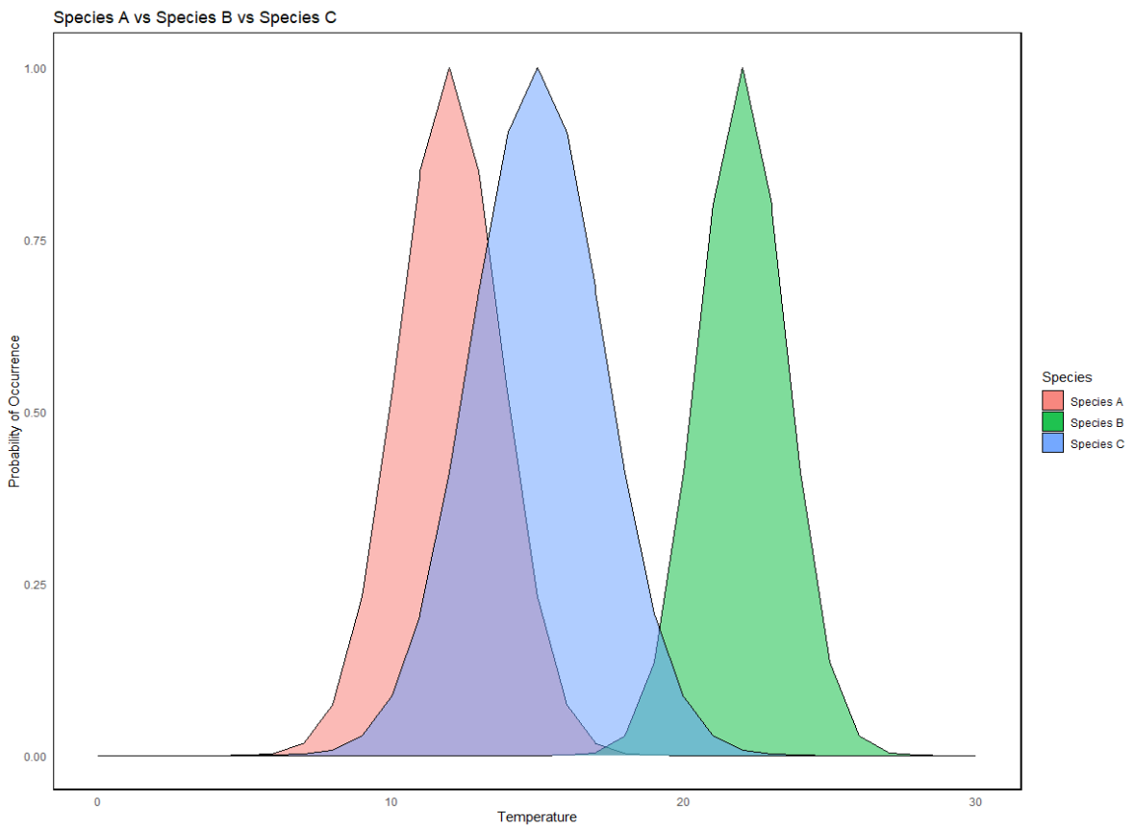

Part 2: Ecological Theory and Species Distribution Modeling (SDM)
Purpose: To practice interpreting Species Distribution Modeling (SDM) outputs and understanding the influence of model variables
Teaching Approach: Think-pair-share, making hypotheses
Cognitive Skills: Knowledge, interpretation and comprehension, hypothesis
Figure Set Background
The goal of this exercise is to link conceptual concepts to application. In particular, we want to extend concepts of niches to spatial diversity through species distribution modeling. Species distribution modeling builds on the concept of a species' niche by examining the relationship between species distribution and the physical environment. SDMs utilize environmental conditions required by the species and known species occurrence point to project the potential distribution of that species (Leith and Franklin 2013). Species distribution modeling (SDM) has arisen as a popular approach to estimating a species niche. However, measuring a species niche is full of challenges; one approach is to use measurable traits that influence a species niche and use those traits, specifically environmental traits (e.g., temperature, precipitation, food resources) to model the potential distribution of the species. This quantifies the niche indirectly through the relationships of species occurrence and the environmental variables. SDMs provide an opportunity, given selected traits, to estimate the probability of a species occurring in a spatial location based on known points where the species has occurred. SDMs can provide useful information about the environmental variables that influence a species distribution, predict potential range expansion of invasive species, and aid in natural resources management.
Despite being a popular method of modeling distributions, there are many limitations to SDMs. Biotic interactions are a difficult factor to measure that play a critical role in a species’ realized niche. Competition for resources, predation, or dispersal are fundamental principles that influence a species’ niche but how can they be measured and applied in a SDM? Due to challenges in acquiring biotic interaction data, such information is often omitted from species distribution models (SDMs), leading to significant drivers of a species’ niche being unaccounted for. Additionally, data limitations such as relying solely on presence data or incomplete datasets are common in species modeling. These limitations arise from constraints in resources, funding, and the practical difficulties of data collection. For example, obtaining environmental data at the appropriate resolution or scale can be hindered by logistical constraints. Frequently, in species modeling the results are presence only data or environmental data that is patchy, not to the right resolution or scale that is appropriate to the study species and area. Despite the limitations, SDMs can be a useful tool and a practical application for modeling species distribution and albeit indirectly and partially, a species niche.
There are many modeling approaches such as general additive models, generalized linear models, regression and MaxEnt. All of these approaches have advantages and disadvantages including what types of occurrence data is required. For this exercise, we will be using MaxEnt, a popular approach due to its ease of use and requiring presence only data, meaning there is no measured data of locations where a species is known to be absent.

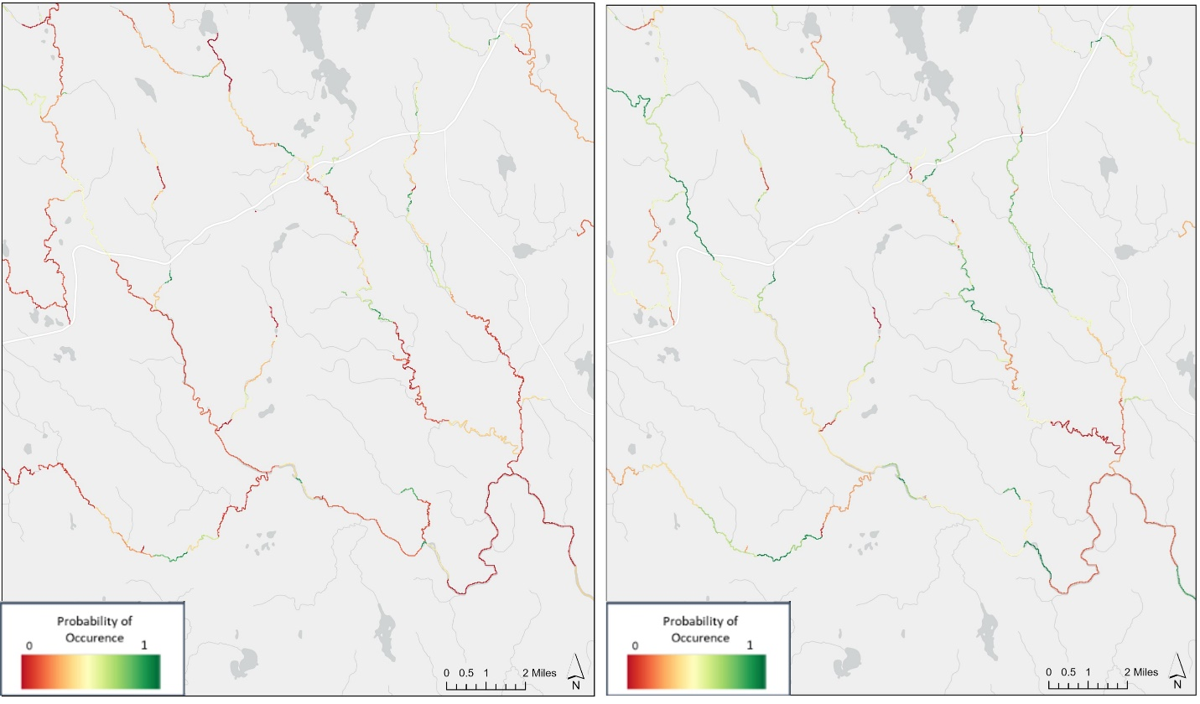
Figure 4. SDM modeled output of Downeast Maine for August. Atlantic salmon (left) and smallmouth bass (right).
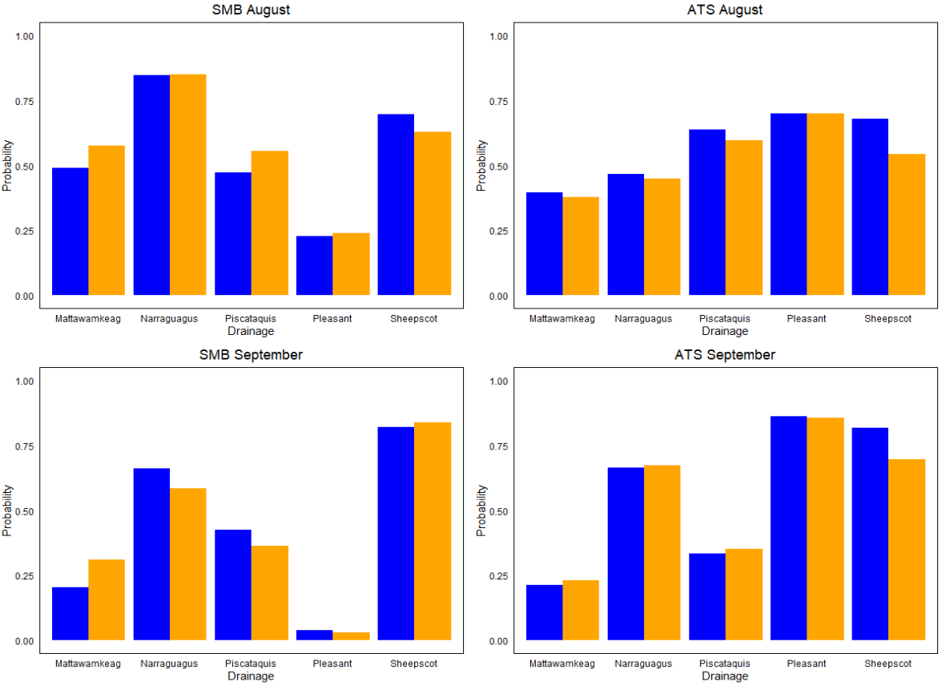Figure 5. Comparison between Atlantic salmon (right) and smallmouth bass (left) probability of occurrence of SDM models with varying environmental variables for August (top) and September (bottom) by drainage. SDM models were modeled using environmental variables including substrate, depth, slope with some models including average monthly air temperature (orange) and some excluding average air temperature (blue).
IN-CLASS ACTIVITY
MaxEnt
Species distribution modeling is a recognized approach to modeling relationships of environmental conditions and species distributions, indirectly quantifying a species niche. MaxEnt (Maximum Entropy) is an SDM method, which is effective at using various types of occurrences data (presence only or presence- absence) and both continuous and categorical environmental data to model complex relationships between species occurrence and environmental conditions. Additionally, MaxEnt can be used in a variety of software (e.g., R, MaxEnt, Python) for ease of use and performs well across a variety of species.
The primary output of MaxEnt is the spatial probability of occurrence map showing the likelihood of a species occurrence across the study area. The probability of occurrence is on a scale of zero to one. If a species has a value of 0.85, then there is 85% likelihood that the species will be found in that location. Additionally, MaxEnt can provide response curves to illustrate the influence of environmental variables on the probability of a species occurrence.
MaxEnt models are trained using the environmental variables that characterize the conditions of the study area. It also assumes that species will respond similarly to environmental conditions across different locations. For these reasons, the MaxEnt results of the study system may not be transferable to another study system due to the complexity of the model. When looking at the transferability of SDMs to another system, the environmental conditions of the new system need to be accounted for as well as underlying factors, such as dispersal.
Species Distribution Modeling Limitations
All analyses, models, and scientific investigations come with limitations and assumptions. Addressing limitations and assumptions identifies the boundaries of the research, provides validity, and an understanding of the generalization and transferability of the data. Limitations of SDMs, independent of the modeling method used, need to be considered and addressed when designing the model, specifically the data used. Additionally, relating the ecological principles to the model design is critical as SDMs are based on ecological principles such as species interactions, niche theory, species-environment relationships, dispersals, and disturbances. Frequently, biotic interactions are difficult to measure resulting in exclusion from the model.
SDMs are dependent on the environmental conditions used. The readily available data that can be found is a useful tool; however, when modeling the approach of “throwing the kitchen sink at it” is not the best approach. Meaning, that despite having many variables not all variables are relevant to the study species and including unnecessary variables or variables that don’t have a direct ecological value to the species may add model complexity, collinearity, model overfitting, be computationally expensive and greatly impact the results.
The quality of the variable is also important. Commonly, environmental variables use surrogates for a given target variable. If modeling an aquatic species that is significantly impacted by water temperature, but when water temperature is unavailable, is air temperature sufficient? Is this the best variable to use? Probably not, since water temperature has many factors that influence it, but air temperature may provide some useful information and is often used as a surrogate for water temperature.

A Species Distribution Model of Atlantic salmon and smallmouth bass in Maine
We have considered SDM models, how they relate to niches, and their limitations. In this exercise, we consider the distribution of Atlantic salmon and smallmouth bass in Maine rivers to demonstrate how environmental conditions affect species differently, indirectly identifying each species’ realized niches by the relationship of species occurrences with the environmental variables.
In these figures, SDMs were modeled for Atlantic salmon and smallmouth bass for the month of August and September under two scenarios. Both scenarios were modeled using substrate, slope, and average water depth. One scenario was modeled including the average monthly air temperature and the other without temperature. We ask if variation in environmental variables included in models is important in these drainages.
Test your knowledge
Look at Figure 4 and 5 and read the captions. Individually, then with a partner, go through the following step(s) and be ready to share your answers with the class.
Step 1: Examine Figure 4, read the caption and examine the two maps. What does each map represent? What do the colors represent? Can you see the area where the colors are one color on one map and different on the other? SDMs do not consider underlying processes in the actual modeling process. What underlying factors do you think could be playing a role? Do you notice a difference between the maps in the amount of coloring between the two (i.e., does one map as a whole have more areas of lower, middle or high probably of occurrence)?
Step 2: Examine Figure 5, read the caption and examine the four plots. What is the purpose of the plot? Do you see difference between species and months? This is modeled using air temperature for fish. Do you think there would be any differences in the probability of occurrence by month and species if this was modeled with water temperature? Do you see any trends?
POST-CLASS ASSESSMENT
Please complete the following questions as homework.
- Figure 5 illustrates SDMs for various drainages across different months. It presents two models: one that incorporates air temperature and one that does not. Formulate a hypothesis to explain why the changes in the probability of occurrence varied among the drainages when air temperature was included or excluded from the models.
- Find an article on SDM. Identify the assumptions, limitations, and main findings of the article. Be prepared to share with the class.
NOTES TO FACULTY
This section describes how model outputs are dependent on the variables put into it. It might be helpful to give some clear examples of how model inputs might change the results. For example, Figure 5 is showing months (August and September) that are relatively close in temperature. While these months can have very different values, it may be helpful to ask how they expect the model results to change if say January and July temperatures were used in the model. Another great point to make on model inputs and outputs is what you place in the model. A good analogy of model inputs and outputs is making a cake. If you want to make a cake and have it turn out delicious, you need certain ingredients such as flour, sugar, eggs, oil, baking powder, and flavoring. All of these ingredients together would make the best cake, which in this analogy is the model output with the ingredients as the model inputs. Say we don’t have baking powder or eggs. The cake can still be made but the outcome would be a dense dry cake. Say we make the cake and use all different flavorings like mint, vanilla, banana, and lavender that are available. The cake looks good but it probably doesn’t taste good. The point of this analogy is that in modeling it is important to identify important variables but the impact of these variables on the model can greatly change the outcome and this is something to seriously consider in all models.
Test your knowledge answers:
Step 1: Examine Figure 4, read the caption and examine the two maps. What does each map represent? What do the colors represent? Can you see the area where the colors are one color on one map and different on the other? SDMs do not consider underlying processes in the actual modeling process. What underlying factors do you think could be playing a role? Do you notice a difference between the maps in the amount of coloring between the two (i.e., does one map as a whole have more areas of lower, middle, or high probably of occurrence)?
Answer: Each map represents the SDM output for ATS and SMB for the month of August. The color is a representation of the probability of occurrence with green being a higher probability and red a lower probability. There are many areas on the map where we can see different colors in the same area for each species. As a whole, we see that the smallmouth bass have more areas where there is a greater probability of occurrence. There are not as many areas where salmon have a relatively high probability of occurrence. As discussed in Part 2: Ecological Theory and Species Distribution Modeling, integrating biotic factors into SDM models poses challenges. However, it is crucial to acknowledge that biotic interactions, although not directly modeled, can play significant roles in species distribution. Potential underlying causes influencing species distribution may include competition, predation, and dispersal limitations, which can arise from barriers like dams. It is important to note that these models represent theoretical distributions, as not all biotic and abiotic factors could be incorporated. Remember that species distribution models rely on known occurrence points, which may have been influenced by abiotic and biotic factors that were not modeled in the SDM. Understanding that not all factors can be included but should still be acknowledged as potential influences is important aspect of SDMs.
Step 2: Examine Figure 5, read the caption and examine the four plots. What is the purpose of the plot? Do you see difference between species and months? This is modeled using air temperature for fish. Do you think there would be any differences in the probability of occurrence by month and species if this was modeled with water temperature?
Answer: The purpose of this plot is to show the difference between models with varying environmental variables and to show how changes in variables can affect the outcome of the model. With ATS, we do not see much change in the models with different variables for the month of August. However, we do see some variation in September. For smallmouth bass, we see more variation between the two models in the drainages for the month of August than we do in the month of September.
If we were to use water temperature, we would likely see changes in the model output and it would be more representative of the true distribution of these species than the distribution here using air temperature. Air temperature can be highly variable whereas water temperature takes longer to fluctuate greatly in temperature. When comparing these results, if we were to run these models again but use water temperature instead of air temperature we may see bigger differences between the two models.
We can see variation in the drainages between the two models, suggesting that in those drainages there is an underlying unseen effect. This suggests that those drainages could fluctuate in temperature more due to their hydrology, geomorphology, and the influence of groundwater.
Post-Class Assessment Answers:
- Figure 5 illustrates SDMs for various drainages across different months. It presents two models: one that incorporates air temperature and one that does not. Formulate a hypothesis to explain why the changes in the probability of occurrence varied among the drainages when air temperature was included or excluded from the models.
Answer: There can be various hypotheses explaining why different drainages exhibit varying probabilities with and without temperature considerations. The geographic features of each drainage play a crucial role in determining its temperature profile. Drainages located near mountainous terrain or in proximity to the ocean, for instance, may experience different air temperatures. Additionally, species distribution models often utilize air temperature instead of water temperature. However, water temperature is influenced by factors such as canopy cover, baseflow, groundwater input, and other variables that can significantly affect aquatic habitats. Consequently, air temperature may not always accurately reflect water temperature dynamics. Similar to the challenges with biotic factors discussed earlier, some environmental variables are challenging to incorporate into models. Nevertheless, these unmodeled factors can still influence species occurrence and thereby impact the model's predictions.
- Find an article on SDM. Identify the assumptions, limitations, and main findings of the article. Be prepared to share with the class.
Answer: There are numerous SDM papers for students to choose from, each presenting various limitations and assumptions they may encounter, including:
- The availability of environmental data and the quality of the data.
- Exclusion of biotic interactions
- Sampling Bias
- Model Complexity
This exercise is designed to help students engage with real-world data, allowing them to appreciate the benefits of SDMs while gaining a deeper understanding of the limitations and assumptions inherent in these models.

Part 3: Human Inference and Dams
Purpose: Communicate influence of anthropogenic influences and link human inference on local scale to large scale impacts
Teaching Approach: Think-pair-share
Cognitive Skills: Knowledge, critical thinking, interpretation, application and comprehension
Figure Set Background
The goal of this exercise is to link concepts of human influence on species distributions and in turn species interactions. In previous sections, we have discussed temperature, a critical variable to all organisms and a variable that is and can be significantly altered by human interactions. In this section, temperature still plays a role, but we would like to focus specifically on how dams impact species distribution and interactions.
The figure set focuses on three rivers found in eastern Maine. Each river has a varying number of dams present on the river. The East Machias River with one dam, Narraguagus River with one dam, and the East Branch Mattawamkeag River with two dams. Two SDMs were modeled using MaxEnt using variables such as depth, slope, substrate, August average air temperature with one model including dams and the other excluding dams. The figure set compares the species probability of occurrences for ATS and SMB with and without dams. In Maine, there are hundreds of dams of various sizes with some dams being documented and others not. Settlers in Maine began building dams to harness the power of water and so dams have been present in Maine for a very long time. Due to the longevity of dams, in Maine it is impossible to fully assess populations, such as their distributions and abundance pre-dam vs post-dam. The data used in these models has been collected in the last 20 years resulting in all variables having an influence of dams to each element. While it is impossible to completely remove the influencing dam element to the variables, we can assess how the number of dams may impact the probability of occurrence for each species.
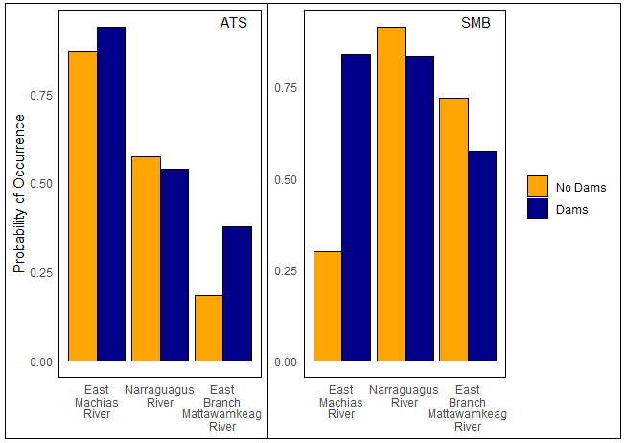
Figure 6. Comparison of probability of occurrence in the presence or absence of dams for ATS (left) and SMB (right) in three Maine Rivers. The rivers from left to right have one, one, and two dams, respectively.
IN-CLASS ACTIVITY
Impact of dams
Imagine floating on a tube in the river during two different summers. The first summer, you were able to float from start to finish with little interruption. During the second summer, you were only able to float part of the way down the river because now there is a large dam blocking the river. How did the dam change the river? In this section, we explain some of the impacts dams may have on hydrology, habitat alterations, and species interactions.
Dams are structures built across a body of water to control and manage the flow of water. Dams were built for the purpose of water storage, hydropower, and even for recreational purposes. Dams impede the flow of water creating alterations in the river above and below the dam, which ultimately causes habitat fragmentation. Habitat fragmentation refers to the division of a continuous habitat into smaller patches or fragments.
Hydrology
The purpose of a dam is to alter the flow of water for some benefit. Dams influence water flow in many ways including regulation and water storage. Depending on the size of the dam and the river, a dam may serve as a barrier that in some cases alters water flow so greatly that the flowing water near the dam may slow down to a degree where the river above the dam may resemble a lake more than a river due to the amount of water stored and the decreased water flow.
Below the dam, the river water flow can significantly be altered based on the amount of water released over the dam. The dam impounds water but that water cannot be stored there indefinitely resulting in water being released over the dam. The amount of water released can vary throughout the year following a natural seasonal pattern such as spring having heavy flows or summer when flow decreases. Regulating the water flow at a dam means that amount of water released may not resemble the natural seasonal flow that typically would occur in that river.
Habitat Alternations
Dams impound water, altering the water flow and the potential storage of water above these impoundments. A consequence of water flow modifications can be seen in habitat fragmentation. Habitats that were once accessible now have a barrier that impacts the habitat accessible and available to a species. In Maine, Atlantic salmon are an endangered species with habitat loss and alterations as a key player in the reduction of this species. Atlantic salmon are an anadromous species, meaning a species that spend their adult life in the ocean and migrate upstream in river to the spawning ground where they lay their eggs and return back to the ocean. Atlantic salmon stop eating relying on energy reservoirs to endure through their migration. The Penobscot River houses the largest migration of Atlantic salmon and has four large dams on the river. Salmon were once able to swim freely upriver but now have to navigate past many dams before reaching their spawning ground. Navigating a dam is energetically costly and difficult to pass. Dams have significantly fragmentated accessible habitat for migrating salmon.
The presence of dams alters the flow of sediment. Sediment is carried by rivers, leading to the accumulation of finer sediments near the impoundment and reducing the sediment transport downstream of the dams. Alterations in sediment transport can affect downstream erosion and even change the geomorphology of the river channel. Additionally, dams influence the water temperature and water quality. Storage of water above a dam allows that water to consistently be exposed to solar radiation, increasing the water temperature. Riparian habitats may be altered in vegetation and canopy cover, which also may result in increased water temperature. Results of sediment alterations, increased temperature, and decreased water flow can impact the water quality by reducing nutrient levels, changing the water chemistry, and reducing the amount of dissolved oxygen.
Species Interactions
Dams create severe alterations in habitat as well as habitat fragmentation, resulting in potential reshaping of the ecosystems near impoundments. The raising of water temperature and the reduction in water flow can shift the ecosystem to favoring warm water fish, waterfowl, and various reptiles and amphibians. Common warm water fish found near dams include highly aggressive predatory species such as largemouth and smallmouth bass and chain pickerel to name a few. When juvenile salmon are migrating to the ocean for the first time, they can be delayed at dams and subject to predation from fish residing in large numbers near the dam such as bass or pickerel. Congregations of juvenile migrating salmon near dams may also become prey to waterfowl and other avian predators.
Test your knowledge
Look at Figure 6 and read the caption. Individually, then with a partner, go through the following step(s) and be ready to share your answers with the class.
Step 1: Look at Figure 6. What do the axes represent? What about the colors? What are the species?
POST-CLASS ASSESSMENT
Please complete the following questions as homework.
- Look at Figure 6 carefully. What are possible reasons why the species are affected differently with and without the presence of dams?
- Focus on SMB graph of Figure 6. The East Machias River is listed as having one dam and the East Branch Mattawamkeag River having two. Why do you think there is such variation in the probability of occurrence with and without dams? Come up with a hypothesis as to why the number of dams on these rivers affect SMB probability of occurrence differently.
NOTES TO FACULTY
Here students are going to need to do some critical thinking outside of ideas they may be familiar with. This section is focused on fish, and while there is background on habitat alterations favoring warm water species due to increasing temperature, students would benefit from a basic understanding of the differences between warm-water and cold-water species. Recognizing these distinctions is essential for comprehending how temperature variations can impact species distributions and interactions in aquatic ecosystems. Students can use think-pair- share to address the questions and the instructor can circulate around to see what topics students are finding challenging that may need additional discussion.
Test your knowledge answers:
Step 1: Look at Figure 6. What do the axes represent? What about the colors? What are the species?
Answer: Y axis is the probability of occurrence, and the x axis represents three different rivers for both ATS and SMB. The colors represent the SDMs with blue including a dam variable and the orange excluding the dam variable.
Post-Class Assessment Answers:
1. Look at the figure carefully. What are possible reasons why the species are affected differently with and without the presence of dams?
Answer: The presence of dams has different impacts on the distributions of the two species. One of the primary reasons for this could be attributed to the alteration of water temperatures caused by dams. Dams can significantly change the water temperature, influencing which species are found nearby. This graph shows that each species' distribution is altered when dams are included in the model. These differing distributions can be partially attributed to the number of dams present in the river, which affects the habitat conditions for each species.
2. Focus on SMB graph of Figure 6. The East Machias River is listed as having one dam and the East Branch Mattawamkeag River having two. Why do you think there is such variation in the probability of occurrence with and without dams? Come up with a hypothesis as to why the number of dams on these rivers affect SMB probability of occurrence differently.
There are several hypotheses that could explain why species exhibit different probabilities of occurrence depending on the number of dams present. When dams are introduced, they often lead to an increase in water temperature, which can affect species distribution. Let’s consider the East Machias River, which has one dam. When dams are included in the SDM there is a significant increase in the probability of occurrence for SMB.
In contrast, the Each Branch Mattawamkeag River, which has two dams, shows higher probabilities of occurrence in both the no dams and dams present scenarios. This could be due to the compounding effects that multiple dams have on a river. For instance, adding one dam to a river can cause significant changes in habitat, particularly in water temperature. However, if a river already has a dam, adding another may not have the same impact as adding a dam to an undammed river. The initial dam would have already altered the water temperature, so the addition of a second dam may not further change the temperature significantly. Consequently, the impact on the species distribution may not be as pronounced with the addition of a second dam compared to the first.

Part 4: Scale and Resolution
Purpose: Identify the importance of scale and resolution
Teaching Approach: Think-pair-share
Cognitive Skills: Knowledge, interpretation, and comprehension

FIGURE SET BACKGROUND
This figure set shows the relationship between resolution and scale in modeling. Scale refers to the extent or level of detail that data has been measured and can be displayed in terms of spatial or temporal dimensions. Resolution is the level of precision that the data represents. Scale and resolution are core elements of many models, specifically SDMs. Here we ask, do scale and resolution matter?

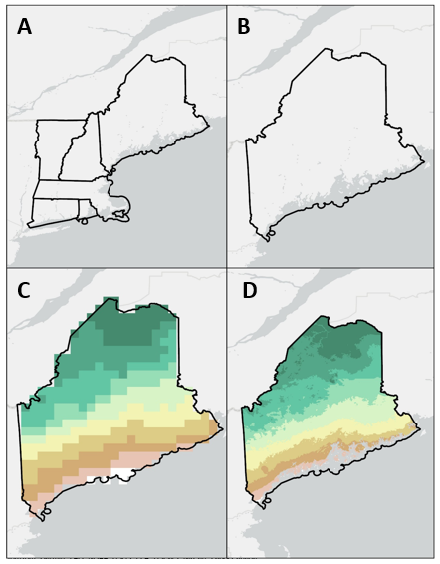

Figure 7. Scale vs Resolution. Large scale study area of New England (A) and a small scale study area of Maine (B). Large resolution of 344 km² temperature data in Maine (C) and lower resolution of 0.86 km² temperature data in Maine (D).

IN-CLASS ACTIVITY
Scale and resolution are critical principles of SDMs. Scale refers to the study area. For example, the study may be occurring over a regional scale such as New England covering a large geographic area, or may be focusing on a smaller, more specific area such as the Penobscot River in Maine. Scale determines the interpretation of the results and the ability to infer patterns and processes. Resolution refers to the level of detail. Often when using environmental data it is in raster format. Raster data are spatial grid cells (pixels) that represent geographic features with each cell having a value. Resolution can refer to the pixel size of a specific environmental variable. Why do these matter and how do they affect a model design?
Let’s compare two species, the African elephant and American red squirrel. Elephants are large animals that seasonally migrate hundreds of kilometers to find food and water as the environmental conditions change with the seasons. The squirrels inhabit forest and wooded areas where they establish territories and search for resources within a small range (meters to acres). If you were to model a SDM for the elephant that moves across the savanna, would it be appropriate to use habitat variables that span the entire continent of Africa or focus on a specific country? African elephants can span a large portion of the African continent. The scale of the study ultimately falls into the question being asked. Let’s say SDMs are developed for the entire African continent for the elephants. We are using environmental variables and need to choose the resolution based on the scale of the model. If an environmental variable is available at 10m or 1km, which do you think has the better balance for data accuracy in the model and computational intensity? While 10m provides greater resolution, using 10m for an entire continent is computationally expensive and may not provide greater detail than the 1km when working at such a large scale.
While red squirrels can be found across the United States and Canada, let’s say we are only interested in the squirrels in Yellowstone National Park. The scale of the study area is localized to the forested areas of Yellowstone. When deciding on environmental variables, the resolution available is 10m or 1 km? What resolution would be a better balance for data accuracy and the computation time? In this case, 10m resolution would provide a more accurate representation of the species distribution given the smaller scale.
Often when obtaining environmental data from different resources the resolution of each environmental variable may not be the same resolution across all variables. For example, climate data is often found in higher resolution such as 1km, 5km, and even 1000km. Elevation and slope can be derived from digital elevation models at a resolution of 30m. How do you deal with data that is of varying resolutions? Typically, you have to go at the greatest resolution meaning that if a raster is 1km, you use the data at 1km. Other options include looking for a dataset with similar resolutions or omitting environmental variables with insufficient resolution if possible.

Test your knowledge
Look at Figure 7 and read the caption. Individually, then with a partner, go through the following step(s) and be ready to share your answers with the class.
- Look at Figure 7. What is the scale of graph A and B? What is the resolution of graphs C and D?
- If you are studying a moose that has a range between Maine and New Hampshire what scale would you use (A or B) and why? What would the advantage be to using the resolution in C or D?
POST-CLASS ASSESSMENT
Please complete the following questions as homework.
- Consider three different organisms in varying habitats, various sizes, and various types (e.g., mammal, fish, bird, insect). For each organism, act like you are going to run an SDM. Come up with a question to ask, identify three environmental variables that would be important to include, the scale of the study area, and the needed resolution of the environmental variables. Briefly explain why you choose those variables and resolution.
NOTES TO THE fACULTY
This section is meant to help students understand the magnitude of scale and resolution. Students can use think-pair-share to address the questions and the instructor can circulate to identify topics that require further discussion.
Test your knowledge answers:
- Look at Figure 7. What is the scale of map A and B? What is the resolution of map C and D?
Answer: The scale of map A is all of the New England states and the scale of map B is the state of Maine. The resolution of map C is 344km2 and the resolution of map D is 0.86km2.
- If you are studying a moose that has a range between Maine and New Hampshire what scale would you use (A or B) and why? What would the advantage be to using the resolution in C or D?
Answer: If a moose was able to move between states it would be necessary to include those states as the scale. In this example, it would be better to use the scale of map A. However, it would be ideal to reduce the scale to include only Maine and New Hampshire if those are the only states of focus.
The advantage to using resolution of map D is that you can see finer details when compared to map C. This would be advantageous when working with a small scale and desiring more detail. Map C would be advantageous if you were working with a large scale and needed a balance between detail and computational time.
Post class assessment answers:
- Consider three different organisms in varying habitats, various sizes, and various types (e.g., mammal, fish, bird, insect). For each organism, act like you are going to run an SDM. Come up with a question to ask, identify three environmental variables that would be important to include, the scale of the study area, and the needed resolution of the environmental variables. Briefly explain why you choose those variables and resolution.
Answer: The world is their oyster as they say. There are many options a student can pick. An example could be a sea otter. Variables could include proximity to kelp forest, substrate, access to freshwater, and water quality. Sea otters thrive in kelp forest and near tide pools where there is shelter and invertebrate prey items. A question could be how does sea otter distribution change in the presence of a rising temperature? Water quality and access to freshwater and kelp forest are all likely to be impacted by a rising temperature with potential shifts in sea otter distributions. In this case, we are going to look at the habitat from California to Alaska so the scale would need to be large to incorporate the area within and between these states. In terms of resolution, a compromise would need to done between detailed data and computational time. Resolution of 1km or 10 km and maybe even slightly larger would be beneficial to finding that resolution balance.
LITERATURE CITED
Fay, C.W., M.A. Hachey, and R. Saunders. 2006. Maine’s diadromous fish community. Fisheries Magazine 31:529-547.
Fritts, A. and T.N. Pearsons. 2006. Effects of predation by nonnative smallmouth bass on native salmonid prey: The role of predator and prey size. American Fisheries Society135:853-860.
Hirzel, A.H. and G. Le Lay. 2008. Habitat suitability modelling and niche theory. Journal of Applied Ecology 45:1372-1381.
Kearney, M., S.J. Simpson, D. Raubenheimer, and B. Helmuth. 2010. Modelling the ecological niche from functional traits. Philosophical Transactions of the Royal Society B: Biological Sciences 365:3469-3483.
Leith J. and J. Franklin. 2013. Species Distribution Modeling. Pages 692-705 in S.A. Levin (ed), Encyclopedia of Biodiversity, 2nd Ed. Elsevier.
McCue, M.D. 2004. General effects of temperature on animal biology. Pages 71-78 in N. Valenzuela and V.A. Lance (eds.), Temperature-dependent sex determination. Smithsonian: Washington DC.
Middaugh, C.R., B. Kessinger and D.D. Magoulick. 2016. Climate-induced seasonal changes in smallmouth bass growth rate potential at the southern range extent. Ecology of Freshwater Fish 27:19-29.
Stanley, J.G., and J.G. Trial. 1995. Habitat suitability index models: nonmigratory freshwater life stages of Atlantic salmon. Biological Science Report 3. US Department of the Interior, National Biological Service.
Valois, A., R.A. Curry and S.M. Coghlan. 2009. Smallmouth bass (Micropterus dolomieu) invasion of Gulf region rivers: Evaluating the impact on Atlantic salmon (Salmo salar) populations. Department of Fisheries and Oceans, Canadian Science Advisory Secretariat Research Document 2009/075, Ottawa.

